Friday 20th February 2026

Such a strange feeling waking up on these days. A 21 hour journey ahead of me. Preceded by a 5km run and a morning at work.

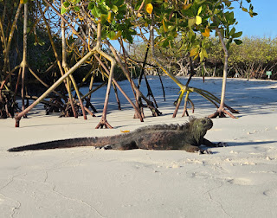

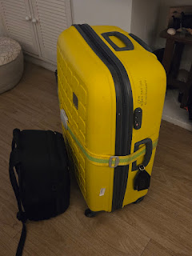

Last minute wardrobe change as it was pouring with rain. Annoying because I definitely won't need my waterproof running jacket that I bought for a half marathon up Snowdon, in the Galapagos, it just won't be necessary.

The Galapagos taxi arrived and dropped me to National Express. £9.00 ticket to Heathrow which I think is brilliant.

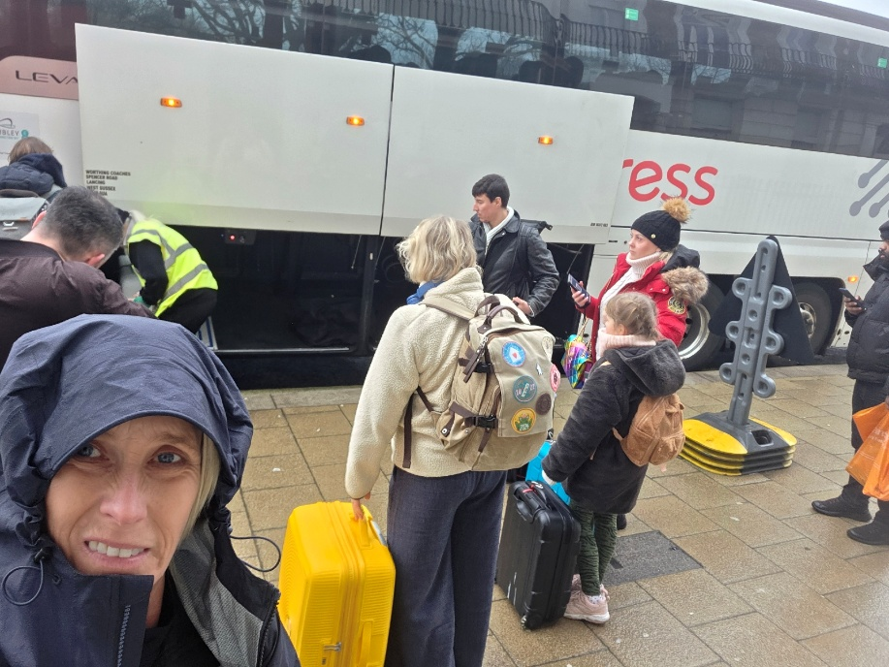
Chatted to a lady who is off to Mumbai, nice normal person also with a yellow suitcase, we agreed not to mix them up as she will arrive in Mumbai with fins and snorkel stuff and I will arrive in Galapagos with 4 trays of Ferrero Rocha....
I KNEW it would take longer than 2 hours to get to Heathrow on a Friday afternoon ! Pleased I got the 14.50 coach so had no stress. It took 3 hours. Checked in at a stand thing which spat a luggage label at me after I had scanned boarding pass, next was the luggage thing, put case on. 20kg ! Then I had to pick up a hand scanner and scan the bar code on my case myself. This will all be brilliant when every single traveler has done all this once and can then just cruise through without even needing to see a member of staff. For now, the frantic staff members must rush around shouting things like, pick it up, pick it up, now scan your bag, put this here, lift it this way...

Anyway it was a relief to see the giant yellow suitcase go, I just hope I see it again some day.

Next was security, now no need to put liquids in plastic bags, presumably everyone now thinks no-one will make a bomb from contact lens solution and shampoo. Makes it all much faster. Stood in body scanner and did an upright snow angel, got sent back, had zip up gym top on, this now classes as a jacket and must be removed.
My hand luggage camera bag got pulled aside and randomly swabbed, I desperately tried to think of the last time I came into contact with any drugs. Morphine after an operation in 2019... phew, should be safe but still stared at the results screen with bated breath. CLEAR - thank the lord....

Plane
3 seats, just me and a lady, me in the window and she is in the aisle seat. Both very happy with this ! Meals, we folded down the spare middle tray for our drinks and nodded our idea approval at each other as we tucked into a funny little meal in a cardboard tray.

I started a film but fell asleep ! I then slept on and off for around 7 hours ! Breakfast came calling from its trolley in the aisle and my sleep ended, as did the film this time !

It's so surreal how this little space is temporarily your whole world, you plug things in and you organise stuff and you sleep and you eat. Odd. 1 hour 7 mins left. 40,000 feet.... this is more feet than I can imagine.
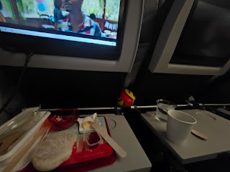

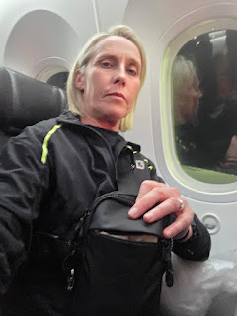

For all my concerns that this wasn't an Emirates plane, it's actually really nice and very new. It's so new that it has a USB A and a USB C plug in, there is no remote control, it's all touch screen. So Avianca, I shall be more excited next time I am boarding !

Plane Bogota to Guayaquil

Knowing time would be short at next airport with various documents to do, this plane just needed to leave quickly. It didn't, we had a huge queue to take off, I could see all the planes on flight radar queuing right back up the taxi bit.. then when we finally got there and just about ready to go... all the cabin crew were running to the back of the plane, they were calling for a doctor, I have absolutely no idea what was happening but everyone was crowded around a girl. I really thought the plane was going to get off the runway.. but suddenly everyone sat down and the pilot was leaving come hell or high water. I do hope the person was ok.

I had 3 seats to myself so just lay down for the duration of the flight. Everyone was a bit unsettled because of the start and I think knowing that Guayaquil airport has so many regulations before flying onwards to The Galapagos.

This is not a myth. I had spent 4 months researching what I needed so I had it all in advance... but everything I had pre prepped still required scanning a code and filling so many details in, which would be fine if the esim that had worked fine in Bogota would also now just work here !! I got more and more demanding of the people there, why when something isn't clear and is so complicated, why don't they change it, simplify it.

The airport wifi was slow, I couldn't select that I was from the UK, so someone trying to help selected Afganistan instead and with zero offence meant to anyone I asked him if I looked like I come from Afghanistan....

Then airports that existed and that I will fly into in 3 hours time, were quite simply not an option to select.

Once again I told anyone who would listen, what a ridiculous system and advised them all that this was incredibly stressful whilst trying to get to a plane about to leave.

I have never been so grateful for finding out that a flight had been delayed by one hour !

Eventually I had the transit card, the declaration code, passport and boarding pass... what a stress...

We were offered a complimentary juice and snack, not really necessary for an hour delay but nice anyway, I had 2 !

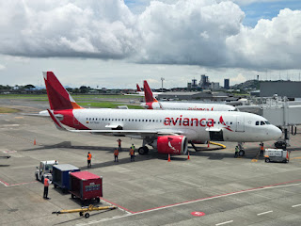

Boarded final plane and by now I had left home 28 hours ago... full flight, I was suddenly excited and as flew into Baltra Island I knew why I had wanted to do this, the remote rugged islands below were breath taking.

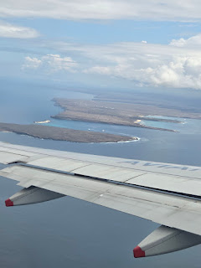

Bit of a worry seeing case in Dog checking department. Just picked it up and left !
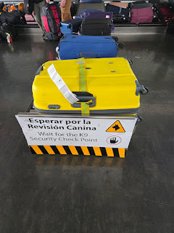

The heat wrapped around me as I got off the plane, I'm fairly comfortable in this heat and had thrown a different top on, saw an Iguana as we walked into terminal, and birds. This is going to be amazing.

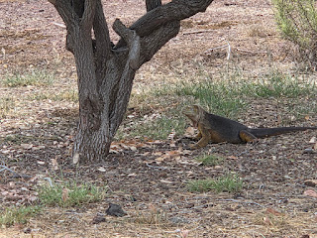

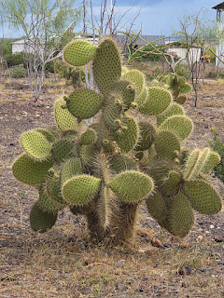

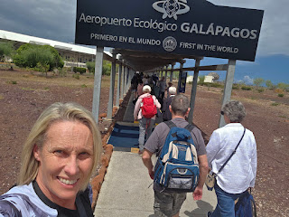

Bus for $5 to ferry, I love how everyone just piles off and follows each other, no-one saw the Iguana below the Baltra Island sign, or the Frigate birds circling above us or the crabs lining the slipway.

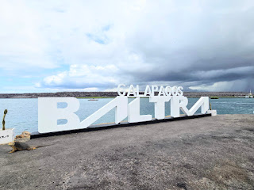

45 minute bus ride from Baltra to Puerto Ayora. Found a giant tortoise by the bus station. Taxi $2 to my accommodation.

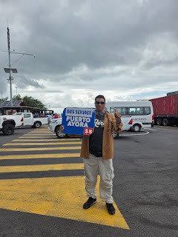

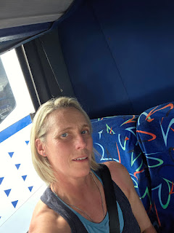

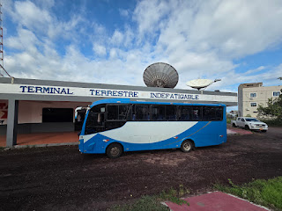

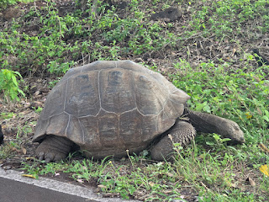

I travel cheaply so I can travel more ! My own room with a shower $90 for 4 nights.

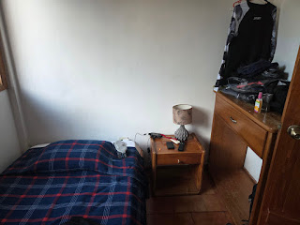

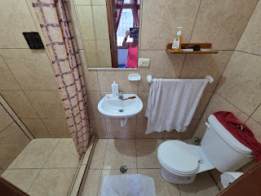

After a long journey that was 33 hours door to door I showered, walked down to the pier which was so close and found a meal. Rice and veggies $5.00 the pier was surrounded by giant birds, Pelicans and Frigate birds. Baby black tip reef sharks swam all around. I think I'll be happy here for a few days !

Early night in bed at 8 ! Considering the worship singing party that seemed to be going on and the loud air con unit. I slept really well.

Sunday 22nd February 2026

Awake at 4.45 so made myself a coffee and I'm basically waiting for it to get light so that I can run to Tortuga Bay. It's only 2.7km away so it’ll make a decent 5km run
I’m sitting at the end of the Pier and was quickly joined by a Pelican and watched a reef shark hassle it. Pelican got annoyed and flew off ! Can hear a huge sealion sounding cross about something nearby.

I set off to follow the trail to Tortuga Bay.

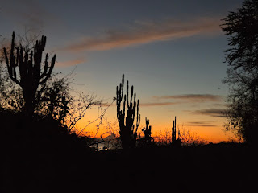

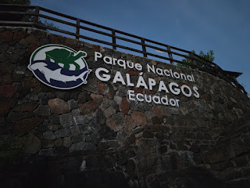

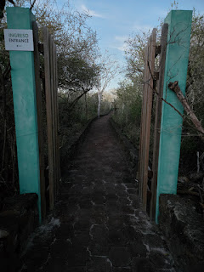

A really neat path across the cactus shrubbery type forest. I was there at 6.30am and it was still getting light, the bird life was amazing, so many I need to look up, the timing meant I knew I would reach the end of the 2.5km trail bang on sunrise. This started as a 5km run but I got so distracted with so much wildlife that I changed it on strava to a walk, otherwise strava friends will judge my pace !
No-one was on the beach, amazing, found a Pelican and Iguanas on some rocks and spent ages taking photos. The mosquitos were horrendous but I have a new way to deal with them... I was so hot that they simply drowned as soon as they hit my skin.. genius....

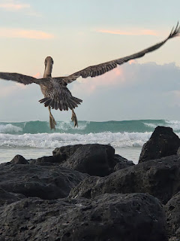

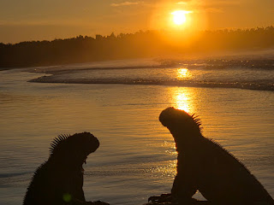

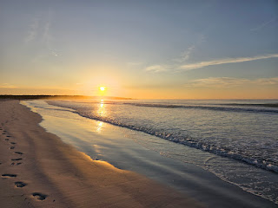

Also found a marked and protected Green Turtle's nest

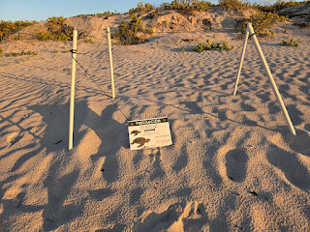

I then walked the full length of the beach and found another bay tucked away in the Mangroves called Playa Mansa, it was flat and stunning.

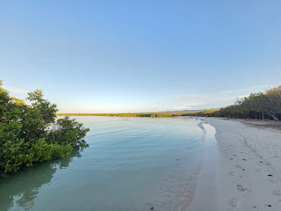

I watched reef sharks and eagle rays in the shallows. Carried on round a headland and found my very own Blue footed booby. More of a thrill to find myself, people pay fortunes to go on tours and walk in long slow lines. I just can't do that and like my Father, it would drive me mad. So when you do the research and obsess over maps it means so much more.

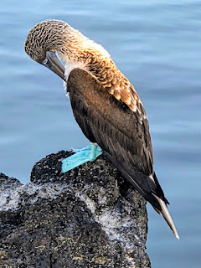

Then I ended up walking across some scrubland and it was like the ground was alive Marine Iguanas everywhere, even popping up out of burrows.

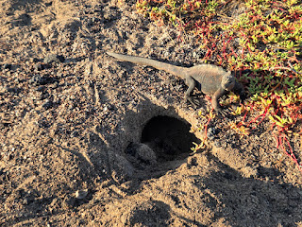

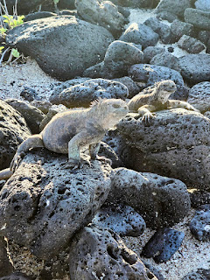

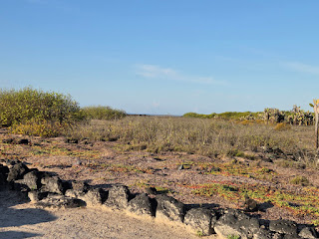

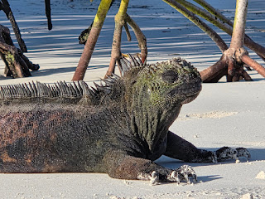

Back along Tortuga Bay and half ran half walked the trail back into Puerto Ayora. I went straight to the pier, and jumped in where I had seen local kids going in the day before.

I watched Pelicans diving in to catch fish and the Brown Noddies sitting on their heads waiting to steal the fish !! Video and mini documentary of this on Facebook and Insta.

Found a coffee and literally had to calm myself down, I am beside myself with the amount of wildlife, it's unreal.

Had a slight itinerary whoopsie, no ferry to Floreana on 25th so will stay extra night here and ferry on 26th instead, luckily my amazing single room basic living accommodation was free for an extra night. Phew.

Decided to get a water taxi to Las Grietas, snorkeling in a gorge type place. You just go the pier and a little yellow taxi pops across and you tell them where you want to go. Chatted to a couple from Holland who are travelling the world on motorbikes ! Except they just sold them, so even more money to spend on travel. Watched marine iguanas swimming, funny little things bobbing along.

Water Taxis

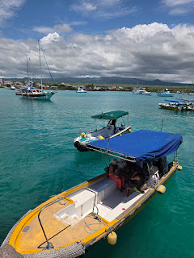

My new Dutch friends Jonny Depp - Jonny and Deb ended up being nearly as funny as me......! so we actually snorkeled Las Grietas together and basically we are new best friends.

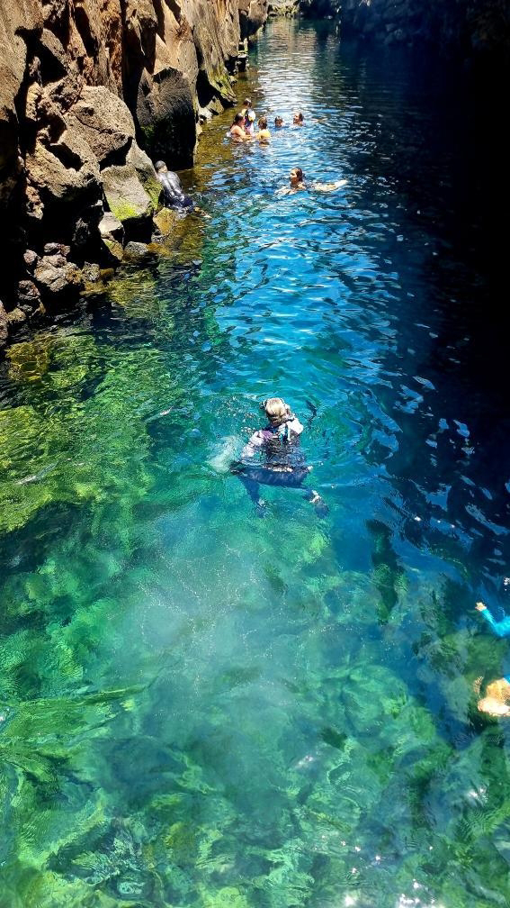

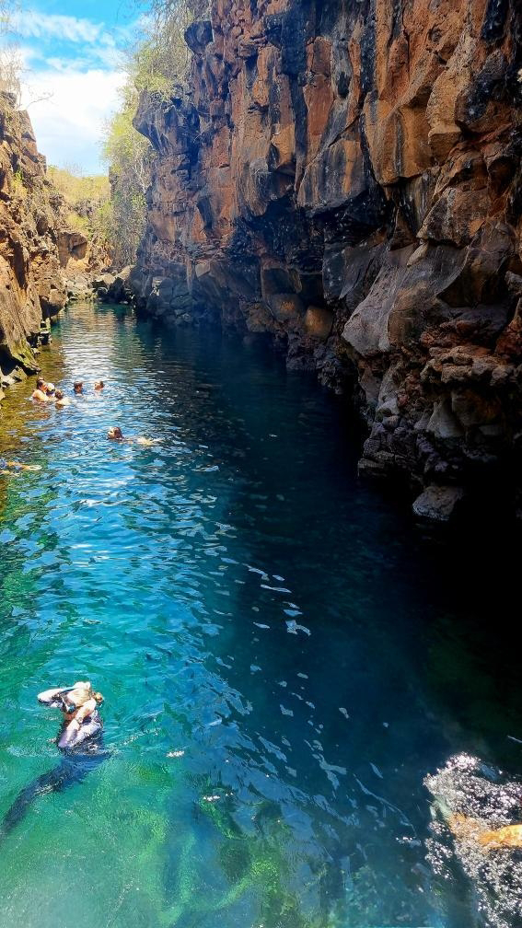

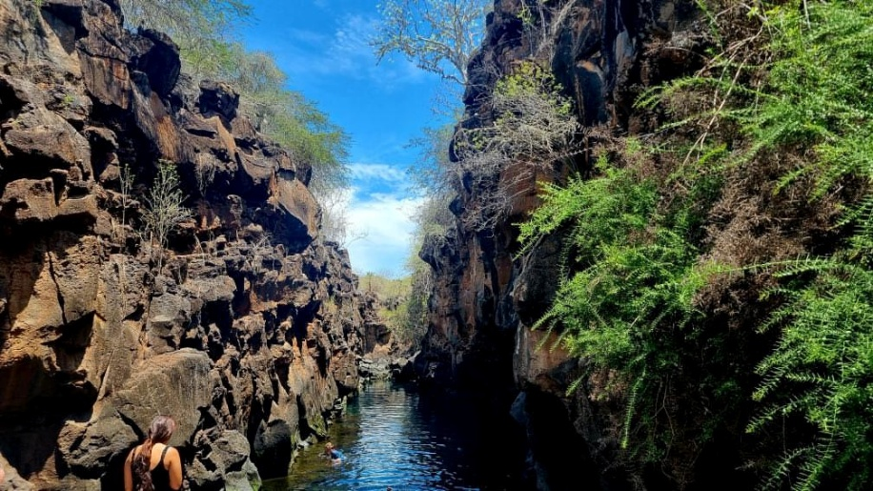

Jonny is 73 and needed to walk a bit slower, and along with our guide Lenny, it was a comical group of 4 people. Deb has an accent that sounds very similar to a Danish accent I know, we laughed about this.

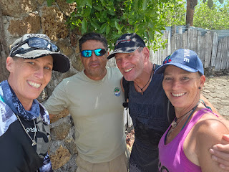

We even walked back to the water taxi together, which then detoured to a yacht to collect 2 girls, this along with the police on the water taxi earlier led me to believe we were now mixed up in a trafficking ring... to make things worse one girl was Danish... she had hurt her knee very badly and was getting a water taxi to the hospital.

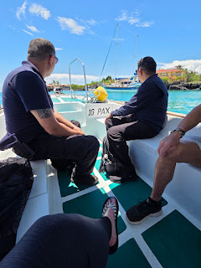

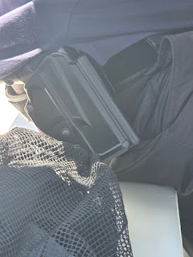

An actual gun- right next to me.

We got off the boat and I went for a drink with my new pickle friends..

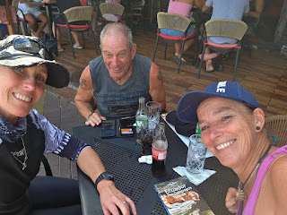

The cartel and trafficking story got worse with a huge Police presence all around the Pier and a road closed and someone being searched behind me. The Military literally stormed down the Pier with guns held high, it crossed my mind to start running, but felt that may draw suspicion to me for absolutely zero reason ( aside from still being worried about being in possession of my diving knife ) Subtle selfie to get Police in photo. If they do need to speak to me I will now have annoyed them on many levels, secret gun photos, secret selfies ( and a diving knife )

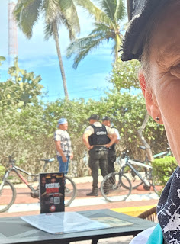

Me and Jonny Depp had a lot of giggles about word differences and somehow pickle came into it. So somehow they already knew I hated being around people and tours, but off we went to hang out.... for the exact reason that we didn't have to hang out made it totally fine to do so. We had some real giggles and somehow I am now meeting them for dinner which even they already know is an odd thing for me to do....

I went for dinner ! I know people won't believe me but I did ! It was a a restaurant next to Hotel Crossman and I met Jonny and Debby there, we had more laughs, and the language differences caused some hilarious moments like Clogs and the word Klompen - yes you had to be there.

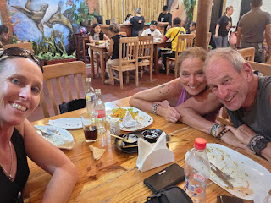

I had a skewer and fries and a coke, there is no zero alcohol beer or diet coke ! I think the sugar in the coke isn't such a bad idea when away and in this heat ! Still we didn't want the day to end so we all went for a coffee ! By now it was 10:30pm ! what a long day, made even longer by the fact that my phone time was out by an hour so I had actually got up at 3:45am to go and see the sunrise at 6:11 ! No wonder it was still so dark on the pier at what I thought was 5:30am, no light in the sky at all and I was thinking maybe because we were on the Equator that the sun would just come up suddenly and really quickly ! I was really confused as to why it didn't even start getting light until 6:30.... It wasn't until 1pm that this came to light and we laughed at my sunrise mis timings, so in fact it had only still been 8am by the time I had run to Tortuga Bay and got back and had a coffee, so this was the longest day in the world. Not helped either by my watch being on uk time and that's an hour out anyway, so calculating the time from that was also all wrong, By then I had no idea what the time was, let alone what it was in Thailand and Australia is probably in 2028 already......

Monday 23rd February 2026

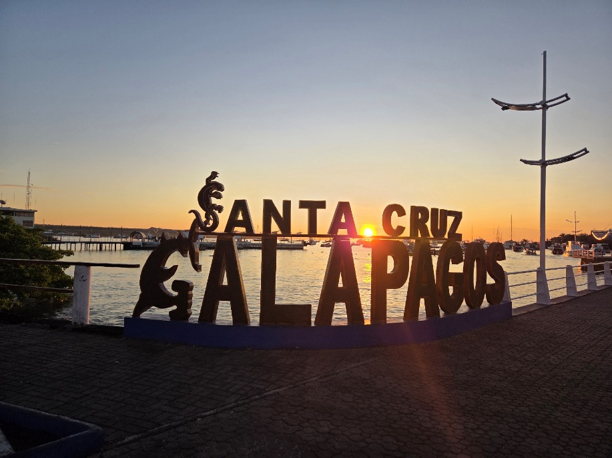

I can't resist sunrise when I am away... Just that hour when no one is around aside from locals getting going with their days, water taxis moving around and boats being loaded up.

I managed to find the little heron from yesterday and he's on my bird list. Watched the Brown Noddies feasting on small fish, the 2 naughty seals from yesterday still messing around and the Frigate bird dive bombing the seal after he caught a fish.

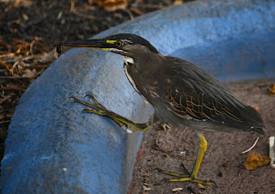

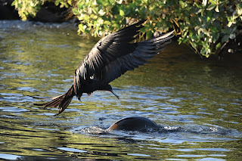

The heat has got me today, a long journey and a day in the sun yesterday, it wipes you out. So I got a taxi to The Charles Darwin Research station and learnt all about the tortoise breeding programmes. 158 tortoises have just been released back onto Floreana Island where they have been extinct for nearly 200 years. Taken by Whalers and fisherman as food for long trips they eventually died out. I cant believe this is happening at exactly the same time I am here and I'm going to Floreana in 4 days time.
It was fascinating hearing about Darwin's research into the evolution of species.

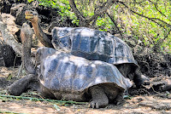

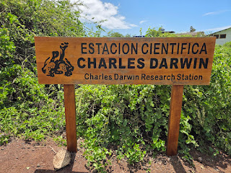

I got to meet Lonesome George, he was the last Pinto Giant Tortoise, found in 1972 and they tried for 40 years to breed with him to carry the species on, but it just didn't happen and after he died in 2012, it was established that he was infertile.

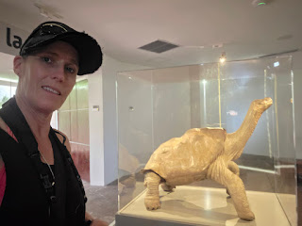

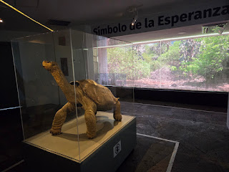

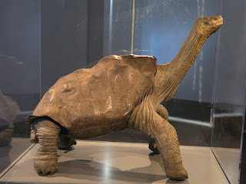

It was such a hot day but just as we got to the Museum and cafe it absolutely chucked it down. I think the most torrential rain I have ever seen and that includes Indonesia, Tropics in Australia and Thailand, oh and the new rain we have in England now.

The museum has lots of original samples collected by Darwin and similar like this skeleton of a lizard.

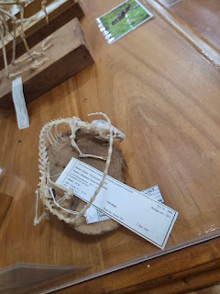

A huge collection of tortoise shells.
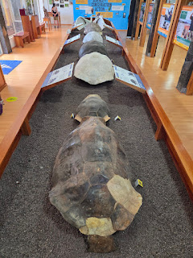

I wrote in the visitors book. What dreadful writing I have, lucky this journals not hand written....
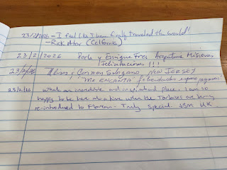
Popped to nearby beach Playa de la Estacion, a possible nice little snorkel cove for another day.

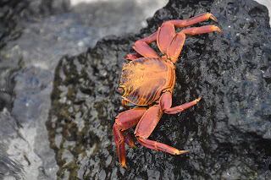

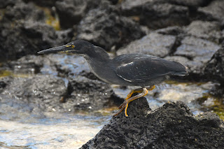

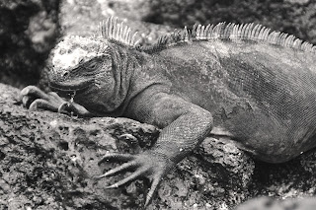

I went to the Pier to wave my new best friends off, but missed them, waved to all the big boats leaving anyway ! Then spent a random hour just hanging around the Pier, Sealion, Turtle, Rays, Iguanas swimming, I was very busy rushing from one pontoon to another.

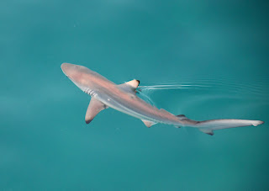

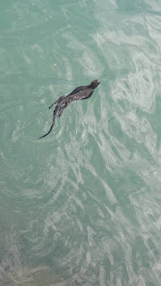

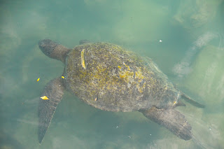

Really sad to see a Turtle with a huge propeller mark on his shell.

Decided then to get a taxi to Galapagos Frontier, it's like a sanctuary really where the Giants wander around a huge expanse of land. Trees, long grass, swamps.

I dislike tours ! Apart from Jo's Tours... I mean when you book it in an office and they pick you up and you pick other people up and eventually you actually get going and then everyone discusses their name and where they are from and when they arrived and when they are leaving and what their great grandfather was called..... So I generally avoid this frivolity and research stuff myself and how to get there and basically wing it which is what happened today.

I generally like to think of myself as pretty organised and practical. So.... got out of taxi and wandered into Tortoise land, absolutely no one around, so I wandered around a building saying Hola a lot until 2 people appeared and by sheer luck a group had just left. Now, once I am at whichever destination I am avoiding doing as an organised tour, I am then of course happy to pay the people at the place for a tour and their knowledge, this is respectful and they can't just have people willy nilly galavanting around petting tortoises.

So the girl was happy for me to catch up with the group who had just left, grabbed a water, bad move as then had too much to carry ( water doesn't fit in my amazing new sling bag )

Then we realised I only had my flips on and the ground looked somewhat swampy.. but as luck would have it there was a huge rack of wellies for just such events. So the guy found me a pair which felt just amazing on bare feet... off I set with the girl who was to catch me up to the group in front, we practically sprinted over very uneven lava rock dotted land that resembles the moon surface as I clutched my camera, my bag and my water, all whilst my feet were sliding around in my new blue wellies...

We found them after passing huge tortoises at a run, no time for photos...

Phew, now I could amble along with them, no no no, apparently this was a Tortoise marching tour .... so still I clutched all my belongings and tramped along behind. There were only 2 others, perfect, a small group. Still we did the obligatory questions, I didn't really care when they arrived, nor them me... or when we are all leaving... pleasantries exchanged, on we tramped and stumbled... I have never wanted my incredibly practical trail shoes so much....

Unbeknown to me the terrain was only going to get worse... we now entered the rockiest looking Lava tunnels ! My feet slipped and slid forwards, backwards and sideways in my wellies as we navigated steps and rocks.

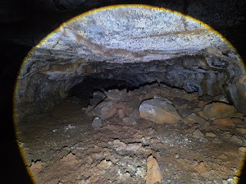

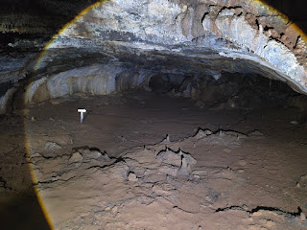

It was absolutely incredible! These tunnels were made by flows of lava 2 million years ago. Stalactites rose from the floor formed by stalagmites of dripping lava above. On we clambered and, along with all my belongings, I now had to hold a bloody a torch aswell !

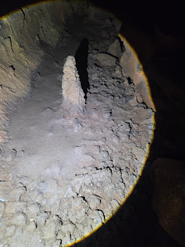

There were other sticky uppy things, but these were made from gases coming up from the ground.

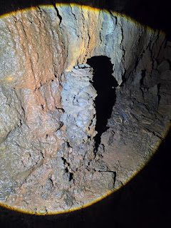

Eventually we had covered 600 metres of tunnels, ooh there was also a lava bubble aswell and you could imagine the lave glooping up through it, although sadly now it just looked like a bumhole....

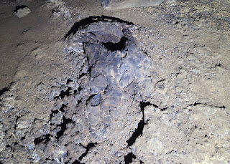

Now, the expedition had been hard enough and I have never felt so ill prepared in my life but as we surfaced from the centre of the earth it was now raining torrentially. Shit ! I had my camera which has to be protected at all costs, so I took my top off, wrapped it round it and also tucked it into my baseball hat.

Blue wellies, shorts and a bikini top was my chosen outfit as we trudged ALL the way back. Past the swamp with huge tortoises wallowing like hippos, no photos here, no hands and camera undercover....
I was so pleased to get back to base, discard my wellies, wring my top out and use a serviette to wipe a small amount of moisture from the top of the camera... what an absolute trek that was !

Thankfully a couple of tortoises were just outside the centre and the rain had eased off enough to grab some photos.....

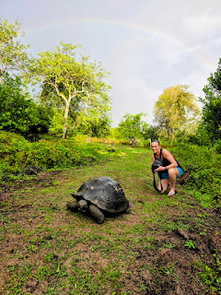

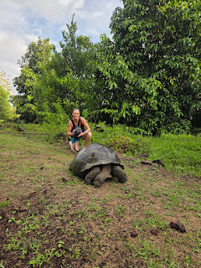

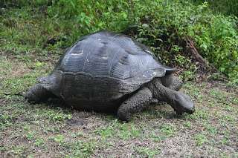

My taxi driver came back for me, and now he had his family in his car aswell ! He kindly dropped me back to my little home where I wrung all my clothes out and jumped into a very welcome shower.

Dinner, just around the corner, easy, until marching along the street towards me was a military man holding a rifle with a little group of people behind him, a sniffer dog and more armed people, for gods sake - they seem to do this when an important person is walking to the shop or wherever they were going, what a lot of pretentious crap, no-one even seemed to know who it was anyway - but they didn't like me taking a photo and told me so, reminded me of when I took a photo f an armed person as I crossed the border from Croatia into Bosnia, he had a fit about it aswell. Well they shouldn't draw attention to themselves and then not admit they exist. Stupid.

It was an easier day as I had got taxis to places but another good sleep wouldn't go amiss.

Tuesday 24th February 2026

I feel shattered, the journey and the 1st hot day with a run and a lot of walking in the sun. I also realised that diet changes travelling and I normally eat a lot of fruit and veg. So, found a cute little market and got bananas, apples 2 huge slices of watermelon and an avocado- I can cut it with my diving knife !
So hopefully some nutritional value restored. No wonder some people are sluggish all the time with rubbish diets. It makes a difference people !!

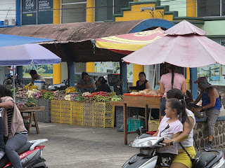

Without much energy I wandered to the pier and round the side where I had noticed a cafe place, it’s where all the local fishing boats come in and I also think where the locals grab some simple food. The coffee is strong and lives in a huge Urn and you just help yourself, no oat lattes here, or really anywhere. ( and also a big lack of double deckers !) Amazingly this little basic tucked away place suited me just fine as I watched sea lions, Rays and herons around the fishing boats. A boat was surrounded by people from restaurants picking up huge whole fresh fish. The Sealion also waiting patiently.

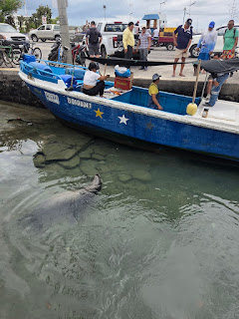

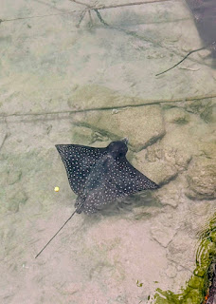

Big palava as he was thrown a chunk of fish and was immediately dive bombed by Frigate Birds and gulls. He lashed his head side to side to rip chunks off the fish with his sharp conical shaped teeth designed for gripping and tearing rather than chewing.

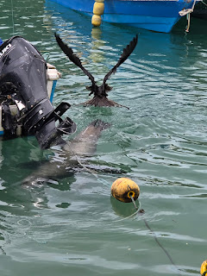

I asked for a menu but this was simply a list of 5 items on the lady’s phone with an English translation underneath, I somehow ended up with rice vegetables and an egg.
Beautiful rays came by below me and the little heron was so cute sitting on a boat propeller catching his own fish.

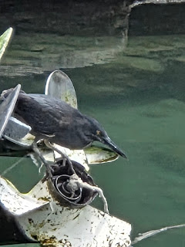

Then the rain came, it was torrential beyond torrential so I settled in for a wait. The place was so basic with not even a fridge of drinks but I could see all the fisherman had a refreshing looking lemon drink so asked for one of those... it was in a huge bucket at the base of the fridge. It was delicious, lemon and honey I think.

I sat for 2 hours in the end but the entertainment had been wonderful to watch.

The rain eased and I made a dash to the next door supermarket, needed supplies.

As I left the rain was coming again so ducked into favourite coffee shop amidst huge lightening flashes. There’s people struggling past with luggage off to catch boats to other islands. Travel is travel and you just have to get on with it.

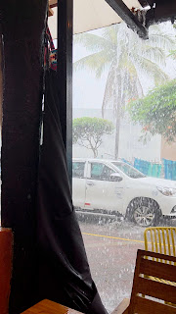

So I had a forced much easier day which I think I needed and with wi-fi I could just chill and watch a film. I don't want to write Netflix and chill because my hairdresser told me about that phrase !

So hopefully energy levels restored and I can rush around like a lunatic again tomorrow.

Wednesday 25th February

And that is exactly what I did !
Thank the lord, woke up with more energy and felt normal.
Off to pier for sunrise. Big Fella was commandeering the pier, I was standing watching him and he suddenly reared up tall and lunged at me with an open mouth ! Friendly chap, 200kg of blubber, not fun.

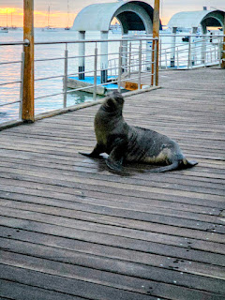

I watched the tourists starting to turn up for tours and also saw knee girl from the other day, it was her ACL ! I knew that's what it was going to be. They were off to Isabella for the day.
My brain started ticking, my new best friends are on Isabella... could I get a last minute ticket... found a tour operator open and he made it happen ! I rushed home and packed a bag for the day frantically trying to think what to throw in !! Go pro, spare camera, long sleeve top, sunscreen, power pack, oh and an apple ! Ran back down to man and he escorted me to ferry queue and I was in !!! Bloody brilliant.

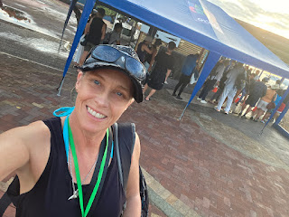

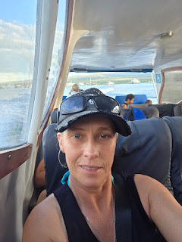

So now I'm on a boat, not big, they seat 32. It's a 2 hour crossing, no hardship for me to be on a boat ! Although the seats are very low, so I solved this by sitting on 2 lifejackets, people behind will have suddenly seen me get a foot taller...

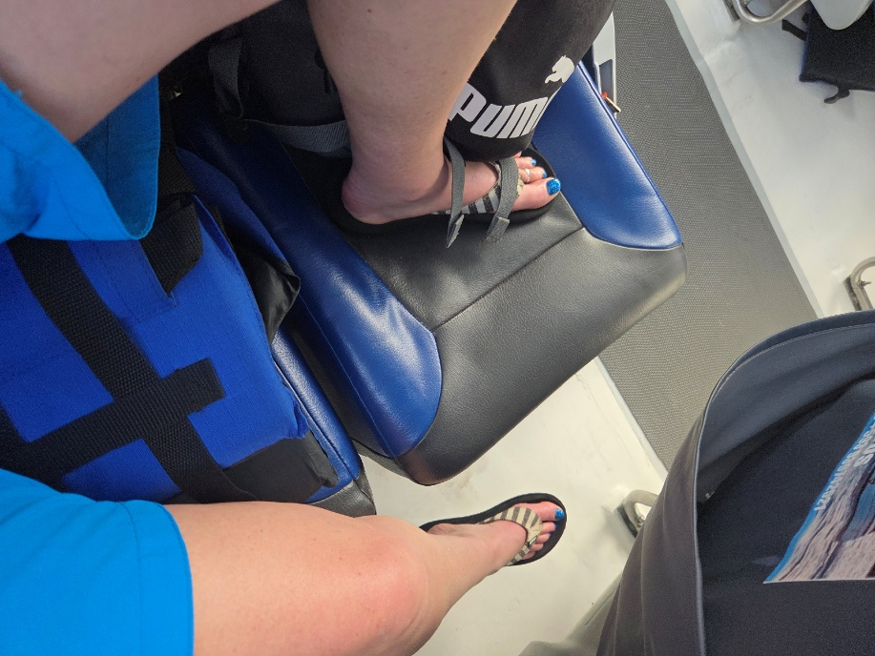

It is actually part of a tour but I won’t do the tour, it's tortoises which I've done and flamingoes which I’ll go find myself. The beaches are lovely so I shall stay local to the pier, do my own tour and get on ferry back. I absolutely can not bear the thought of getting on a bus and shuffling along with a crowd of people all day, I don’t care when they arrived or what they are doing, or what their names are.

Immediately Isabella was beautiful with white sand beaches and Mangroves.

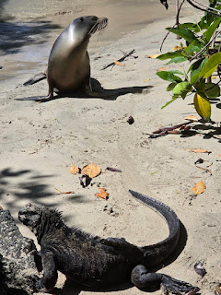

My new best friends met me for coffee after I had messaged them telling them to wake up and get up and I was coming on a boat ! They must be so pleased they met me !

I had looked up what I could do with only 5 hours and there was a beautiful snorkel place very close to the pier. Concha de Perla and weirdly that was their plans for the day anyway ! So even if they didn’t get my message I would have bumped into them there.

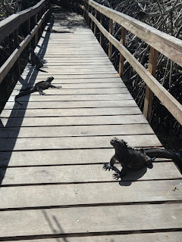

Seals and Iguanas were strewn across the walkway and required some navigation.
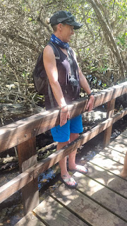

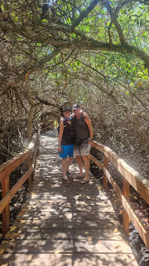

It was a stunning cove of Mangroves and lava rocks creating a safe lagoon to snorkel. Immediately in the water and rays were beneath us. Closely followed by seals ! They shot under us so fast. A first for me, i haven’t swum or snorkelled with seals. Need not have worried, as the morning went on, the steps and platform got very very busy with them and at most 8 of them were getting in and out around the humans !
We joked that we were looking for the big 5 so a good start with 2. Rays and Seals.

I had on my wish list to film Marine Iguanas in the water and as they swam across the bay from lava rocks to Mangroves it was easy to swim with them and keep up.

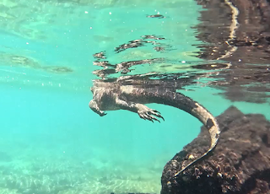

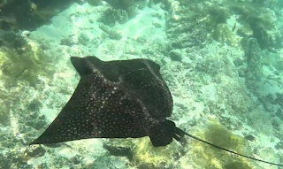

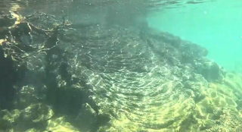

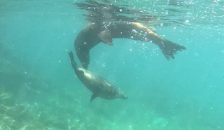

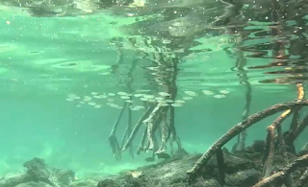

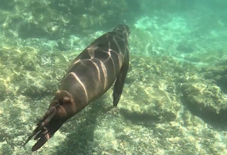

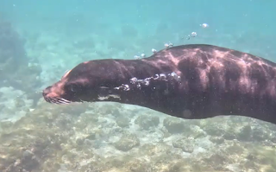

So that was 3 of the 5. Next was a huge green turtle, water a bit murky as they were further out, but I’ve filmed them before so not too worried.

The 5th would have been Reef Sharks but none around.

The time and fun with the abundance of seals more than made up for this and getting to see them so close was amazing. There was even a pup suckling from Mum while Dad lay nearby watching everything and everyone !

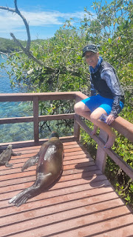

It was an amazing 4 hours and also as a solo traveller, really nice to share it with my new friends ! Debby had even bought me a piece of cake aswell, they had stopped at a bakery on the way. This made them rated very highly as new friends ! Also when you get out the water you are always starving , so a huge slab of cherry bakewell cake was so welcome.

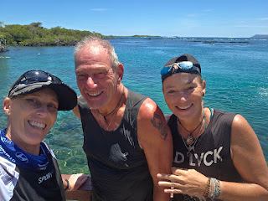

We spent as much time on the steps and platform with the seals as we did underwater.

Quick taxi to main beach and a coffee, then time for my boat back.

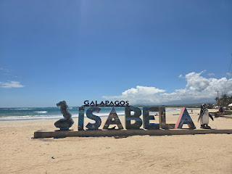

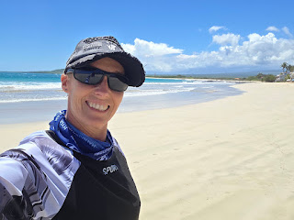

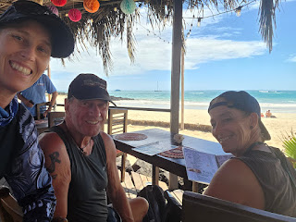

You pay $1 for the water taxi to the various boats that were leaving and we had different coloured lanyards on, yes lanyards... only for boarding the right boat and our dingy happened to have a mix of 2 boats passengers on, it was so obvious he was going to drop some people on one boat and some on another, but when we pulled up to a boat that wasn’t this particular ladies boat.... Big big panic set in, she was beside herself and I think she thought he would force her at knofepoint to get on the wrong boat. Just sit down and shut up. You’ll go to your boat in a minute, people never cease to amaze me with their total lack of logic.

What an incredible day and I still need to go through the go pro footage.

Thursday 26th February 2026

Travel Day today, started with walk to pier and needed to get some cash out as Floreana won’t have card options or atms.

Today is the reason I decided to come to The Galapagos. I watched a film on Amazon Prime about a couple from Germany who went to Floreana after the First World War to escape the world. I like their ethics. It showed them setting up a humble home next to the only source of freshwater. They built a wooden home and grew vegetables and fruit. There were 3 of them.

Friedrich Ritter and Dore Strauch (1929): A German doctor and his partner who arrived to escape Western civilization. To avoid dental emergencies, they notably had all their teeth removed
The Wittmer Family (1932): Heinz and Margret Wittmer, along with Heinz’s son Harry. Margret gave birth to Rolf Wittmer, the first person officially born in the Galapagos.
In 1932 The Baroness arrived accompanied by 2 amorous companions who both vied for her attention.
In comparison the the Wittmers they were boisterous and impractical causing havoc over water supplies and neighbourly relations.

Later the Baroness and one companion was to disappear and was never found, whilst her other companions skeletal remains were found on a nearby island along with the fisherman he had tried to travel with.

The death of the Baroness remains a mystery to this day.

The film was fascinating and at the end they showed actual footage of them on the island along with information that descendants of the Wittmers now run a small tourist hotel on this remote Galapagos Island. At that moment I decided I wanted to stay there. I booked flights a few days later and fashioned my own itinerary.

Most who travel to The Galapagos Islands pay a lot of money for liveaboard boats and do stop offs at each Island. These trips coast £5 to £10,000.

My flights were £1200 !and my total accommodation for 2 weeks was £420
So, it’s a really special day today to travel to Floreana and stay in the Wittmer Hotel or Wittmer Lodge as its also known. £30 a night for my own room and shower room. There’s no air-conditioning and its basic.
I have 8 nights on this Island, far more than most people who just visit for the day or spend 2 or 3 days. I wanted the time to explore, see the water source and the Wittmers original set up. I can also have time to just watch the wildlife and study behaviours.

So I am at the Pier with a different lanyard today. Water Taxi, keeping a close eye on Clive's yellow suitcase.

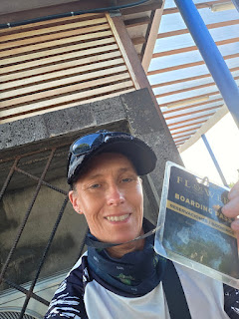

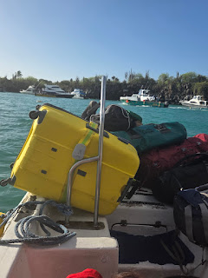

Thursday 26th Afternoon
Choppy crossing with quite a swell, a couple of people got sick, As Floreana came into view, I felt a bit emotional and I don’t know why, I had set my heart on coming to this Island with so much History, that combined with wildlife and Charles Darwin spending 5 weeks here, it just seems to mean so much.
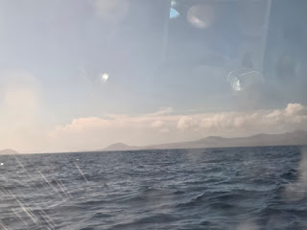

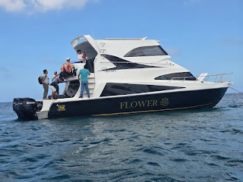

A simple pier and a water taxi from the boat, welcoming committee were all lined up on the steps.

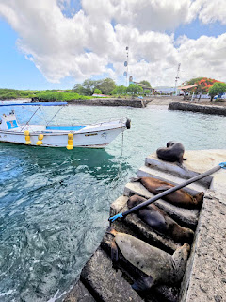

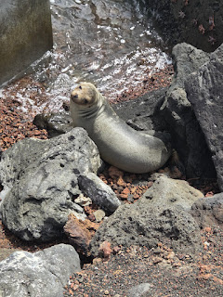

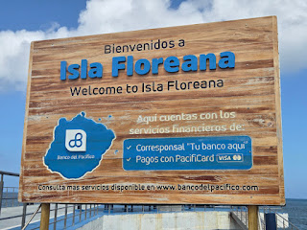

Passed through security which was a metal table and a security guy and he only looked in my hand luggage, I could have had anything in my suitcase.
So now I stood at the start of a very gravelly road, not at all conducive to suitcase wheels. I knew my hotel was only around 200 metres away but just wasn’t too sure how I was going to cover that distance. A car stopped, and the guys asked me if I wanted help – yes yes I did !! They were amazing and put my case in the back and made me jump in the front and they took me to Hotel Wittmer. The place I had set my heart on staying at.
I met Erika Wittmer, Grand daughter of Heinz Wittmer, the first settler here and her nephew Hans who has just taken the hotel over. They were so welcoming, showed me to my amazing room, for a budget traveler, this was just one of the most wonderful rooms I have ever seen. I knew I wanted to be on the second floor as it has the view.

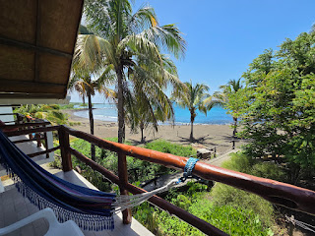
Hans made me breakfast, no idea what it was going to be, I think you just eat what they prepare, Erika explained this was really similar at the 3 restaurants they have here. It was pancakes, maple syrup, 3 pieces of bread and some Floreana homemade marmalade, made from fruits here on the Island. I ate everything.
The view from the hotel is amazing with Black Beach right in front of it.

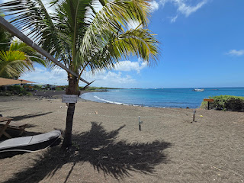

I set off to explore nearby, the Island is only home to 150 people in simple homes, the grocery store was a store with around 6 shelves of not much nutrition. I bought some cheese biscuits, not sure why but felt I should buy something and they had no large bottles of water, I wanted to know I had lots of water ! I have none at all. The little village is a grid of around 4 roads and looks like a noughts and crosses board on the map. No tarmac, all lava gravel.
I knew there was a small accommodation beyond my hotel so I wandered there and found a guy sitting on a veranda surrounded by Iguanas, one was particularly colourful and I already knew that species vary between Islands and that Floreana has the most brightly coloured.
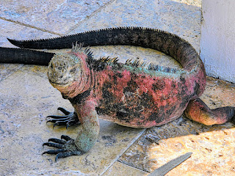
I apologised thinking it was his room ! But it was the entrance to a building he built and does air bnb. He welcomed me and asked me to sit down and did I want anything. Yes, I really wanted a coffee ! So he made me a coffee in his kitchen and he even found me some batteries I needed for my mouse – there was no way I would find them anywhere here. Frank used to own a cargo company and retired after being offered a huge sum of money and now lives here. He has a sailing boat he goes off on and looks after the mini lodgings he built right on the beach.
This is what I like doing, meeting local people, not wandering around in groups on a visit to a place. Frank had so much history to share and I want to write it all down before I forget, Floreana Wittmer the second child born to Frederick Wittmer is still alive and lives here ! I can’t believe I can meet her, she featured in the film and the original footage I watched. She had 3 children, Erika, Ingrid and Trudy. Erika ran the hotel, I had met Ingrid who takes care of the humble bar / café – she made me a lemon and passionfruit juice. There was a tour group sitting in front of the café and the guide was telling the story, the story that’s the reason I am here.
Anyway, back to Frank, he was good friends with Rolf, first child born here on the Island and brother to Floreana.
When Frank had his cargo company they stopped here at the Island regularly bringing supplies to the Island and at 9pm all the lights were switched off, so if he arrived late he would radio to Floreana in her younger days and she would carry a paraffin lamp to the rocks at the end of the bay, the lighthouse showed the other end and so he would moor up in the middle of those 2 lights.
Next he pointed out a white post and a chuck of concrete that had been a grave until heavy rains washed it all away and a skeleton was exposed, Frank and others collected it all and moved it to the cemetery. The whole beach area was the old burial ground as the sand was easy to dig. The guy was identified as a Government official who had died on the Island.
I was still worried about water supplies so Frank rang both local shops ! when they get water they will call him.
Next we talked about wildlife, so he rang the local guy and guide Santos, Santos came straight to visit and we talked about the recent release of the 158 tortoises and how I might be able to get to the release site which involves a 10km walk, alternatively we can get a boat and walk 2km but we need other people interested otherwise it will cost me $400 and that’s not going to happen.
I can also get a bus up into the hills to see the early settlement and caves where Ralph and Floreana were both born, and where the water source is. So tomorrow I will do that and Santos will come with me so he can tell all about everything and birds and wildlife.
I’m sitting in my room with this incredible view as I write. I feel like one of the luckiest people alive to be here in such a remote desolate destination.
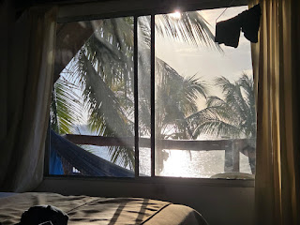

I spent 2 hours chatting with Frank and Santos, I have both their numbers and they both speak English, so feel I have back up if anything goes wrong. Oh and Santos will bring me 2 x 5 lites bottles of water later ! Phew.
I wandered to the pier and grabbed some bottled water from the very small kiosk there, Water, and large Gatorade and a strawberry fanta thing – I don’t really drink fizzy drinks, but in this heat I feel it’s a necessity. I was going to sit on a bench but it was occupied by a seal, so I sat under a tree and spotted a beautiful little nest with a head sticking out ! Below me, sealions played at the shore and just across from me sea lions were dotted all over the pier.
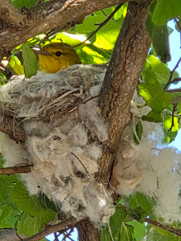

The beach is partially roped off as it’s Iguana nesting season, One had chosen to dig just outside the ropes and I could see that tour people were going to disturb it so I made a ring of fallen coconuts around it !

Friday 28th February 2026
5:30 alarm, my biggest issue is that I can’t make a coffee, I’m not sure that anyone on the island has a kettle !
Packed a bag with binoculars, Gatorade, grabbed camera and set off on a mission to find a flamingo lagoon. The walk was spectacular over lava paths, the noise it makes under your feet is crunchy and hollow. The landscape is desolate and runs alongside the coast so it was a stunning walk with perfect views of very typical Galapagos scenery.
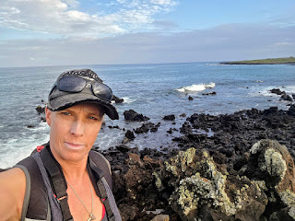

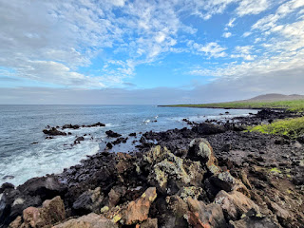

I found lizards along the way and shells, so many shells and then it seems that the thing to do is then place your shell on a nearby rock where others who have gone before have done the same. I found bones, maybe a sea creature, maybe a human, who knows.
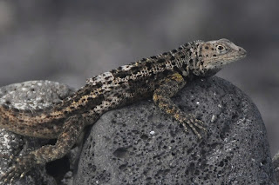

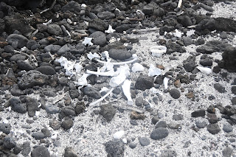

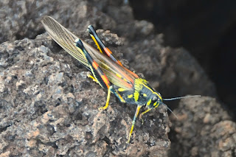

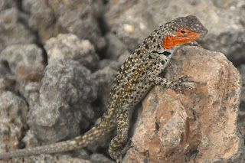

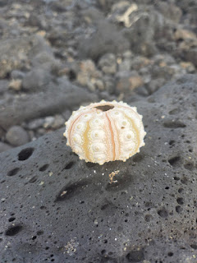

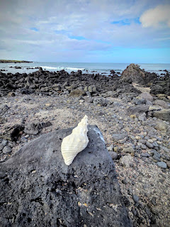
Then to my sheer delight as I rounded a corner, there was a tall blob of pink !
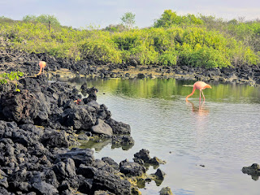

I was beside myself to see truly wild flamingos just pottering around a lagoon.
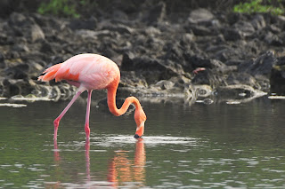

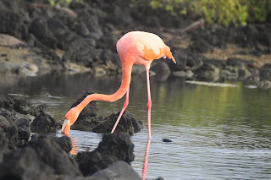

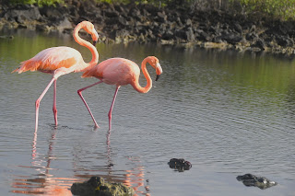

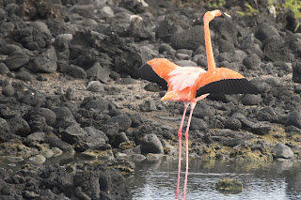

I sat and watched them for an hour, there was also a huge nest site of Iguanas, lots of holes and even one that had been predated with an empty soft shell. This made me sad, but nature is nature.
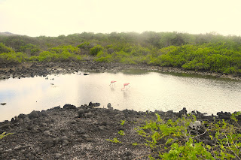

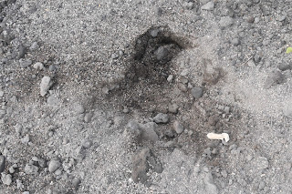

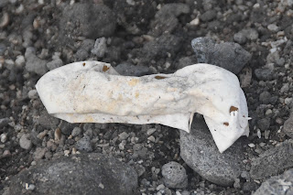

I did the most epic wildlife rescue of a crab laying on its back, I saw his legs moving, so gently turned him over and was going to get him back to the water, he was already dead….. it was the wind blowing his legs, so not my most successful rescue.
One of the funniest sights I have seen was all the Iguanas huddled together on the top of the highest rock.
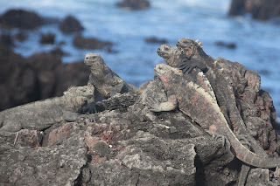

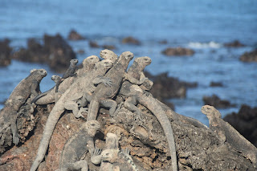

I also spotted a finch which I think is Darwins finch, I need to look it up, it was a funny little thing and these birds don’t see humans, he was so interested in me and flew side to side stick to post and even came and fluttered about a foot in front of my face, I guess he decided I wasn’t a threat and nor was I an insect that he could eat. This is actually a Galapagos Flycatcher !
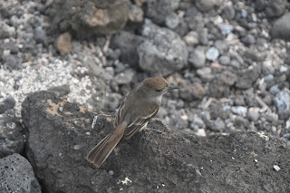

I wandered back, and it’s only a 20 minute walk, showered and had breakfast, ready as ordered at 9am.
Decided to set of in search of water again, I found the main street, this is a very loose term and I’ll get a photo of it, it did have a restaurant named after The Baroness, and I found another restaurant saying it has pizza. I was happy to find another shop but unless you want fairy liquid or a washing up brush, it didn’t really help me and I advised the guy in the shop that if I don’t find water I will probably die, he wasn’t that bothered, so back to the little tiny kiosk by the pier and 3 x 1 litre bottles of Gatorade seems to be the easiest large amount of liquid I can buy. I found Frank there ! He was having an ice cream. Told him I was off to visit him next, so we ambled back across Black Beach together and went to Wittmer Villas as his establishment is called, he bought the land from the Wittmers. We sat once again on the veranda and had a coffee, it’s honestly like my own private café and we chat away happily, bound to get on as individuals who are happiest in nature and remote places. The very best Iguana of the Island lives at Franks, definitely King Iguana of Floreana, he’s stunning.
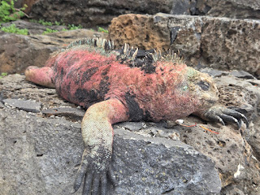

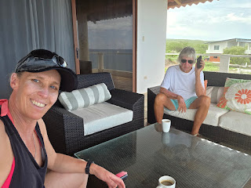

Seals cavorted up the beach as we enjoyed our coffee and he told me that there is a family of penguins who come across the bay, so I need to keep an eye out for them, I have never seen any type of penguin so hopefully The Galapagos Penguin can be my first.
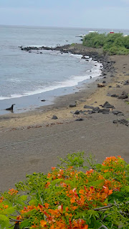

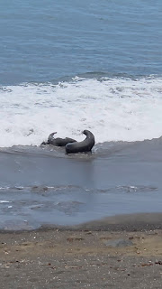

To anyone reading this and you don't like history or have heard quite enough about Floreana, probably just skip to tomorrow !
I went to the bus stop at 3pm and I would meet Santos so he could tell me the history up in the Highlands. The bus !!
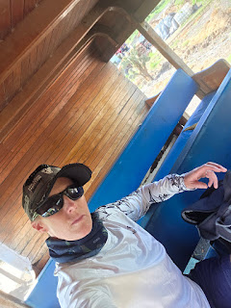

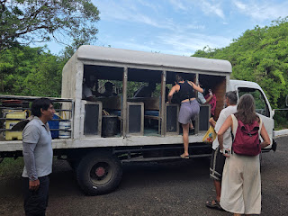

As you drive up out of the village, the road is tarmacced, you pass the cemetery and also the Helicopter Pad, used for emergencies.
Then it starts to becomes the farms, papaya, Pineapples, Potatoes, Orange, Cows, Donkeys to help with the work.
8km up we stopped and Santos started telling me stuff, we saw the Tortoises, these are NOT Floreana tortoises, years ago friends of Floreana Wittmer brought her 2 tortoises, a male and a female, for years they lived in the back yard of Hotel Wittmer, not the best place for them, so the National Park moved them up into the Highlands where 30 of them now live surrounded by a big wall, but a huge area for them, eventually they will die out because they can’t reach the beaches in order to lay eggs and the ground up there is too hard. 3 times a week they are fed huge big leaves, they won’t eat grass because the Wittmers fed them big leaves and it’s all they know !
There were 4 other people who had also got on the bus, I think they suddenly realised that I was probably going to pay Santos so they dropped back, presumably as they didn’t want to pay. They missed so much history which I was pleased about because I didn’t really like them and I want them to leave my island.
Santos showed me the original water source for the island, it never dries up. Santos as a boy used to get sent up with his donkey to get water, he’s only 37 now, so this was still recent. His donkey would always get skittish at a certain point and panic. One day, the aunt of Santos came with a metal detector and on the path Santos travelled they found a big metal thing and underneath it were human bones. The bones were excavated and moved to the cemetery. The donkey was never skittish on that part of the path again.
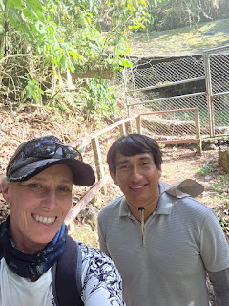

As a boy at school, they did a camp up in the caves and they each had to choose a cave to sleep in.
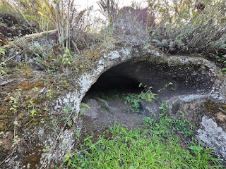

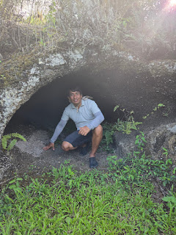

As we stood at a high point he showed me all the hills surrounding the island and it was suddenly glaringly obvious that the whole island is in the Caldera / crater of a volcano, it was so clear to see.
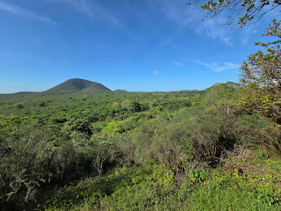

Another Santos story, he was playing with his friends on the lava near the caves and they found a shell, like a military shell, they could barely carry it, no-one knows why it was there as it’s too far from the coast, maybe discarded mid flight during a war ?
Anyway, back to the Wittmers and the history, I saw the original cave used by pirates where the Wittmers lived until they built their house. This is where Margret gave birth to Rolf, she was already 5 months pregnant when they arrived in 1932 - What a strange time to leave your post war torn Country of Germany and relocate to one of the most uninhabitable islands in the Galapagos. The cave had benches and also a fireplace and chimney. The Wittmers also sculpted out a large shelf at the back, a safe place to put the child.
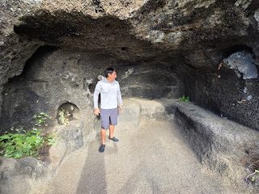

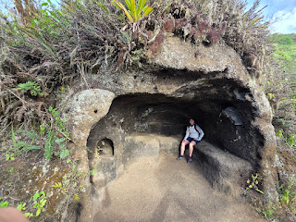

There were other caves surrounding this one, they even had grooves in the walls where gates or doors were put to close them off.
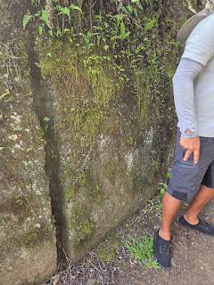

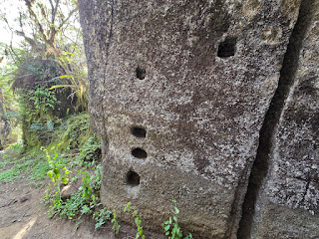

Even steps rising up to a higher level. So the Wittmers had their house, didn’t actually see that as it’s within the National Park, this house was near the cave and also the water source. Meanwhile the Ritters who had arrived earlier than them in 1929 were located further down the hill also close to a water source. The 2 families lived in harmony until the stupid Baroness arrived and caused havoc. In the end Friedrich Ritter got sick, they say through maybe eating a chicken that had something like Avian Flu, he died, Dore returned to Germany and wrote a book about Floreana. Now the Wittmers were left on the Island. By 1934 the Baroness vanished, never to have been found. I bet she is somewhere on this Island, I also think the Island still holds so many secrets and that more will come out. This Island the same as the others moved 5 miles over the last million years.
There is also a weather station near the cave and once a month Santos has to download the data and its sent to The University of Floreana in Germany !
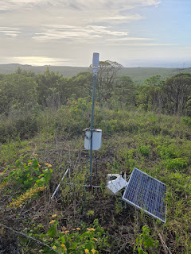

Up above the Wittmers area are more caves, these are just being opened up in the next few months by the National Park, it is said that in pirate times maybe 70 people were living in all these caves. Santos used to play in the caves when he was young, but they are all closed off now, well until the next few months.
So the Wittmers remained, eventually Rolf met a girl from the mainland and the population continued. Speaking with Santos about how you can meet people, you have to meet someone from the mainland, otherwise reproduction will go wrong. There are some cases of this on the Island, I had noticed this already, the lady who runs the store married her first cousin and 2 of her 3 children have problems. So it’s kind of an unwritten rule now that it has to be people from the mainland. I didn’t want to offend anyone or mention cross eyes too much but Santos understood what I was saying and he met his wife on the mainland – phew……..
The Island is an unforgiving place and not for the feint hearted which is why so many very early settlers never lasted long, an Irish guy traded water for rum in 1807 but only lasted 2 years. Norwegians came in 1920 but the struggle for water was real and it all got too hard so they left in 1925.
In 2029 just 3 years time will mark the first 100 years of the Island being properly inhabited.
I finally found water today, although it’s drinkable from the source in the highlands, I can’t walk 8km just because I’m thirsty, and what’s stored down here is in large plastic containers, fine for laundry and showering but even the locals boil water to drink, so without a kettle or any means of boiling it myself I have survived on 1 litre bottles of Gatorade. They rely on the boats bringing the larger bottles and as for things like batteries or anything normal, even Frank next door has a local who he gives a shopping list to who gets stuff from Santa Cruz for him maybe once a month.
This evening there is a big cargo ship moored in the bay and tomorrow this will replenish a lot of the daily stuff including large bottles of water. Fruit, you need to know the farmers who grow it and people trade stuff, same with meat, one of the farmers kills a pig every Wednesday and you tell him what you want. So it’s really basic living. Now I’ve found water and also means to make a coffee via a coffee machine that Erika Wittmer has found for me, I’ll just run water through it and use that for my coffee granules – phew, big relief.
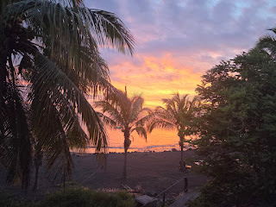

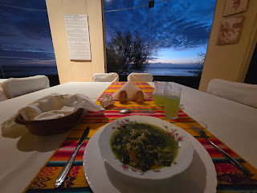

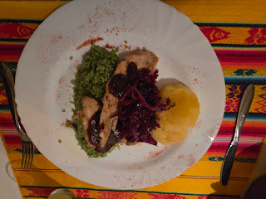

Saturday 28th February 2026
Another amazing day ! I loved having my little coffee machine that Erika had given me, it’s just nice to get up and potter around with maybe the news on and a coffee, although the world seems to have lost the plot. I am wondering if because there are such major things going on, I could maybe just stay here and do conservation work and no-one would really notice.
I set off for a walk at 6am, this time I headed south to La Loberia, a little sandy bay maybe 2 or 3 Km away, you can see the white sand from my house ! The birds were plentiful as I got more photos of ones that I need to identify, if I were ever to go on dating apps which I cant think of anything worse, I would have to include these riveting snippets of information……..
The Iguanas were strewn all over the path still waking up, they only seem to function in a million degree heat of the day, you literally have to be careful not to trip over them. I had the coast on my left and passed lava beaches with a family of 4 seals seemingly sleeping looking like logs at the edge of the water – Can everyone just wake up now ! C’mon, it’s a lovely morning and we are all in the Galapagos.
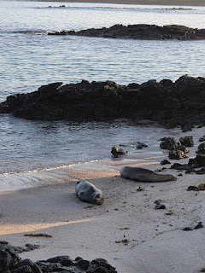

I followed the lava rock lined sandy paths until I reached the little bay I was heading for. What greeted me was I think quite simply the most stunning view I have ever seen, it’s sheer desolation, the sun was coming up over the tops of the volcano crater and gradually filling the caldera and chasing the shadows away.
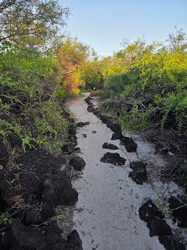

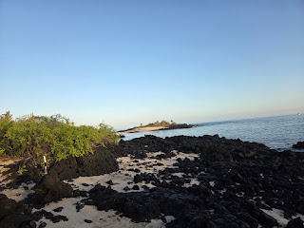

I was looking at crystal clear water with 3 sealion pups playing, twisting and swirling around effortlessly in the water. I walked over the lava boulders to watch them, hilariously they all came over and stared at me ! 3 little heads and mum ! The pups were bored quickly and sped off, Mum wasn’t so sure and barked at me a lot, realising I couldn’t just turn and run on the slippery rocks and remembering the huge Sealion rushing at me in Santa Cruz, I retreated respectfully, she seemed to sigh and then swam away but with an ominous sideways look !

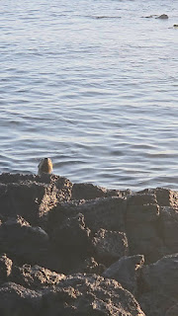

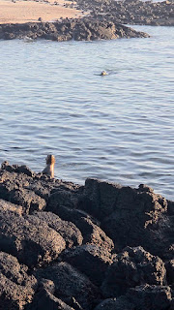

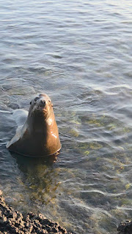

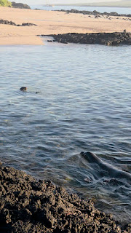

I climbed the rocks so I had a view looking down on them and spent around an hour drinking in the site before my eyes. This, this is the place…. This immediately became etched into my soul, like Orkney did to me in Scotland, you don’t choose those places you just feel it.

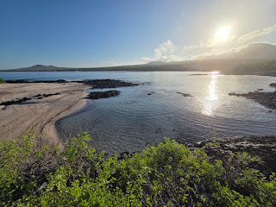

I made videos to bore anyone who may be watching them, you poor same people also reading this ! At least I know my mum reads it ! Thank you Pam, also incidentally when I create posts and add the hashtags, #motorhomingwithpam comes up every time ! I watched the sun come up and stupidly I had forgotten my hat and sunnies as I set out in the shade of the early morning, so I put a small towel on my head and I am sure looked very fetching, it’s not looks here, it’s surviving !
I walked back in 20 minutes and had my breakfast, prepared and ready for me at 8am. I use that time to sort through all my videos and photos of whatever pre breakfast expedition I have been on.
I took my coffee to sit outside just as the Flamingoes did a fly by !
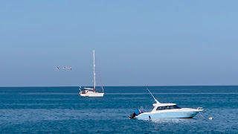

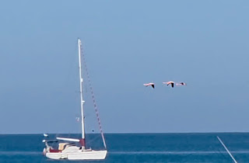

I called Pam, wi-fi is such a marvellous thing and I video call and we have a proper catch up. The 4 people from the bus yesterday walked past on my beach, I still feel a little disgruntled that they didn’t want to pay Santos anything yesterday for his tour. Anyway – they rectified this ! As I was chatting to Pam the girl came running up the beach to tell me that the penguins were in tha bay ! We had talked about it yesterday and the fact that Frank said there is a little group of them that do appear, so poor Pam I had to shriek, gotta go, the penguins are here…..
I was so excited to see them in the surf, they are so quick and really hard to photograph, have to think quickly and just got video onto them and kept it rolling, picked the best bits out later. These are heavily cropped in photos from the video, so I have to improve on flamingoes in flight and Penguins in the water.
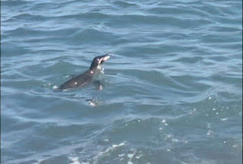

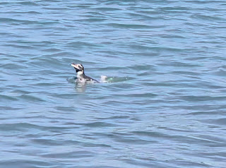

So, I have to now backtrack on what I said about them, it was really kind of her to think of me, and they had seen me sitting there, and to run over to me to tell me was really a nice thing to do, so the 5 of us stood and watched them together. I thanked them genuinely profusely.
Frank was just heading back up the beach with his mask and snorkel so I ran over to say hello, poor Frank ! He asked about my morning and seems genuinely so happy that someone can really appreciate the Island in the way that I do. We agreed to have coffee together after my snorkel.
I am a little conscious that I have absolutely no way of getting any more money here on the Island and so only have the cash I have with me. I need $100 for a trip Santos has arranged for me tomorrow, so I had decided to have a cheap day, this involved $5 at lunch for a snack of a packet of crisps, some chocolate wafers and a coke. This literally was my only choice, and I spent $4 on a juice later. Phew good, cash stash is safe.
So, snorkel, I have all my stuff with me and a special netting bag to carry it all in, mask snorkel, fins, go-pro, other underwater camera. I needed to treat my mask first as when I was in the lagoon in Isabella Island, it was fogging up badly. So, smeared toothpastes in it and rubbed it around and leave it a few minutes, then ingeniously I had brought a small bottle of fairy liquid from home, made up a bottle of that mixed with water. A bit of this in your mask before you go and it’s crystal clear for a good hour. Donned my snorkel outfit, basically to completely cover me, you see so may people caught out with snorkelling with lobster red backs and backs of legs. This way I knew I could stay in the water as long as I liked.
Hmmmm… beach snorkelling can be interesting, put fins on and have to walk backwards into the sea, with waves crashing it would be very easy to look like an absolute idiot, something that’s tends to come quite easily to me anyway.
I made it deep enough that I was now buoyant and off I set, it’s always slightly daunting, those first few second but it quickly feels like home ! I love it and set off towards the rocks, immediately to my left was the biggest green turtle I have ever seen, huge, total body length with head and tail must have been around 5 feet, this was a female with a shorter tail, we got swept back and forth in unison as the swell came and went, sometimes I was too near here and its hard to back up. Then another one appeared and I spent ages with them, their head markings are individual to each animal.
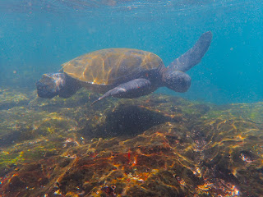

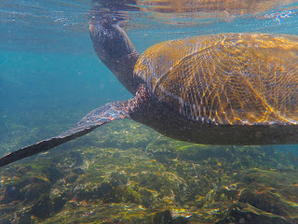

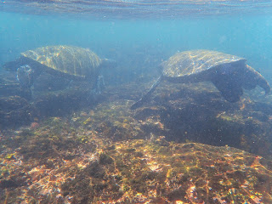

I wonder if anyone has a record of the individuals here on Floreana. In the Maldives my good friend Ish studies them and there are records of hundreds of individuals.
I also found the largest Ray I have ever seen aside from the Manta rays. I need to look it up. Not a good photo as he was resting under a pipe that runs out to sea ( actually what does that pipe do, I need to find out )
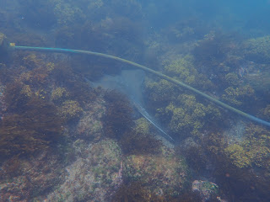

One of the turtles set off across the bay and I went with her, over the sand was a little murkier, but deeper down I did see a sizable White Tip Reef Shark. I know the young black tips stay in the shallows and bays until they are around 5 years old before heading out to sea, I think this White Tip needed to leave home now.
I popped to visit Frank but he had gone out, so the rest of the day was spent sorting more photos and videos, a hobby in itself that I enjoy so much when I am away on these trips.
After my snack lunch at the pier watching the sealions fighting on the pontoons. I couldn't sit on my chosen bench as it was occupied.
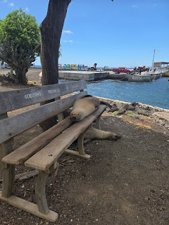

I was horrified to come back and all these people were on my beach, they were swimming and using the hotel to change.
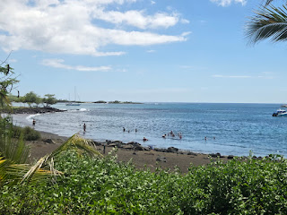

I didn’t like it. I did however discover that the Ornate Pelican with a hosepipe sticking out of its mouth is in fact a place to rinse off the black sand after the beach. My shower plug hole will be so happy I made this discovery. One of the people left this running and in defence of the Islands water situation I immediately switched it off, I felt very protective of the Island !
I think the most lucrative business on the Island is Ingrid making the juices and cocktails for these visiting tourists. There are no other businesses, the shops do nothing and have nothing, the restaurants can’t have menus because they won’t know what food they will have. I would open a coffee shop and also buy a boat and do simple short boat trips to the places hard to get to.
Anyway, this is my plan because I can’t come home there’s a war and there are no planes.
That was my day really, The afternoon is just relaxing and having a 7th shower… I even lay in my hammock on my balcony. The heat wipes you out so you have to balance it.
Dinner was lovely – I had a juice at Ingrids first, she commented in her very broken English that I looked beautiful when I am clean……….. I think she meant in comparison to board shorts, surf top and baseball hat, a sarong and a simple white V neck T-shirt looked very different. I had dressed up a little more because they had laid the table outside for me on the beach with a fire going, I felt it required a little effort on my part in recognition of their efforts.
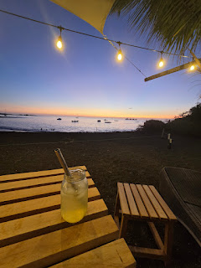

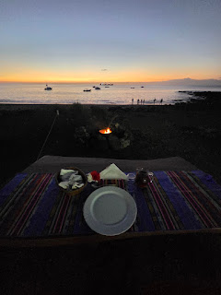

Tomorrow – oh dear, tomorrow is a 10km hike in Equatorial heat to get to the very famous Post Office bay and a lovely snorkel spot. Thankfully we won’t have to trek back uphill and a boat will meet me and 3 others and bring us back.
We leave at 7am so I didn’t want to have them cook me breakfast at 6:30 so I asked Hans for some bananas – I HATE bananas but just like before a run, they are such good energy, so I shall have coffee and banana for breakfast. Almost feel a bit nervous about such a walk, but I’ll have long sleeve surf top on and head will be covered. I’ve frozen a bottle of water aswell !
SUNDAY 1ST MARCH 2026
Met Santos my guide, he’s my guide….. at 7am along with the 3 other people who had made it possible for me to do this - $400 on my own was too much, this way we pay $100 each and it was doable !
We sorted snorkel gear which would go in the boat that would meet us later, my amazing snorkel bag was so useful, I don’t really like sharing things but it made it easier for the others to put stuff in MY bag aswell…
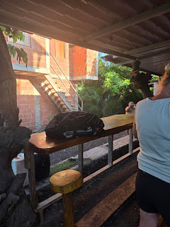

We got the community bus half way up the hill and started our trail walk, hike, trek, expedition whatever you want to call it, well whatever I want to call it I suppose, it’s my journal…. So it’s an expedition.
We started under shady trees and as we got lower and lower the trees also got lower and lower until eventually the shrub lined lava paths turned to just lava.
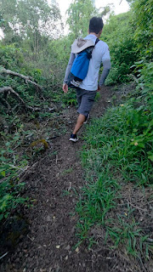

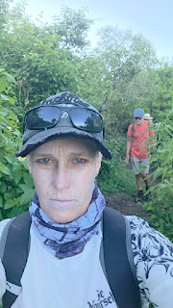

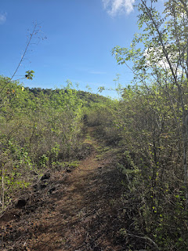

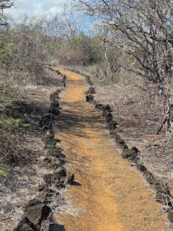

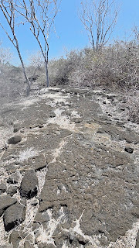

We had a rest after 30 mins, already so hot. I asked Santos how close we would go to the release site of the 158 new Floreana Tortoises, we would go right by it ! They were released 7 days ago now in this huge historical event for the Island, when we were within 1km we started looking, they could be anywhere and also no-where to be found. But we found one ! I was so excited to see this little already 7 year old tortoise, made up of the original Floreana Tortoises genetics, there he was with his little tracker on, pottering around the bush they are being monitored in real time by Nasa !
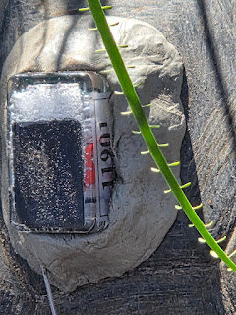

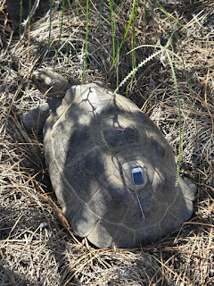

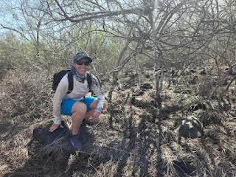

Further on I spotted my own ! I loved seeing them but wanted to spot one myself – of course I did ! there he was. Just a couple of hundred meters further and there was the releases sit, they had all been carried up here 3km from post Office Bay in little crates in backpacks and all released together to make History, these little tortoises had no idea they were famous across the world.
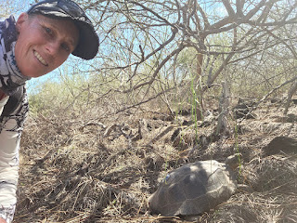

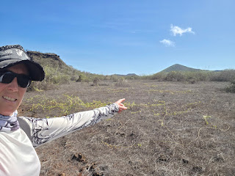

We walked some more and baked some more, my water was running out, should have brought 2 x 1 litres bottles instead of just one. We reached the edge of Post Office Bay and here were the remains of an old Tuna station, one group of people who had tried to live on the Island early 1900’s had set this up and traded Tuna for Rum so not terribly lucrative really and they also left the Island.
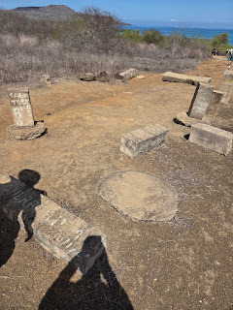

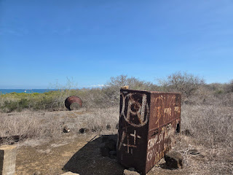

More lava tunnels, huge high ceilings in this one but a welcome break from the scorching sun.
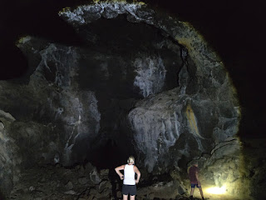

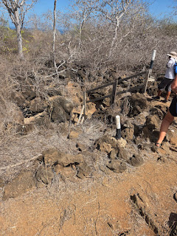

Back down to Post Office Bay, it’s so iconic and was amazing to see.
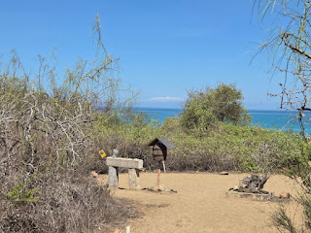

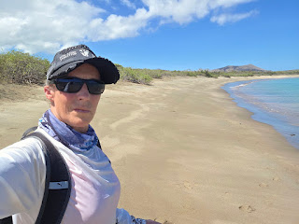

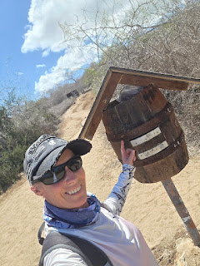

We walked a bit further and saw the cleared space where the Baroness had planned to build her Tourist Hotel for the millionaires, her house was also here, she had given instructions whilst her companions, the engineer and the architect did all the hard work. Santos had a photo of the Baroness standing outside her house and you can see the matching stone to the right of the doorway that shows around halfway down her back.
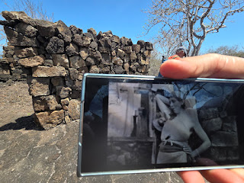

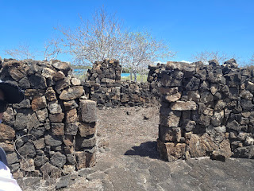

1 more km to get to where the boat would meet us, THE most beautiful little Mangrove and Rock cove. This already belonged to a sealion and she didn’t really want us there and came towards me as I headed for the water, I retreated. Once we were in the water, after checking us all out, these things are huge when they are right next to you, she shot off out of the cove.
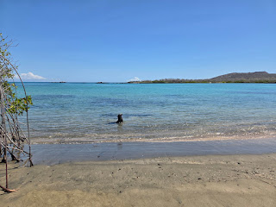

The water was so welcome as I honestly thought I was never going to be cool again in my whole life. It then became obvious why mum had been so bothered, peeking out of the Mangrove nursery – there were the 2 cutest little faces. They watched us really cautiously, but steadily got bolder and bolder venturing out to investigate us. When mum returned, she was much happier and after 20 minutes was laying on her back in the shallows covering her face with her flipper and apparently now totally ok with us being there. In fact she left us babysitting while she went off to fish.
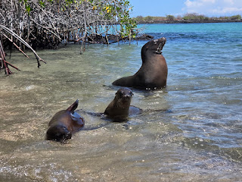

The babies were so funny playing and checking us out, closer and closer they got swimming around us, I was holding the go-pro underwater and still have to check footage but think there will be some really cute stuff on there and really more than anything I could have hoped to have the opportunity to film.
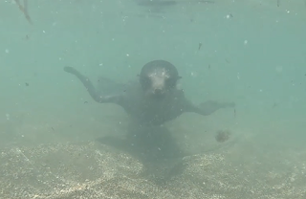

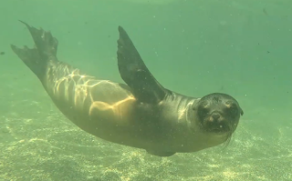

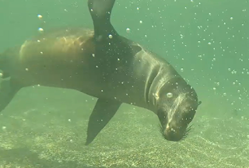

We spent an hour with them, then worried the boat may never come, I was out of water and we considered making an SOS in the sand and who would build the fire and catch the fish….
The boat came – phew, and they had supplies !! drinks and food, we each had a cardboard tub filled with fish rice and beans and we all ate every scrap, it was delicious.
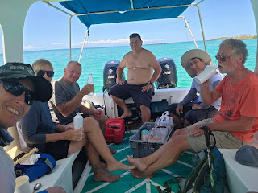

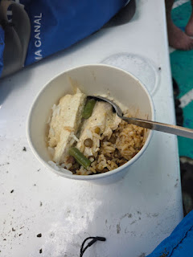

Went past Devils Crown, an amazing snorkel site in the crater of a volcano, but you have to have a license to go there and they gave the licenses to the larger tourist boats, even Santos can’t go there easily, but it was good to see what it looked like.

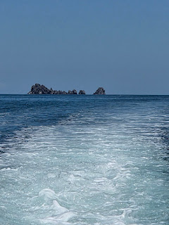

We had a quick snorkel in a couple of rocky coves, not the best snorkel but I got to play with another sealion, I had my fins on now and we swam and twisted and turned in the swell together.

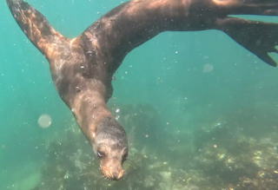

I found a spotted box fish and looked for Nudibranchs but there were none.
Minor engine issue to get going again. Hilariously, anyone tall driving the boat had to stick their head out of a hole !
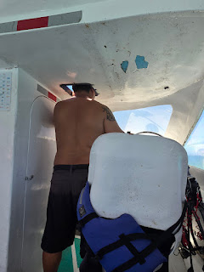

Sadly I think we hit a turtle, there was a huge clunk under the boat, it’s really the only think it could have been. I hope very much that it was ok.
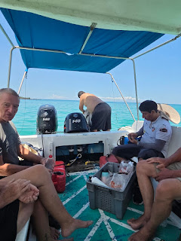

Back to the pier and now the penguins were whizzing around again ! absolutely impossible to film. We all went and had a juice with Ingrid and chatted about our very successful expedition !
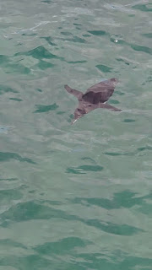

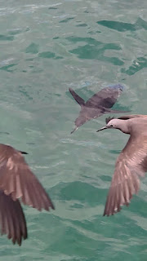

MONDAY 2ND MARCH 2026
A quiet day after the Equator sun expedition yesterday...
No alarm but up at 6.30, I’ve learnt that the heat really takes it out of you and was relieved to see cloudy skies and even a small bit of rain... it was so much cooler.
Popped to see Frank and catch up on the last day and a half, we witter on about all sorts.
Breakfast was leisurely, I had started reading the book written by Margret Wittmer to really get the true account of their landing here to set up a new life from scratch.
Erika came and we spent ages chatting.. she has a small shop and I purchased an actual copy of the book, I had been reading a PDF version that Jorge from the boat Flower had sent to me. Erika stamped the book and signed it from herself, Hans, Ingrid, and of course Floreana whose true name is Ingeborg Floreana.
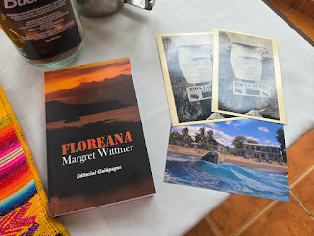

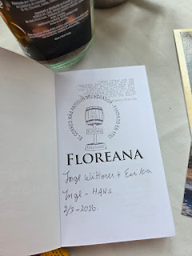

Just as Floreana had taken care of Margaret as she got older, Erika is the daughter who stayed to look after Floreana as she gets older, the other 2 daughters Ingrid and Trudy went off to the mainland and larger Islands at times in their lives.
Floreana did marry, a guy with the surname Garcia.. one day he disappeared, up in the Highlands and was never found. Floreana was given a really hard time with the belief she had killed him, so you see, this mysterious Island holds so many secrets. It's so intriguing.
Floreana had prepared my breakfast and was now clattering around in the kitchen making bread and Goulash, presumably for the people expected at the large set table. So I wonder if I will have goulash for dinner ?
There is also a large apartment above the restaurant, a family who come every year for a month will be staying soon.
I sorted through the post box in true pirate tradition and found 2 postcards bound for the UK. So I take them home and post them when I am there and that’s how it works !
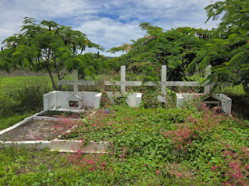

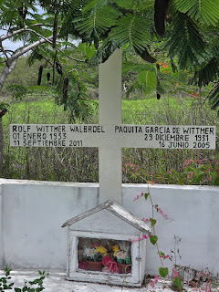

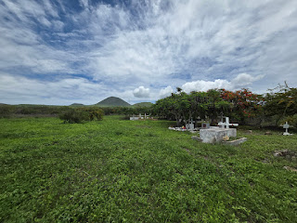

With cloudier skies, I walked 1km up to the cemetery to see the graves of Rolf Wittmer, the first baby born on the Island, and his parents Margret and Heinz. They had larger graves than the other simpler ones.
When it was cooler at 4pm I walked around to the seal nursery again, I wanted photos of various birds.
I found a fallen nest on the way.
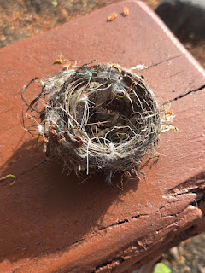

Ooh forgot to mention that on the walk yesterday we found Galapagos Cotton Plants which explained the material I had seen used for the nest by the pier.
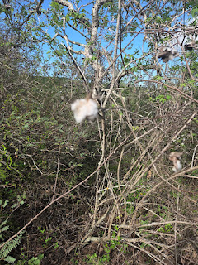

So no great adventures today, just learning more and watching wildlife. I watched the Brown Noddies fishing, knowing that the penguins would be whizzing around below them. I watched the huge turtle heads popping up out of the Ocean, the baby sealion frantically calling mum as he flops across a white expanse of sand, the Brown lizard and the Galapagos Red Lava Lizard as they move off the path, the sealions rolling around in the surface, the black sand giving them a good rub across their blubber.
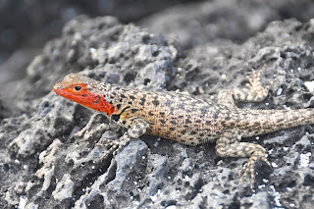

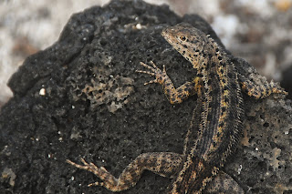

I stood at the top of the lava rocks and watched the waves crashing onto the desolate shores, the white break of the waves a contrast to the jet black rocks.
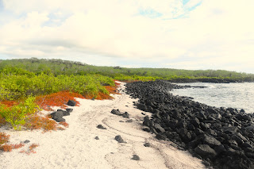

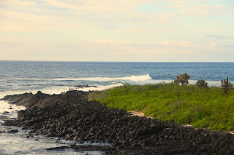

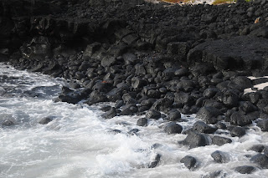

As I stand there I know its a special place, a place where you find yourself and your soul, I'm sure it would accentuate sadness if life was unhappy, for me it fills my whole being with an enormous contentment, an enrichment and confirmation that I am doing with my life exactly as I am meant to be doing, not only seeing, but feeling the most beautiful place I have seen, and I do feel a part of it, not a day visitor that flits through, but a chance to live it properly. People wondered why I would spend 8 days here, on the most remote desolate Island instead of the larger Islands, those that know me will know that that’s exactly why I chose so come here.
I dress up in the evenings, a change from board shorts and surf tops, some would say strange when its just me, but it’s for me !
So not the most exciting journal entry today, but a day of learning and observing, no sealions whizzing past my fins or curious seals pups ! BUT, some real travel stuff... Laundry !! If you've read any previous journals, you’ll know that Jo’s laundry is a feature, its boring but it’s part of travelling! So... normally I just wash it in the sink and rinse in my shower... not any more !!! I’ve made a washing tub !!! Out of a 5 litre water bottle, I was so pleased with myself ! I used my diving knife to cut it....Swirling items around, literally felt like I had just invented the washing machine.. the clothes are still in it, having a good soak.
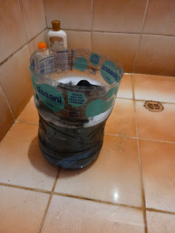

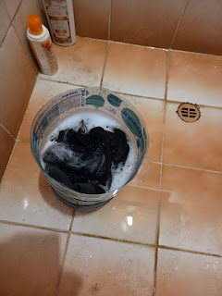

Gotta go, got the laundry to do....

TUESDAY MARCH 3RD 2026
A really simple day spent only walking to the beautiful site where I lay some of Clive to rest, he will be forever happy there.
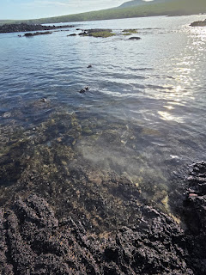

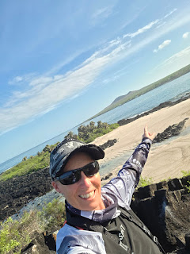

I was so hot by now that I found a rock pool to cool off in.
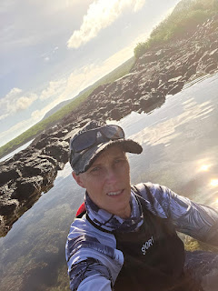

On the walk I noticed the same area being wet, the path was wet. A mystery, could this be another hidden water source.
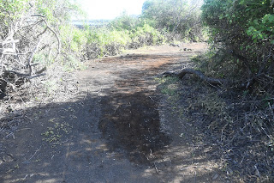

Also saw my Iguana who is always in the same place - he leaves a unique trail behind him as he has an injured tail.
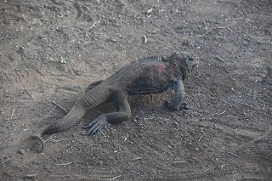

The rest of the day was spent in and out of the water, it was murky today but I found an amazing shell with a bright pink foot.
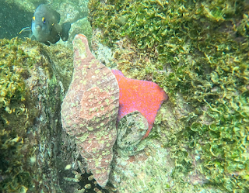

I was completely covered in long pants and surf top, this is not heat that you lay out in, in fact you would be mad to do so, the damp full covering kept me cool enough to be able to spend time on the beach waiting with my camera for the Blue Footed Booby to dive into the water, he’s so hard to get.
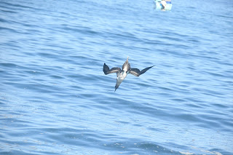

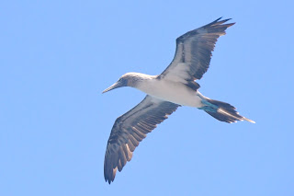

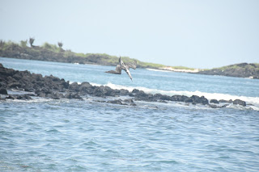

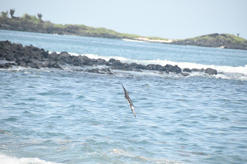

I communicated with the people on the yacht who had come on my Post Office expedition and it reminded me of early settlers waiting for boats to come either into Black Beach or Post Office Bay, they will leave tomorrow before 6am, and again I felt like the early inhabitants so reliant on boats stopping off bringing mail and supplies, now we send messages and photos. I watched them bobbing around on the Ocean and mentally wished them well on their continued journey, they’ve been at sea for 6 years, so hardly need my good wishes !
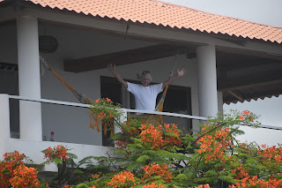

I visited Frank before dinner as he had summoned me, he had a gift for me. Intriguing – so over a coffee and some amazing fruit had had in the fridge, he gave me a little angel he has had for years, he was worried because I do these travels on my own, and now I could be safe and looked over. I was so touched.
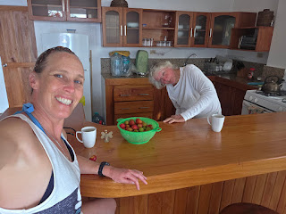

Next I sat for an hour having a delicious juice that Ingrid concocts from goodness knows what and continued reading my book written by her Grandmother. It felt strange sitting reading with members of Margrets family sitting behind me. The sun goes down quickly and there is little twilight, light, then dark !
WEDNESDAY 4TH MARCH 2026
I was asleep by 8:30 last night ! so very awake at 5:30, made my coffee and looked to see if my yacht friends had left, they were gone, they left at 4:50am after a bumpy night in the bay.
I enjoyed my coffee from my little machine and then set out with my camera to go and find the Flamingos again, it was such a lovely 2 hour walk, just me and Blue Footed Boobies, Lava lizards, finches, Galapagos Doves, Iguanas, but no Flamingos today, I was so lucky to find them a few days ago, no-one has managed to see them since !
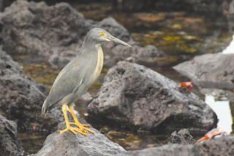

I think Striated Heron

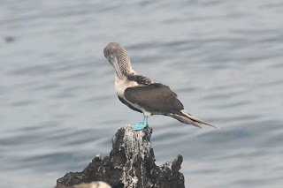

Blue Footed Booby

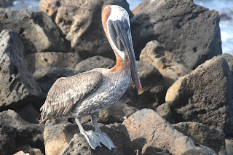

Brown Pelican

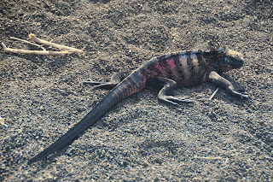

The most stripy Marine Iguana I have seen

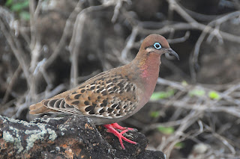

Galapagos Dove
It was cooler again, the cloud cover is welcome especially on a walk and the air was comfortable.
Showered and breakfast at 9 and a call to Pam, it’s so lovely to catch up and she’s been as busy as ever.
Went to see Frank to see if he maybe wanted to go for lunch, so we did, we went to Post Office Bay restaurant, Santos was there, he’s everywhere, there are a whole group of conservationists here and they are staying at Franks House ! They were also having lunch at the same place and a small group of them were outside looking for warblers nests ! I showed them my Warblers nest and the man who was specifically in charge of warblers nests was very happy and grateful ! I agreed to meet with them later and I would so love to know the exact work they are doing here, aside from looking for Warblers nests….
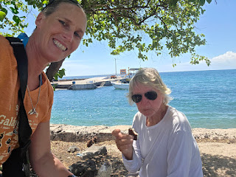

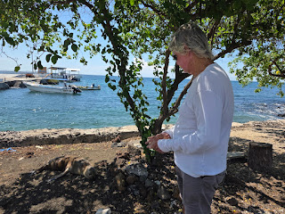

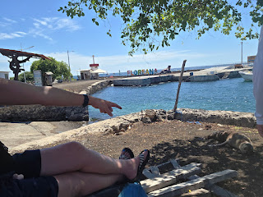

Frank and I walked back and had an ice cream at the pier and sat with a sealion under the Yellow Warblers nest ! said no-one ever !
We walked and talked and bumped into the girl who has just been the English teacher here on Floreana for 8 months, she goes back to Santa Cruz today and was so sad to be going, Frank has been a good friend to her, she struggled when she was first here, a hard place to live but they talked and chatted and she settled in.
I found out that it’s the Wittmer family who pay for a teacher to be here at the school.
Now a couple of hours to relax with my amazing view, chatted to my next door neighbour Simon who had walked all the way to Post Office Bay AND back, I really was very in awe, he also managed to find one of the released tortoises and was equally as happy as me about this.
I recharged for a couple of hours, you kind of have to with this heat. Then Frank called me to see if I wanted a coffee. He was sitting chatting to Sonya Kleindorfer who is leading the Science group and has been coming to Floreana for 18 years studying the Darwins Finches. They have been netting and ringing birds and know that at least one finch is 18 years old, something never established before and incredible. They are building a Citizens Science Project building here so that citizens can contribute data and photographs to the studies. So a walk observing finches can be a contributing factor. They also want to bring this into education in the school here, she said enthusiastic English people will be needed ! Wouldn’t it be amazing to contribute even in a small way to the ongoing studies started by Charles Darwin in 1835.
They spent 2 years eradicating a parasite that was affecting the nesting of the warblers and finches, this was done by providing “feather stations “ for the birds, they would take treated feathers back to their nests and this would self fumigate the rest of the nest and eventually the parasite was gone. Nests were also sprayed with anti pecicide stuff. Over time the larvae of the Vampire Fly are getting smaller and smaller.
They study the behaviours of the birds and how this evolves, the personalities of the birds and how this affects evolution and changes. I was absolutely fascinated and couldn’t believe I had the opportunity to speak with this lady.
So tomorrow morning I will walk and watch the finches and photograph the different plumages that depicts the ages of individuals.
THURSDAY 5TH MARCH 2026
After speaking with Sonia yesterday I felt I had a better understanding of Darwins finches so set off with camera on a mission.
I now know the female isn’t another species, she is the female Ground Finch – check this !
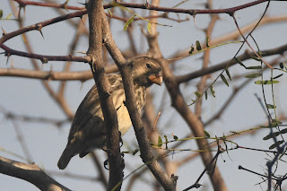

When I had been on the Post Office bay expedition, Santos had pointed out that a local way of marking a trail was to lodge a rock in the fork of a tree, so when I noticed a rock in a tree off to the left of the main track, I couldn’t help but follow it. I went rock to rock with sometimes a plastic tape tied around a bush aswell, you just looked for the next sign. It was intriguing and I wonder what the path is, maybe it’s to do with the Finch conservation science each year so they can follow the same trails. I climbed higher and higher over lava flows and rocks, conscious I was alone and really didn’t want to fall or turn an ankle, so I took it really slowly. I went about 200 metres up photographing finches as I went, I noted some display behaviours between and male and female, he builds a display nest to show the female, also saw him with nesting material in his beak.
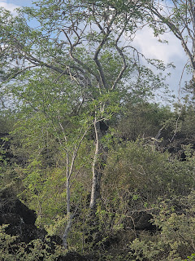

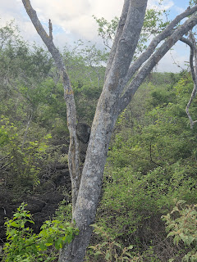

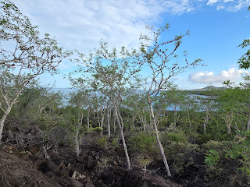

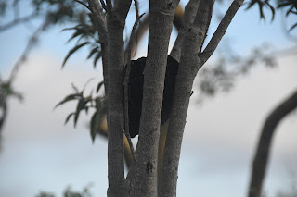

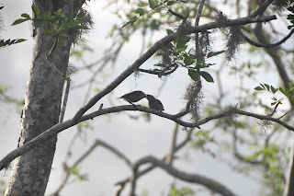

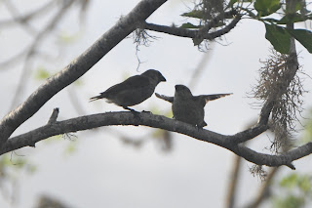

I came back down following the tree rocks in reverse and got back on the main path, saw my crooked tail Iguana, always in the same place.
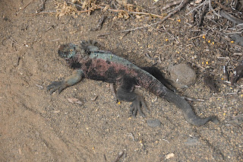

Out to Seal rock and watched one of my sealions playing in the sand.
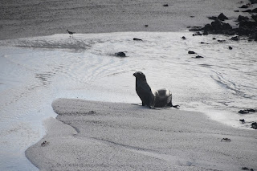

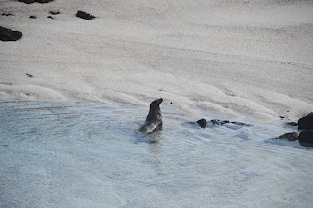

Walked back and popped to see Frank, there was great excitement as one of Franks guests had heard a green turtle digging last night and right at the base of his steps was a huge hole with tracks leading up from the sea and then other tracks leading back down. I can’t believe I was sleeping 50 metres away and missed this. I only have one more night here so will venture out around 2am and see if I get to see anything.
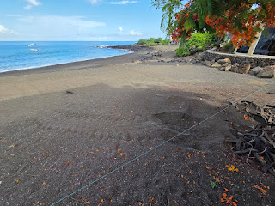

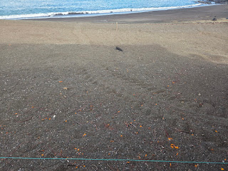

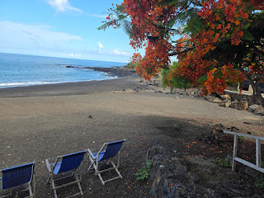

It was still absolutely magnificent to see none the less.
A quiet rest of the day admiring the view of the Ocean from many different seats ! Found Frank wandering by the pier so we went for lunch again.
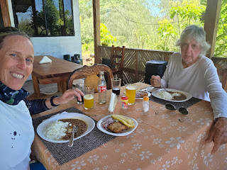

He hijacked the bus to drive us back, its only a short distance but hard in the heat.
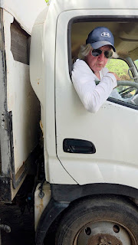

It was hilarious as we drove one block on the gravel tracks.
I took the photo I wanted of the main street !
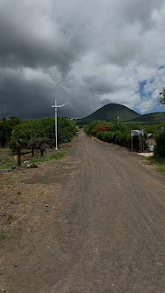

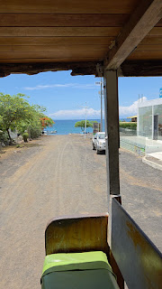

Then spent a beautiful evening chatting and laughing as we watched the sunset.
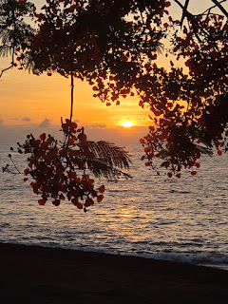

I laid more of Clive to rest on the lava beach where green turtles lay their eggs, where seals lounge around, the Pelicans fly and the boobies fish. He will be happy here forever more in one of the most beautiful parts of the world. Frank came with me and he asked me if I wanted to say any words, I told of what a wonderful man Clive was and how he taught me to travel, and to love the Ocean and now he will always be here. He would have loved to meet Frank, thats' what he did, Clive didn't get on a bus with a group of tourists, he spoke to the local people and really got to know a place, I am eternally grateful that he passed this on to me.
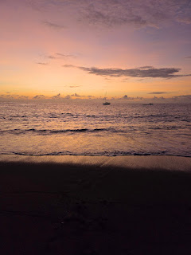

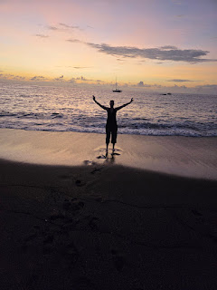

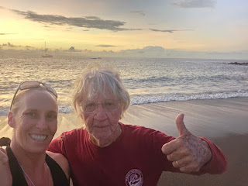

FRIDAY MARCH 6TH 2026
I had the funniest night, I set my alarm for 1:30 and sat on the beach for 4 hours under the moon and the stars, just above the high tide line in a deckchair I stole from Franks !
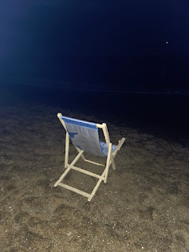

All night I watched avidly to see a break in the surf and a turtle coming up to lay eggs. I watched and watched and every half an hour did a patrol of the beach just in case I had missed one coming up. I didn’t… the conditions were so perfect with high tide at 4:24am and a full ish moon. I’ve seen baby turtles hatch and go back to the sea but I’ve just never seen the female haul herself up the beach and lay the eggs and it would have been so perfect to be able to film it but it wasn’t meant to be this time. By the time I saw Frank later on, he already knew I had been sat out there all night, I had seen the conservationists get up around 4 and leave at 5, so they probably saw this stupid idiot on turtle watch ! It was such a shame, but never mind, we laughed that tonight probably 3 of them will come up !
The seals lumped around, making a racket and glistening under the moonlight and let me imagine what it would look like if the big female had come up, I think what would have been so amazing here is just how big they are, about 5 foot head to tail in comparison to turtles in Bali around 2 foot long, so it would have been amazing.
I did go back to bed for an hour and then went and did my Flamogo walk because I love it so much. Watched a million turtle heads all bobbing around in the Ocean, probably all getting ready to come onto Black Beach tonight….
I found a dead Booby, sad but good to see up close, I wonder if they sometimes break their necks, the speed they hit the water like the straightest bullet from the sky.
No flamingos but no matter. Back for breakfast and did some postcards. Wrote my Floreana Poem out for Frank on 2 postcards !
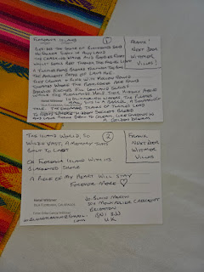

Managed to have a photo with Ingeborg Floreana Wittmer ! I was very pleased about that. Pretty much her life story is why I am here.
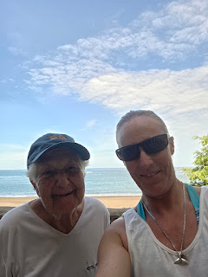

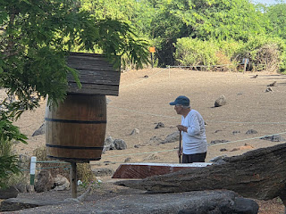

A snorkel and coffee with Frank, I found an amazing huge shell and it will live on his coffee table, too big to take home and not allowed to anyway.

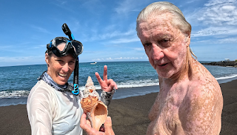
I packed leisurely and easily, no stress.. I do these kind of trips often and everything has its place in the suitcase !
Hans kindly drove my suitcase to the port as I had zero chance of pulling it on gravel paths and even less chance of carrying it !
My luggage got checked at the port, a loose description of customs... thankfully he didn’t notice my lava rocks ! Thank god I left the shell at Frank’s, that would have been taken..
Knowing the port would be so hot, I had wet my long sleeve before I put it on, keeps you cool for ages... 3 dingys of people and suitcases to load on.
I was watching out for Frank and bless him he appeared, hard in the heat of the day for him. We said goodbye and I gave him the postcards I had written the poem on !
Got on boat and opted for back seat... bad move as only ones in the full sun... but the right clothes make it manageable, I would have turned to a crisp otherwise.
I felt a little choked waving to Frank and the Island.
The German man next to wanted to talk, I didn’t. He had visited just for the day and asked how I had spent 8 days there, I pointed out that I don’t like tourists....
Boat trip was flat as a pancake... returning to Santa Cruz was a little like coming home, the hostel lady gave me a big friendly Hola and a hug, I saw the man i booked Isabella tickets with, he shook my hand and also gave me a hug !!
I have a much larger room and own shower than my first stay... and only $20 !
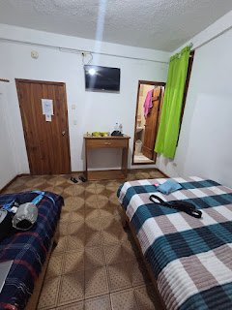

SATURDAY 7TH MARCH

Time to go home ! One final walk around the Pier with a coffee, said goodbye to the Sealions, Galapagos Gulls and one final small seal pup.

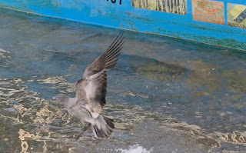

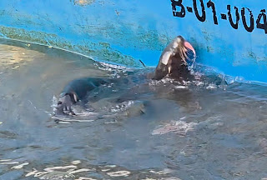

Grabbed a pastry ( not a Danish One ) for the plane and my taxi came at exactly the same time an email came saying that my first flight was delayed by 5 hours....

I went anyway. The taxi drives me to top of Santa Cruz and then you have to get a ferry across to Baltra Island. Knowing the airport was basic, I waited 2 hours as ferries came and went.. it was more interesting with a cafe on a jetty with birds and Seals and a friendly Navy Marine who put me onto his wifi !

Called Pam to let her know I wouldn’t be home anytime soon !

Crossed over to Baltra Island on the 5 minute ferry, I didn’t want to suggest that they could have fitted a runway at the top of Santa Cruz to save the ferry debacle.

The runways were built in the second world war for the military.

I spoke with Avianca the airline who had by now rescheduled all my flights over a period of three days instead of one! Each one with a hefty 12 hours before the next.

So, I killed 6 more hours by sitting in 3 different places for 2 hours each ! Finally boarded plane at 5.30 pm instead of 11am and basically a tiny one and a half hour flight had taken up an entire day.

Presented my hotel voucher in Guayaquil and was taxied to hotel along with 2 others. They would only have 4 hours at hotel... I was the only one affected with a long haul flight.
Played around in the hotel and had a lovely time ! Even washed and dried 2 pairs of pants !

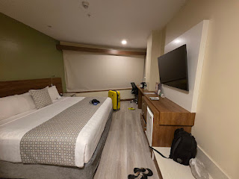

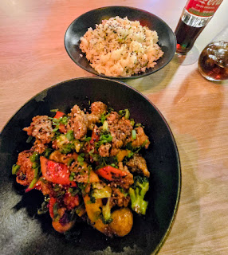

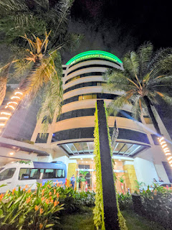

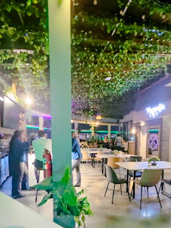

SUNDAY 8TH MARCH

Managed to sleep. Then taxi back to airport.

Straightforward flight Guayaquil to Bogota, well straight forward apart from a million children... no idea how people deal with that ! Very hard work. Just stay at home and play with your toys.

Landed in Bogota, so had gone from Equador to Columbia.

So now I had a 13 hour wait !!!
Found Avianca desk and shared my woes. Showed my original schedule where I could fly home all on one day versus their schedule.

Credit to them, they produced a hotel voucher, lunch voucher, dinner voucher, hotel taxi AND a one day Columbian Visa ! Otherwise how do you leave the airport.
I do wonder what may have happened if I hadn’t asked for hotel, I don't think anyone would have been calling my name on a loud speaker and running up to present me with a voucher.
I just knew they would do it. They are obliged to.
Immigration, despite a 45 minute queue seemed happy with my 1 day visa and welcomed me to Columbia, I said thank you and how happy I was to be here for 13 hours...

Taxi, hotel, another lovely hotel. I had a lovely lunch and unlimited coffees from a machine in reception.
Had a rest and shower and then went for dinner.

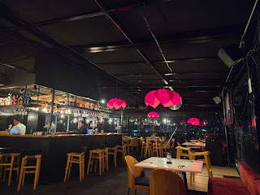

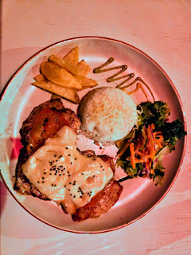

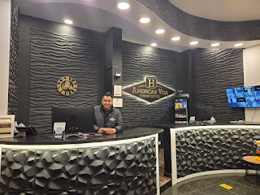

I finally got home a whole day later.

Floreana Island
Beside the shore of blackened sand,
No fairer sight in any land.
The crashing waves and boobies’ flight,
While seals rest through the fading light.
A turtle’s head breaks through the blue,
The ancient paths of lava hue—
They crunch and ring with hollow sound,
Toward where the flamingos are found.
Darwin’s finches fill the lowland shrubs
While the highlands hold their history above.
In glimmering waters, Post office Bay,the pirate’s mail
Sits in a barrel, a seafaring tale.
The emerald tracks of turtles lead,
To nests where hidden secrets breed,
And lava rocks begin to gleam,
Like shadows in a golden dream.
This island world, so wild and vast,
A memory that’s built to last;
On Floreana Island, with it’s blackened shore
A piece of my heart will stay forevermore

