Monterey Bay

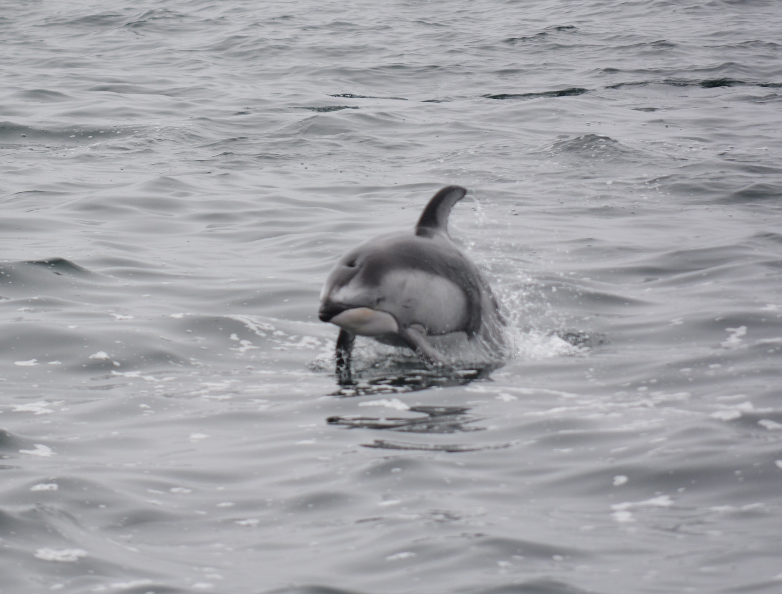

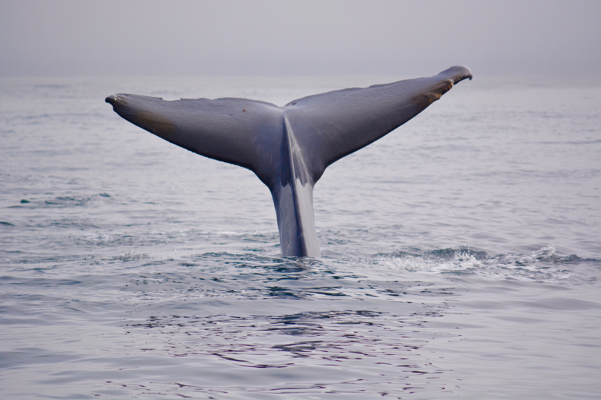

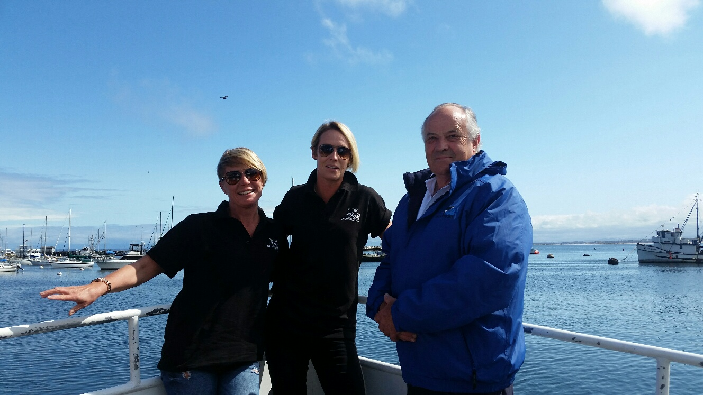

May 22nd 2016

Lovers Point Inn

Pacific Grove, Calefornia

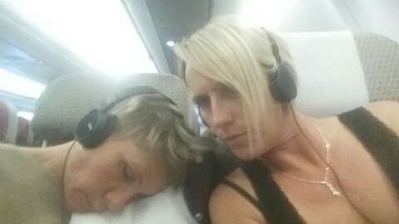
The journey started as a gamble, found a village close to Heathrow, parked car, called a taxi and bingo, I considered myself a genius. So simple.
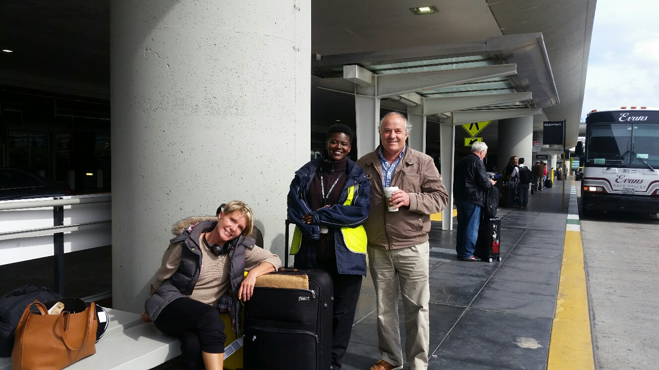
Check in not too painful, dawdled around airport as though we had all the time in the world, did shopping, got breakfast, panicked because we hadn't had the compulsory airport drink. This nearly cost us our flight, reaching departure lounge 29 minutes before flight and establishing that it shuts 30 minutes before flight !! Just made it. Clive was already on the plane. We had 2 seats together so didn't have to contend with anyone else which was a bonus and we could just look after each other.
The flight was fine. San Francisco airport was not ! It took nearly 3 hours from landing, to leave the airport, with the majority of that time spent in the immigration hall
We then endured a 2 hour very bumpy minibus journey to our hotel. I think they specifically designed the roads with regular mini grand canyons in just to keep you awake.
Hotel, basic but fine. We were all so tired by the time we checked in that Clive had no idea what he was signing and not one of us could comprehend the shower operating instructions being shouted at us by a very over loud American Lady.
We managed dinner over the road and a drink.

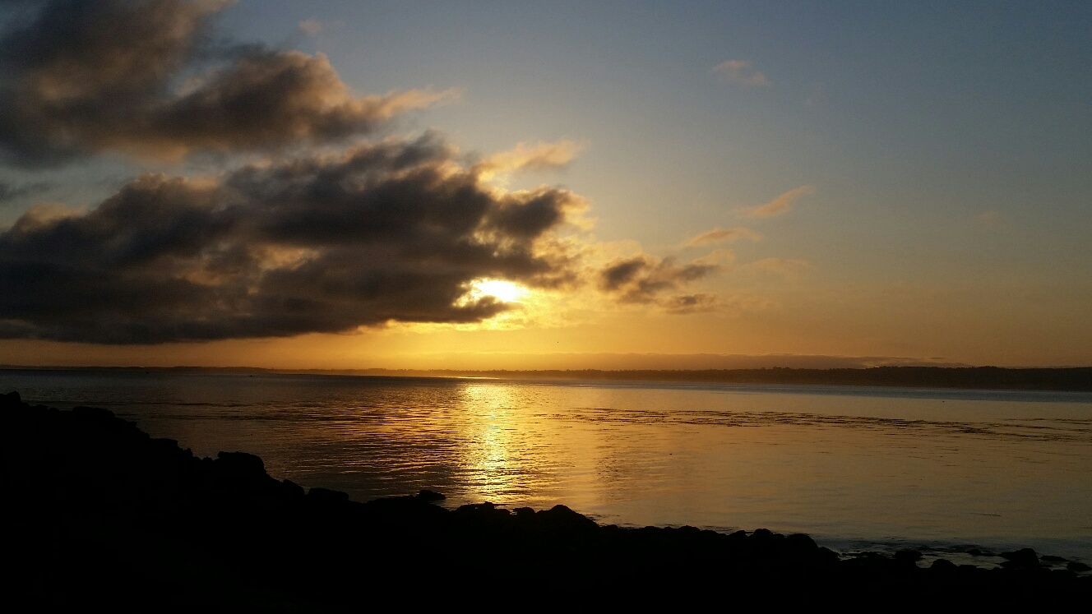
Day One - sunrise was lovely, camera lens jamming was not - but quickly resolved. We took a lovely stroll along the front into Monterey, passing seals, sea otters, pelicans and other wildlife along the way. We Sussed out the lay of the land and booked on a Whale watching trip for the afternoon. What we failed to suss out was how to turn English money into dollars with no banks providing this fairly simple service ????
First boat trip. Monterey Bay Whale Watching. Excited to be setting off with cameras, we encountered breaching humpback whales. This was to be beaten by an unexpected amount of blue whales. We were literally surrounded on the boat by them. It was an amazing experience and involved about 800 photos, all of which had to be sorted out later.
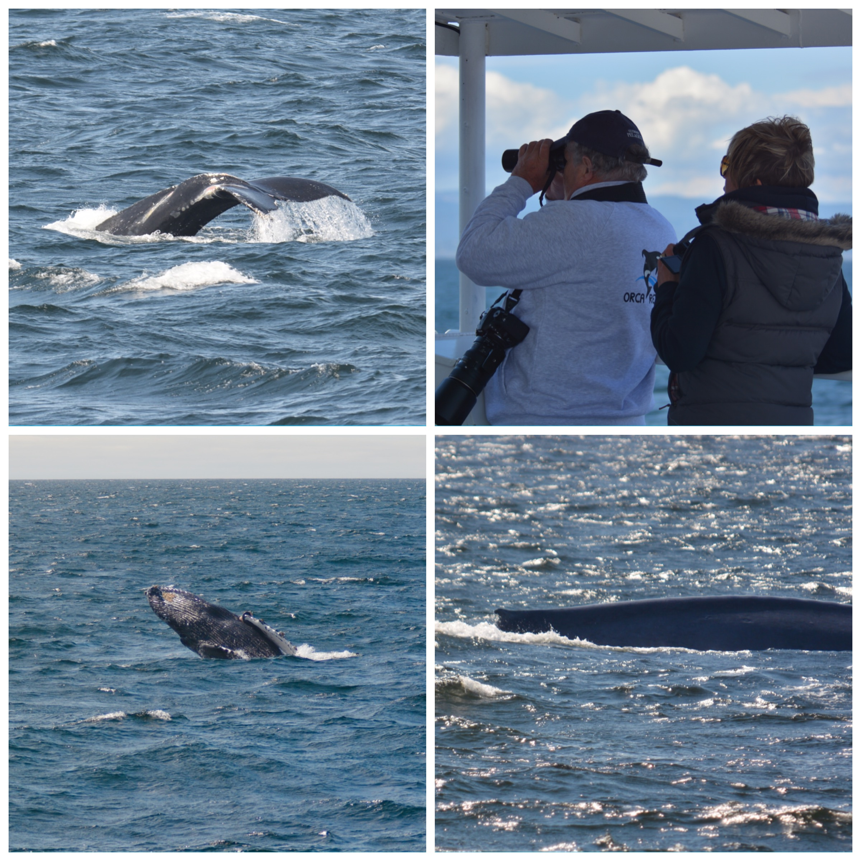
Day 2 - we knew a little more what to expect and worked on getting better pictures and obviously hoping for orca. We are learning lots, like the breathing patterns of the humpbacks before they dive and show you a tail fluke. Then they may breach, giving a great photo opportunity. We became complacent about humpbacks and headed further out towards the blue whales again. The sonar equipment that the guys had on board was showing them that an abundance of krill below us in the natural seabed canyon was what was keeping the blue whales milling around feeding. Everywhere you turned was a blue whale. We had plenty of opportunity to improve on the previous day's photos. It does become fantastically addictive.
Day 3 was the same trip again the only difference being that the common dolphins made an appearance on the way out and came in to bow ride the boat. It was beautiful to just watch them right beneath us.
Then we decided that we needed a change from Whales and made a spur of the moment decision on Day 4 to hire a car. Enterprise made it really easy which was such a pleasant experience as most things have been pretty hard to arrange or make happen - they even came and picked us up and by 10:30 we were off. We had asked for the smallest cheapest car and it was still big car, nothing is small in America least of all the volume control on people's voices !
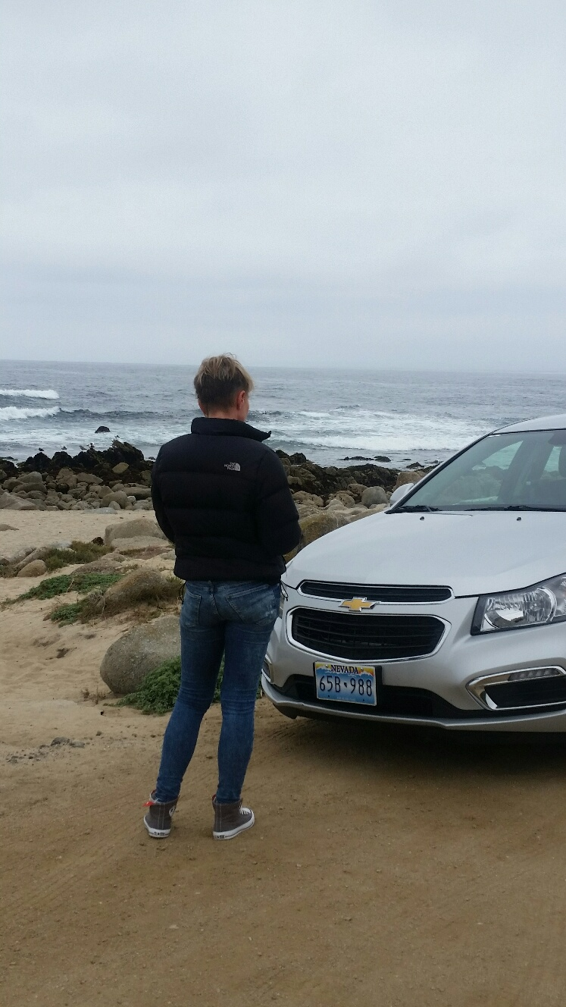
So, we set off from Lovers Point and cruised around the coast on the highly recommended 17 mile scenic drive.
Our first stop was to take a photo of the car ! An unsuccessful photo shoot as the photo only shows us. We were also treated to lots of the little squirrels. It's so strange seeing them on the beach, obviously very used to humans as they have no fear in coming over to look for food.

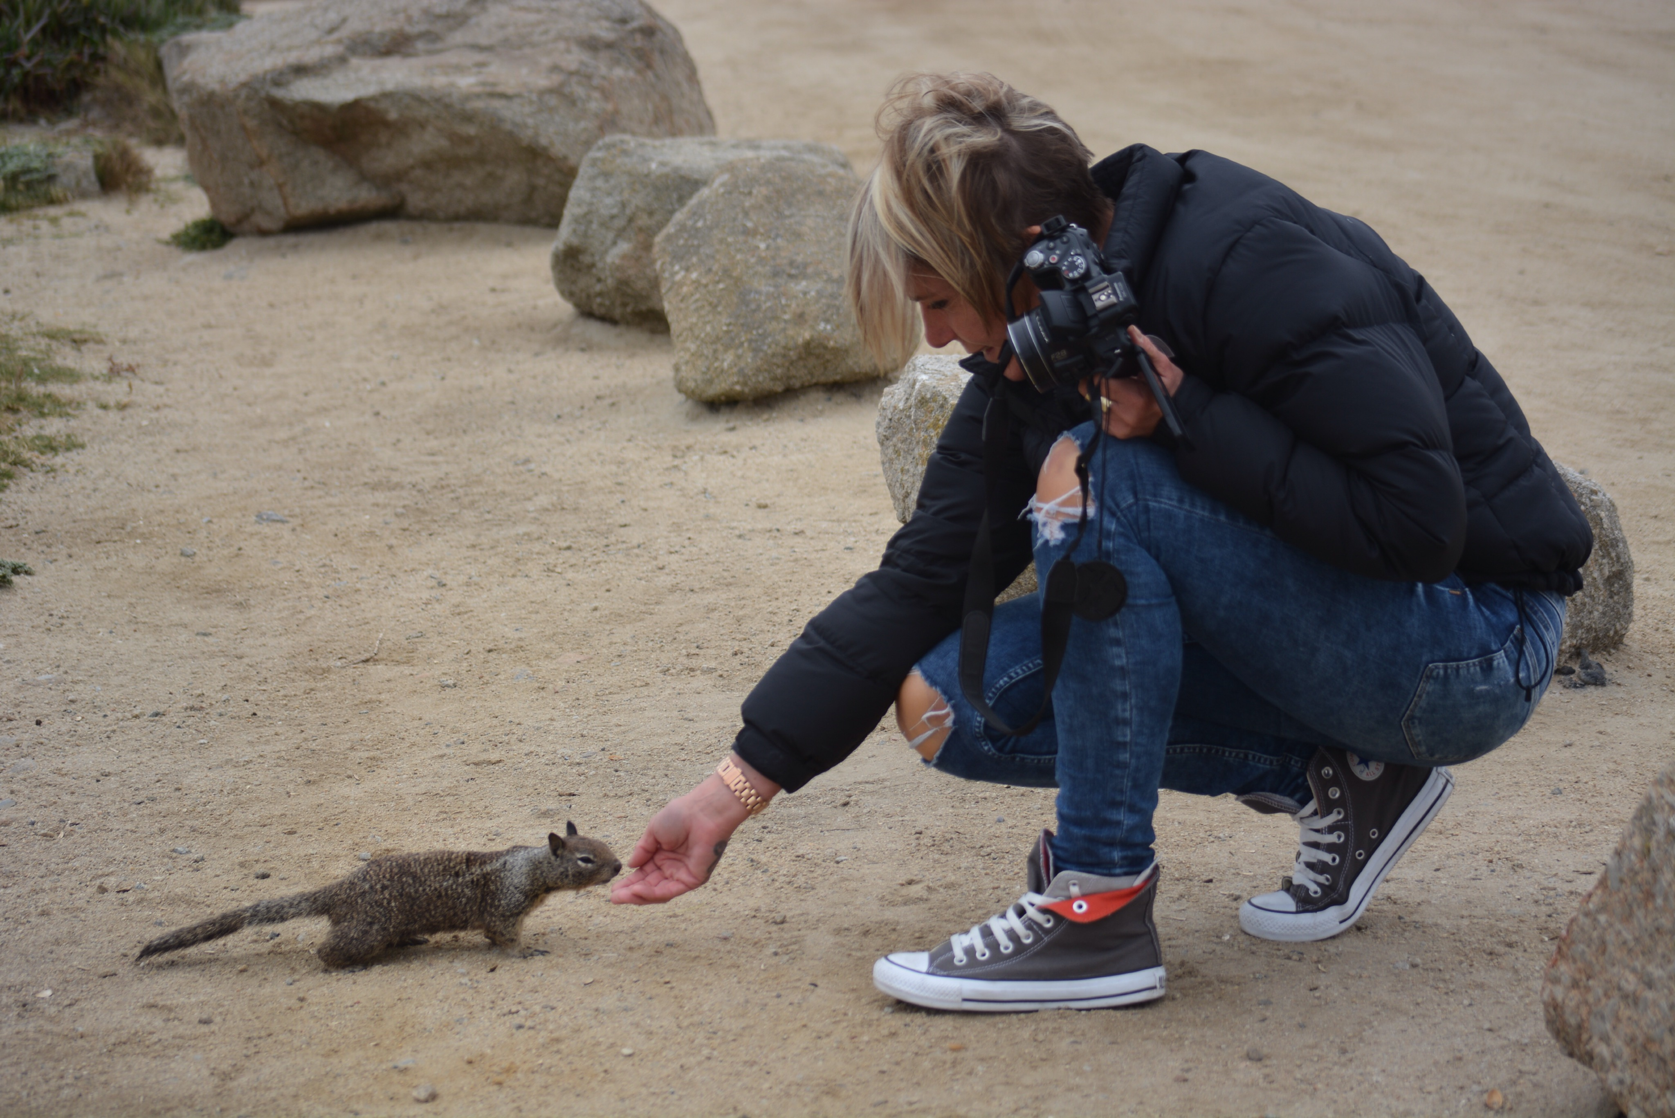
We pulled into almost all of the suggested view points and had lovely views of the rugged coastline. As we passed a golf course we saw a deer and got out to stalk that along with the vulture looking birds. I had a vague recollection of there being such a thing as a turkey vulture and was very pleased with myself when that turned out to be the case.
We saw Bird Rock, initially you think covered in cormorants but when you look closely they are intermingled with seals and Pelicans aswell. Some of those rocks are pretty busy !
We carried on, getting to drive on Highway 1 which just felt like a very American thing ! Our next stop was Carmel. A very cute little town with lots and lots of boutique type shops all very close together. They even have some of their own laws. The funniest being that you need a license to wear high heels...... A law not really enforced - but brought in to avoid any lawsuits by ladies tripping over uneven pavements or tree roots.
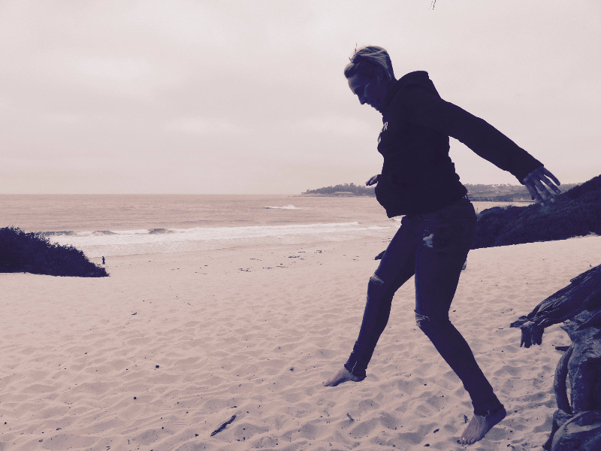
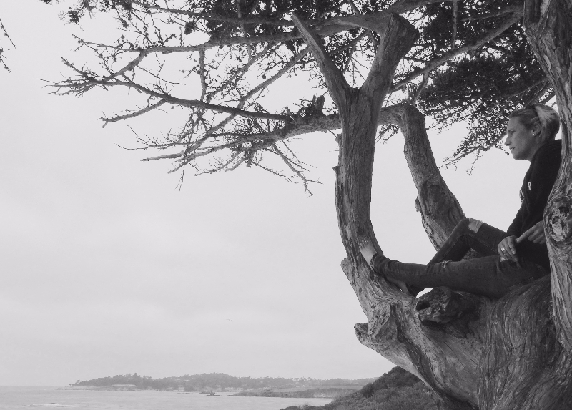
We found a little bakery and had a coffee and a pretzel, and then wandered around the little shops. The shop full of cowboy boots was of particular interest, the $999 price tag was not though.
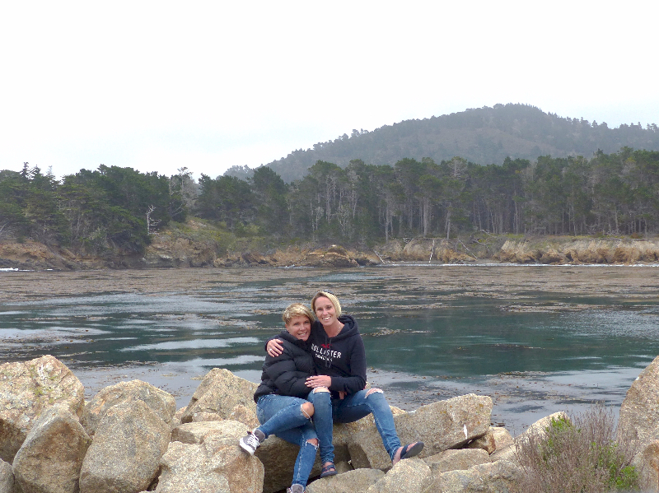
Next we drove down to Carmel beach, with beautiful white sand it would be a great beach in warmer temperatures. There were a couple of surfers and some rolling waves. After we had walked the white sand, I jumped in and out of a tree....
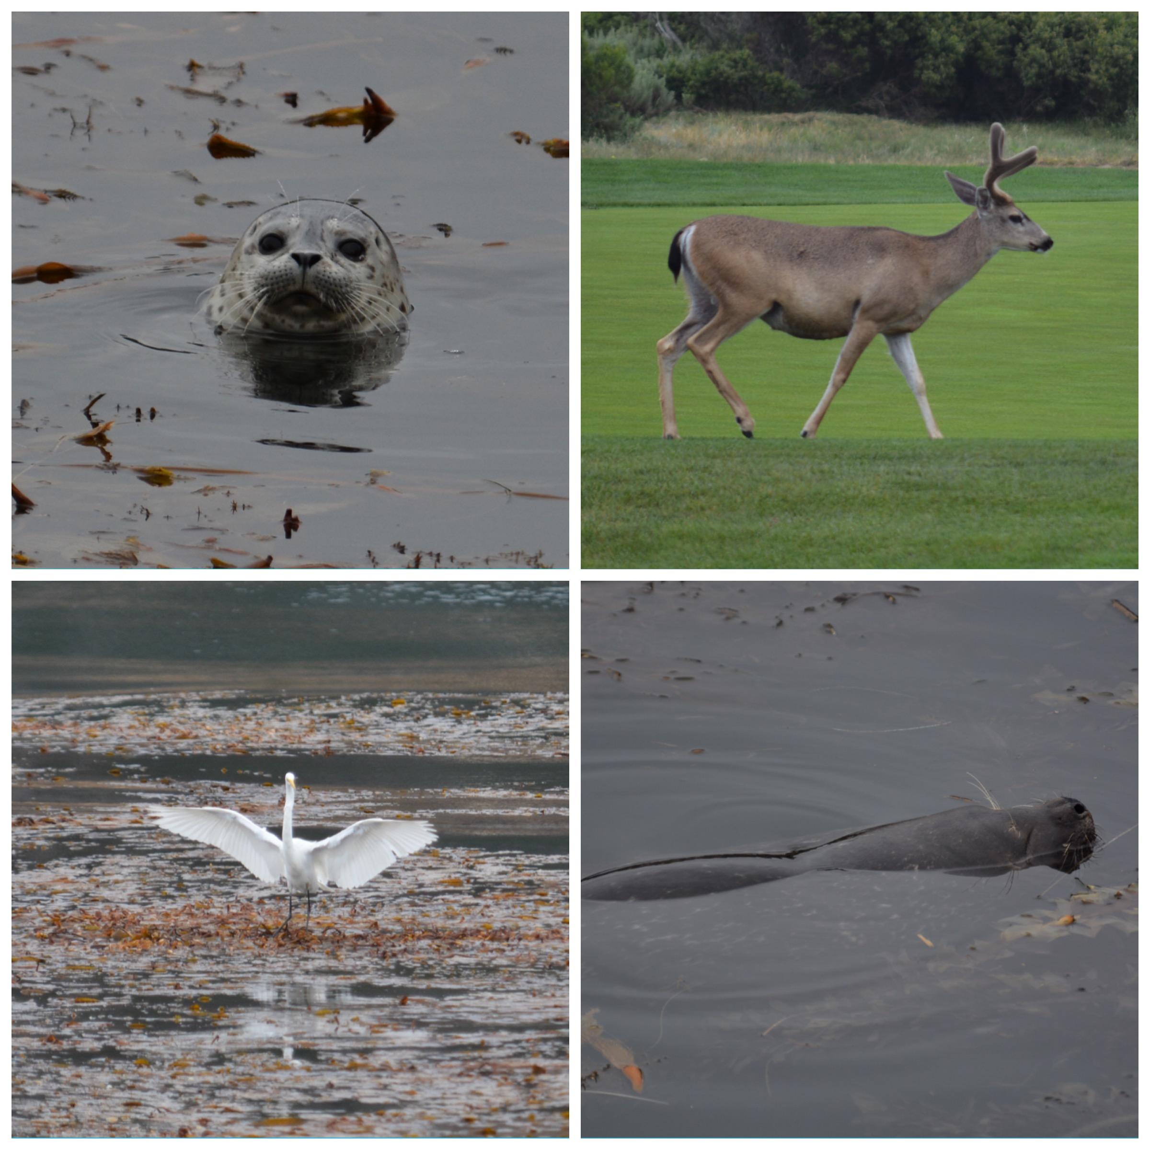
The next place had also been suggested by locals. Not Los Lobos as I wanted to call it, Point Lobos. A National Park. So pleased we went to see it, the first little carpark was next to a little inlet lagoon, and despite there being no sun on it, the colours were still wonderful. An emerald green with a beautiful sheen all over the kelp. We only moved about 50 metres from the car but whiled away an hour with the cameras, seals in the kelp, an egret balancing on top of the kelp, he would land, then stay there until he had sunk up to the tops of his legs, then fly off to a new bit. Then we had endless fun with the camera on timer trying to take a photo of us with the lagoon in the background.

We drove round the rest of the park but it was mainly the same rugged coves. Having been out for 6 hours we headed back ( on highway 1 ) it was nice to have had a different day. We caught up with Clive who had been out on another trip, shared photos while we hung out on our veranda and had a drink.
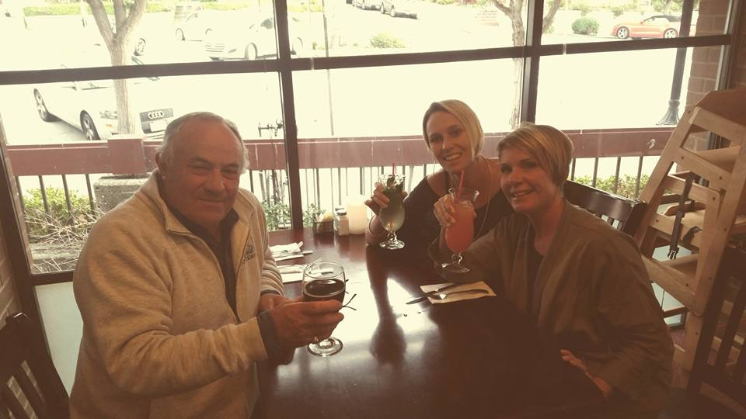
Finished the day with an early dinner at the restaurant that Lucie and I had been to a couple of nights before.
Friday - the day started by dropping Clive off at the wharf for his 8 hour all day trip. Then I went and wasted an hour by driving around finding fuel, we had only used $3.99 ! Also got a coffee and watched Clive go off out to sea.
Drove car back to Enterprise to establish that they had been open since 7:30 ! Never mind. They gave me a lift back to Lovers Point, Lucie had done very well getting up when I left and had sorted her photos - it's very hard to keep up with photos and journals and Facebook...... Perhaps we should bring a PA with us on holiday for admin purposes.
Breakfast and then a 10 mile run. We ran from Lovers Point around the coast past the seals laid flat out as usual on the beach, ran along Cannery Row, on past Fishermans Wharf and further up through a park and eventually stopped as we guesstimated 5 miles. Saw 2 different birds through the trees, a woodpecker and something else I need to look up. We also had the Marines training around us, they only did a 3 mile run though so we are clearly alot fitter.
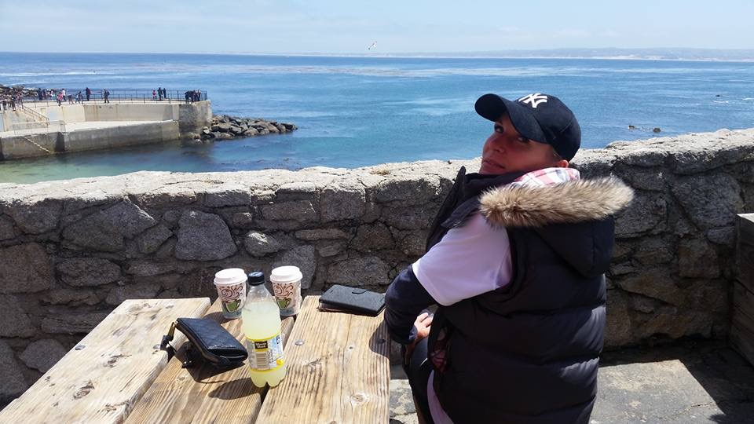
It was nice when we got back not to hurry as we weren't booked on the boat until 3pm.
We pottered around and tried the grill on the beach for a snack.
Got ready and headed for the wharf only to find that it had been cancelled.
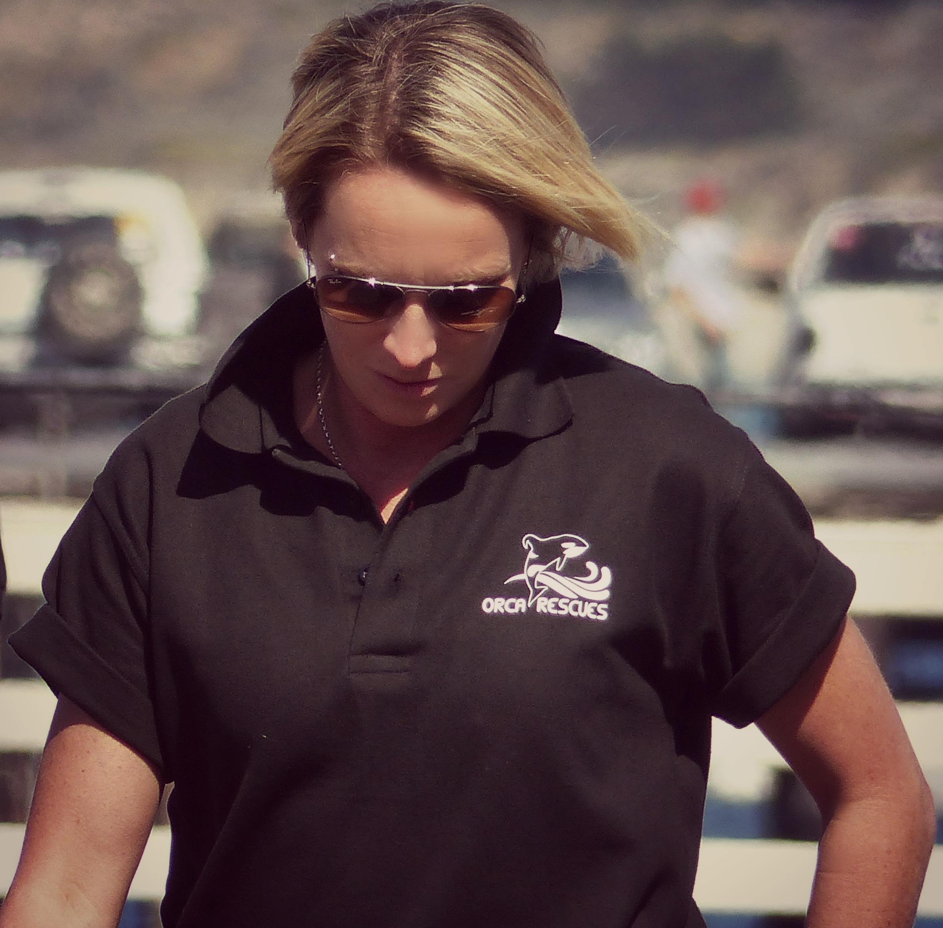
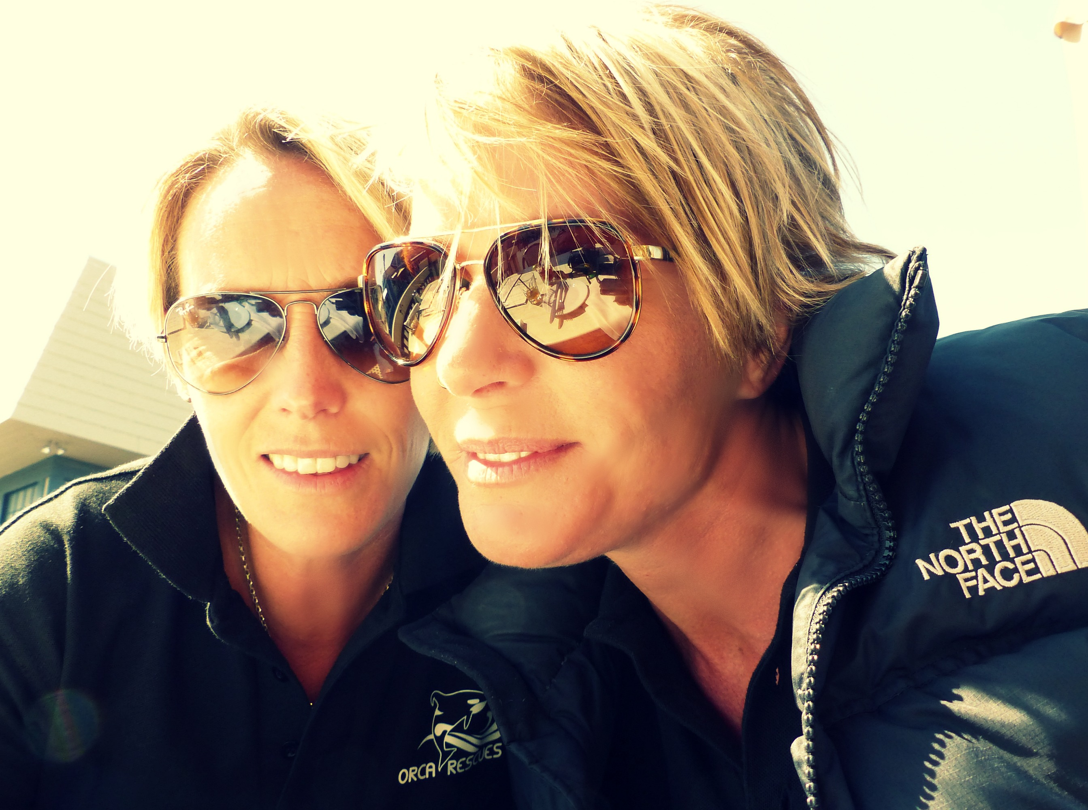
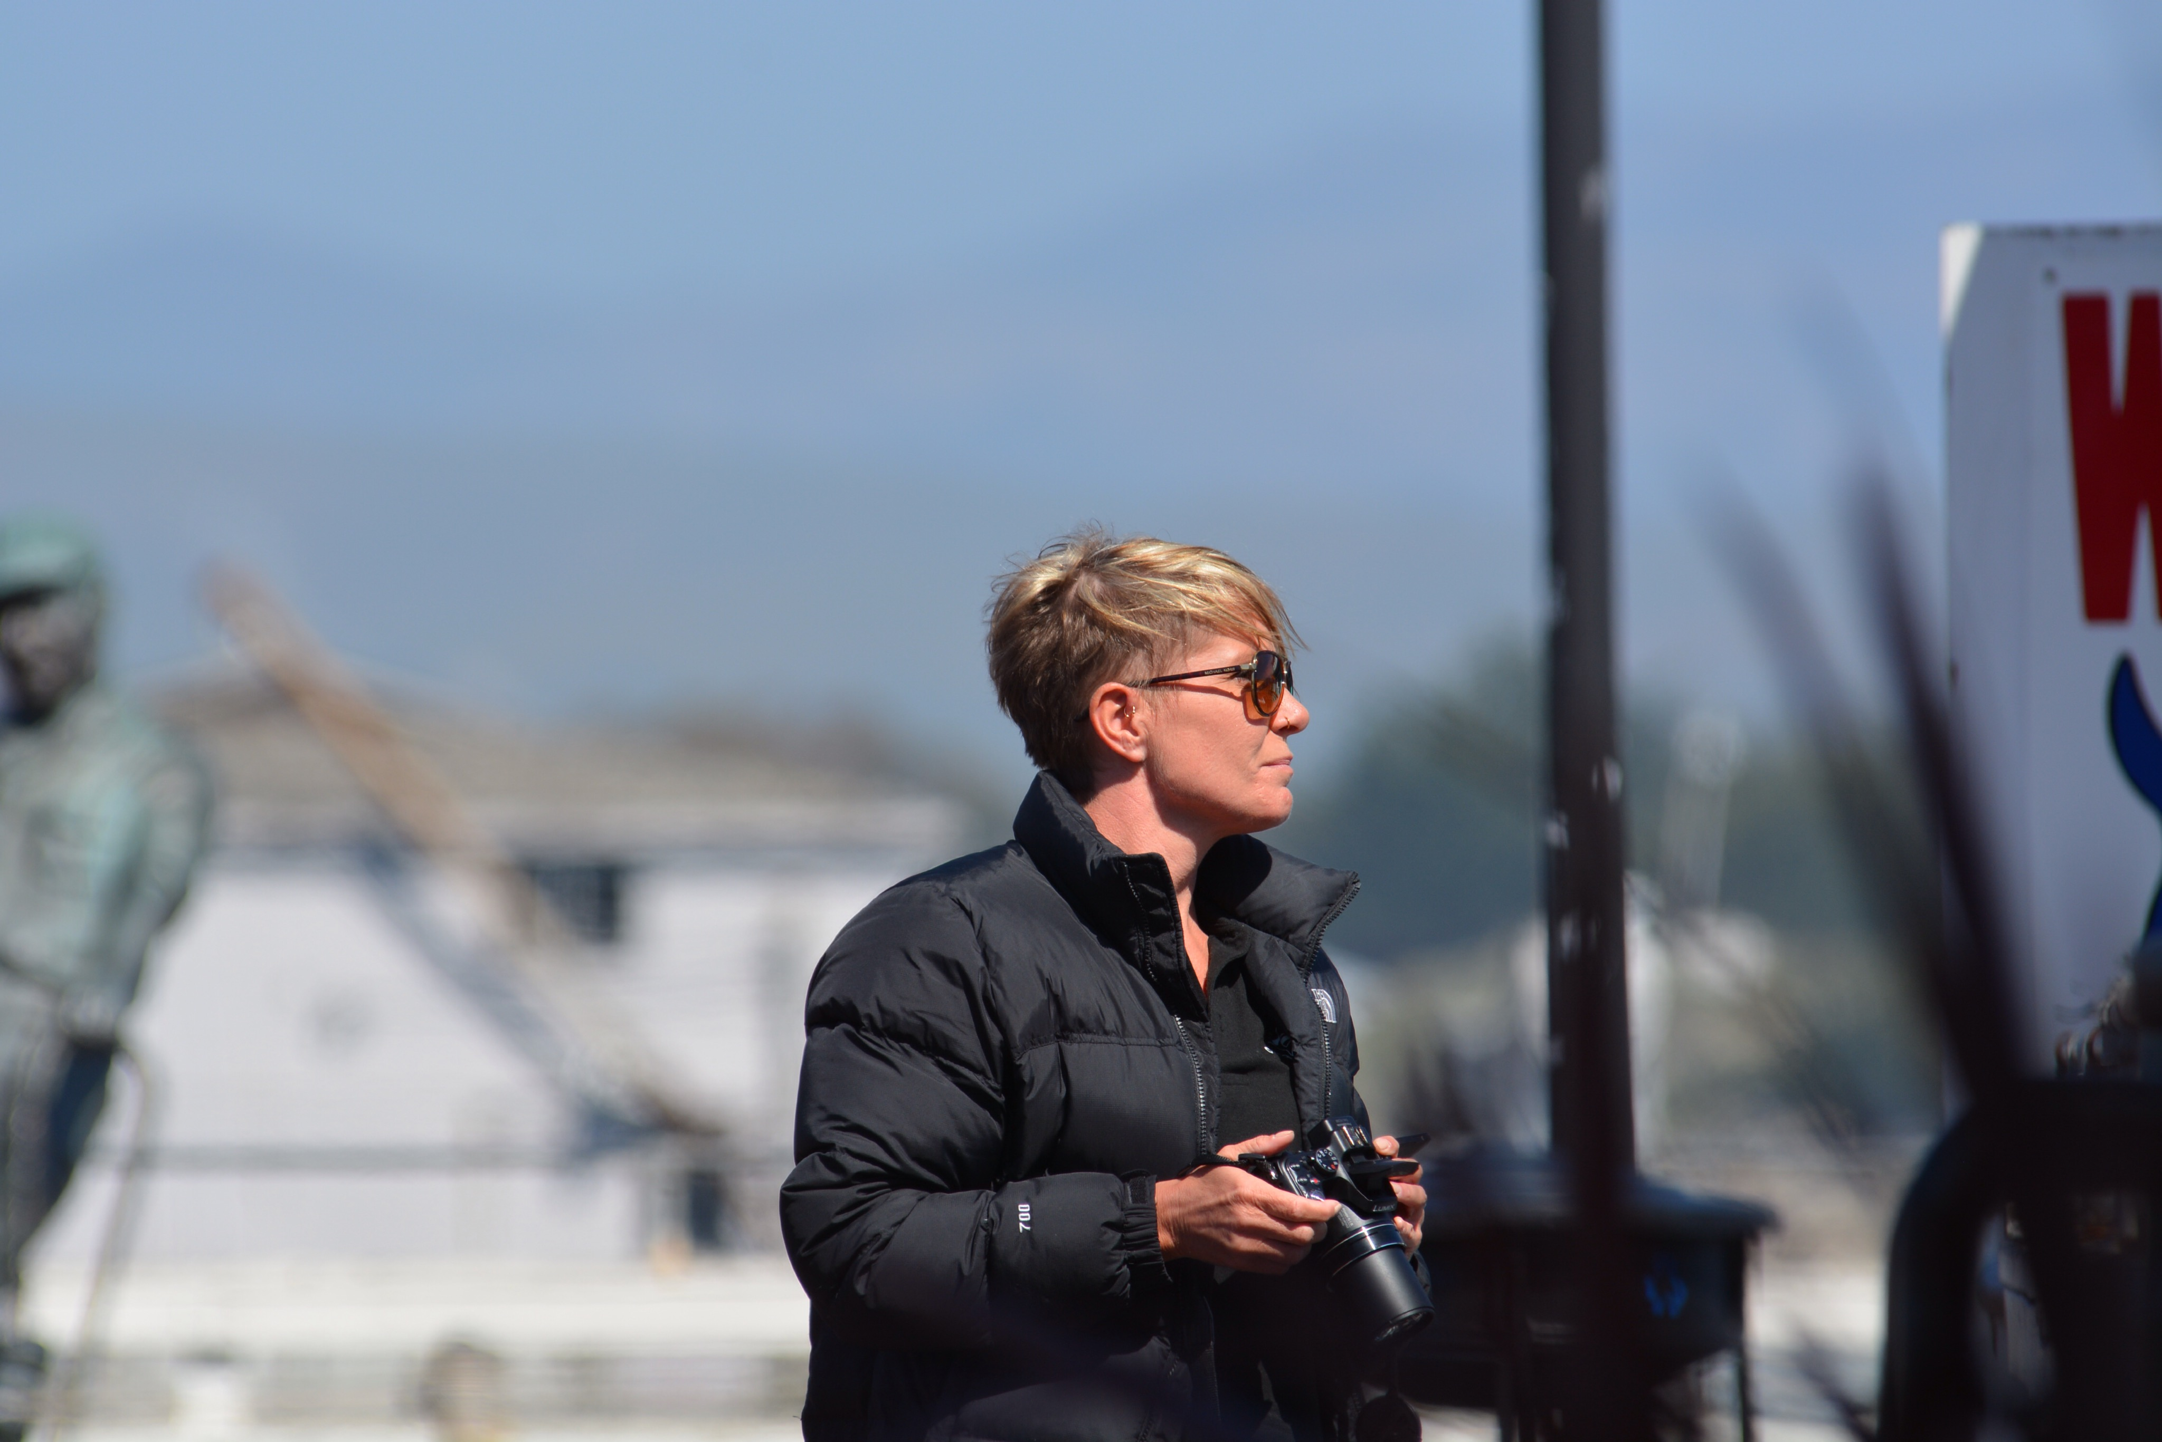
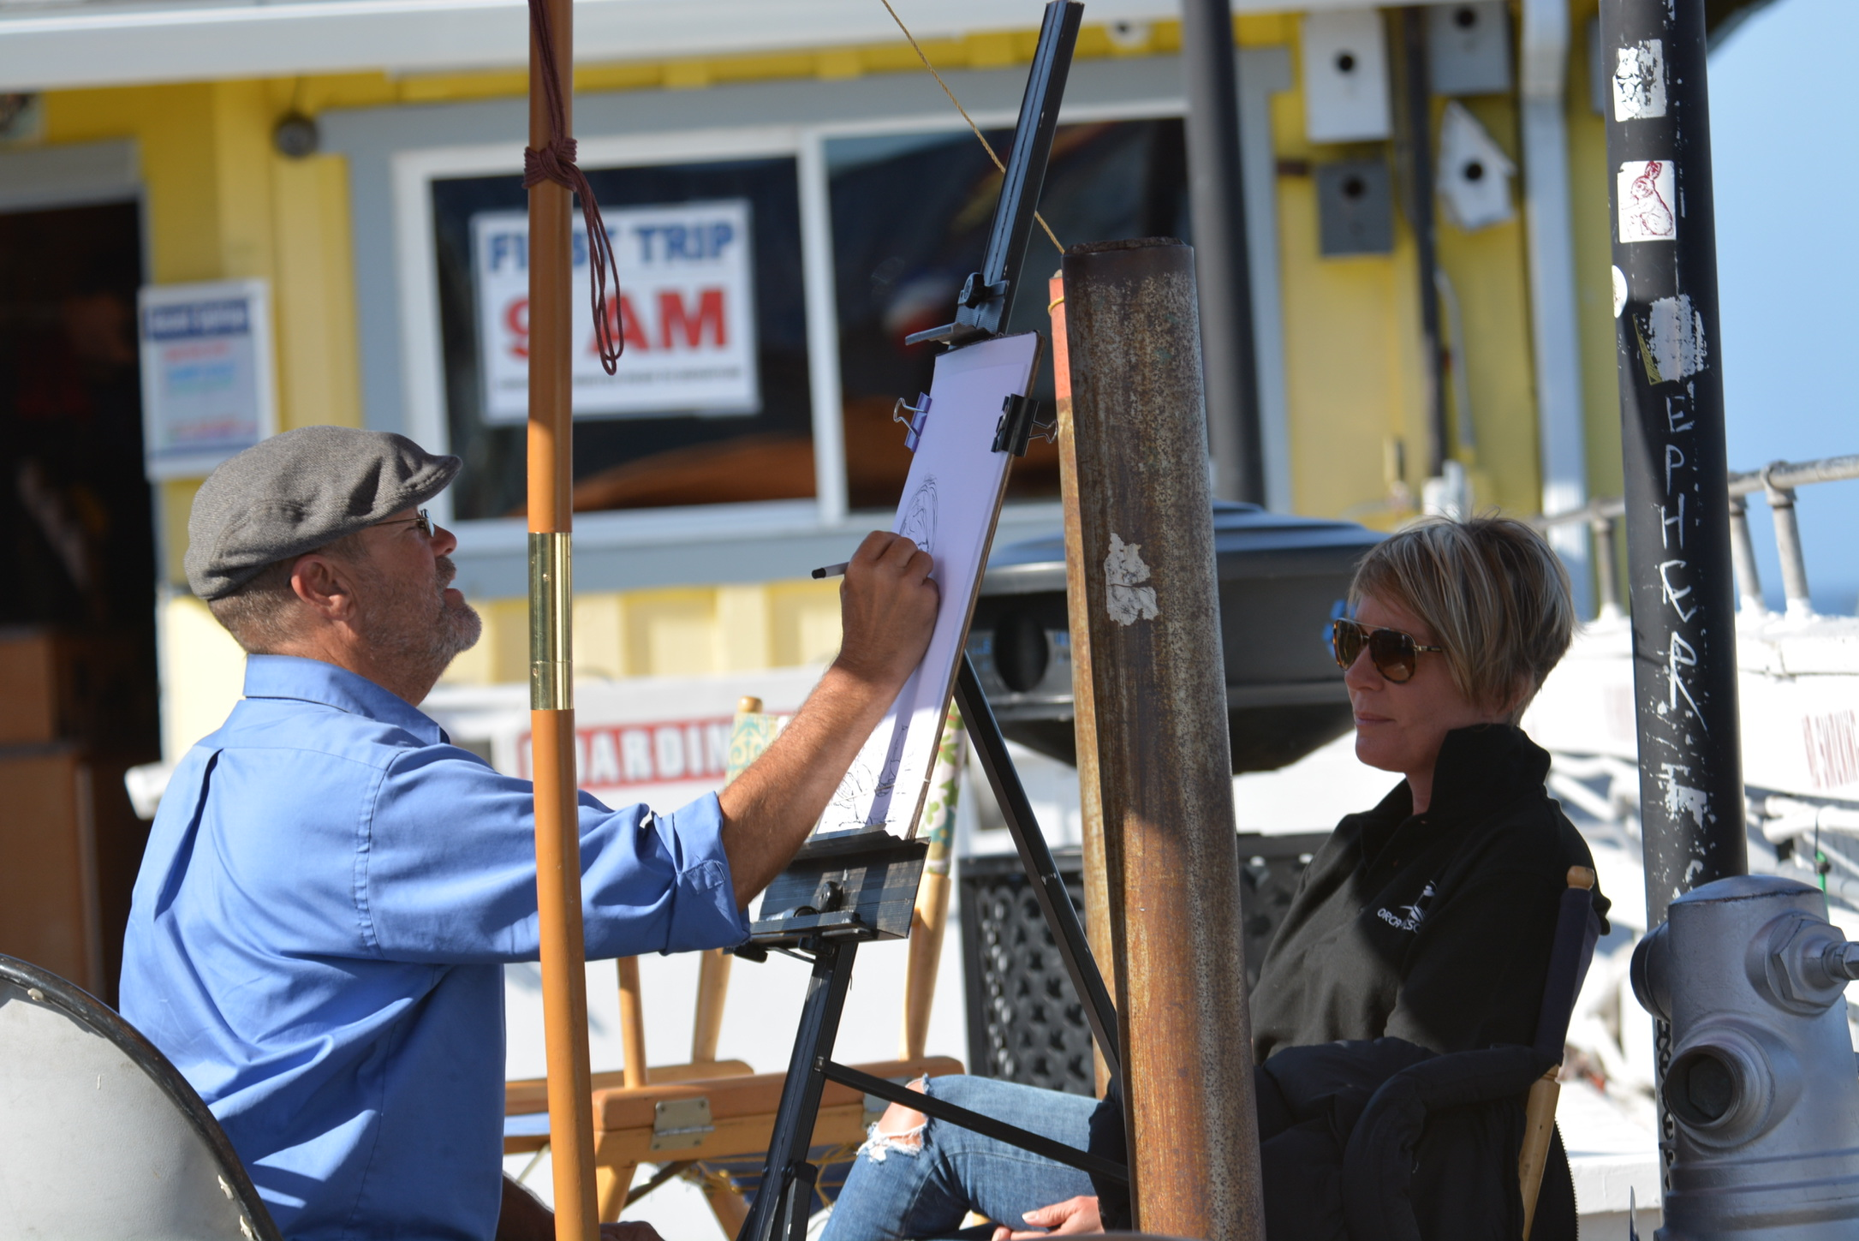
We knew that Clive was due back in at 4pm and had passed a sign for all day happy hour cocktails, so there was only one thing for it...... Cocktails and messing about with cameras taking photos of - yes, ourselves ! Endless fun. The restaurant people weren't impressed we weren't eating but we didn't care and just ordered more cocktails.
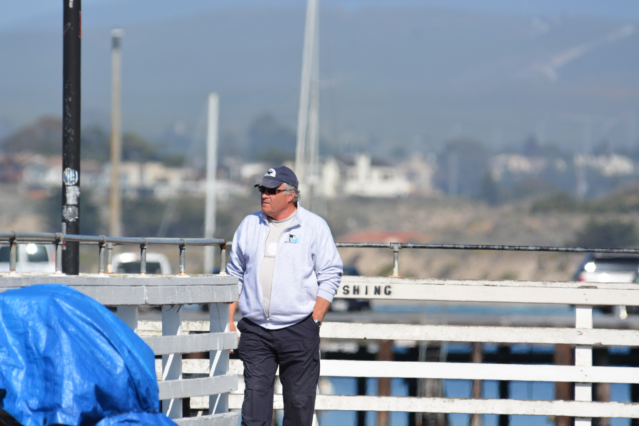
We had also spotted a caricature artist and felt obliged to have one done. We took photos of Clive as he came off the boat and then had a couple of drinks with him.
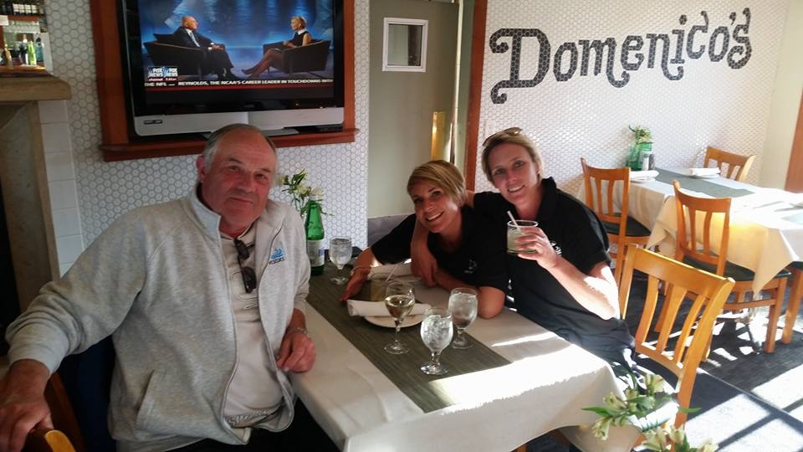
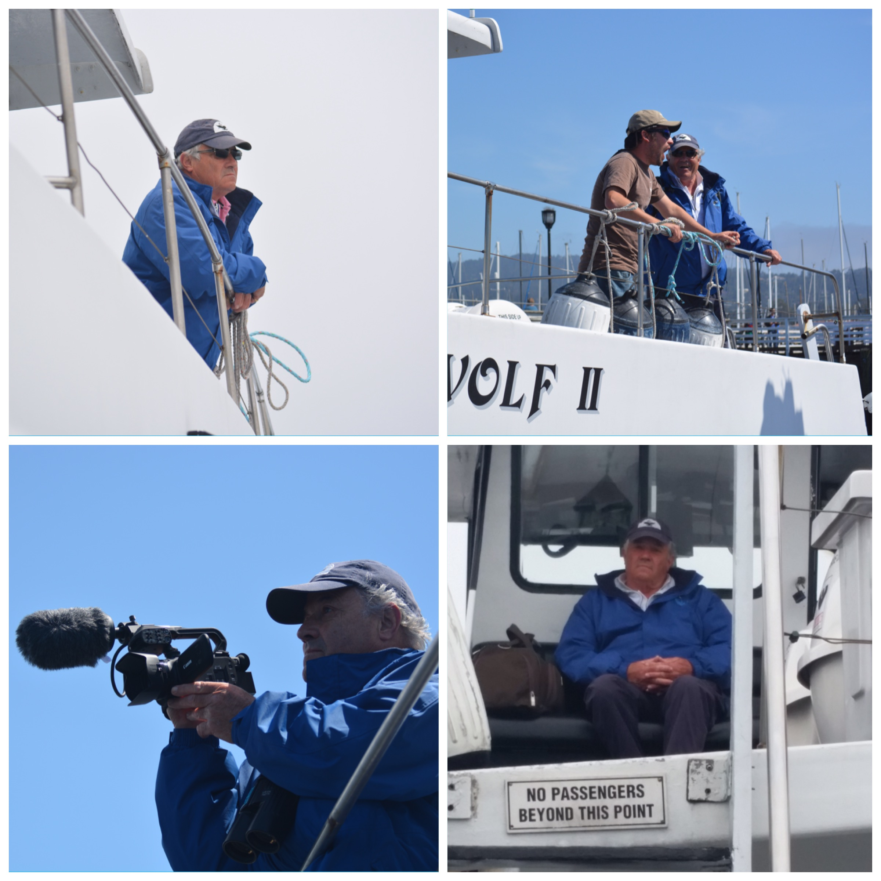
The restaurant next door was more friendly than ours so we went there for dinner. We both had chowder in gigantic bread buns.

Skipped a couple of days at sea, really busy weekend as memorial weekend. We attempted the aquarium, paid a million dollars and hated it. It was 5 people deep at every tank and full of screaming kids. We left. Fast.
General Boat Life ! We liked our boat and had a place to put our bags, we could have a coffee, we could skip across the cabin to get to the other side of the boat. We could lean on the rails to steady ourselves to take photos. It was basically our boat....

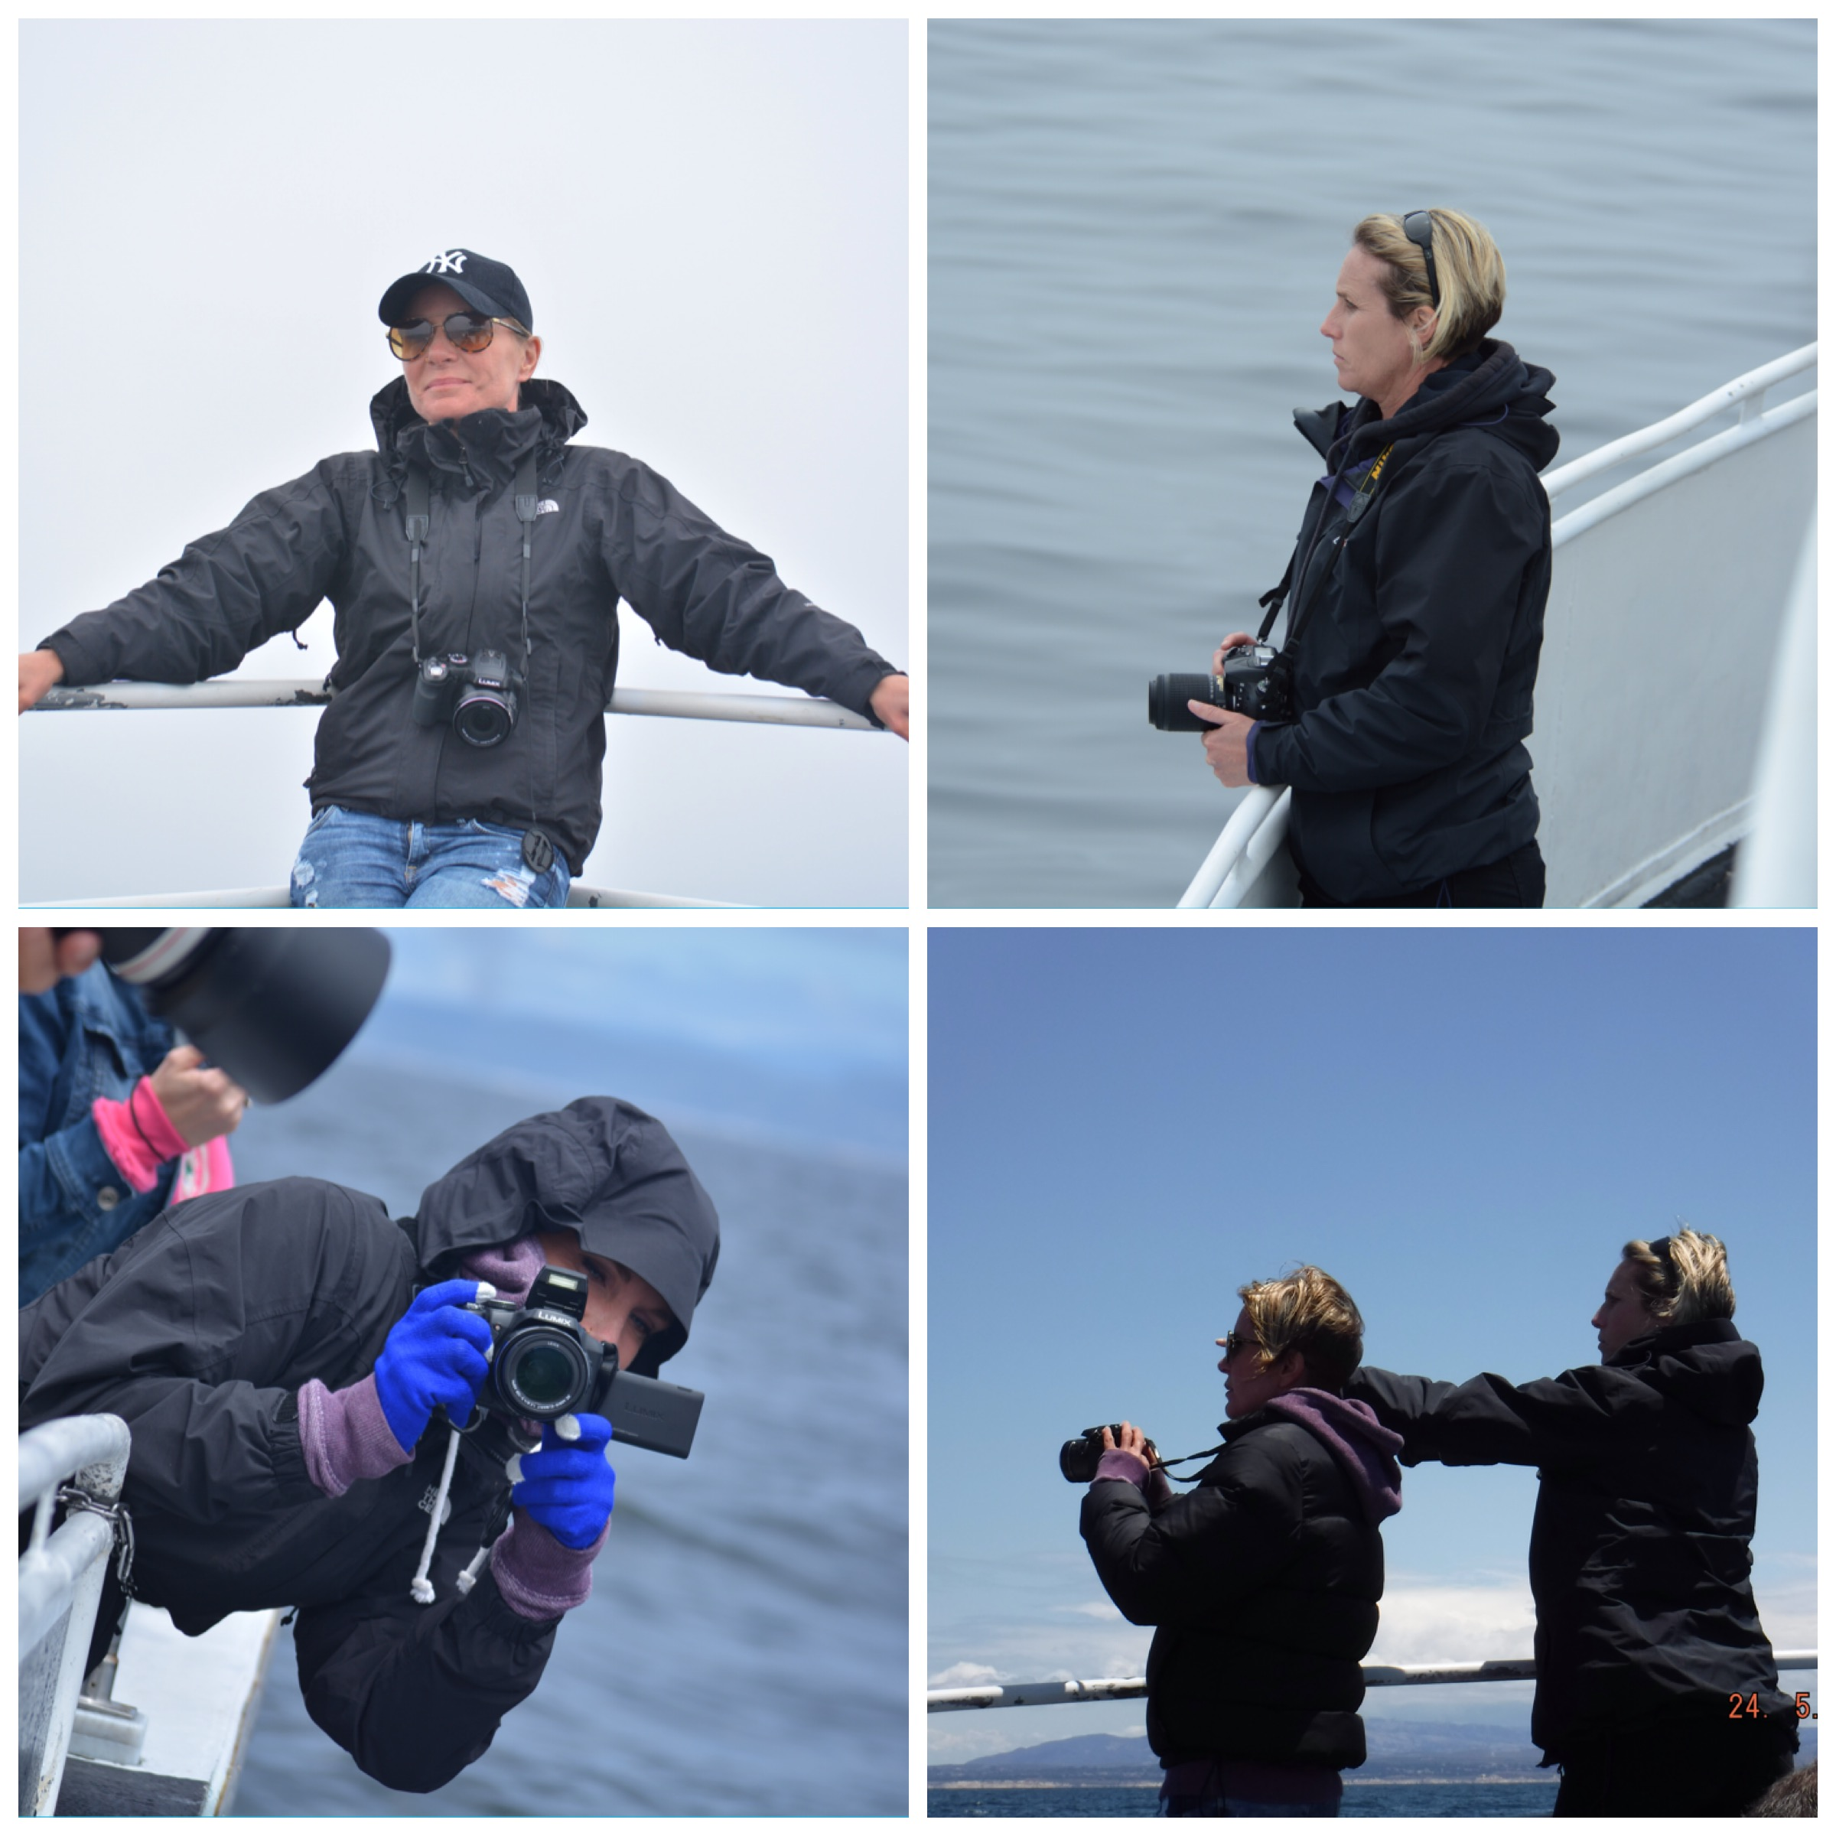
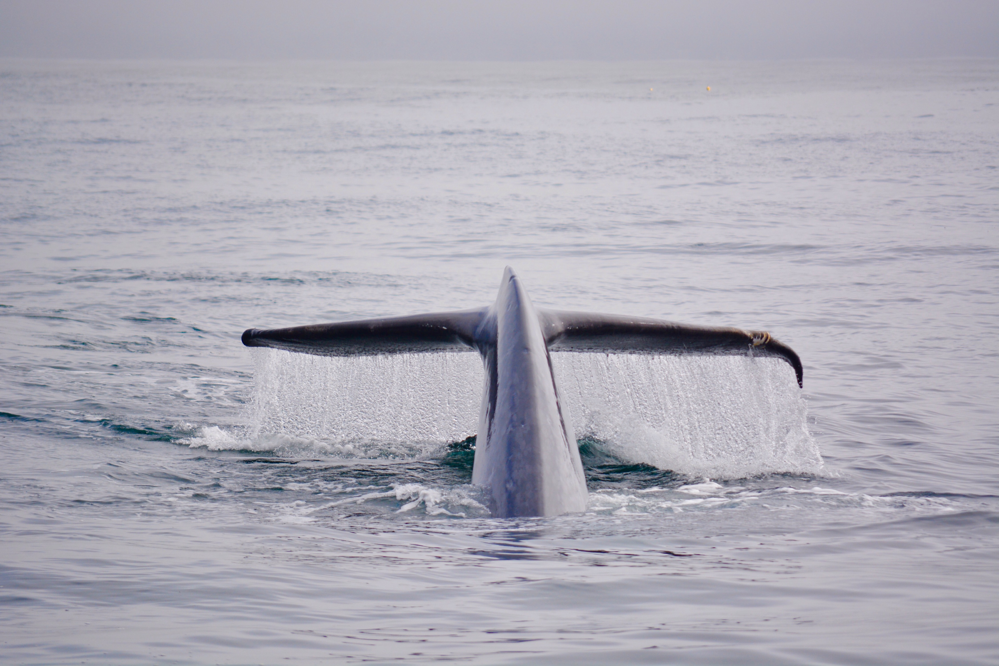
Tried another day at sea. Set off at 8am, the surface was flat but there was quite a swell and we amused ourselves watching what must have been the most horrendous family day out that this particular family were ever going to have. It started with the little boy being held over the toilet whilst Brian the deckhand tried in vain to tell them to take him out the back in the fresh air. This was followed by the daughter being hauled down the outside of the boat projectile vomiting as she past the open door to the cabin.... Brian appeared again with a large spray and lots of kitchen roll. By now, mama Chinese was cuddling the freezing baby looking like she would have paid for a helicopter to remove her right there and then. All was ok for a few moments until Granny Chinese who had sat with her eyes closed at the table since we got on the boat needed escorting to the toilet while Brian featuring again, went and grabbed a family member to supervise her wobbling around in the toilet, Brian stood outside armed with more kitchen roll.
We headed out to the humpbacks and managed to improve on photos while having them in the sun. Followed by blue whale tail flukes also with sun on.decided to maximise the day and the next trip was going out at 12:30 giving us a 10 minute turn around. We all had jobs to do as we leapt off the boat first. Clive had to go and pay and get us on the next trip. I had to go and get food for us all and Lucie just had to go to the toilet !!
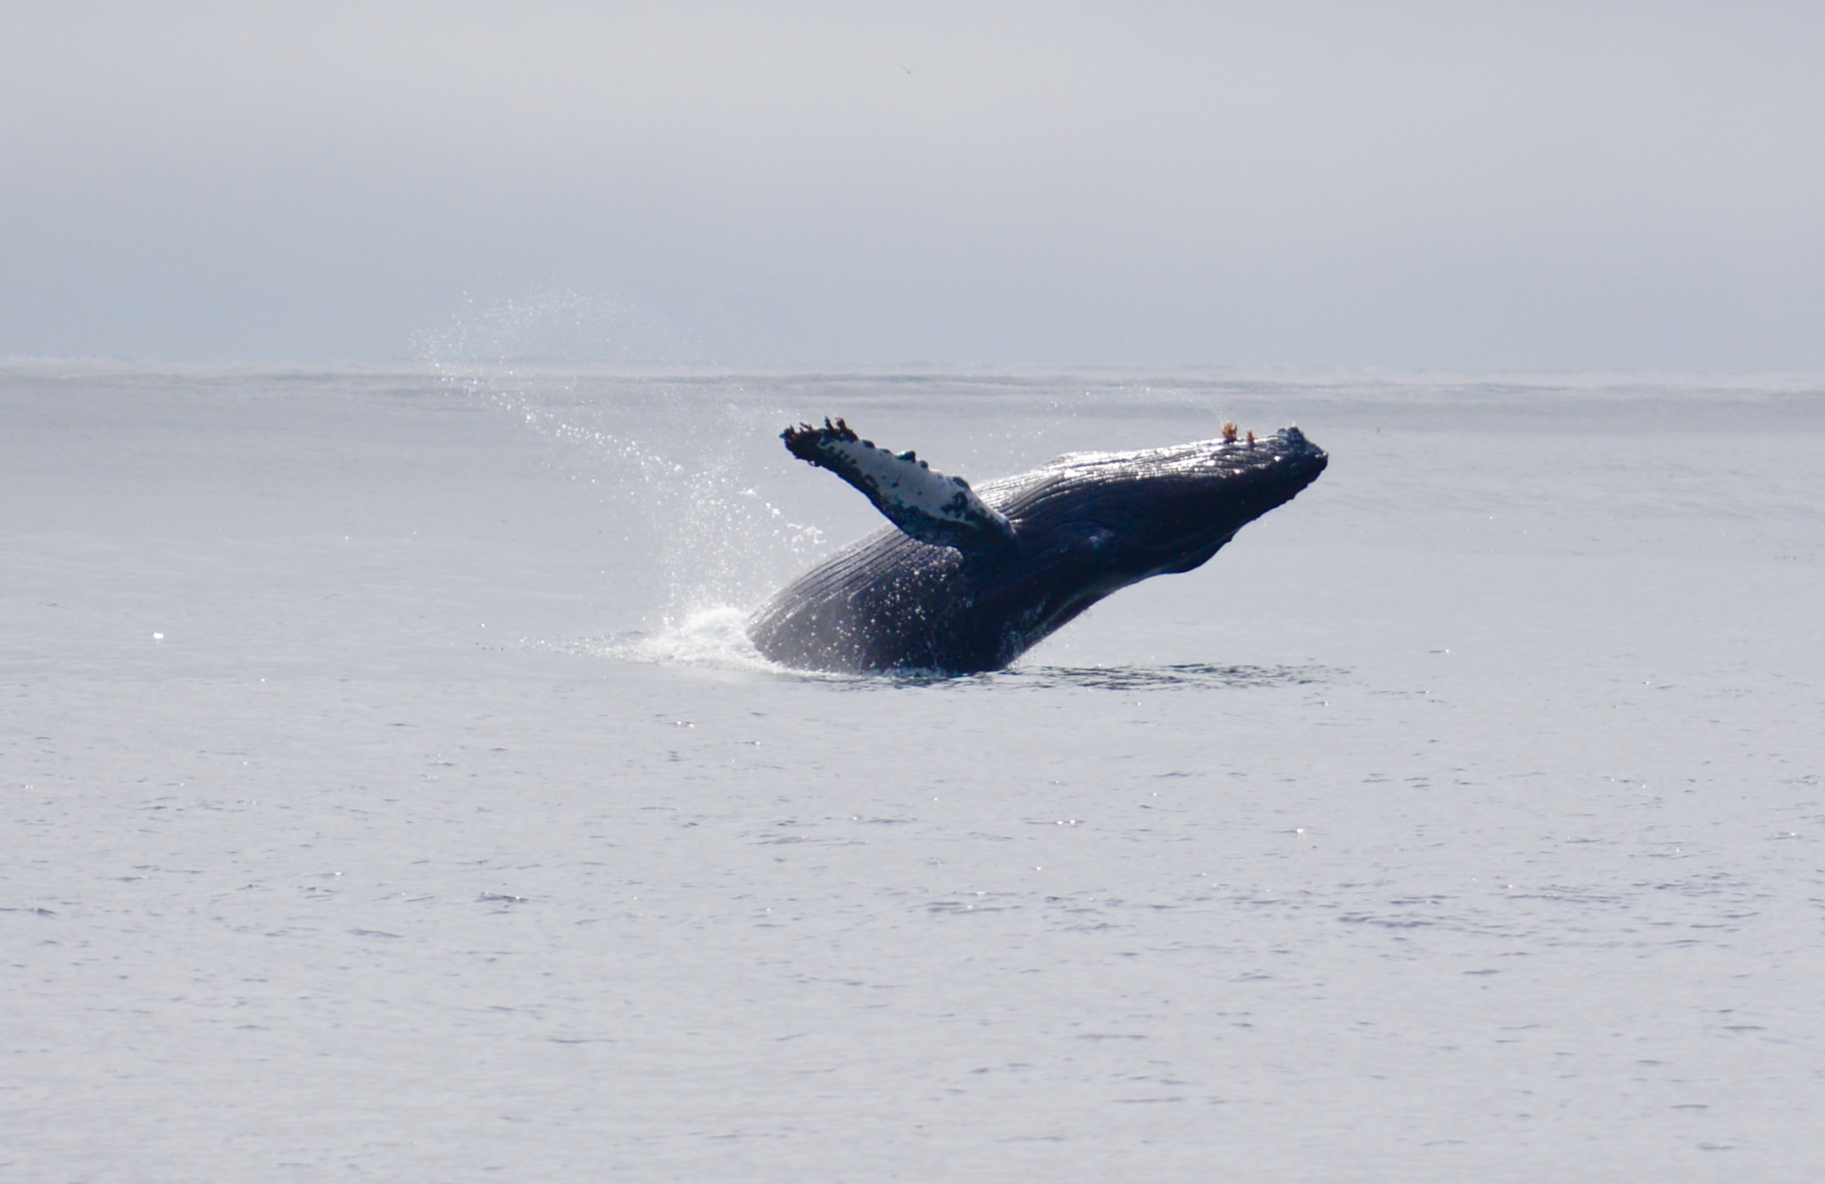
I managed to find me and Clive a hot dog and Lucie a slice of pizza ! We all ran back on the boat and off we went again. This time we were minus the Chinese vomit family which practically meant that Brian had the afternoon off......
We headed in a different direction in the hopes of Orca - this wasn't to be but we did get to see humpbacks lunge feeding which was a first for many on the boat (including Brian)
So 7 hours at sea, no orca but a great day.

Final full day - Tuesday 31st May
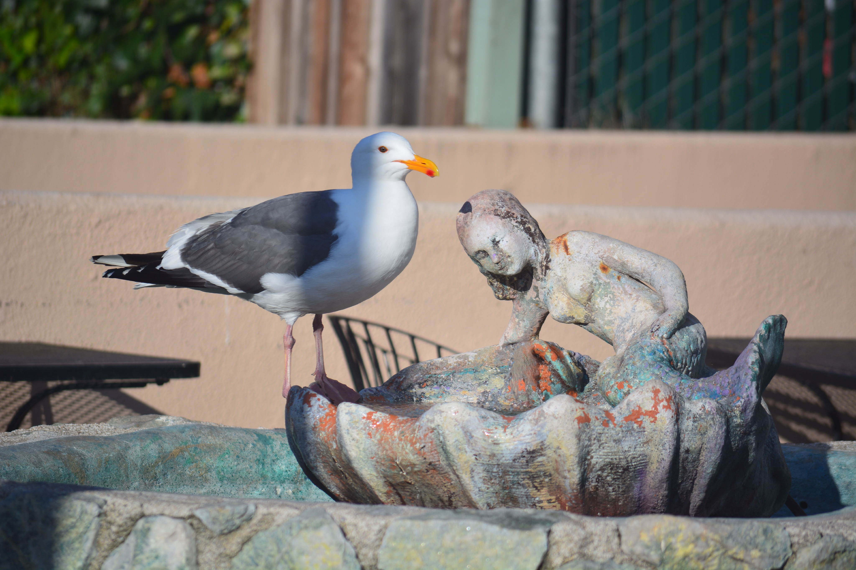
No sunrise again....but got up at 5:45 to head out on 8am trip. This little routine had become a ritual. Get up and dressed then potter to breakfast and have toast and coffee whilst fending off the permanent resident black backed gull. He loved to steal eggs, toast, well anything you left laying around really, coffee out of cups before flinging the cup in a rage spilling coffee over tables.
Clive would have brought his days belongings with him. I would call a cab and have just enough time to pop back to room, grab equipment ( all the time pretending I was part of a documentary film crew ) and all jump in cab. This went pretty well most days bar the exception when a foreign guy couldn't comprehend dropping whale watching tourists at the main Fishermans Wharf and chose instead a remote car park next to the more industrial pier. Clive waited for ALL of his change that day.
Anyway, this particular morning I was going solo on the 8am trip due to the other member of the Martin - Armstrong clan being shattered. So Clive and I set off leaving Lucie strict instructions to join us for the 12:30 trip.
I was torn between seeing the Orca, as much as I wanted to, I didn't want Lucie to miss them. The trip was busy straight away with a seal throwing its sunfish catch around in order to tear chunks off it to eat. Then a minke whale was lurking around at the edge of the harbour, spotted up on the bridge and searched for quietly. One of the naturalists had been told once, if you see a minke whale, don't call it as you won't see it again ! This turned out to be true 2 days in a row !
Next we headed out towards the deep canyon feeding ground of the blue whale. We passed a good giant sunfish on the way. Humpbacks performed as usual once we reached the first canyon edge, pec slapping, breaching and generally milling along. We were on Seawolf 2 again, love this boat and skipped easily around the deck trying to second guess a humpbacks breathing pattern whilst dodging the daily tourists and definately dodging any that were getting seasick. Just an observation on this, it appears to be either very pale unhealthy looking people who seriously look like they just don't set foot outside ever, and fat people who look like the quite simply can't set foot outside, are the ones that get sick !
I had showed off to one lady who was so excited about seeing the blue whales. Told her she would love it, that she would be surrounded by them, it was so amazing how many of them were out there......... The terribly bad news was that the Blue Whales had now left the area ! I felt so disappointed for her.
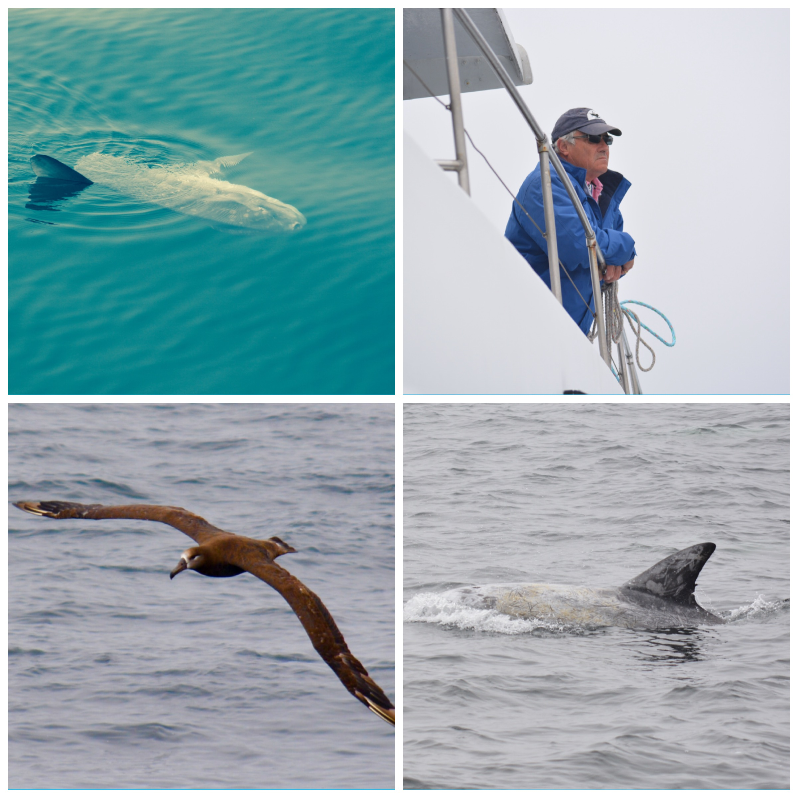
As we steamed back towards Monterey Bay harbour, we encountered Rissos dolphin and also Pacific white sided dolphin.
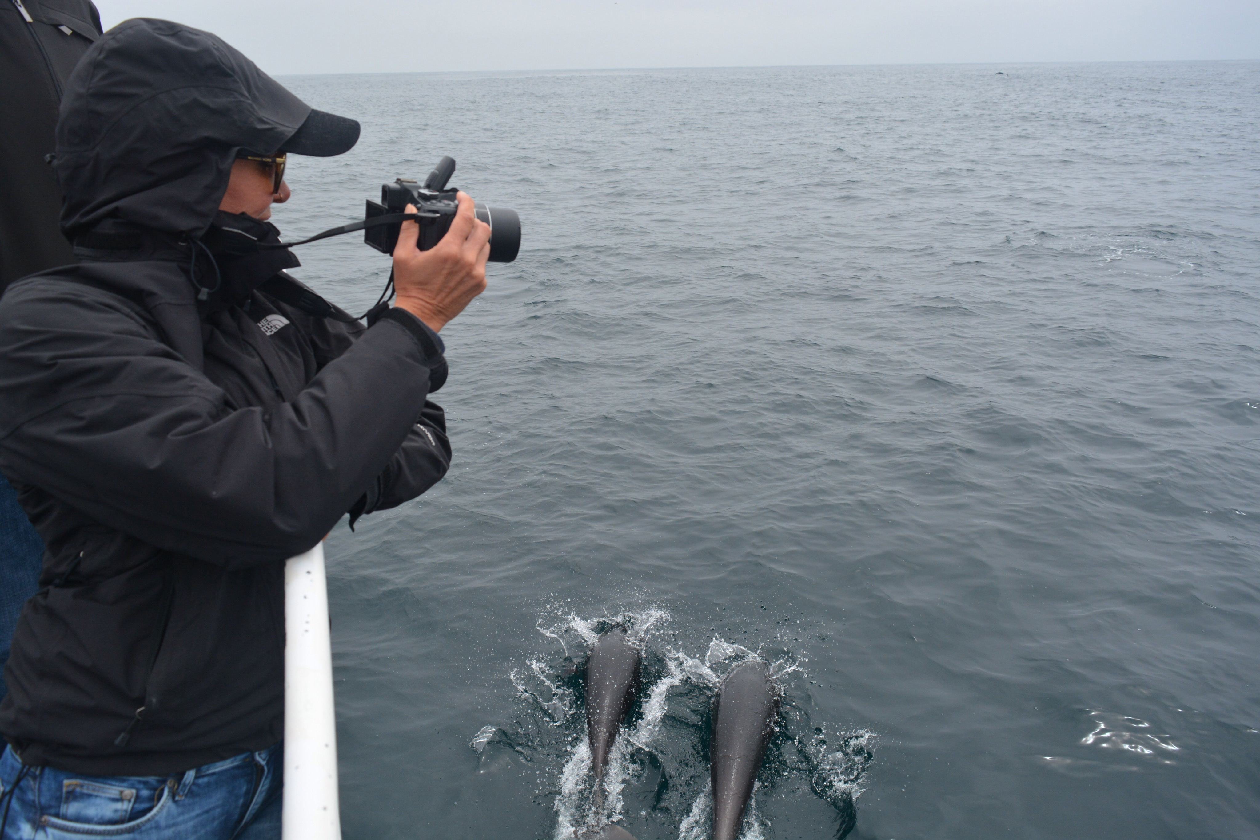
Keen to get back in and pick Lucie up, didn't bother with a food dash as Captain Everet had given Clive the word on the street that Orca were out in the other direction and wanted to turn the boat around fast. I leapt off , Lucie and I leapt back on and we were off again. Everet was on a mission as we steamed out of the harbour not even stopping to faff about at Seal Point which without fail had been the first talking point of every trip ! Not today....... Off we went. Bumped into some Rissos - hurriedly observed them, and onwards.... Couple of humpback, bit of breaching and pec slapping, bit of feeding lunging along the way. Time was ticking by and as Orca got less And less likely we were happy to bump into a huge pod of white sided Pacific Dolphins who were accompanied by funny little Northern Right Whale Dolphins. So called because like the Northern Right Whale, they have no dorsal fin. These guys were fun and it was great trying different ways of capturing them on the cameras.
They stayed around a while and I even had time to switch lenses to try and get the bow riding which I did but unfortunately not the Pacifics, just the Northerns.
We had also learnt to use the time coming back in on the boat to delete all the rubbish pictures, this saved trawling through 700 photos of mainly white water which is what happened when you got carried away with a new pod or new activity !
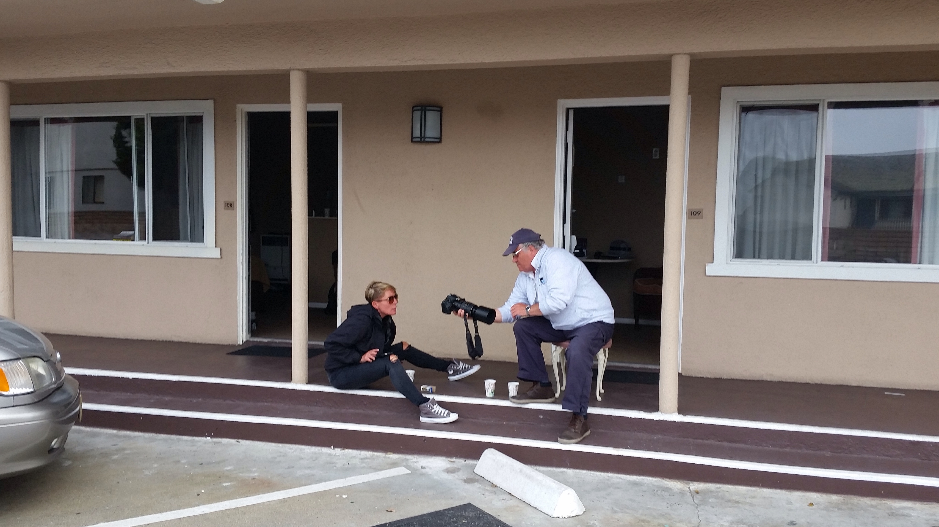
We stopped on the wharf for the obligatory happy hour margarita and beer before heading off back to lovers point.

An hour on the veranda at the end of the day was always pleasant with our friend Jim Beam, also used that time to pick the best photos of the day. As it was our last night we decided to go to the nicest restaurant and Clive went ahead of us as he ambles slowly and Lucie as usual had to finish getting ready !
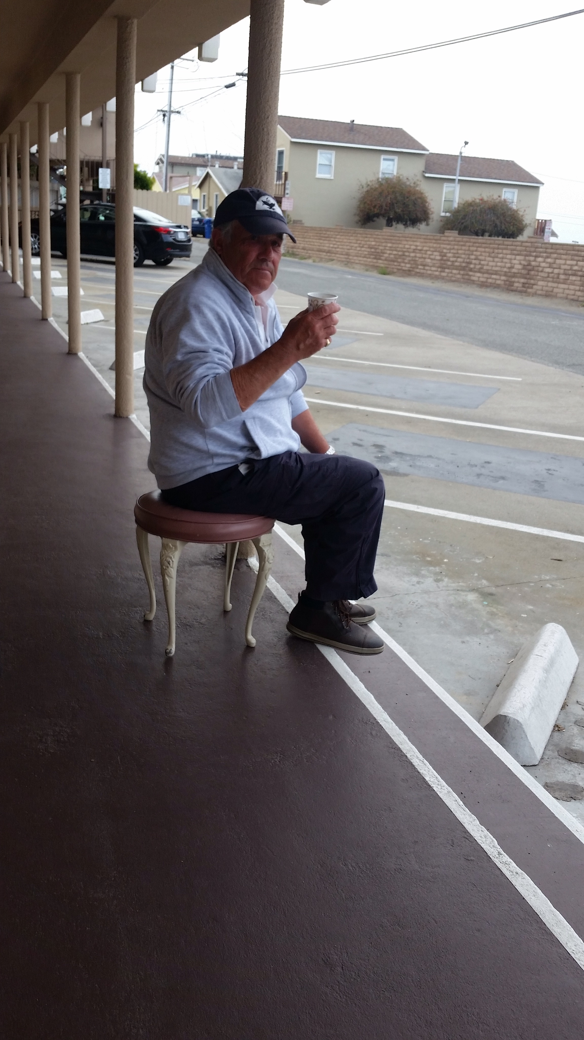
We had a lovely meal and then Lucie and I scurried to the bottle shop and randomly grabbed. Bottle of Amarullo and then set off in pursuit of Clive who once again had gone on ahead. After a quick chat with a guy who wanted to guess where we came from...... He said Wales !!! Anyway, back to pursuing Clive, as we clattered down the road falling off higher than expected curbs and calling out to distant people "Clive, Clive" we then stumbled across him sitting on a bench on the pavement watching yet another deer !! We all found this highly amusing.
Last morning
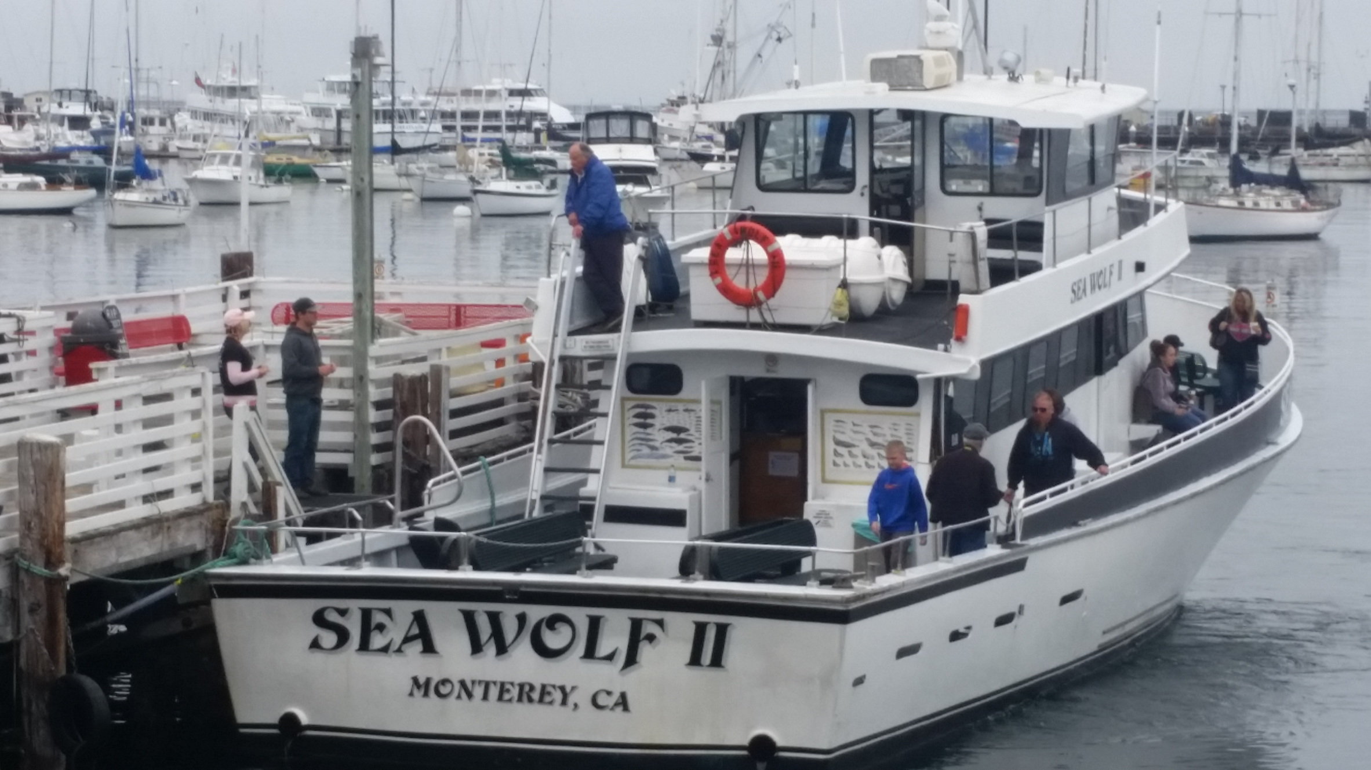
As we weren't flying until 9pm we decided that we could fit one more trip in making a total of 9 trips if we count the failed sunset one ! So having packed and got organised the night before, we got up at 5:45 and did the getting ready and having breakfast routine and set off on our final chance of seeing Orca.
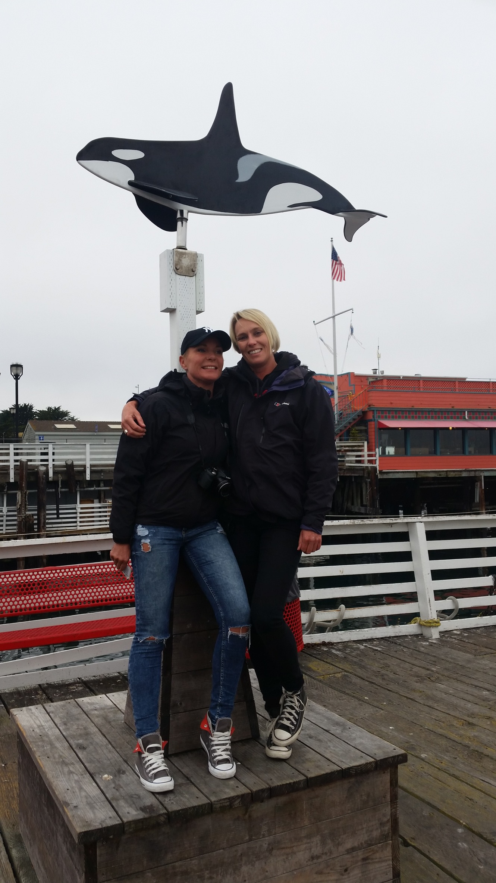
Now that the blue whales had gone, Captain Everet was happy to use the 4 hour trip to go and try and find the Orca. We did seal point as usual then trundled around again for the Minke Whale to no avail.
And off we went, a few humpbacks and albatross. We played a silly game on the back deck, standing with feet together and seeing who fell first with the movement of the boat, another where we tried standing on one leg. Chatted to the deck hand who today was called Joe, had coffee, ate crisps and generally pretended the whole deck was ours....we noted again that the people who got sick were the fat people and the pale people....the pale people also generally have absolutely no interest in being out on the boat and seemingly no interest in wildlife at all and really the whole trip is just the worst morning of their lives. We joined in with photos at the front, I guess you can always try and get a bigger breach - also had the Pacifics come in again, gave me the chance to try some different photos, just using different settings and see if it's clearer. Then we headed back and our dream of Orca was over.
An amazing trip none the less with so many species and having learnt so many new things.
We saw, Humpbacks, Blue Whales in unheard of abundance, Minke Whale, Rissos dolphins, Pacific white sided Dolphins, northern right whale dolphin, giant sunfish, seals, sea lions and sea otters.e kayaked with floating pontoons of sea otters, just us, no-one around and we could just watch them in their cuteness.
A really amazing trip, plans now are to go and do a Safari with Clive ! We also want to go and help with protecting the turtle eggs and volunteer at the orangutan place in Borneo.

