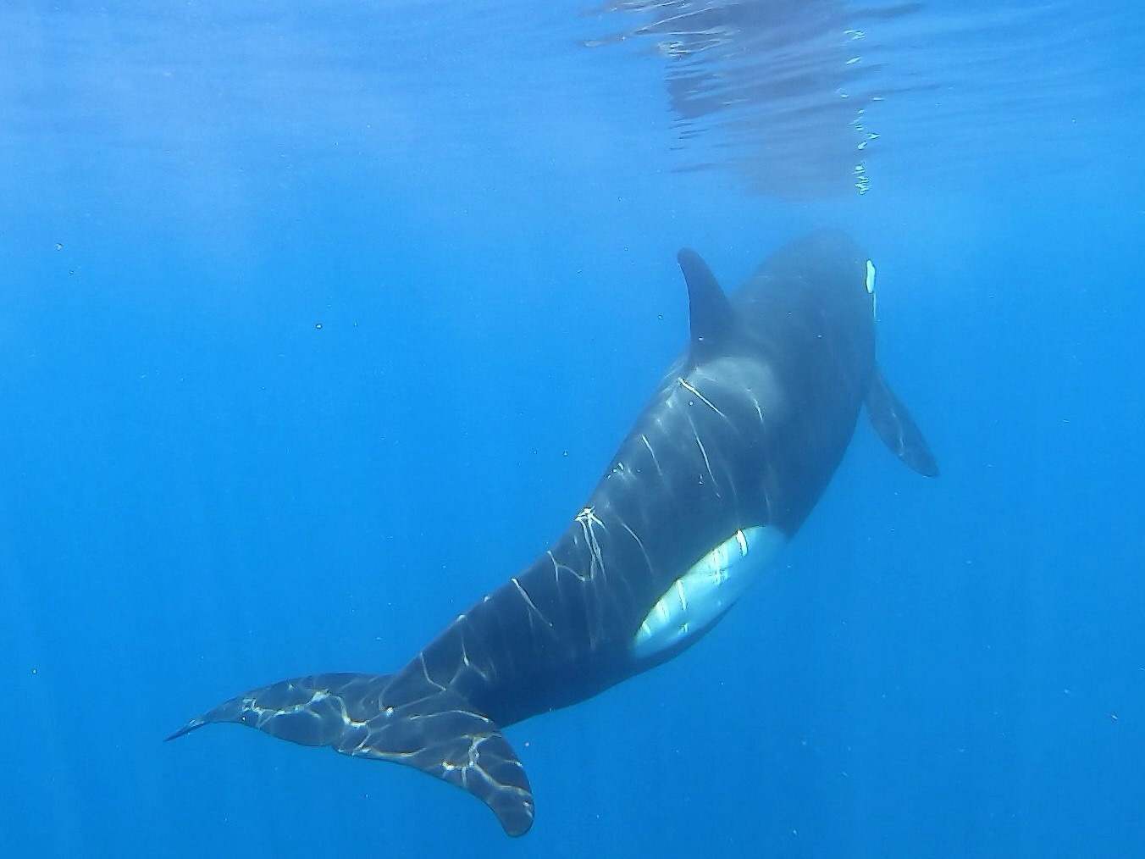

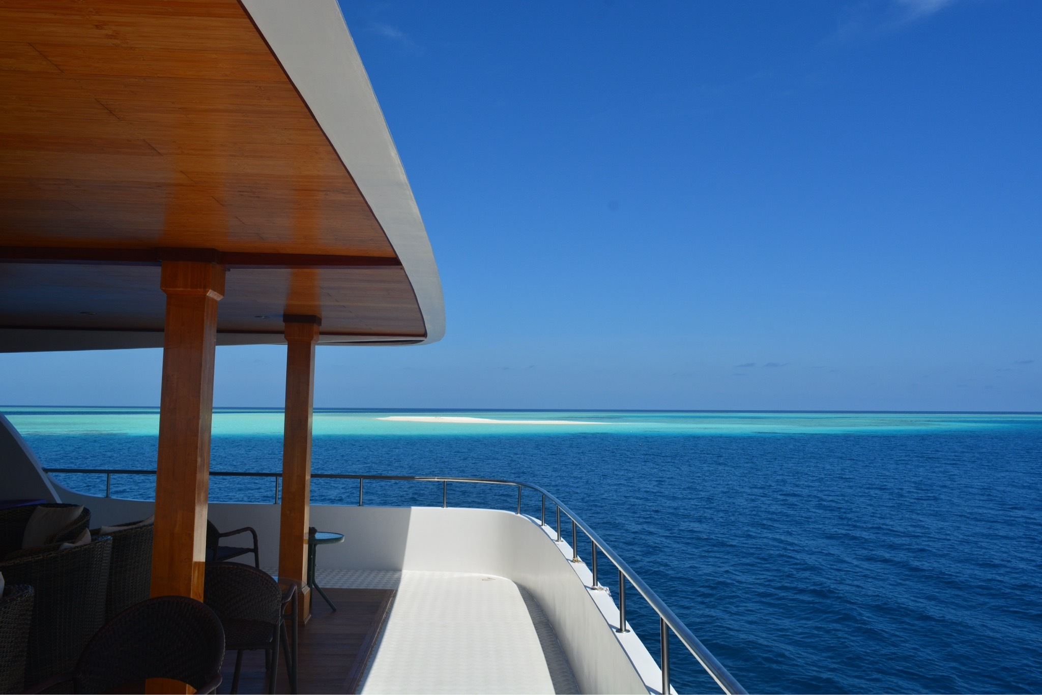

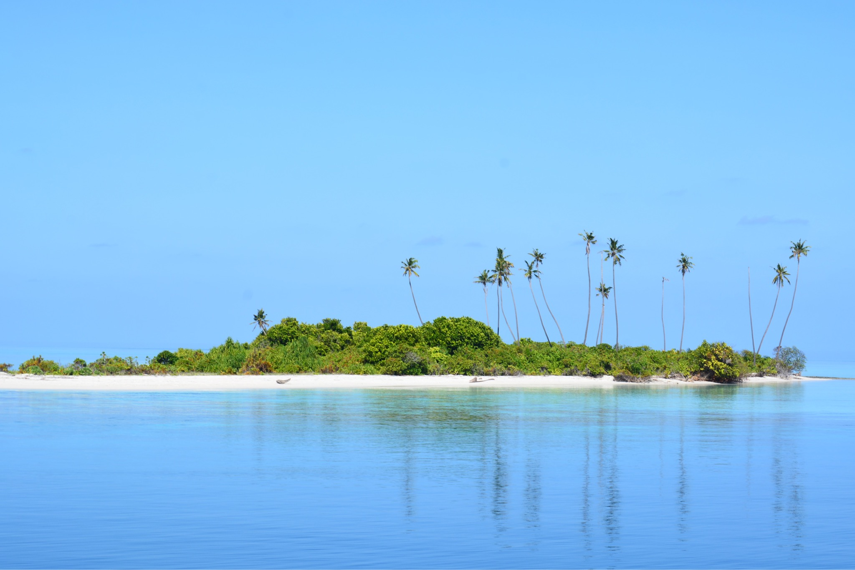

The Maldives

Aboard Keana

Arrival Male

Sunday Oct 14th 2018

Seemingly long journey, Gatwick to Dubai then onto Male with no part of that fitting into being able to sleep.
Was met at Male airport by Dr Charles Anderson who would be our extremely experienced guide and leader for our trip. Clive was already in the Maldives as he had gone a week earlier. Chas is a marine scientist who has studied many species in the Maldives over many years, written many books and submitted many research papers.
We boarded a boat pretty much straight away, it was a dive boat that was to accompany us on the trip along with the main boat.
We boarded Keana and were allocated our cabins. There are only 8 cabins so only 16 passengers which for the size of the boat is amazing. The lower deck has our eating area, along with being able to rush to the bow of the boat when dolphins appeared.middle deck is the bar and a lounge area with plenty of chairs where you can make a base for equipment. There always seems a lot to do with charging various bits of technology, practising with the go pro, working out what to do with go pro footage. Taking some photos on the phone to be able to send home easily and also trying to keep up to date with a journal ! Oh and not forgetting whale and dolphin watching. Chas mainly stays on the top deck with binoculars and one of the guests Tim is also very good at spotting things. It's interesting listening to mainly the men trying to be the first to make a call on a sighting !
Our first day was as Chas had suggested in his information that we were not out of the sight of land before we spotted our first cetacean. It was a dwarf sperm whale, just logging at the surface, quite a large dorsal fin so could have been confused with a Rissos dolphin. A couple of them logged before a definitive roll as they dived.
The sea state was pretty brilliant and we soon came across a pod of spinner dolphins who obliged with a wonderful leaping spinning show. They also came along to bow ride which was a good chance to try the go pro dangled over the edge of the boat.
We moored up in the lagoon of one of the islands and all had a practice run of snorkelling off the dive boat. I was keen to try my various new bits of equipment - snorkel mask and snorkel were a success along with my beach booties that fitted into fins. The fish were amazing and the water was warm.
This is all a bit boring writing wise but I am trying to catch up - I think I will keep a separate list of species that we see.
Dinner was lovely, lots of fresh fish and spicy accompaniments. By this stage I had now been awake for 38 hours and after a glass of wine, retired to the cabin. A lovely group of people, very easy to intermingle with, or also just to be on your own and do what you want.
Day 2 - I got up at 5.30 to catch the sunrise which was just beautiful and no-one else was up yet. I made a coffee and contemplated life, which requires rather a lot of contemplation and heartbreak right now.
We set off to snorkel at 7:30 after checking to see if any Manta Ray were lurking in the area, also not so we pottered to a nearby reef. By snorkelling along the edge of the reef we stood a good chance of seeing anything coming up from the deeper water, I took the go pro and had some fun with it. We stalked a ray, an Eagle Ray apparently, just gliding along below us. It was to be outdone later on in the Ray department but for now, this one was lovely ! As we had left the water a small pod of spinners drifted past a few moments too late.
Normally the snorkelling stuff can stay on the snorkel boat but Chas took his aboard in case we found anything in the day to jump in the water with, so not wanting to miss out I followed suit. Quick shower and breakfast then off we set.
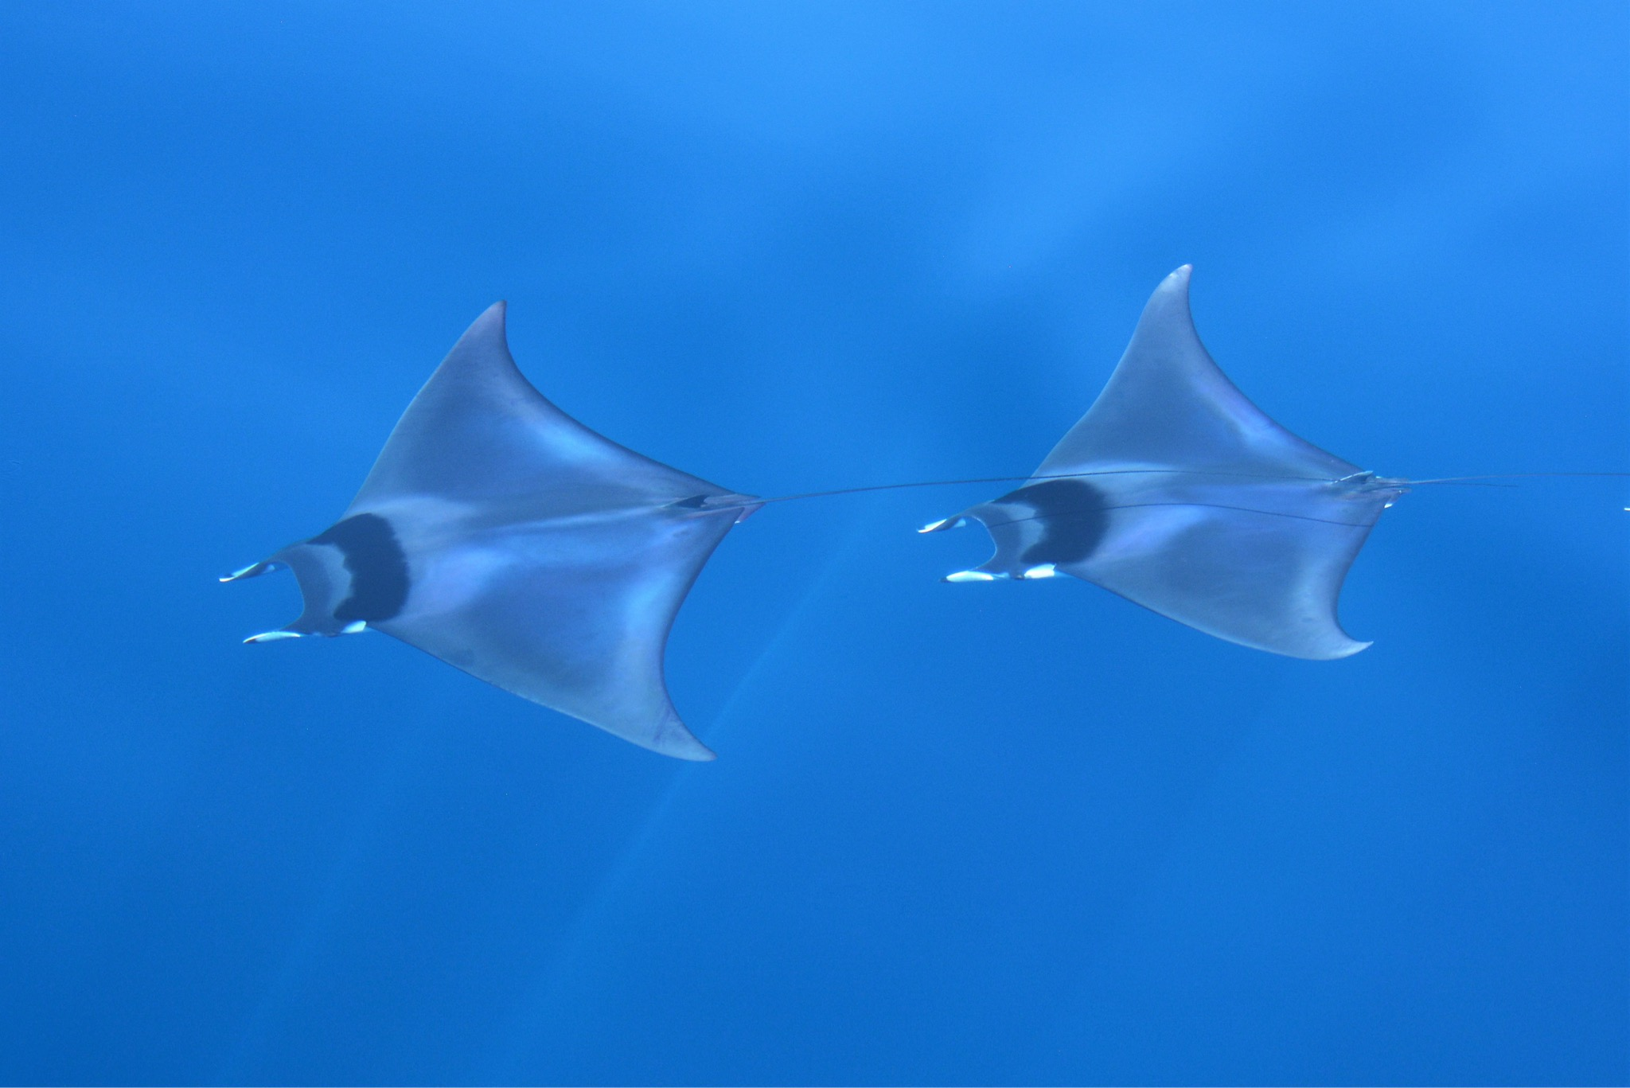
We had a sighting of what initially Chas thought was sail fish but they amazingly came closer and closer, and turned out to be Mobular Rays.... I had never even heard this word let alone seen them even in a documentary. They were simply stunning, a truly magical and mysterious species, there turned out to be 5 of them, possibly 4 males and one female, the weaker males drifted away leaving her with just one. The sea state was incredible and a photo from above looked as though we were underwater with them. Definitely one of my favourite animals I have ever seen.

This was followed by being surrounded by a large pod of Pantropical spotted Dolphins, the go pro was fun again and lenses had to be changed because the Dolphins were so close, watching them bow riding right beneath me was just mesmerising
After lunch, the boys caught a large fish, they pulled it in on the hand line and it was a Dolphin Fish - Mahi Mahi. Huge !
The afternoon was spent stalking some Dwarf Sperm Whales who were far in the distance logging. They are mainly solitary creatures or very small groups and are very wary of their surroundings and things like boat engines, so typical sightings tend to be from a distance. We got very behind schedule due to all the sightings during the day and by mid afternoon we were only actually about 2 miles south of where we had started. Snacks and drinks appear through the day, jugs of juice, and cake. Tea and coffee is available the whole time and it's just lovely pottering around the boat.
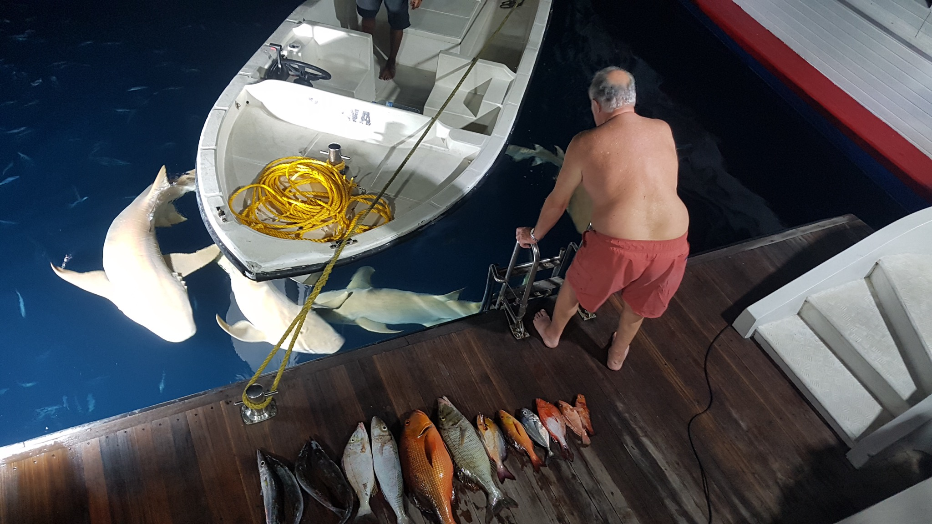
Late afternoon we moored in the shelter of an island. Shelter really a silly word because the sea had been a mirror the entire day. As we got ready to go and snorkel, a large nurse shark appeared at the back of the boat, surreal when you are about to go in the water. Chas then advised us that we would have a very good chance of seeing them off the edge of the reef and that we did. It was amazing, the go pro was a lot of fun, as we watched one shark below us, 7 others came along in a long line, we also saw black tip reef sharks. The island we were snorkelling off is privately owned and had a working jetty so we had to keep checking for boats whilst obsessively looking below. It was a truly fantastic snorkelling experience. As we got back to the boat, there were now 4 Nurse sharks milling around. I was beside myself when Chas suggested that I grab my snorkel and get in the water with them..... Ever so slightly intimidating but in one second that feeling passed as I was in the water literally surrounded by these beautiful curious creatures, long wide flat noses kept coming towards me and veering off to the side. Another absolutely magical experience. The boys came back in in the tender, they had been fishing just with hand lines and had a great haul of fish.

It took a long time for the adrenalin to calm down, we had a great talk in the bar area by Chas, Dolphins of the Maldives.its great fun learning so much all the time.
Day 3
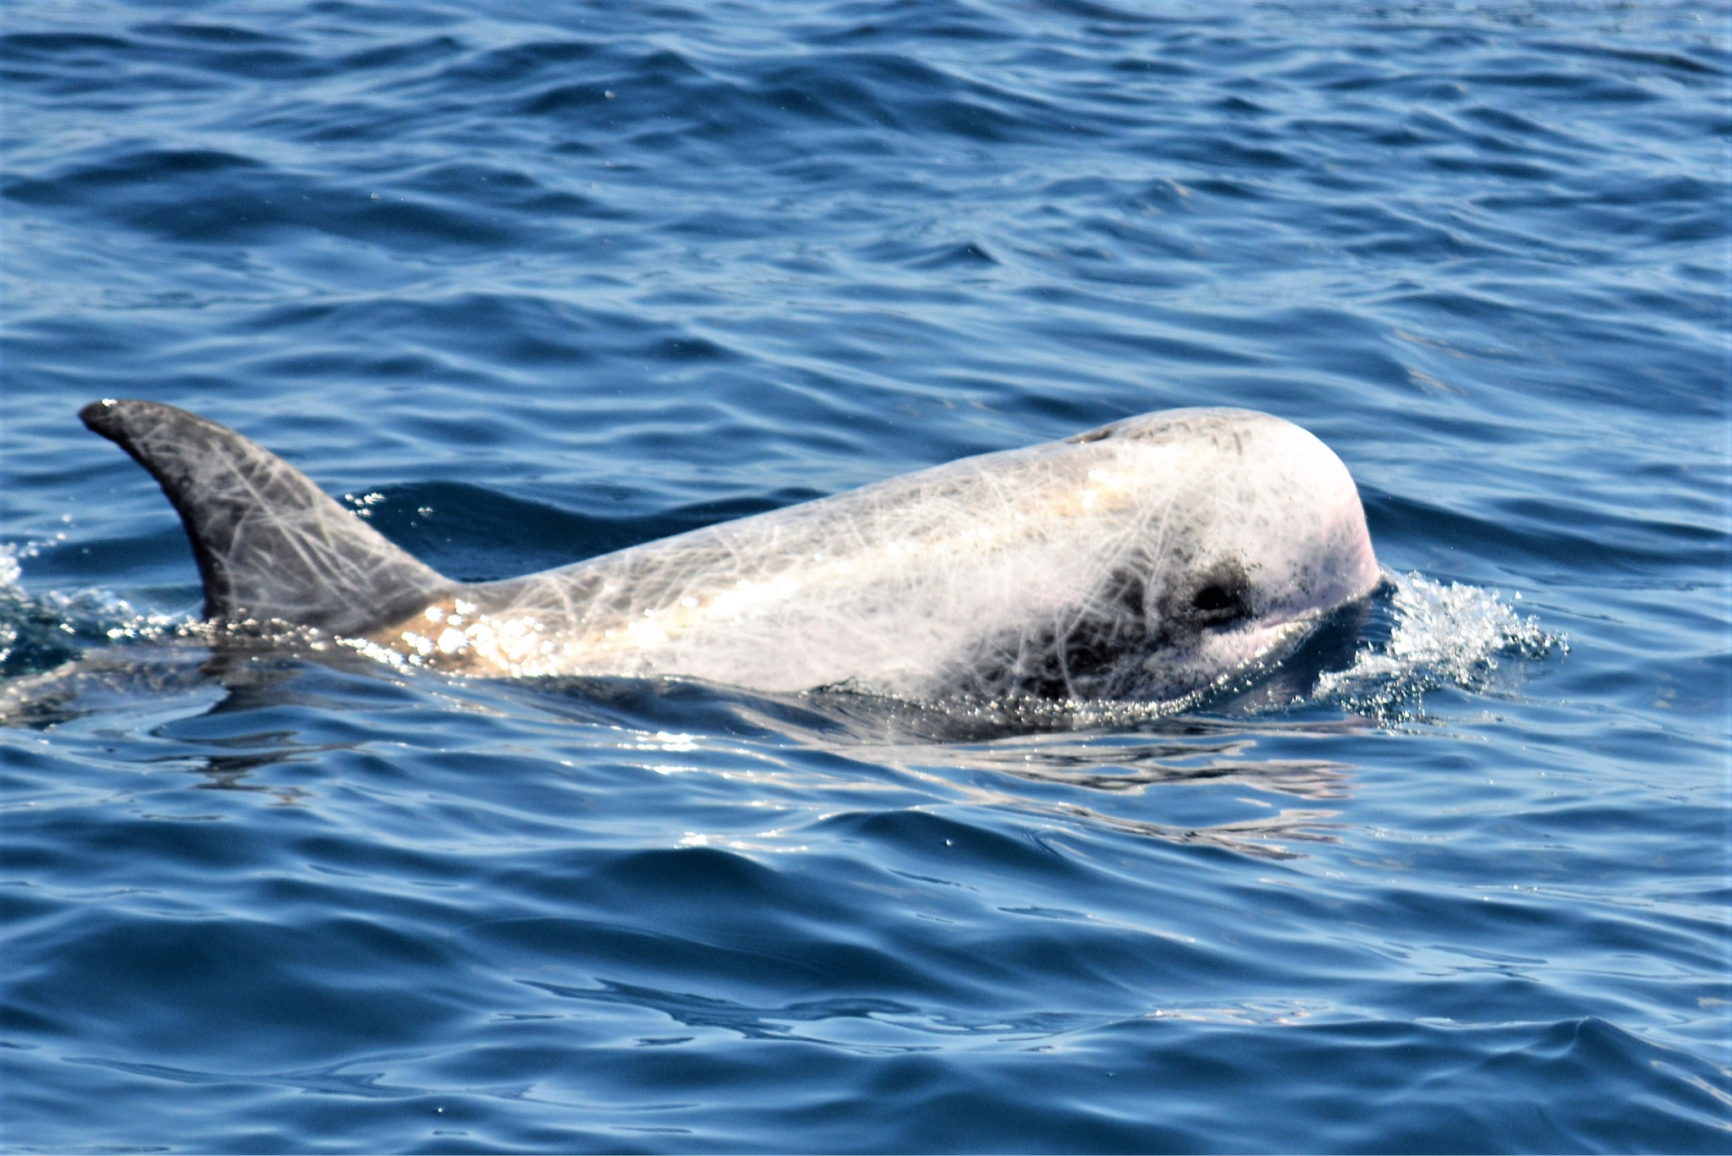
Up at sunrise,of course, and we set off at 6am to catch up time we had lost the day before as we had circled around and around stalking various cetaceans. Each day is so long and so full of things that writing a day behind is virtually impossible ! We had a great Rissos encounter to start with.
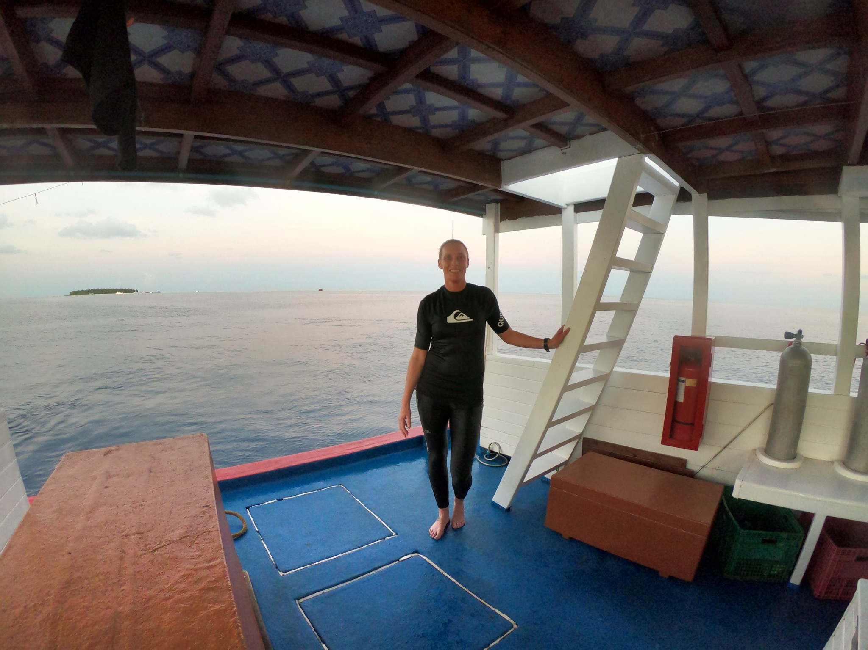
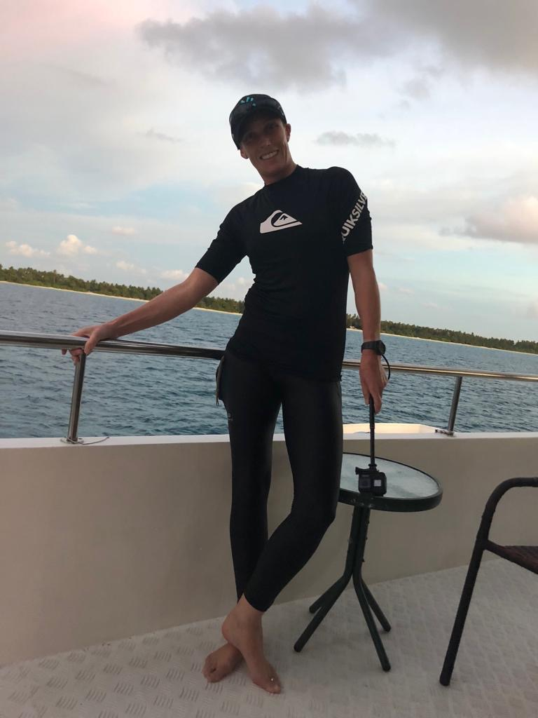
Then after breakfast we had a snorkel on a particularly clear reef which was nice as the nurse shark snorkel although great shots of nurse sharks and black tip reef sharks the water was a bit cloudy. I had a bit of a clumsy snorkel if there is such a thing. Caroline pointed out a Moray Eel and I seemed to temporarily lose control of my flippers and really rather ended up barging in front of her with the GoPro ! The Moray which I have since learnt was a Giant Moray was fabulous with his head sticking out in the crystal clear water and the rest of his body tucked below in a wonderful coral formation. I then duck dived down and managed to come up almost underneath another snorkeller, only alerted to being able to avoid winding her totally because I heard her giggling at me ! So my return time on the Dhoni was spent mainly apologising to people. No I didn't know what a Dhoni was either..... It's the boat that we all pile onto to go for a snorkel.

We always have slices of coconut as we clamber back on board dripping wet and a tangle of flippers and masks and snorkels and GoPros. The guys on the boat are great, you stay in the water alongside and in an agile yet clumsy sort of way remove flippers and hand then up the ladder before clambering up yourself. I tend to get quite cold and end up clinging onto the back of the boat in whichever corner has the sun !
The day on the boat is great with so much space, meandering between the top deck where Chas remains all day, Tim and Joy mainly stay there all day so it's great to be able to get stuff done but a call from the top means you never miss out on any sightings. I spend a lot of time keeping up to date with photos and being ruthless with them and the highlight of this day was really getting to grips with the GoPro app on the laptop. It is not easy at all and there is no obvious manual, the tutorial didn't help much at all. But I worked it out bit by bit, you select the clips you like from a selection of 4 or 5 video clips and it just pieces it together for you and puts it to music, so you don't edit the videos, you cut out the bits you don't want by selecting the bits you like and it uses 5 ish seconds either side.
Day 4
We set off early again at 6:30 and literally straight away had sightings just off the island we had been anchored at. The talk the previous night had been on Beaked Whales to prepare us for them in an area that could be good for them today. The sightings were pilot whales which was a first for me. A huge wide dorsal fin and a group of them together is the usual sighting. As usual started off taking photos while they were still a million miles away which only serves the purpose of having to delete all of them later. We ended up right in the middle of them and we were all able to get some great photos of them logging, spy hopping and generally loafing around seemingly unbothered by a whacking great big boat of naturalists staring fanatically at them whilst waving huge camera lenses at them. We travelled then to a very different reef. It was really wide and we had quite a swell although the water surface was mirror calm and on the far side of the reef large waves were breaking. Chas always gives a pep talk before each snorkel, which way the reef is going and what you may see in that particular location. Today's talk was slightly more serious and included the information not to go beyond the breaking waves as you wouldn't be able to get back and would have to walk the sandbank all the way to the nearest island in order to survive. This made sense as the Dhoni wouldn't be able to get to you across the shallow reef and sandbank. So....... For some reason this snorkel felt a bit more nerve wracking as you navigated the large swell lifting you gently up and down but also the sideways pull of the waves. However in good news, this was a great location for Hawksbill Turtles and I did get a great video of them with the sun gleaming through the water onto their backs.
Whilst we were all faffing around having fun in the water Tim and Joy remained on the top deck keeping watch. It was fun to come back to base and get their update. Tim's sightings are very reliable and mainly backed up with photos so Chas could record them. They had seen Dwarf Sperm Whale, a flying manta ray and probably Cuviers beaked whale which was quite exciting.
We came across another group of pilot whales later on and this time they really were fun and very curious. Even giving us amazing views as they swam right under the bow. One of them upside down giving us a really good look !
The afternoon was quite long with a cetacean lull allowing lots of time to play with photos and sort videos.
We had spent so much time with the Pilot whales during the day that there was no time to snorkel which gave us a slightly longer evening.
Chas gave us another fabulous talk, this time on the " blackfish" group of cetacean which includes the pilot whale and of course the Orca. We do have a chance of seeing them and they generally see them on almost alternate trips so the excitement levels increased even more !
Day 5
The aim today is to make a video of the day. Lots of short clips are definately better than a few long clips, gives you more to play with in making the video.
Snorkelling excelled itself this morning, we pulled up next to a dive boat and snorkelled above the divers. We were right next to a reef as usual but next to that was a channel of sand full of plankton making the water appear green, and there they were appearing out of the darkness and gliding along the bottom like large planes, first just 2 and the thrill of watching them was fabulous. At that stage I was with everyone but found myself swimming alone above the mantas, I could hold the go pro in one hand and swim with the other and kept at the same speed as them. Eventually I was following 6 of them in a line and it was just me and them and was just magical.
We had gone quite a way on the Dhoni but when we got back on it the big boat had come to meet us to save time.
Clive was cross he hadn't come, I think he forgot it was the manta ray possibility and I was sorry he hadn't seen them but was at least able to show him my video of them
Off we set and had another group of pilot whales. The rest of the day was Spinners and then a great group of Frazers dolphins which was high on everyone's list and often seen in the Maldives, a very snubby nose !
The great game of the day however was the beaked whale game.... Two were sighted, typically in the distance then they dive for up to 40 minutes and you just have to wait for them to reappear which could be anywhere. We had eyes all around the top deck and it was almost nerve wracking in case you were the one to spot them and had to make the call, so as I panned round, in my head I was speaking the clock, 10 o clock, now 11 o clock.... I didn't want to call the wrong direction ! Anyway luckily at 22 minutes, it was Chas who saw them and he shouted so loudly "they're up !!" That we all nearly fell off our chairs, then you have about 2 minutes of them swimming along and you have to try to identify which beaked whale it is, only really done by the snout, which they hardly ever show....... So the cameras go nuts each time the head comes up. The choice initially was cuviers, then that was dismissed quickly, followed by the possibility of Longmans beaked whale..... But.... This all changed when Tim had a photo he showed Chas with certain features that made Chas think it may be an extremely rare species, well not so much rare but very rarely seen and possibly only seen by 100 human beings. The name of this beaked whale is..... Deriergala - The photo is terrible as they always surface so far away and the purpose is purely to be a help with id.
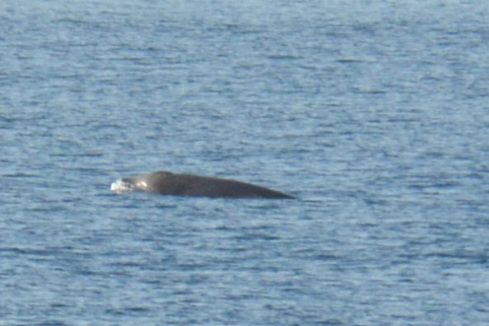
Then it was gone again and you would start timing and again on 20 minutes, up they came, camera went nuts..... Everyone trying to get the snout to help with the ID. Alex, whose parents own the boat that has been chartered is in charge of the drone and up that went and assisted with the identification. Everyone does different things. Alex does the drone, Tim and Clive get the main photos, I do the underwater Go Pro stuff and it all kind of comes together.... It's a lovely group of people to share the whole experience with.
We didn't snorkel in the evening but instead we went to an uninhabited island which was just exactly how you imagine a desert island BUT with a big But, and I was shocked by the plastic that had built up on the beach....
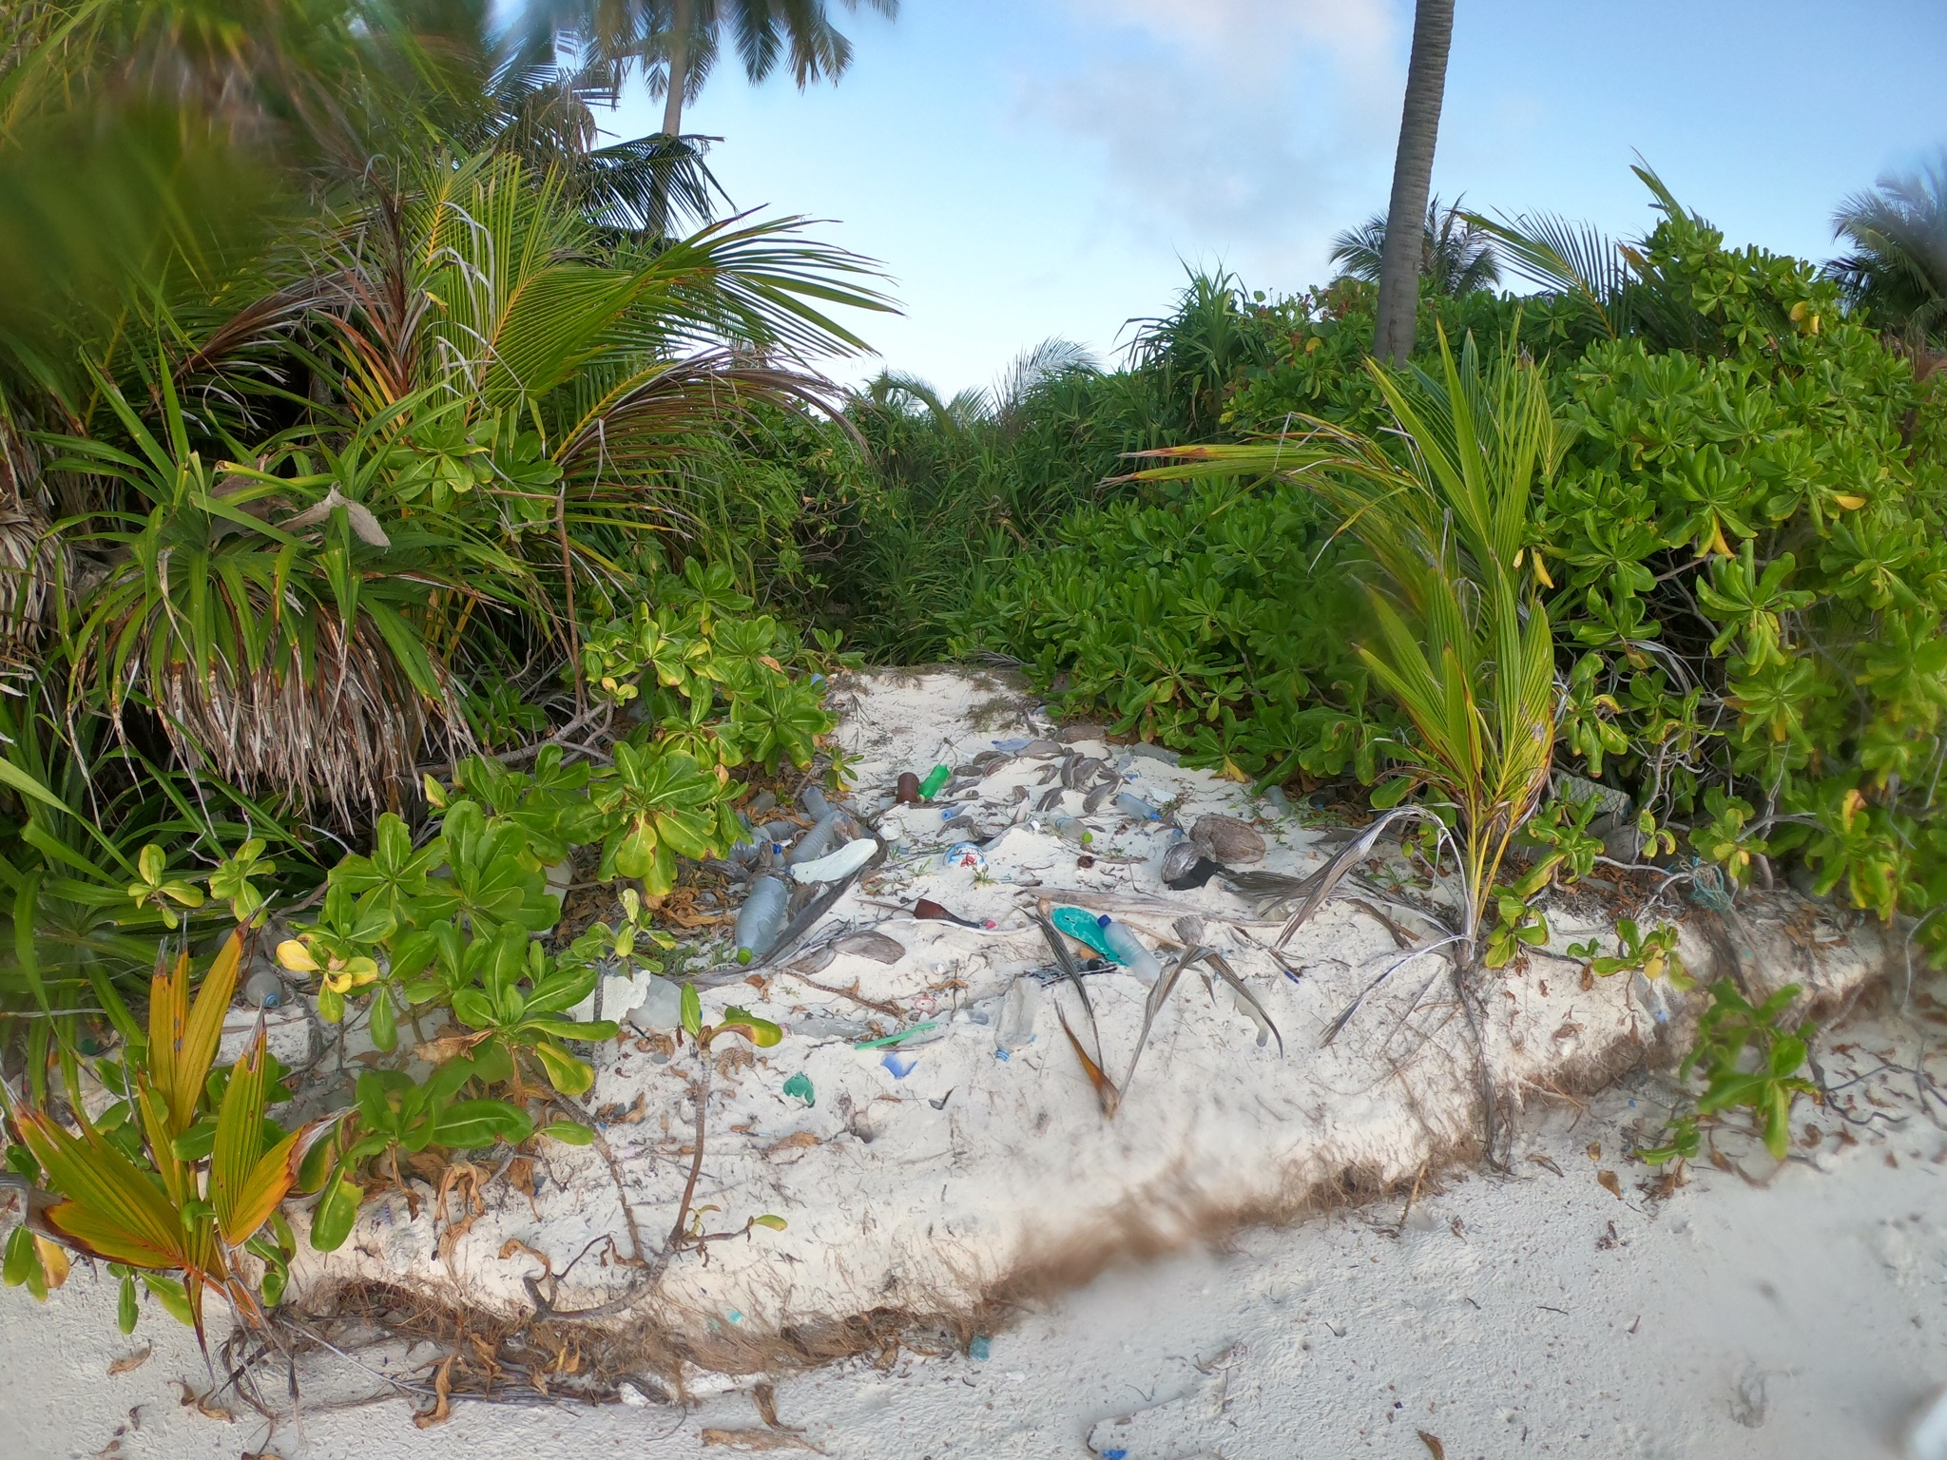
The evening was sort of dedicated to waiting for the Whale shark to turn up at the back of the boat, we had a lovely meal with candles and managed a group photo.
Group photo here
Day 6
Up at 5:30 again... Unfortunately although the crew had kept watch all night for the Whale shark, the bell had not rung.... The plan was that we would all have got up in the middle of the night to see the whale shark..... I had clothes ready just in case...... Snorkelling was due at 7... So time for coffee and get ready. This reef was the prettiest, with some of the coral growing back, so some white and some blue and fabulous coral formations close to the surface, I practiced diving down and holding onto the coral to take photos as I have seen both Chas and Alex do. I really want to take fish photos but the GoPro isn't the best option for this so I will take the little underwater camera next time. I am starting to recognise some of the fish. Coral cod. Pufferfish, sturgeon fish. Butterfly fish, parrot fish... So that's another project.
Now..... What happened next was basically like being in a dream. I was pottering around after breakfast getting equipment sorted, changing batteries, sorting Sd cards, it seems never ending. Anyway, Joy rushed down the steps from the top deck announcing large blows and large dorsal fins ahead.....and that this could be my lot !!! As in I had kept on and on and on mentioning Orca...
I swiftly gathered every possible camera, lense, my binoculars, Go Pro, just everything, bundled it into my camera bag and rushed to the bow of the boat heart pounding, was I finally going to see my precious Orca.
Then there it was, a blow and big dorsal fin up ahead of us. This was just amazing and we were getting closer and closer. I ditched the long lens and put the middle lens on and made sure I had at least a photo of a fin in case it all went wrong and they disappeared. I need not have worried, the skill of Chas and the boat crew means they slow the boat at the right moment and eventually stop and there they were coming towards us. Cameras all around were going crazy, everyone was so excited. Suddenly they were alongside us and the rule of no running on the boat went right out of the window as me Caroline and Joy sprinted up and down the side of the boat taking photos as we went. Then it got really exciting and I judged the Go Pro just about right, it's a decision with consequences because it means I can't carry on with the really close up photos, but by now we were down on the back deck of the boat that is only just above the water surface, go pro on..... And I lay down on the deck with it extended as far into the water as I could just as one of these magnificent creatures came towards us, that size as they power through the water head on, so fast even though they were just being curious, their every move has so much intent. And there she was right beneath us going under the boat and I knew I had the go pro pointed about right, had I captured it at all, I barely wanted to check the video..... But I had it, I had filmed the Orca underwater and the feeling of euphoria was immense, still they were with us and I had the time and chances to try again, as I was watching one smaller female come towards us, she rolled underwater and looked up at us, then where I was laying on the back deck the shouts came from the deck above who had a slightly better overview of where they were, that one was coming up the side of the boat and there he was, as I lay there he was only a meter from me as he glided passed and I hoped and prayed that I had captured him. I had 2:03 minutes of video that time and could barely breathe as I pressed play........ I had them !!!!!! I had them swimming underwater, the whole body length... I wanted to guard the go pro until I could get to the footage on a computer.
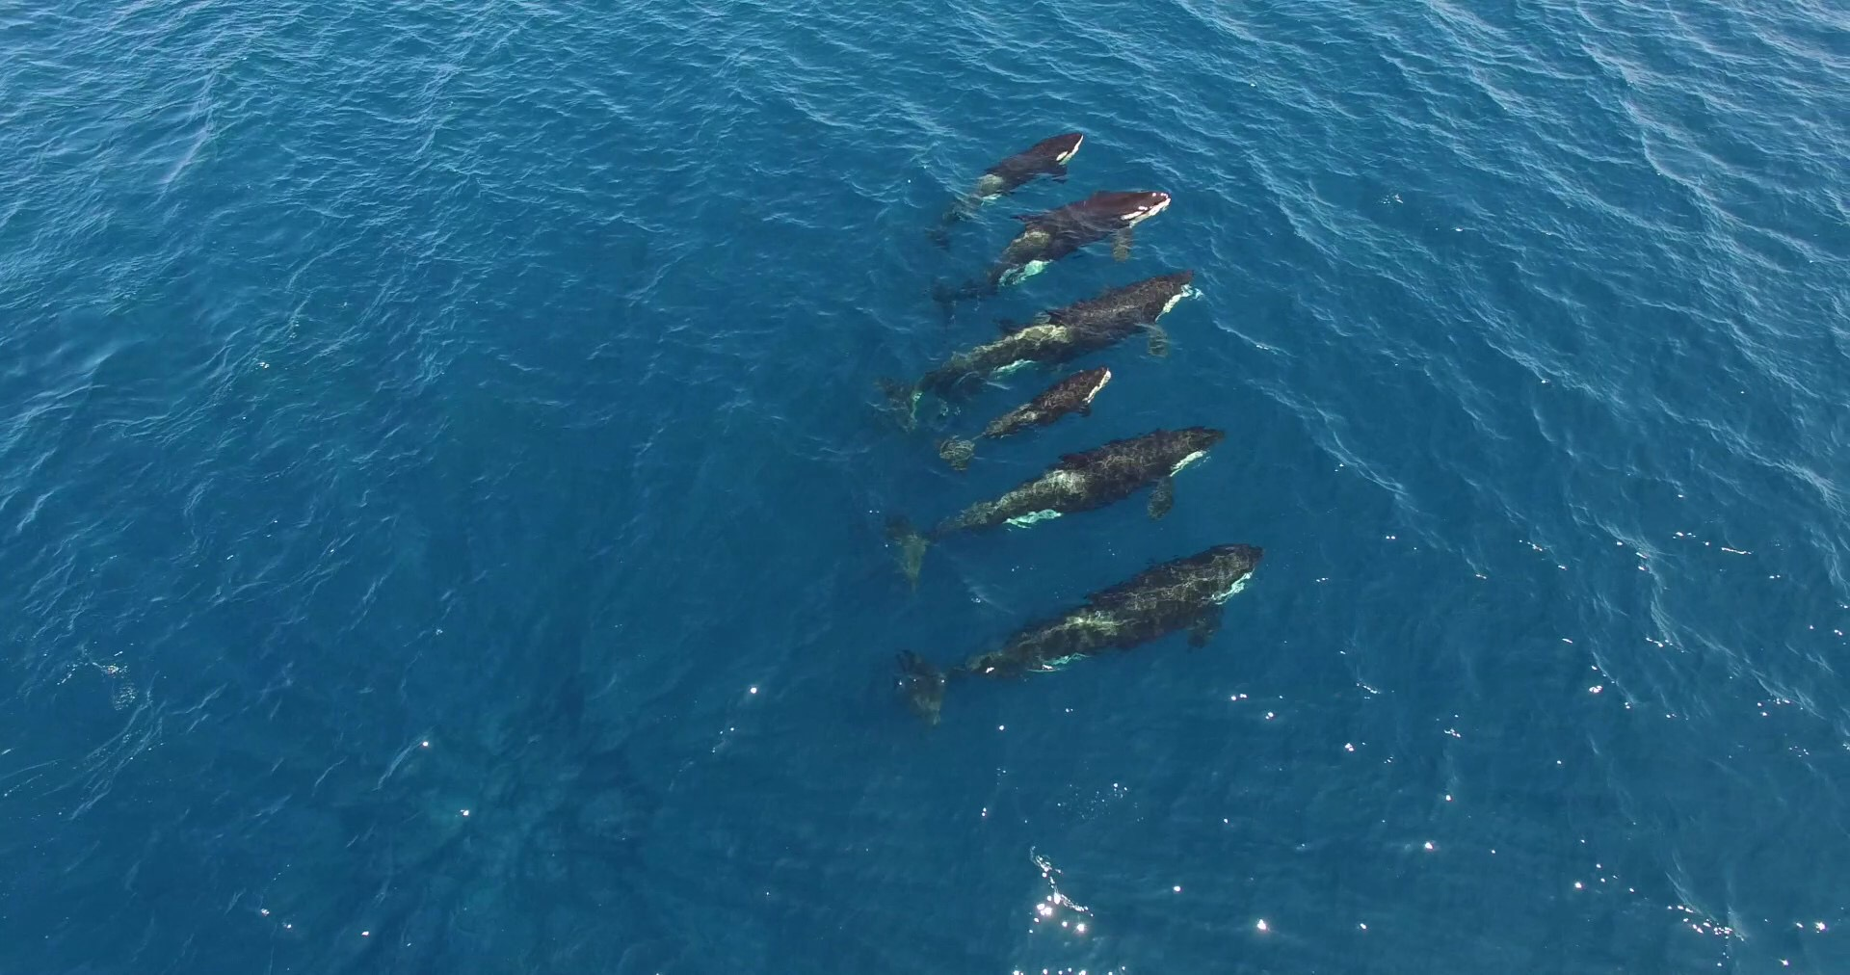
We watched them milling around us, they seemed to be going back to the same bit over and over and I wondered if they were feeding on something larger, maybe already dead as opposed to fish. We are so lucky to have the drone, and sure enough the footage later showed all 7 of them swimming in a line and a large white unidentifiable dead thing floating beneath the surface, so they did have a kill. The line was great, 6 adults with a baby in the middle, and you could see the baby feeding from the mothers mouth as she had a mouthful of the poor dead unidentifiable object.
We had had a very privileged 1 hour 25 minutes with them and it was sad to leave them but they were slowly heading away.

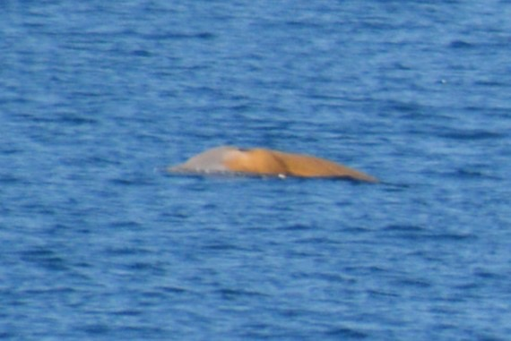
Today's beaked whales were Cuviers, and we played the beaked whale game again. Timing them to come up followed by a million photos. I am not going to play this game any more as it means there are too many photos to go through later.

Talk on Atolls.
The Maldives is a cluster of islands each Atol is in a circle and is a circle of islands. One of the words in the Oxford English Dictionary is from the Maldives and that word is Atol. A Frenchman set sail in the 1600's to get to India. Their boat had about 200 people on board. Large sails. Passengers, civil servants. And the Frenchman was setting out to make his fortune. They came across some islands with palm trees, could be dangerous as their may be reefs ahead. Previously Portuguese had tried to claim these islands. Direction was hard to measure at this time and the Portugese had got it wrong.
The Frenchman came across an atoll turned north to avoid the Atol and of course bumped into another Atol. They crashed into the outer reef in their wooden ship, the ship broke up on the outer reef. Most could not swim. On board was one guy who could swim, he pulled through the reef and the surf a line and a rope and people got through the breaking surf, they salvaged what they could and ended up on the nearby island. Island has minimal population and these 200 people turned up, they split them all up and the Frenchman was taking to another island. The ones that remained on the island they washed up on, everyone was in a desperate situation. Frenchman starts learning the language. The Mali government wanted to check the wreck to see if they had a cannon. The survivors of the wreck ended up basically being tied up in sacks with ropes and thrown in the sea.
Eventually help came in the form of pirates who had heard about the European shipwreck and came to see if they could get any cannon. Pirates set sail, wind died, Pirates speared to death, some survived, and the Europeans thumbed a lift back to India on the pirate ship and ended up in India.
As penniless wretches they bumped into Portuguese, France was at war with Portugal..... Not good.... They ended up being prisoners of war.
Got on a voyage nearlY ship wrecked again, ship nearly fell apart, waited a year to fix ship, carry on, eventually made it back to Europe, and the Frenchman made it back 10 years later, as a penniless man having set out to make his fortune. He wrote a book about the whole thing, made his fortune, invested it in wine, drank it all and drank himself to death !!
How did atolls form. Each was probably formed by volcanic activity. Ships were sent to chart the world. Send out young gentleman to be companions to captains of these voyages. Charles Drawin was recruited as a companion to the captain of the Beagle. He started charting things, experienced an earthquake, realised that the earth actually could move. As he collected sea shells high up in the Andes he realised that the earth really did move. Streams were carving out rivers, lots of geographic things were taking place. Charles Darwin sailed back to England. He started writing up his journey, wrote his notes up, by now an established naturalist, he published his paper on how atolls were formed. Volcano erupts, around the coastline of this volcano was where the coral reefs formed. Over time, the volcano sinks back down, the coral reefs continued living, the cone of the volcano disappeared again, the coral kept growing and formed a circular reef around the rim of what used to be the volcano edge.
100 years later he was proved correct with further geological evidence in relation to the testing of the atom bomb.
Gravity was measured in the Maldives it was found that the gravity in the Maldives was likely that 2000 metres of volcano have sunk down over thousands of years and these have faults in them and this affects the gravity.
India moved, dragged along a tectonic plate and 55 million years ago, and now we have a line of sunken volcanoes...... That are the Maldives. As the waves smashed outside the Atol they carry sand into the middle of the Atol. Most are only 80 metres deep as the sand has filled the atolls. The islands are a piling up of the sand from the outside of the sandbank, rainwater collects on the surface of the sand and then trees grow and the islands are formed.
Day 7
An early snorkel and more chances to play with the go pro underwater, the reef not as pretty as yesterday but still the fish are beautiful.
Pilots with bottlenose were our first encounter,
Pilots with bottlenose and also joined by Frasers aswell. We were all making excuses as to why we would have to come back to the Maldives. Caroline was that she had never seen Frasers, but that excuse got exhausted as we ended up with 3 encounters with them.
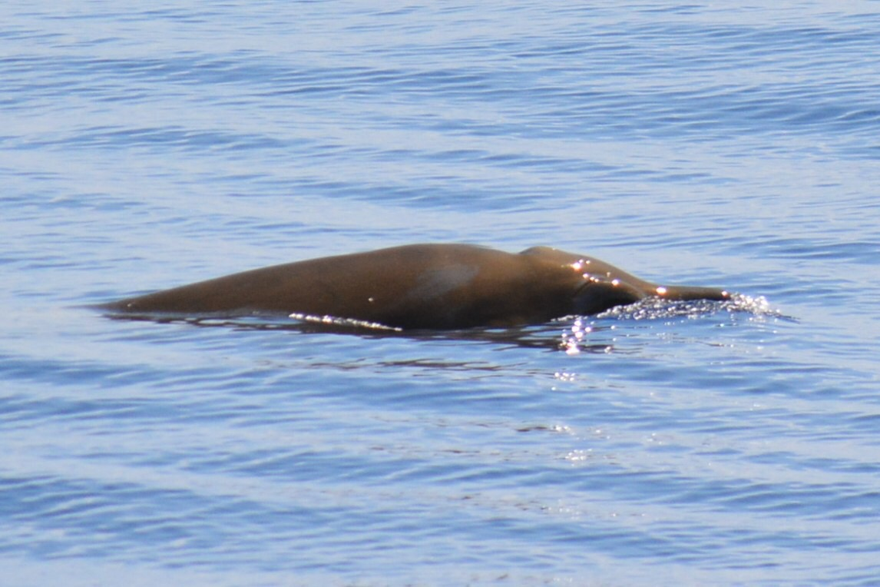
Beaked whales, the sodding beaked whale game again BUT with a variation, instead of waiting 20 minutes for the initially sighted beaked whale to surface probably further away than where it was first seen, Chas had an inkling that these may be Blainvilles Beaked Whales and they have a characteristic of being more interested in boats, so we had the chance of them surfacing nearer. We were expecting about a 40 minute dive from them, so when Tim spotted some fins after 20 minutes, we were all careful not to let those fins, probably dwarf sperm whale distract us from the task at hand and waiting for the Blainvilles to reappear. Another 20 minutes passed and sure enough this time there was excitement that they had surfaced just below the boat and we had a really good long look as they stayed at the surface for a good 5 minutes with about 10 breaths and giving us the ability to get some sensible ID shots instead of a trillion distant photos that you just have to delete later. It was either a group of 3 females as no tooth was showing, or it was a young group of males whose teeth hadn't developed yet. They have a very curved accentuated jaw and in the adult males, a tooth erupts from here.

As I caught up with photos in between sightings Chas came down and rang the bell and demanded that I go upstairs, Tim Joy, Ushi and Clive were already poised with binoculars as I found myself looking at two tall dorsal fins, I asked Chas tentatively if this was what I though it was...... More Orca !!!! He has never had 2 separate sightings on the same trip, we really were being so blessed with sightings. Different encounter this time, they kept moving away and I desperately didn't want them to go. So we pottered around after them and did end up with a shot in front of a desert island of a dorsal fin which made my day. So idyllic and majestic. They are truly mesmerising and such a treat having already had the one encounter.
A lovely day again on this beautiful boat. We kept seeing things so we got a bit behind schedule, but we are now at the northern part of the southern atoll.
We have moored up alongside an absolutely idyllic island that the sun set behind as we came in. One of the most beautiful places I have ever ever seen in my life. We will visit the island tomorrow morning.
It's nice at the end of the day to sit and chat over a glass of wine, Joy and I sat chatting as we looked at the name of the Dhoni moored up next to us. It has a name across the top of it. Quite a long unpronounceable name which confused Joy somewhat as she thought that it was already called Adoni.......... So was the long name where the boat came from......... We laughed and laughed as I pointed out that the type of boat is known as " A Dhoni" like "A Dingy" and the name of the boat is....... It made me laugh especially a lot because that is usually my way of thinking.
Tonight's talk is about corals. They can only grow where there is sunlight. There are about 200 species of coral in the Maldives.
Table corals spread out to gather lots of sunlight
Photo here of table coral.
In 1998 there was an alminio event and all the corals bleached and died, 15 years later they had all recovered. There was another el nino event in 2016 and we are seeing the consequences of this with all the coral being dead. The fish don't care about the coral effect, they use it more to hide in. Algae still grows so the carnivorous fish do manage, but as fast as the algae grows they eat it. The parrot fish is also carnivorous and keep the coral reef clean and are very important for reef ecology, so they are protected in The Maldives.
The pistol shrimp lives on the outer reef and makes a snap crackel pop noise as it stuns its prey with its giant claw.
The Moray Eel who looks so fierce, when he sticks his head out of the hole in the coral, as he looks fierce he is actually breathing.
Scorpion Fish can inflict a venomous sting. Very very well camouflaged against the coral. They have the smallest brain of a fish, the manta ray has the largest. Stone fish... Really looks like a stone, the most painful infliction, the sting is not even relieved by morphine, BUT warm water at a temperature of 42 will ease the pain. It's a reaction to protein. Like boiling an egg, turns the protein from runny and clear to white and hard.....
Just wanted to mention another talk we had one of the evenings. We all went up to the top deck and the talk was on stars and constellations....not he main one Chas talked about was....... Scorpio ! This pleased me no end. It starts with Venus and goes up into the body and the very clear curved tail. I don't think I had ever really seen it before. Anyway, the story goes that Hercules and the scorpion were rivals and one would kill the other and that is why they are totally opposite in the sky. As Scorpio dips below the horizon, Hercules appears on the opposite horizon. This is the constellation that has the 3 bright stars and is known as Orion's Belt, hmm..... So now I am not sure if it it Hercules or Orion or if they are the same thing. Anyway, they basically never get to see each other and I thought this was fascinating. Chas seems to know so much about everything it's quite amazing.
day 8
Up early and the dingy took the first group of people to the island. I had it in my head that I wanted to swim the distance. Chas was happy for me to try. So I put mask and snorkel and fins on to make it easier and. Jumped in and swam ! And swam and swam.... It started as the deep blue, just Ray's of sunlight streaming down into the blue darkness beneath but this gradually got shallower and I could see coral and the sand way below me, then shallower still and I had to weave between pillar and columns of table coral until I really was in the shallows and just on sand, the closest to being washed up on a desert island that I can imagine and I loved it. Terns were nesting and not happy we were all visiting. I then ran a lap of the island, white Sand and crystal clear turquoise water, then I went round again and did a time lapse go pro video, and then just went for a walk with the camera. The others snorkelled but we have done a lot of that and I wanted to appreciate my desire island.
As we left the island, we had pilot whales everywhere, logging at the surface, so placid. Some of them swam upside down under the boat creating some amazing mirror calm photos. Chas felt they were comfortable enough for us to get in the water with them !!!,! Annoyingly my snorkel stuff was on the Dhoni which had already left us, but cobbled together a spare set that Clive had as he has been using his fishbowl snorkel mask, I just feel very trapped in it !! So he wasn't using his other mask and snorkel and the crew amazingly produced a set of fins for me - so off we went, slipping quietly into the water and stealthily approaching the logging pilots whales that were literally surrounding us. The deep blue water gave good visibility but they seemed to glide effortlessly just way from us! Yet if you brought your head up, there they were right there. Then we tried being alongside the boat. The crew had swiftly thrown together a system of a rope all the way down the boat to hold onto and also the life buoy on a long rope at the back of the boat just in case anyone lagged behind and needed to grab it - and this seemed to work quite well and I got some footage of them underwater, each and every single one of these moments was pure magic. So then we decided to leave them alone and everyone was getting back on the boat at the back. I kind of loitered in the water and so did Alex. Just as well as the bottlenose appeared and we swam with them. Hearing their clicking and squeaks underwater was really special in itself but as they appeared out of the big blue as mirages was just amazing. We managed to film them.
After 5 hours of being up, exploring a desert island and hanging out with pilot whales we had now made it about 1 mile and our desert island was still very much in sight which I found highly amusing as I realised we could still see it. We had gone nowhere, but wow it had been worth it.
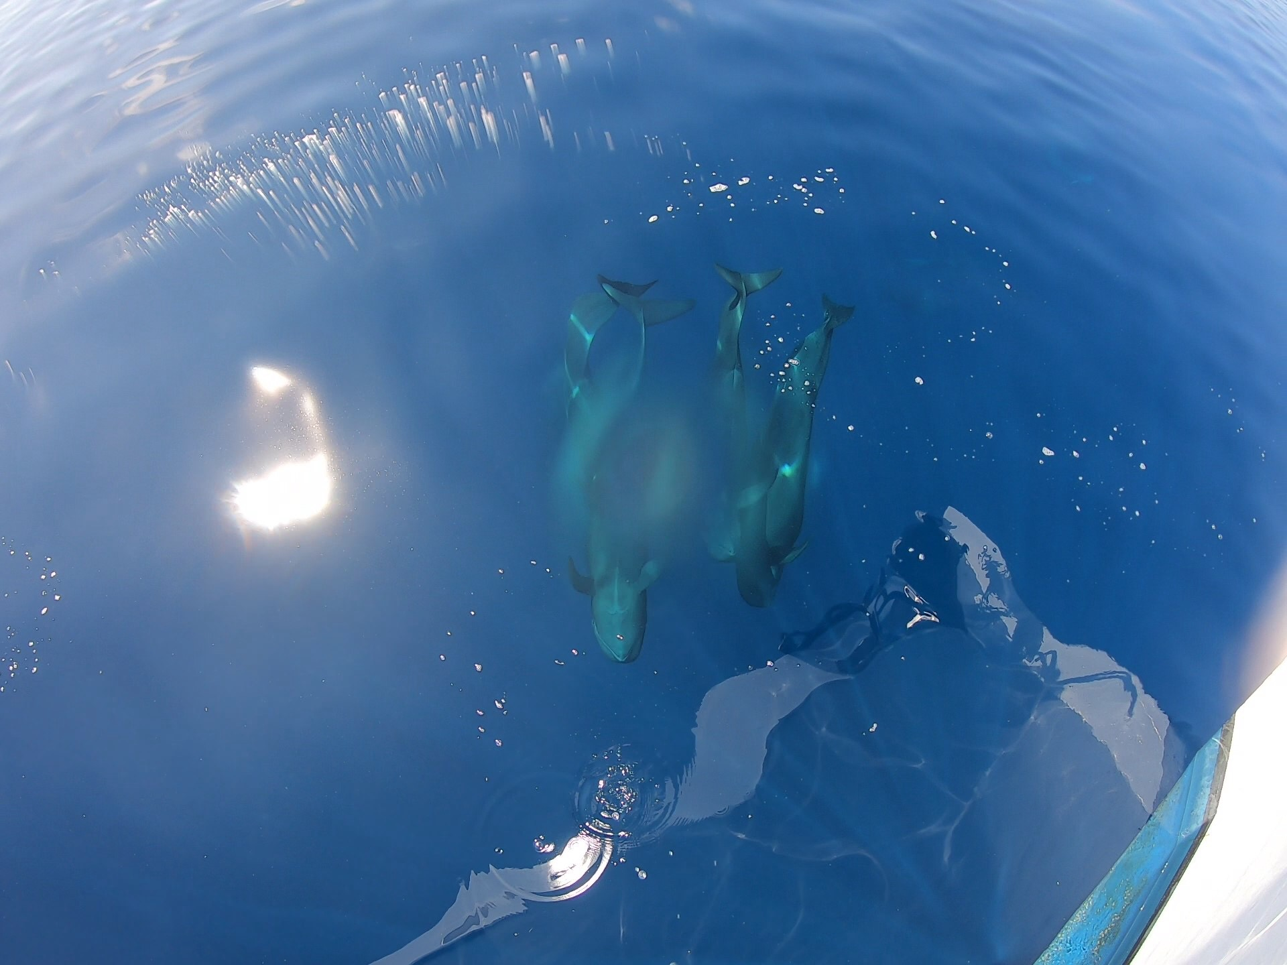
We had another pilot whale encounter with them passing under the boat, it was so hard to make the call to switch from the camera and miss the close up shots to instead getting the go pro very close to the water shots. If I was careful, I could do both and take photos from the go pro videos which worked quite well. Anyway apart from a veeeerrryyy annoying spot of water on the lense of the go pro I managed some OK footage and photos.
Pilots underwater here photo
Ok, so a little bit about boat life.
Cabin Life. A spacious twin cabin and we manage really well together. Washing gets done as we go and popped out on the rails outside with giant pegs. Daddy usually showers while I go on the late snorkel and the shower is mine. We keep it tidy and have a constant rotation of things on charge. Go pro batteries, laptops, phone, camera battery.
Boat life - as much as anyone may think it would be a relaxing holiday in the Maldives, it's far from this ! Up at sunrise, time for coffee and then snorkel. Back from snorkelling and breakfast bell is already ringing whilst you are still in the shower ! So to cut corners I now rinse of on the Dhoni so I don't need to shower... Cunning. Straight after breakfast Chas, Clive and Tim tend to head up to the top deck as by now we are underway. At this stage you can be lulled into the false idea that you can potter around. You can't. As you potter around making sure you have sunscreen on, gathering equipment and changing batteries - generally half way through this procedure someone shouts from somewhere on the boat and off we all go dashing from the top deck to get the best view, pelting down the stairs gathering various bits of technology along the way, choosing which lense to use as you half walk and half run down the side of the boat, how near are these particular cetaceans, what is their behaviour, what are they likely to do.... Do I ditch the camera completely change direction and head to the back of the boat lie flat on my stomach and stick the go pro in the water, do I have enough sunscreen on to do this in case I end up there for an hour in this fierce unforgiving beating sun. Before you know it, your most expensive items you own - in my case - are strewn from one end of the boat to the other. Generally, the specific item I need is either on the wrong level of the boat or at the other end, or usually both. Constantly thinking about the status of the Sd card in the go pro, have I got a go pro battery charged and ready to swap. Then before you know it, just as you had got things up to date on the computer and camera and downloaded everything and even managed to edit it and save it all in various file, you suddenly have 350 pilot whales to go through or 450 orca. And you have to do it because otherwise the singular SDcamera card you brought with you will be full. But then you have to run and get the USB stick to back everything up to because you definitely do not want those precious files in one place only......,phew...., really fancy a coffee, so potter off to make one, someone shouts again and before you know it we are behind Pilot Whales, or sitting waiting for beaked whales to pop up.
There are specific routines on the boat from the crew - like juice time at about mid morning. The juice is so nice and you are generally ready for it having already been out in the sun and breakfast seemingly ages ago. However, nothing gets in the way of juice time........ This morning, another first as we had the opportunity to get in the water with a large placid group of pilot whales, people were excited, maybe nervous, getting random bits of snorkelling equipment together because as in my case, all of mine was on the Dhoni which wasn't with us - great...... So Clive had spare mask and snorkel and the boat had spare fins, also getting go pro ready..... JUICE TIME.......!!!!!!!! Large jug of juice and a box of glasses were being carried along next to me........I explained politely because they are all so nice, that I had a bit on and was quite busy and could I possibly have my juice when I got back and that perhaps everyone else would appreciate that then aswell..........
Following sightings and sometimes in the middle of a beaked whale stalking and timing its dive sequences the lunch bell rings !!! People on the top deck wait for the beaked whales to go back down knowing we then have 20 minutes at least before they surface again, another dash downstairs, grab a bowl of lunch and rush back upstairs balancing a bowl and binoculars.... Love a coffee after lunch, but this rarely happens.... Someone sees something and off we go again. People kind of have their chosen places in the boat. Steven and Mrs Steven sit on the middle deck without binoculars or cameras which I don't really understand how that 9 hour day passes, Paula also tends to sit there and chatter away with them. Oh and also Lin. Monica can be found wandering around the middle deck or sitting at the front where she has managed to get the best videos from that angle. Tim Clive and Chas sit on the top deck where Caroline spends most of her time and so does Ushi and also Joy.... however, if there is a sighting and depending on what it is, myself and Caroline rush downstairs and head for the bow. Tim and Clive stay up the top, Chas usually comes to the bow and Joy can appear with camera and go pro. It is only in extreme circumstances that Clive and Tim appear on the bow. Extreme circumstances basically means Orca.........
We generally run behind schedule as we get distracted stalking beaked whales or getting in the water with a large pod of pilot whales, so the afternoon tends to be a boat ploughing forward situation, but of course something always shows up..... Then we moor up, then it's snorkel time.... Then shower and the bloody bell is ringing again for dinner, oh, and somewhere in amongst that lot is a talk from Chas.
Tonight's is about the seasons of the Maldives. I am secretly catching up writing this !! Because there just isn't time !!!!
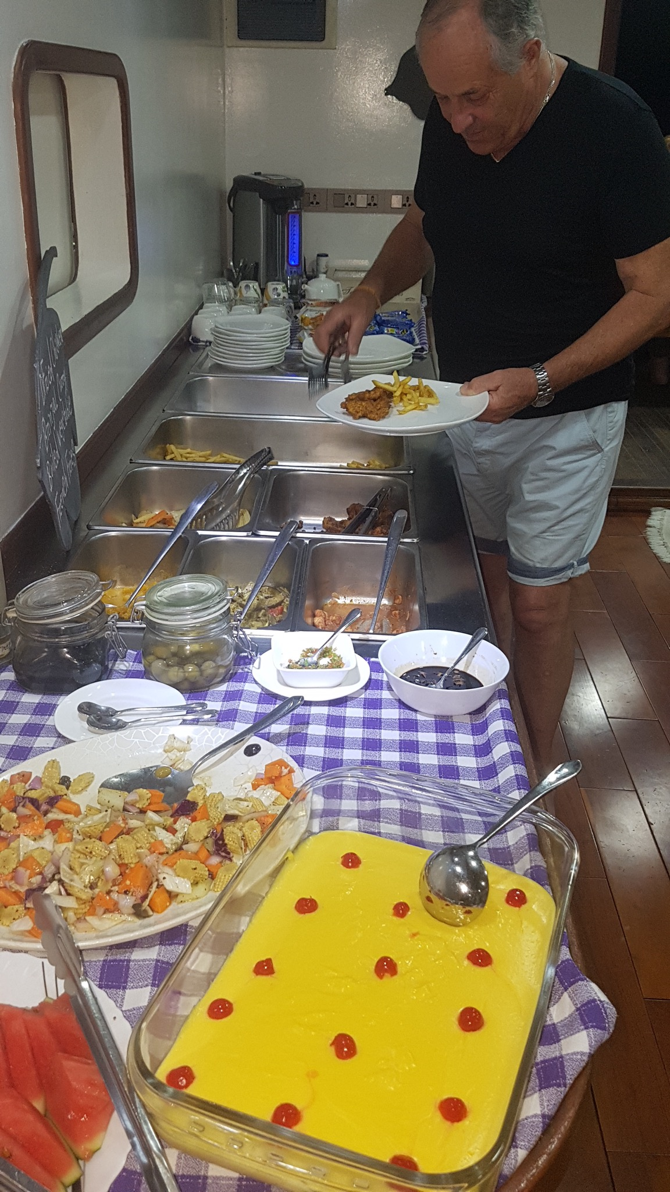
After dinner, everyone has been up since 5:30 in my case, or 6ish.... Been in the sun all day, dashed around a boat, got in the deep blue ocean with pilot whales, stalked Orca, filmed Frasers, and everything else.... So it's bedtime at about 9 - but I need more time than this and end up catching up with photos and videos so tend to go to bed last ! I haven't even had time to sunbathe.
Mealtimes.
I think they have been fabulous. Every meal is fish or chicken and sometimes fish they have caught that day, salad, vegetables, rice... It's been great tasty healthy food. We all sit together either on two picnic benches out the back or if that is in the sun we sit inside. You just plonk wherever there is a space and chat to whoever is at that table, also if you don't feel like chatting that's also ok.
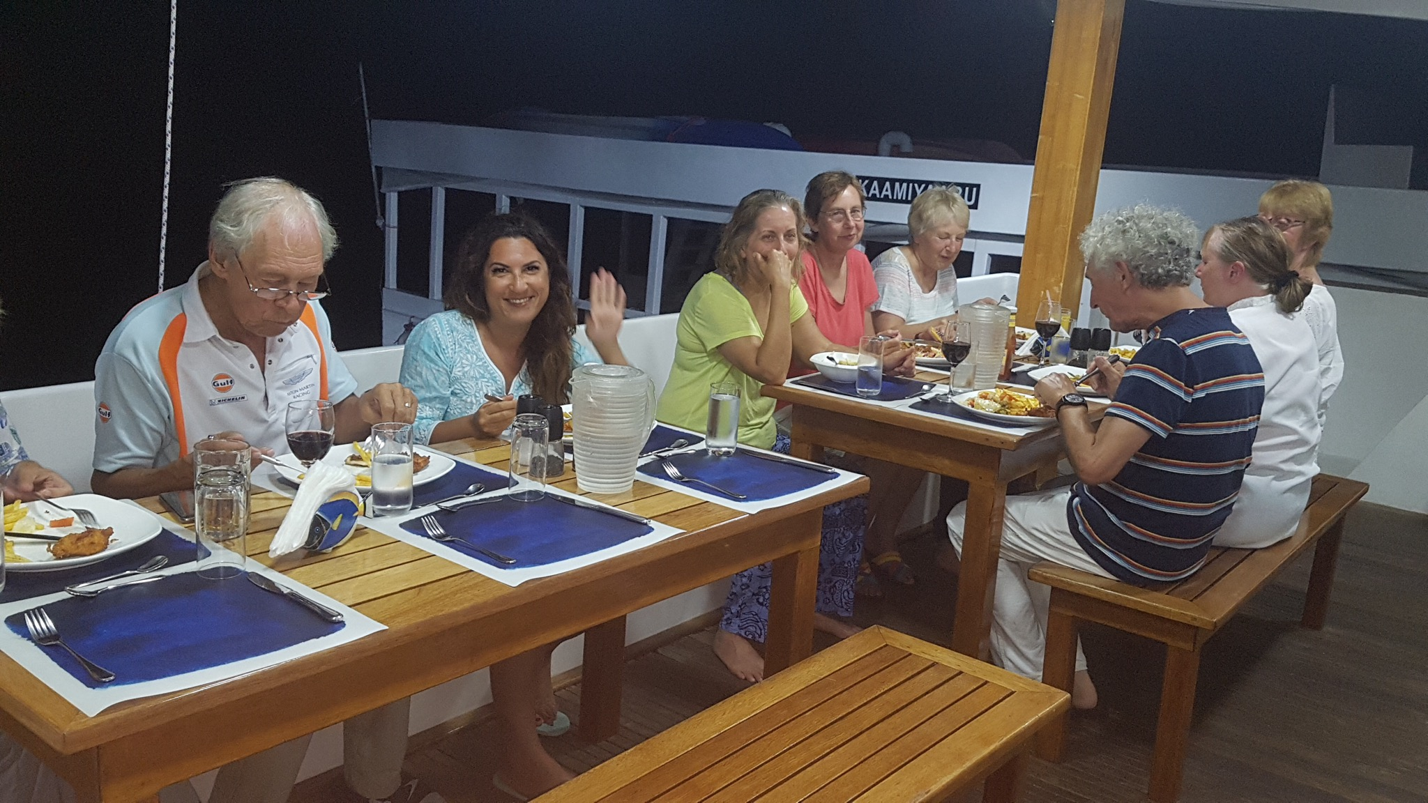
Meal time photos here. Group meal and pictures of food.

Quiet day Day 9
Phew..... A respite in the rushing around the boat, keeping up with photos and emptying SD cards etc etc. It made a nice change to actually go for a few hours without any sightings. We did stop for lunch and tried something new by putting stinking frozen fish bits out to attract some birds... Nothing happened ! But it was different and it was worth a try.

Day 10 and last day. We had a great snorkel again, each reef so different and this one quite murky, but it was more chances to practice diving down and I even found my own moray eel. I wanted it to be a different one to the Giant Moray I had seen and so dived down and held onto the coral as I had watched Alex and Chas do and managed to film him. I shall look him up later.
Meanwhile prior to this I had got quite close to the edge of the reef and the swell kind of rocked you in and out, as I turned one time, a larger wave was upon me but not breaking so I rode over it but realised that Paula, who is so lovely and 67 and very polite was much further in than me and sure enough got caught in the crashing wave. I was worried she was shallow on the coral and had got cut but she seemed OK and we swiftly moved into deeper water as Alex was shouting from the Dhoni for us to move away ! So... Then we found a hawksbill turtle, and we followed him for ages as he swam and dived down and fed on coral, really munches it with that sharp beak, then he would potter along and then he would come up to the surface, I dived down at one point and its deceptive, he was much much bigger as you got closer to him in about 5 meters depth of water. I messed it up a little as went down too quickly and too steeply. Really need to take a couple of seconds to sink and equalise and then carry on. Meanwhile Caroline turned and in the murkiness right next to her was a manta ray ! She tried to get the attention of Chas who just looked the other way, we really all need walkie talkies under water, it's so hard to communicate a sighting. Also saw a black tip reef shark and a shoal of filter feeding mackerel type things who looked so funny going one way past you with their mouth closed and coming back the other way with mouths wide open filter feeding the plankton. This is why the water was so murky, Chas calls it Manta soup.....
Breakfast time..... Then off we set, a long way to - not Tipperary- but Male..... This meant crossing the main channel from the West Atolls to the East Atolls and it got quite interesting with quite a swell and windyness..... I worried about Paula as she had just left the bar / lounge area to go the front when there was a particularly big roll over the swell, but she made it safely and was ok. I went to the bow and enjoyed the freedom of the waves splashing over the front and got totally soaked, therefore upsetting the lunchtime routine, bell went for lunch and I went to get the thickly caked salt off me !
We did have some spinner dolphins come in and it was a final identification practice and photos, but because we all had these now, it was also lovely to just enjoy them.
The swell really did get very rolly so they changed course to go. The shelter of an Atoll, and as we approached Male we had, well I did anyway, such a clear view in binoculars of the long low pale and brown back of a cuviers beaked whale, in a similar area that Clive had seen it on the boat from his island back to Male at the start.
We moored up mid afternoon and it was nice not to rush, organised packing and then relaxed. I felt quite honoured that CHas had asked me the evening before if I could organise the collection of tips for the crew and also to do a thank you. I like to maximise these opportunities and so write a mini speech thing so that I got it right. I will paste it below.
We had a couple of drinks followed by a group photo shoot on the top deck with Thomas the barman taking photos with everyone's cameras. Then we were treated to an amazing video by Alex of the whole week, the trip to desert island, the orca, the frasers in front of the boat, us all coming back aboard, general boat life, it was a really great 15 minute video. The. A final dinner and then a thank you to everyone and handing over the tips to the captain.
My little speech below....
Well... i was told this was going to be a relaxing trip....

And yesterday.... it was.... prior to that we have all encountered far more sightings than i am sure any of us could have possibly hoped for.
Cetaceans didnt stand chance of going unseen with the strategically placed sets of eyes specifically positioned around this wonderful boat in the locations that suited each person most.
Some of us tried to make that every single deck, facing every single direction, holding every available camera lens all at the same time.
While we either failed or succeeded in our attempts at capturing those mesmerising moments, what was apparent was that very successfully each encounter was absolutely maximised by Dr Chas Anderson.
Hopefully clapping.
....... apart from chumming.....
ALEX.... You were going to have a mention here but then you made a false whale shark call.... no seriously thank you for everything you have done from flying the drone to checking snorkel currents and producing various sizes of fins at opportune moments...
But.... there have also been a fantastic team of people looking after us.
The food has been wonderful... so a huge thankyou to the chefs and the kitchen
The crew on the Dhoni who tirelessly escorted us on and off and helped with masks and snorkel and helped us back aboard...... and who can cut amazingly thin slices of coconut.
Thank you to the Dhoni crew.
Our cabins were wonderfully looked after every day, beds made and towels changed and very much appreciated.
Of course along with Thomas meeting our bar needs and the regular bell ringing and Juice TIME call of ......
We just want to say a thankyou to all of you for all of your hard work. You really have made it a ffuly wonderful experience.. Please accept this from all of us as a very very big thankyou.
Thank you......

