April 19th 2025

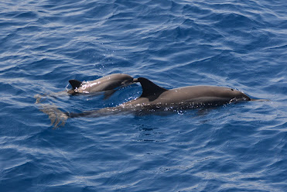

Sitting on a redundant luggage carousel watching the active one ! Those few moments where the trip may get off to a bad start and you are grateful that you put shorts vest and pants in your hand luggage aswell, just in case the worst happens.
Thankfully eventually the bright yellow case with Clive’s name still proudly etched into the side with marker pen appeared.
Exiting the airport through nothing to declare always makes me nervous despite being fully legally compliant for this country.
On entering the Maldives I knew it was ok to have a diving knife in my luggage. I just wasn’t quite so sure on the vapes or Clive’s ashes. I’d had the idea and Pam agreed that scattering some of him at sea here in the Maldives where Clive and I shared the same trip back in 2018 was a good idea. My last words to him as he slipped away from this world was to be free of his pain and to go to the Ocean.
As I walked outside the intense heat not only hit me but also wrapped itself around me and even squeezed me a little bit. I aimed for the taxi rank and was thankful there was no queue. Emirates was as brilliant as ever and we even had an Easter Chocolate with our meal.
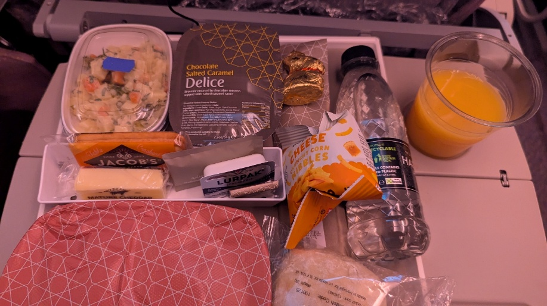
The flights were only 6 hours to Dubai and then 3.5 to Make but I hadn’t anticipated not sleeping at all. So I was beginning to flag. I found the smallest little taxi in the world and set off across the industrial looking Male.
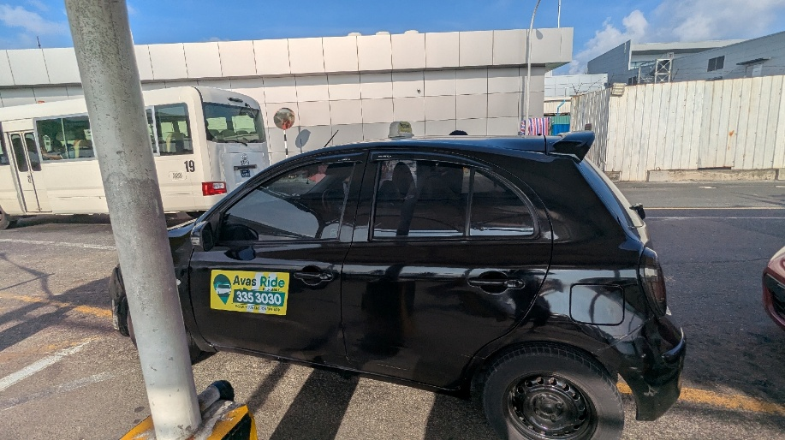
It’s not the prettiest part of the Maldives at all. Its resorts and the islands that are the tourist brochures.
We drove through tiny back streets that surprisingly reminded me of Bali and Thailand Narrow streets lined with mobile phone shops and people bustling around. We pulled up outside the entrance to the tour inn a single doorway a single doorway lost in the height of the six story buildings.
My little taxi holding up the rest of the traffic as I dragged my cases out and found some cash to pay the taxi driver seven U.S. dollars this was cheaper than arranging a pick up from the hotel which was going to be $25 return. A funny little building with a single entrance hallway with a lift the 8th floor labeled as reception. Reception was blissfully air conditioned and I received a warm welcome a cold flannel and a bottle of cold water, the lady behind the reception was Stephanie, who had been texting me before my arrival. I checked into my little room and was happy to abandon my suitcases on the floor. The shower room was beckoning.
By now I was absolutely shattered but knew I needed to go out to get some supplies and find something to eat. From my room I could hear the welcome noise of completely different bird sounds, I always very at home in the warm air and the parakeets along with the repetitive call of the Koel who proudly shouts his own name from the rooftops in search of a mate.
I headed back to reception to sit on the little balcony with a non alcoholic can of beer. I don’t drink anymore so this adaptation of alcohol was the norm for me and I watched the sunset over the tall roofs as I caught my breathe after a long journey.
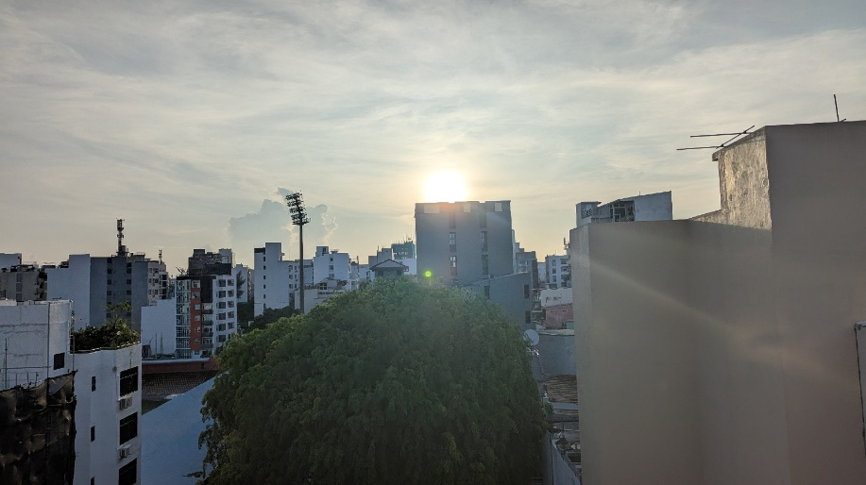

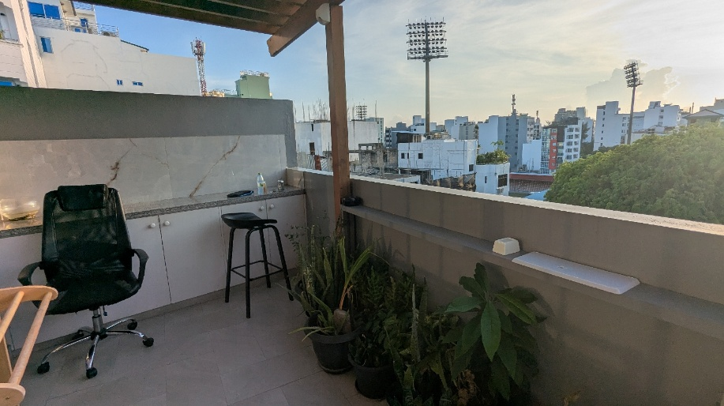

Out on the baking streets the heat of the road seems to double the heat of the air I found the supermarket suggested by Stephanie but it was closed I realized this was only for the next 10 minutes while prayer time was happening in a building opposite the supermarket prayer music blasts from a speaker. So I went off to find some food instead a hard task amongst mobile phone shops but I eventually found a little noodle place and was happy to sit and wait for a dish to be prepared with energy fast disappearing. Feeling better after some noodles and vegetables I headed back to the supermarket.
Grabbed a couple of bananas, some milk to have instead of the milk powder offered, and a mars bar, I was relieved to get back into my air conditioned room.
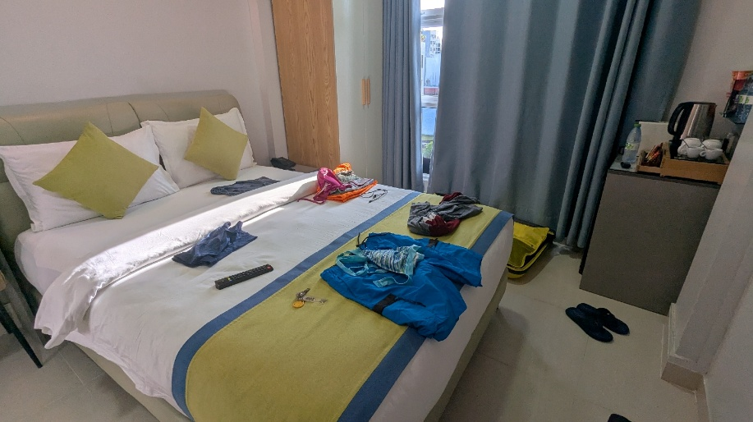

I was grateful not to have to unpack, instead just using bare essentials. I just have to get the cases onto the boat tomorrow and then I can reorganize everything.
The purpose of my trip is to board MV Keana for 13 nights on another Wildlife Photography trip. It’s my third trip with renowned Cetacean scientist Charles Anderson. He charters a boat and then sells the cabins to Wildlife enthusiasts. Loving the ocean as much as I do it’s just the epitomy of living life and fulfilling dreams. The trips require strict saving. They’re not cheap with a cabin being in the region of £4000 and flights on top. But to me it's worth every single penny. This particular trip has been funded by selling a lot of the photography equipment that Clive left me. I’ve kept the cameras and lenses that I will use and am lucky enough to bring 2 camera bodies on each trip. One with a short lense and one with a long lense, meaning that as Cetacean show on the horizon and then end up by the boat, I simply switch camera instead of fumbling around changing lenses.
Exhausted from travel and the adaptation to heat I fell into a welcoming cool bed with the Aircon humming in the background.

Sunday April 20th

Solid 10 hour sleep to reset ! Wandered around Male, it’s the part you don’t see on Brochures, it’s busy, it’s hot and it’s industrial . There’s no tourists because everyone gets off the plane at the International Airport and gets straight on a boat or seaplane to head to their resort.

There are shops but it’s hard to find a café.

Taxi to airport to meet Chaz and new boat friends, it’s always lovely people and of course all Wildlife enthusiasts so it kind of always works.

Seeing Keana again was great. Clive and I were on her in 2018. My cabin is amazing and secretly the one I wanted. The 2 front ones have dual aspect windows, I didn’t want to wish too hard but was so happy.

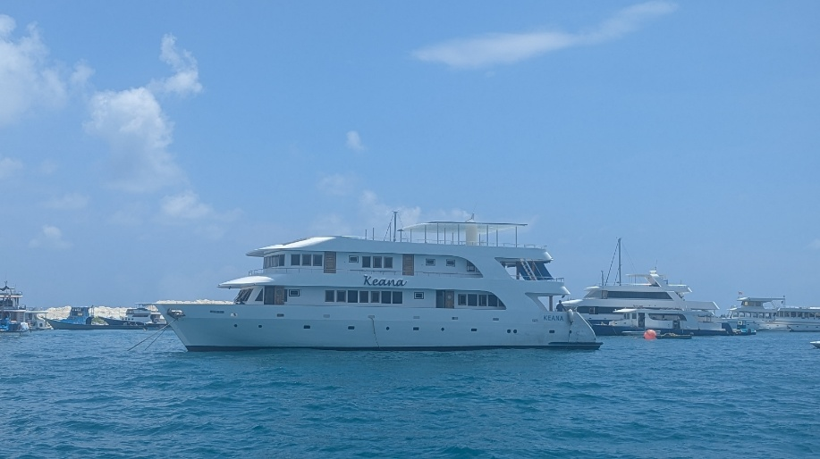

We settled into cabins and I sorted my stuff and put a million things on to charge. Boat sockets can be temperamental but nothing a rolled up sarong keeping the plug up can’t fix !
And then it starts, the bell rung and lunch was ready. Buffet style, some beautiful tuna steaks with vegetable rice and soy and onion sauce. Delicious. Then we were off heading away from Male. Within 20 minutes a pod of spinners came in. Docile for spinners who always look like they are in a hurry to get somewhere, these were happily logging and drifting along. They made sure that they leapt out if the water when my camera was facing the other way. It’s lovely sitting on the front deck and chatting to new friends. It’s definitely going to be a lovely group of people which I was very lucky with on my previous 2 trips aswell.

Mum and calf
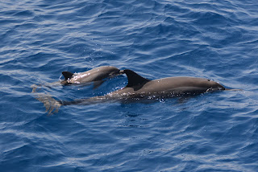

Photos from laptop screen as too hard to get good WiFi on laptop. When I get home I'll swap them all to the original better ones.

Left the spinners and then there were Rissos, again, happily logging and floating around. Their tall dorsals can be confused with Orca at a distance.

Then we carried on with some way to get us headed up the Northern Atolls. My last trip in the Maldives was the Southern Atolls.

Getting to know everyone’s names which is a challenge. We have 2 additional scientists on board from the Maldivian Research department so there’s going to be lots to learn from them.

I want to work on my identification skills, so many characteristics and marking of different dolphins and I also want to learn the scientific (latin ) names aswell.

Today’s candidates for this are The Spinner Dolphin Stenella Longirostris – so long rostrum makes sense, their beak is long. The other lucky one for today on my learning schedule was Rissos Dolphins Grampus griseus. No idea on word meaning but they are Rissos !

Chaz who leads the trips does a talk each evening and this evening was the history of the 30 year research programme which this trip in April of each year contributes to. The same – ISH – path is followed up through the Northern Atolls and each sighting is recorded, how many in a group, behaviour etc and how that’s changed over 30 years.

So today was a test for all the equipment and miraculously I don’t seem to have forgotten anything, I have a total of 6 cameras with me each with a different job ! 2 underwater ones, 2 big cameras, 2 go pros and of course my phone for scenery and boat life shots.

First snorkel was great to try out the new underwater camera. My amazing Christmas present from Lucie and I absolutely love it ! So can continue building my catalogue of reef fish. Aswell as filming stuff on the GoPro.

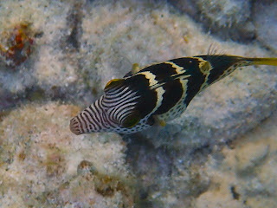

Sharp Nose Puffer Fish

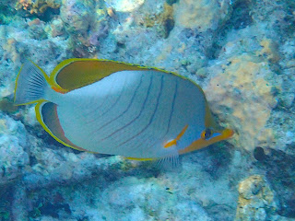

Yellowhead Butterfly Fish

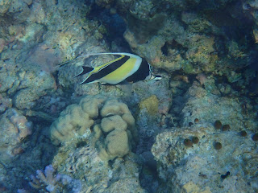

Reef Bannerfish
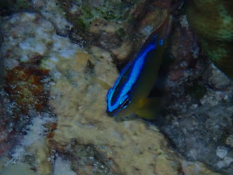

Cleaner Wrasse - unsure actual ID

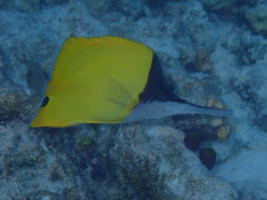

Longnose Butterflyfish
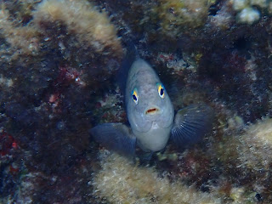

No Idea who this is - hard to ID front on !

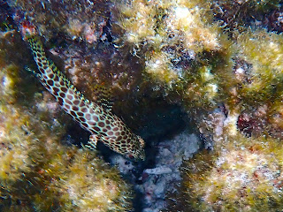

We have a dive boat aswell as the main boat. It’s called a Dhoni - It’s flat bottomed so we can get nearer the reef s, we have a crate each that holds fins, masks and snorkels. I have scuba dived but far prefer free diving with the masks and snorkel, it’s a lot Freer than faffing around with tanks and watching your air and keeping an eye on your dive buddy.

Just as we were getting on the Dhoni the boys had been out catching fish, we eat a lot of fish. I’m torn with fishing but it’s not as bad as the Dairy and Meat industry. Anyway it was still fascinating to see the sailfish they had caught.

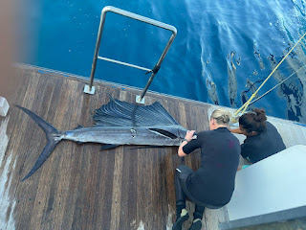

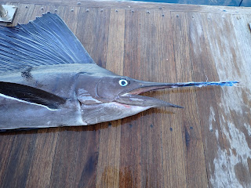

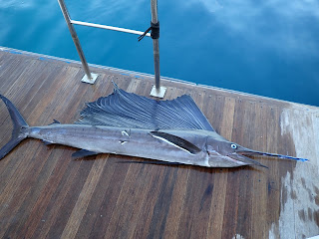

Tomorrow we'll set off at 6.30 with a big wide channel to cross so should be lots of different cetaceans to see. For a wildlife enthusiast, it really does not get better than this.

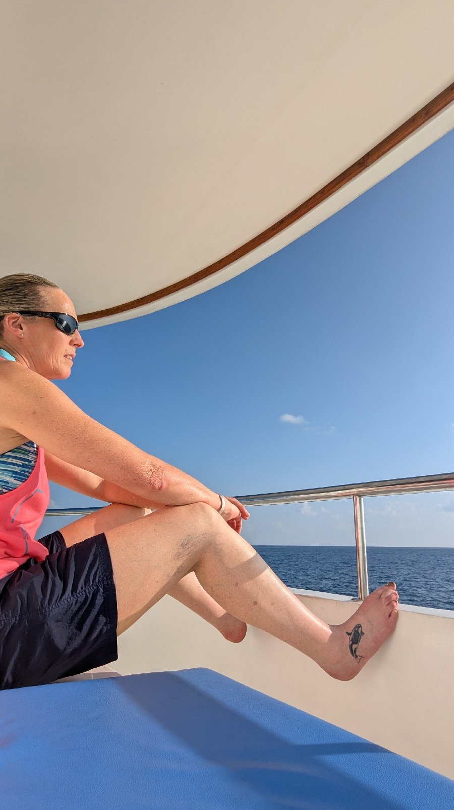

Monday 21st April

Sleeping on a boat is amazing, a natural gentle rocking as you drift off, mind full of the days adventures. Except just as you are about to actually fall asleep you become aware of a rhythmical knocking, like a tennis ball rolling back and forth in a drawer and hitting either end. After 2 hours I wanted to kill the imaginary tennis ball. Succumbed to investigating and it was the square based wooden stool gently knocking the floor as the boat rocked. Said stool nearly got thrown overboard.

With sunrise at 6am my alarm was set for 5.30 with the dream of catching a photo of breaching spinners across the early morning rays. This was not to be and I was awake at 5am naturally ! Still, a morning coffee just outside my lovely cabin was just perfect.

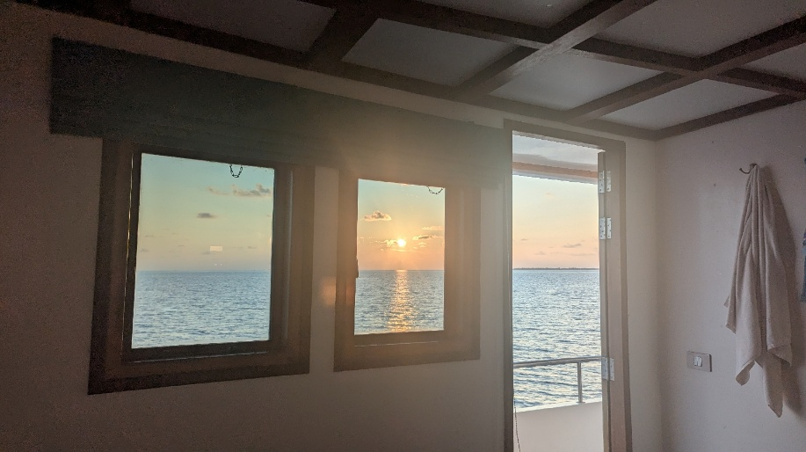

My cabin is one of the nicest 2 at the front with dual aspect windows and door onto main deck. I can run in and out to my heart’s content with cameras, binoculars, cups of coffee. It’s just blissful.

The boat has 8 cabins so a maximum of 16 guests. We are 13 on this trip. I have my own bathroom, there’s rules on a boat. The water for showers is salinated seawater and although plentiful it’s polite to turn showers off while you soap and shampoo, but with plenty of training for this in my caravan it’s not a problem. Toilets are normal but nothing aside from body secretions allowed in it. The cabin boys would rather empty a bin of tissue than unblock the toilet system. Just a boat fact.

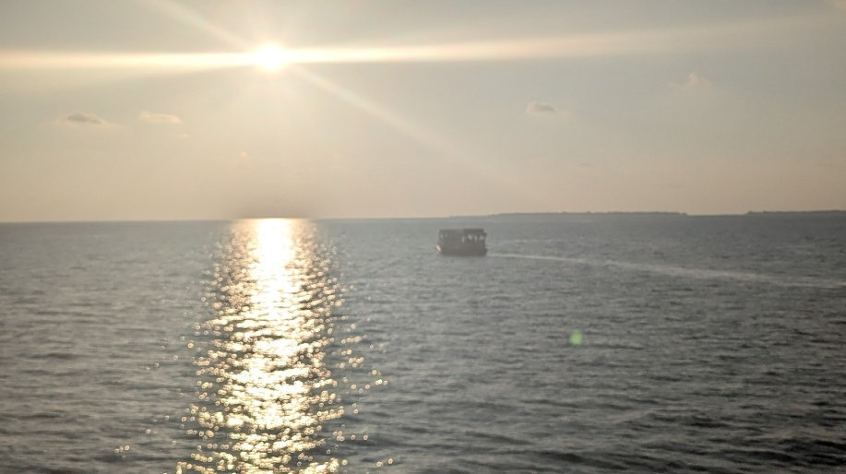

At 6am the Dhoni left the boat and set off as we have a long distance to cover today and we’ll meet up with it again later.

Chaz appeared at 6.30 and presented me with a walkie talkie, I’ll sit at the front on my bench and can let him know if I see anything. Roger this over that and copy something else.

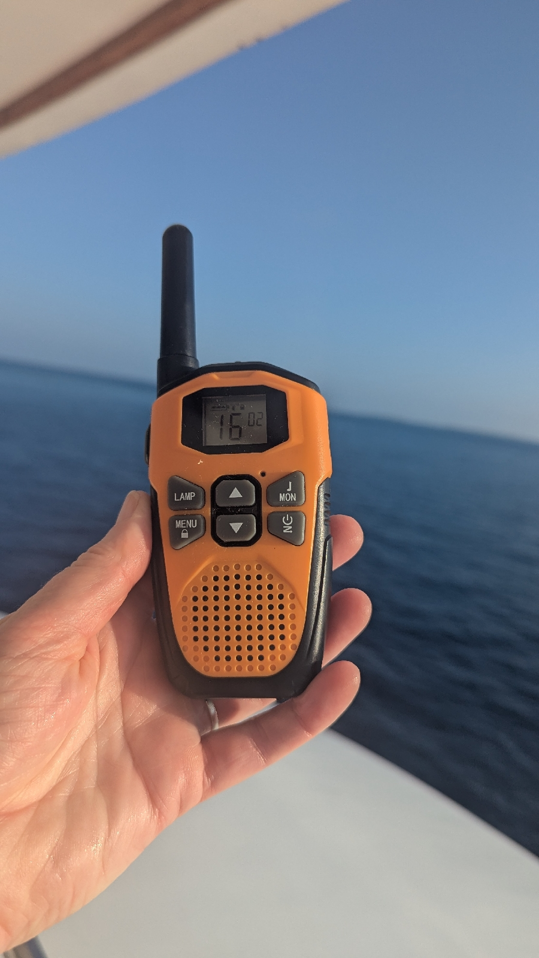

Lots of splashing in the distance and a large pod of Striped Dolphins came in. Their behaviour includes lots of activity and then they go quiet. Then all rush around again. Went down to the bow and had some fun with them, their stripe is so sharp along their flank from the beak. It’s quite striking. Got in a stress with hat and glasses, can’t have them on leaning over the bow for fear of losing them as I bury my head down to be right above them. Then immediately it’s just too baking hot to be without them ! About 20 minutes on the bow in the full sun is about as much as is manageable.

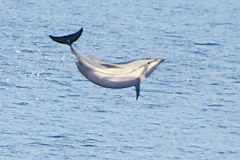

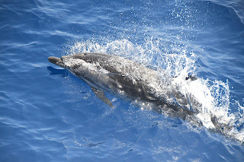

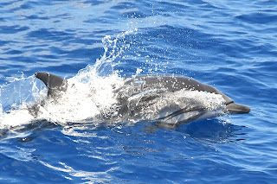

Quickly downloaded Striped Dolphins shots but had to succumb to jumping in a cold shower. Added extra sunscreen and some zinc on lips and nose ! It’s good stuff but I don’t want to look like I’m playing cricket....

Came out of shower and radio was on my bed with Sue announcing from the top deck they’d seen 4 fins. Right ! Pick everything up again and back out onto my lovely front deck seat.

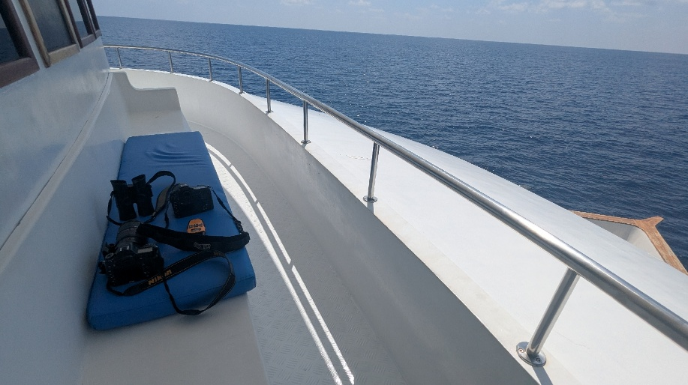

We stopped and lulled around and then 3 huge Pilot Whale fins appeared ahead, massive. Switched between the 2 cameras and lenses and got some lovely shots with the sun glinting off their backs. They give you a warning when they’re going to dive as each appearance they curl their back up more until eventually it’s a steep angle and the tail comes out the water with a good view of the fluke.

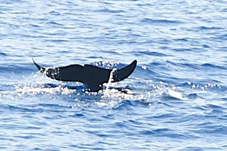

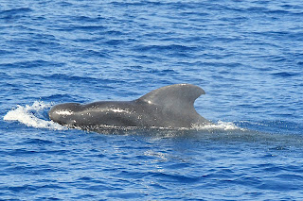

Onwards we went, until we slowed again, and Chaz came through on radio, sighting 200 metres at 2.30 ( clock face ) Dwarf Sperm Whale - we didn’t see it on our bow seat, and after waiting 15 mins we moved off again. They often lay logging in a paler strip of the sea, no-one really knows why, least of all me.

Michelle and I were sitting on our bow seat. Very comfortable as you can put your feet up and rest your elbows on your knees.

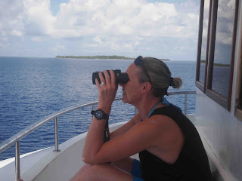

Otherwise your arms fall off holding binoculars for hours on end. Up ahead were large things ! As we got closer we eventually decided on Pilot Whales who are often accompanied by bottlenose. This was our confusion in trying to get the ID right, it was both. Huge Pilot whale fins and particularly chunky Common bottlenose dolphins Found in the deeper water - The Southern Atolls tend to have the Indo Pacific Bottlenose.

Common Bottlenose on the bow.

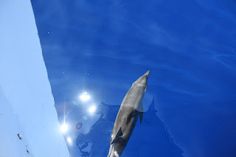

Scampered down to the bow and only just escaped heatstroke – with no time for this I necked a load of water and put Aircon on in cabin.

Snorkel at the end of the day is a chance to cool down or if you are me, to get really cold !
Today I tried my new diving knife. I realised on previous trips, what would I do if I found something like a turtle entangled in netting or rope of fishing line. The boat is to far to swim back to to ask if I can just quickly borrow a knife, so I wanted my own diving knife !

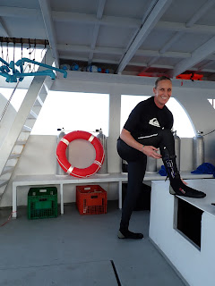

Strapped to my leg, it's a bit of a Lara Croft feel !

I did cut some line on this snorkel but not with anything entangled in it.

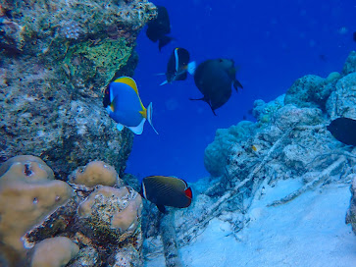

Chaz gives a talk each evening and tonight was about the Maldives as a country. The Country stretches 500 miles and runs north to south in a long line consisting of the Southern Atolls and the Northern Atolls.

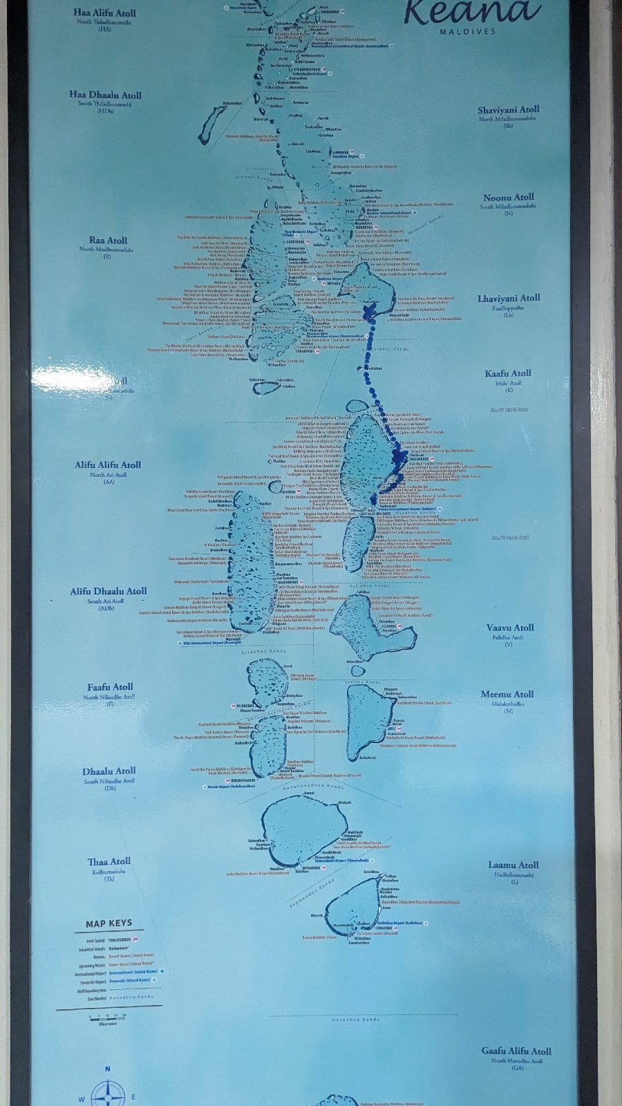

There are 1200 plus islands and when all that land mass is added together it only totals 300 square miles. The Atolls are circular ish reefs and islands. And it’s the calm of the Atolls that the Spinner dolphins spend the day where they are safer. Then they head out of the Atolls at night to go and hunt and will dive 50 to 60 metres to find the fish they like. They’re safer to feed at night with less chance of being predated. That’s why early morning is good to see the Spinners coming back in after a long night.
We have seen 3 of the dolphins of the Maldives so far, Spinners, Striped and Common Bottlenose. The other 2 are Fraziers and Rough Toothed dolphins, Fraziers I have seen before but Rough Tooth will be new for me if we manage to see them. God this is so boring if you are not a wildlife person, but a wildlife person will get it !

Tuesday April 22nd 2025

Up at 5.30 for coffee and to see if I could see the Spinner Dolphins coming back into the Atolls from their hard night hunting. Chas has studied this data and made graphs and the most activity is 5am – The Atoll on a map looks like a little neat round circle but anchored just inside the edge of it I can't see the other side at all. We’ll set off at 6.30 back out onto the middle channel and deeper water and looking out for sightings will begin again.

Morning routine is busy ! Jump in the shower and then spend ages putting sunscreen on. It’s best to do it straight away because once we start watching, we get a sighting and you’re distracted chasing around the boat and standing on the bow, within15 minutes I would be frazzled. You can’t ask all the dolphins to just wait so I can pop back to my cabin and put sunscreen on.

Learning from previous trips and the tedium of putting sunscreen on, pick up the bottle about 7 times, I poured 2 bottles of sunscreen into one large screw top pot ! Ingenious and saves alot of time.

I nearly came unstuck yesterday after hanging off the bow with a camera and a GoPro. Just managed to avoid heatstroke. If anyone’s had heatstroke, it’s a horrible feeling. I necked even more water whacked the Aircon on in a desperate attempt to cool my body temperature. I’m drinking between 2 and 3 litres of water a day. We have 3 water dispensers around the boat and you just refill and refill your bottle basically as many times as you can.

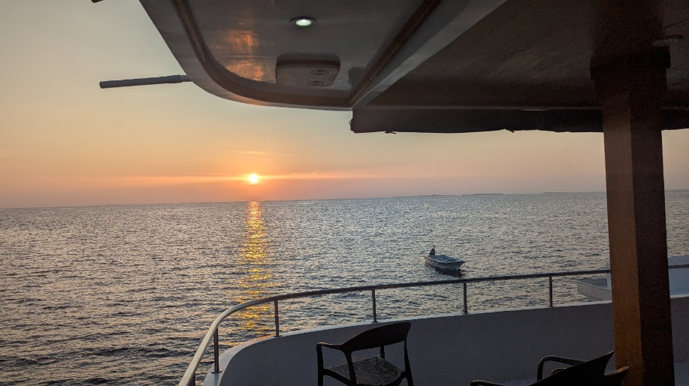

Breakfast at 8 by which time I’ve been up ages, As everyone else was finishing, I saw alot of splashing coming towards us and announced the arrival of dolphins, everyone quickly finished breakfast and then I had to apologise as it was only some fish jumping. But big tuna, so not totally stupid.

Our first sighting was around 9am when a huge pod of Bottlenose dolphins came in, around 1200 leaping and splashing and bowriding. I’m trying to improve on existing photos by thinking about angles of the animals, where the sun is, what level of the boat I’m on, otherwise I’m just on the bow getting heatstroke and posting alot of photos of the backs of dolphins ! They stayed around an hour and provided great entertainment so why the hell anyone wants to see them floundering in small tanks is beyond me and one day all these SeaWorld places will convert to providing responsible whale watching trips instead.

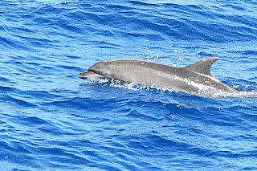

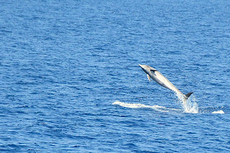

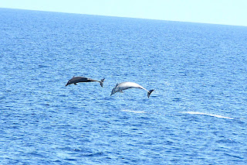

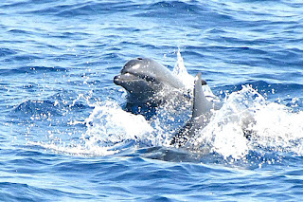

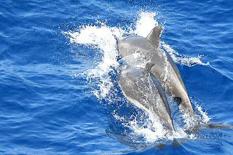

Birds of the Maldives I am not good at but was happy to have the right camera with the longest lens in my hand as a White Tropi Bird flew over. Their numbers have diminished as their ground nests are now so disturbed by tourists. A couple of the older and privately owned resorts now protect them and rope off areas where they nest. And there they flourish with 100 breeding pairs.

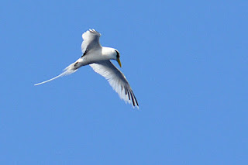

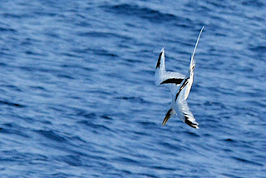

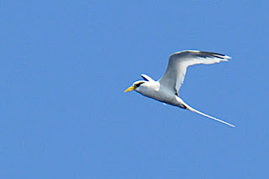

I ventured up onto the top deck which is painted white to reflect the sun but it also makes a blinding glare if you wear contact lenses, so I am normally on the front deck. Everyone was standing around with binoculars all facing the same way searching for the elusive Dwarf Sperm Whale which had been seen. He sits miles away and looks like an upside down surfboard. I lifted binoculars and found him, advised everyone that he was at 11 o clock, took a photo and left again to go to my deck !

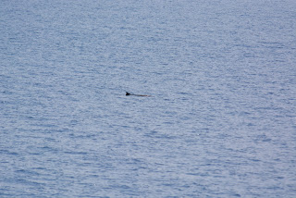

Yes, this is literally all you see of this silly little Whale !

Then we had a snorkel, it was beautiful with some lovely corals in areas ( unfortunately not the areas in the background of my photos ) I now take 2 cameras snorkeling and switched between the GoPro and the Olympus underwater camera which, if you get it right, takes pristine shots.

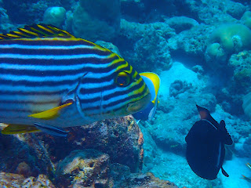

Oriental Sweetlips

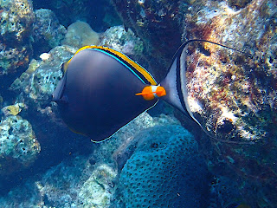

Elegant Unicornfish

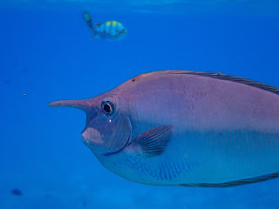

Unicorn Fish

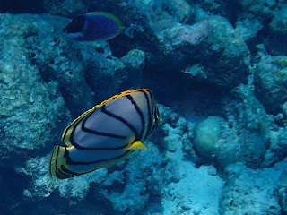

Meyers Butterflyfish

Also some lovely big shoals of fish and as I watched a black top reef shark skulking around, itwas so interesting to see the fish form a tight shoal, using their numbers to look like one much larger fish. Fascinating.

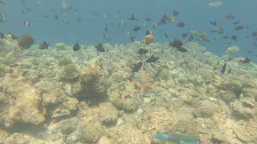

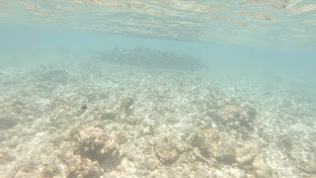

Now, the next event was pretty a special. We found Pilot Whales, very docile in the day as they hunt squid at night. With 2 scientists on board, Chas suggested that they jump in the dingy with the hydrophone. He wants to start collecting sound recording data across the Maldives. I happened to be standing next to him as he instructed the girls, then turned and asked if I wanted to go to. THE most stupid question ! We were going right now because the Pilots were staying around the boat. Think quickly JBM how can you maximise this amazing opportunity.

I threw my snorkelling top on, a dingy on the water is sunstroke central. I grabbed the GoPro and my other underwater camera which doubles as a normal little happy snapper aswell. Didn’t want to take my phone. So me and the 2 girls jumped into the dingy with the hydrophone and the headphones and went speeding away from the big boat in a big circle to end up in front of The Pilots. The girls frantically worked out what they needed to do, this was a kind of experiment for them to get used it. Lucky I was on hand to hold a phone or pass a microphone ! I wanted to be useful so that I would then be essential all the other times they do this – So I took pictures to record the event and with my other pair of hands, got the GoPro in the water.

Hydrophone going in.
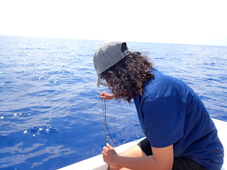

The pilots were slowly logging towards us.

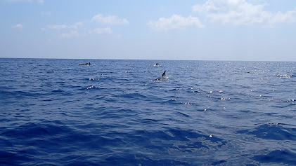

Eventually this huge black Whale ( who is actually a dolphin ) larger than the dingy was alongside us and going under the dingy. So the gopro was as deep as my arm length would allow and then it’s guess work, you’re filming blind from above the surface. Thankfully I got him in full shot and will enjoy editing that video later but here’s a screen shot for now.

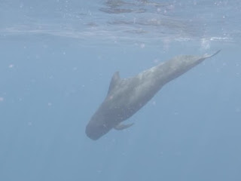

Ish was listening on the monitoring equipment.

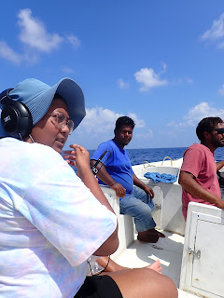

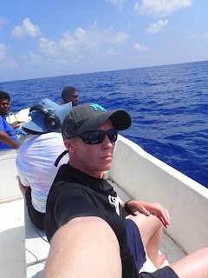

I was making myself invaluable documenting everything.....

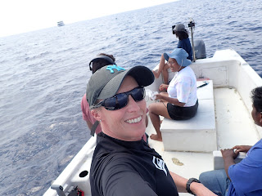

They definitely could not do this without me.......

It was an amazing experience and the 3 of us were beyond excited. Eventually on this trip Spinner dolphins will be recorded and more Pilot Whales, but this was a great trial run with some great audio of the song and clicks from beneath the depths.

We headed back to the boat and of course then everyone wanted to go, so I hopped out and 8 of the others went as I watched helplessly as they once again had the Pilots right underneath. I could only imagine the further footage I could have got.

But we have a ploy and the girls will tell Chas that they think it’s a great idea to have the go pro aswell and as I am the only one on this trip with said essential piece of equipment, I will therefore have to accompany them on every single Pilot Whale Hydrophone dingy mission.
I don’t think they were as keen on a boatful of everyone else !

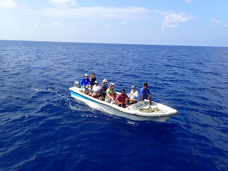

It was all amazing and I am sure that there is a scientist somewhere who needs an assistant in the Maldives !

We all just chilled milling around the boat, some watching and some eating ice creams.

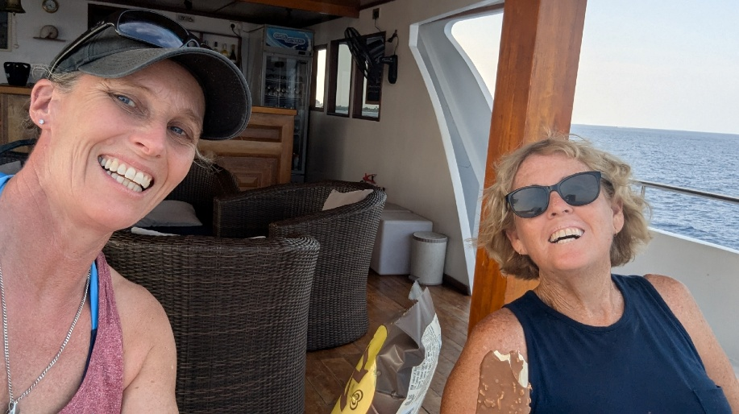

Thankfully owing to the over excitement of Hydrophone dingy trips, it was decided there would be no 2nd snorkel and as we drifted into an Atoll for the night we all sat with a drink on the top deck and watched the sunset.

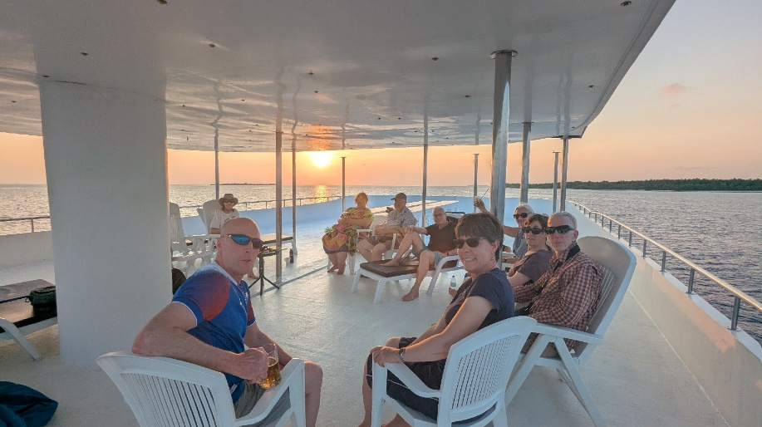

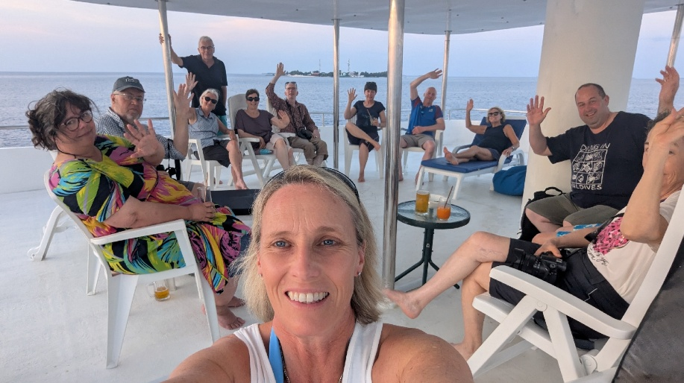

Just another stunning day.

Wednesday 23rd April

Another beautiful sunrise with morning coffee. I love this time when no-one else is around. As I sat having my coffee at the back of the boat the sound of puffing infiltrated into my ears, I know that noise ! Sure enough as I stood up, a lone dolphin was approaching the boat, he milled around and then did a very slow purposeful lap of the boat, puffing as he gently broke the surface. Unsure of who he was I grabbed my camera and took a few shots and more blurred ones on my phone. He left as peacefully as he had arrived and I felt honoured that it had just been me and him.

It couldn't be a Spinner dolphins as they don't travel alone.

He was Bottlenose shaped but half the size of the chunky Bottlenose dolphins we had spent ages with yesterday. I showed Chaz the photos and he was in fact an Indo Pacific Bottlenose. A beautiful start to the day.

The engine started and we headed off.

I like to do the early watch shift, not that we are on a rota or anything, we can do what we like but otherwise at that time it would only be Chaz on the top deck and only one pair of eyes on such a vast Ocean is just not enough. So I headed to the front to be the second pair of eyes.

We had a lot of radio contact as he radioed down that there were splashes ahead. So the engine slowed, but the Spinners disappeared off in the other direction.

Next I radioed up to Chaz that I had a glint on a body at 10 o clock. Swiftly followed by another radio message to him that it was in fact a glint on a plastic bottle about a mile away !
When there are lots of eyes during the day then everyone would turn to check out the sighting and either the excitement grows as others confirm the same or it’s swiftly eliminated as a plastic bottle.

Snorkel was next at around 11am, still loving playing with new underwater camera. Some nice coral and fish, a Whitetail stingray and a grey reef shark, oh and an octopus that wouldn’t come out of his coral reef crevice.

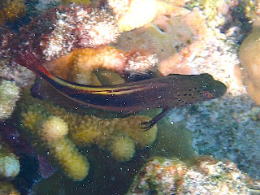

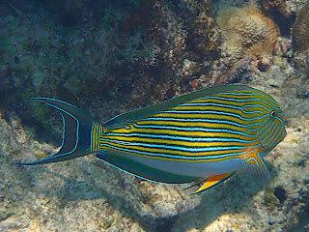

Striped Sturgeonfish

Back on board sightings were quiet but we did follow a series of lone splashes in the distance. Eventually deemed to be a Sailfish, but the speed he was travelling indicated he was being pursued. Poor thing must have been worn out, but we were not to establish who his hunters were.
Finally a good group of Spinners and another chance to get better side on photos.

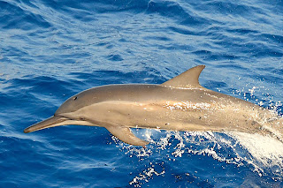

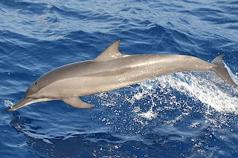

So a less manic day compared to yesterday and nice to have a breather from sorting hundreds of photos.
Chaz gave a great talk in the evening about the Atolls.
If you look at a map the Maldives is a series of 2 lines of circles next to each other.

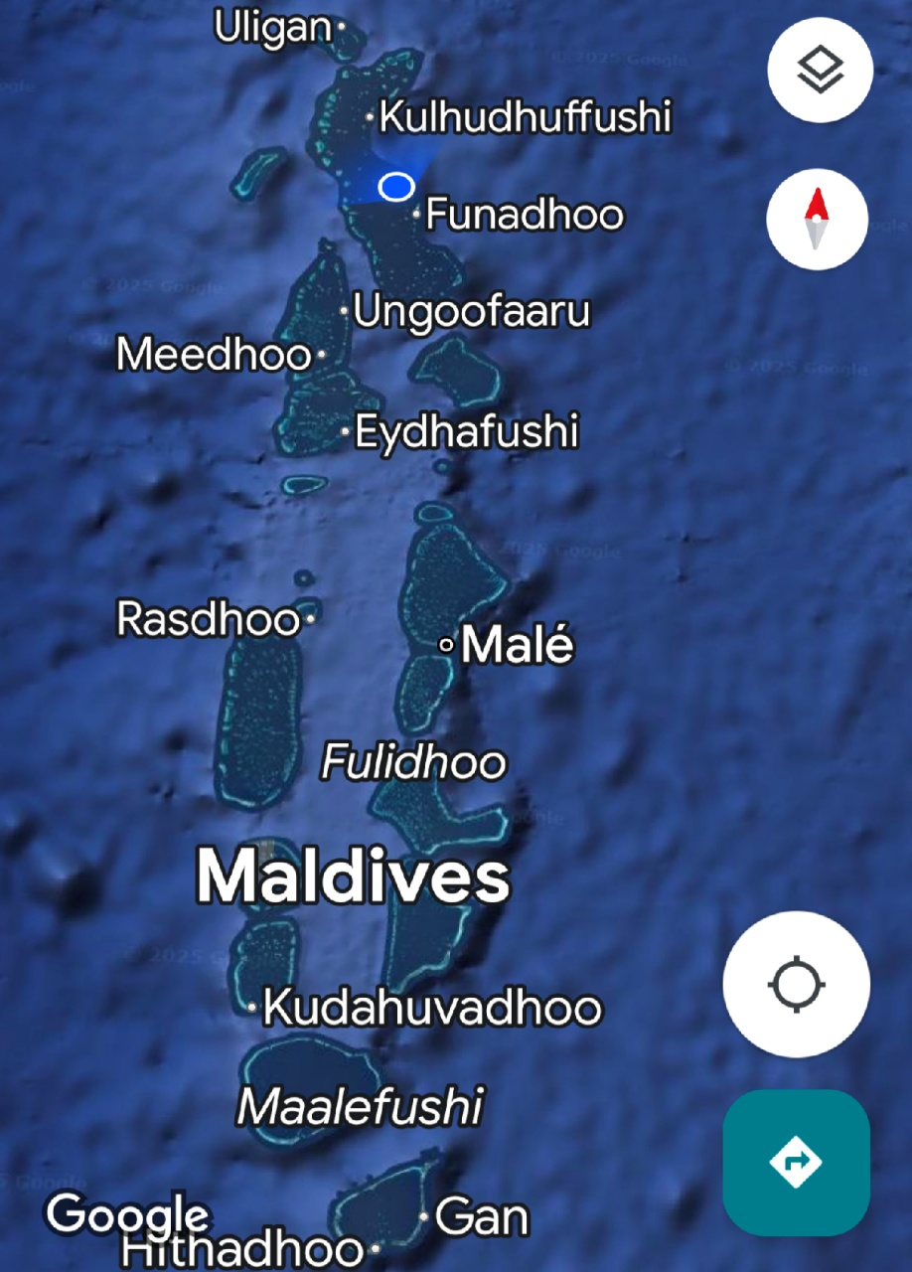

Billions and billions of years ago as India moved away from …… need to fill this in, volcanic activity pushed volcanoes from the softer plates beneath the seabed. These volcanoes rose way up out of the water. At sealevel on the edges of the volcanoes, sunlight allowed coral to grow. As coral dies it sheds an old outer calcium layer and new coral comes. That calcium layer builds up and builds up to form a hard reef around the edge of the volcano.
However the softer plates beneath the base of the volcano, meant that the weight of the volcano forced it to sink again, leaving a circle of reef. A very old explorer had worked this out after finding a volcano elsewhere that had fossilised seashells at the top of it.
He had spent time in The Maldives after being shipwrecked on the edge of an Atoll because explorers didn’t know about these sharp edges reefs. He had a terrible time being forced to live on local islands, Maldivians didn’t take kindly to foreigners and the 200 shipwrecked men were sent to live on Male, eventually escaping on a pirate boat and ending up back home in France 10 years later. But, he had learnt Maldivian words during his time trapped in the Country and one of those words was Atoll. So a Frenchman used a Maldivian word to name these structures which were eventually mapped out properly by the navy. And people could now stop getting shipwrecked, although this does still happen sometimes.
The Atolls nearest India are the oldest as they were dragged along the earth’s plates as Continents separated then 2 more in front formed. So the oldest at the top are 55 billion years old, while all the way at the base and way below The Maldives is Reunion Island. Famous to us for wreckage supposedly from MH370 being washed up there. That Island is currently an active volcano, so it’s the youngest sibling of the already formed Atolls and one day, it too, will probably sink down below the surface of the Ocean
So finally I understood these strange circular structures that we shelter in at night and venture out of during the day to the deeper water. The deep water can be 2000 metres deep whereas the center of an Atoll is 60 metres.
So essentially we are anchored in the centre of incredibly ancient volcanoes.
There is even a satellite image of the Atolls showing a sunken Atoll, it sank quickly without the Reef having chance to form.
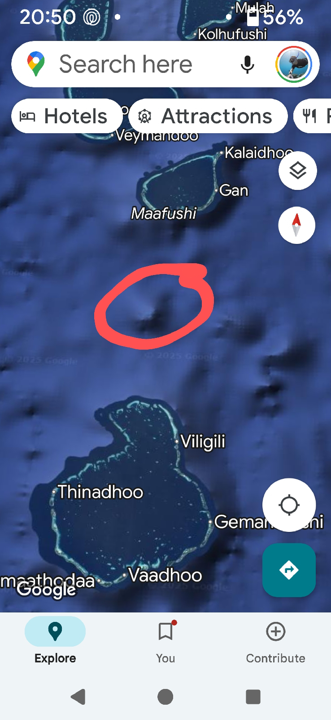

So, the end of another very educational day.
Thursday 24th April

Early snorkel at 7.30, well not early for me, I did sunrise and coffee of course.
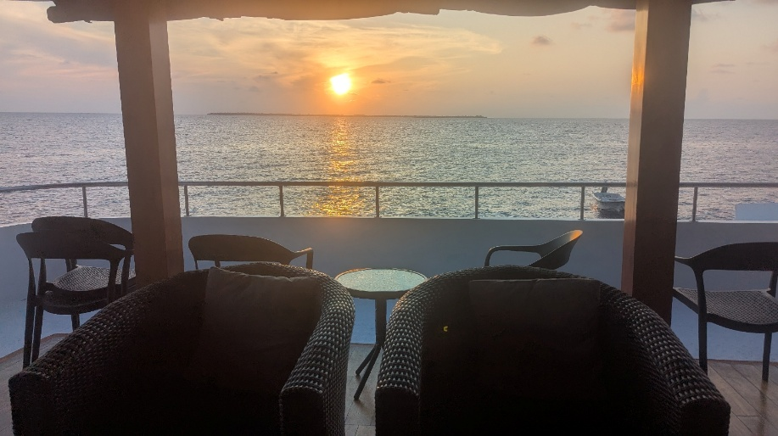

A long sloping reef, if you lay still you feel like you are flying over coral and fish. I’m trying to find Nudibranch, Seaslugs, to photograph but they are eluding me. The surf was breaking at the edge of the Island and you have to be careful not to get tangled up in that.
I’ve found a time saver because heaven knows you need them with these manic days. There are freshwater showers at the back of the diving boat, and if you stand at a funny angle you can actually have a full shower whilst rinsing everything at the same time, cameras and snorkel outfit so that saves having to have a shower when I get back to the cabin. Can dry and go straight to breakfast.
Breakfast when we got back which is especially needed after a snorkel.

I’d discovered after my snorkel that my go pro just didn’t want to turn on and I have no idea why. Worried that it may be needed later IF we were sent out on the dingy, I was so pleased that I’d brought a spare ! Got it out, checked card, charged batteries and tested it. Ready, just in case !

Armed with my radio I went to the front and after 2 hours there were splashes up ahead. Secretly everyone is looking for blows on the horizon indicating Whales, maybe Blue Whales, Sperm Whales, False Killer Whales. Alas the splashing was dolphins. The semi disappointment was quickly replaced as we realised the dolphins were Rough Toothed Dolphins and I've never seen them before. Now there was pressure to get the headshot ! It has a funny sloping forehead and pink mottling down it’s side. Can’t think of the word – pigmentation ! That’s it.

They stayed for ages, leaping around like slopey headed lunatics and were then joined by Rissos Dolphins. These are the scratchy ones ! Covered in tooth rake marks as they bicker and argue. The older ones are so scarred, they take on a white appearance. These today were youngsters with just a few scratches and still quite dark.

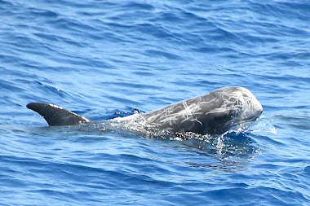

Both have a tall dorsal but the Rissos has a stubby little face – not too much going for Rissos really is there, covered in scratches and a stumpy face ! The Rough Tooth have a snout.
Walked past on of the girls who said they were going on dingy with hydrophone ! Am I coming, dingy leaving about now ! Raced back and got pre prepared spare gopro and threw a Snorkeling top on and got to the back of the boat and the dingy had gone ! Nishad had thought I was joking about having a spare go pro and knew my other one had stopped working ! Anyway they turned back for me and I leapt on, and held on ! It’s fast. We sped towards the Rissos and Rough Toothed and threw various bits of equipment in the water ! The aim to record Audio and visual.

The girls are still getting used to hydrophone and these are all practice runs. The dolphins were slightly too far from the boat and I didn’t really get anything apart from a blob of shapes and the gopro was also angled too high and filmed a lot of the surface and not deeper ! These are all the things you have to figure out and why the practice runs are so good.

Back onboard I downloaded that lot of mainly deep blue sea and surface videos.
Onwards we went and quickly had Pilot Whales and Bottlenose at the front of the boat. Just for fun I took photos out of my cabin window showing the Whales at the front of the boat - with a view.

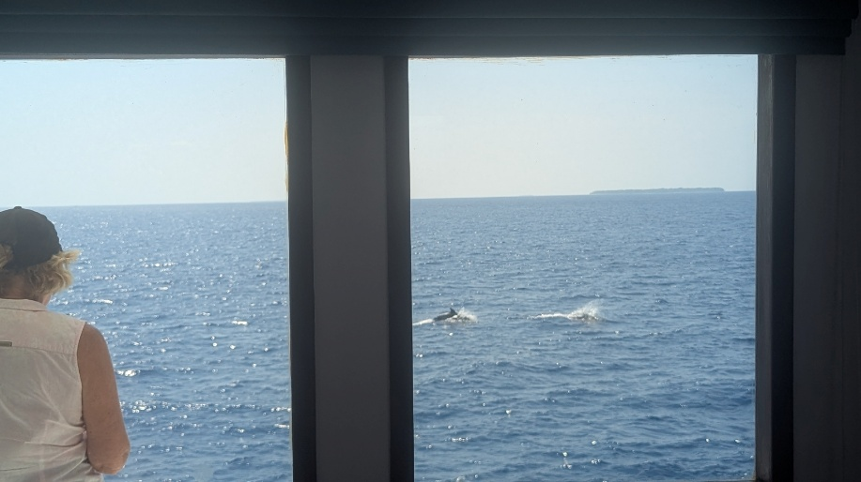

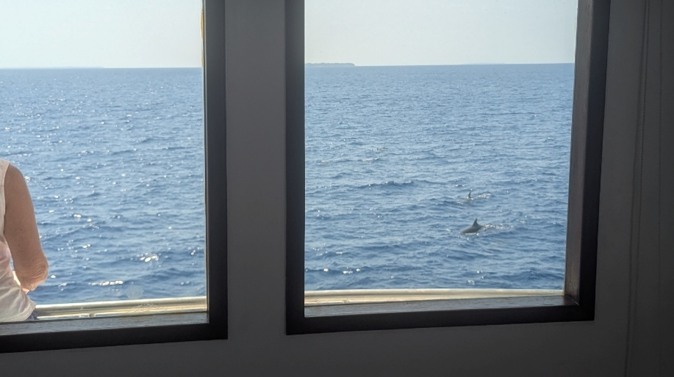

Damn it, dingy going out again..

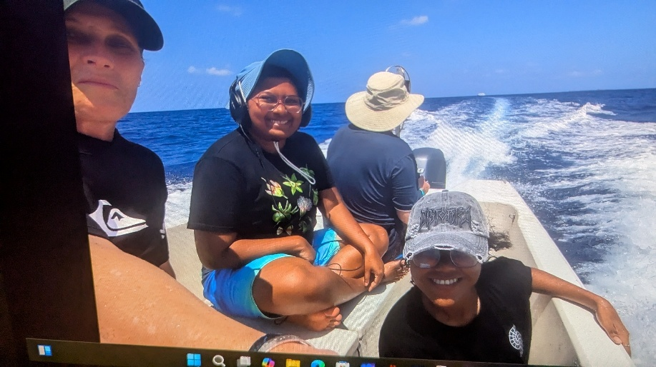

Better this time and got some good Bottlenose underwater. It’s stressful just having to think quickly, it’s not like a film set where everyone can get set up and someone shouts Action. The action is already happening and you only have that one take to get it !
Easier afternoon with no further sightings and after faffing around with the dingy, no time for a second snorkel.
Nervously checked my Rough Toothed photos from earlier and was really happy to have some decent head shots and a breach !

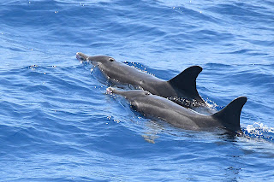

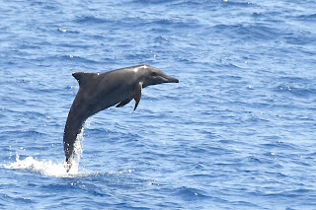

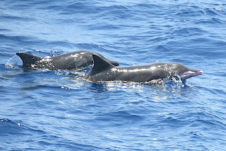

Boatlife and laundry ! Chuck things to soak in sink in travel washing liquid, swirl around and scrub and then hang with giant pegs outside in the hopes that pants and bikini tops don’t fly off into the Ocean never to be seen again. So far, so good.
So aside from laundry, another exciting day and new things !

Friday 25th April
Less manic today. A visit to an inhabited Maldivian Island. It even has a harbour, women must cover their knees and shoulders and men must cover their knees, and the oddest thing of all is that we had to put shoes on. I haven’t worn shoes for a week !
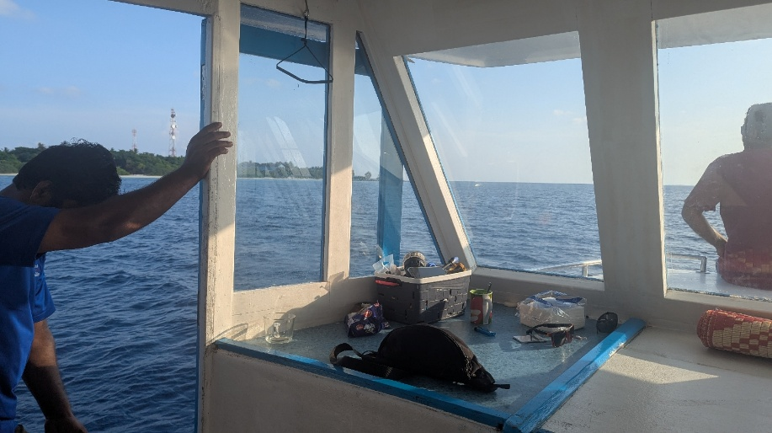
We jumped onto the Dhoni ( dive boat) to get across to the Island, we were only going 100 metres but of course got distracted by a small pod of Spinner dolphins and took a detour to follow them. 30 minutes later we actually got to the Island.
It's a step back in time, with houses made of Coral.
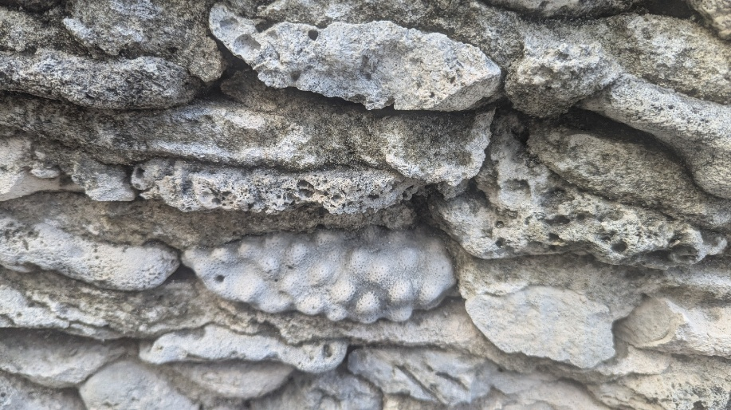

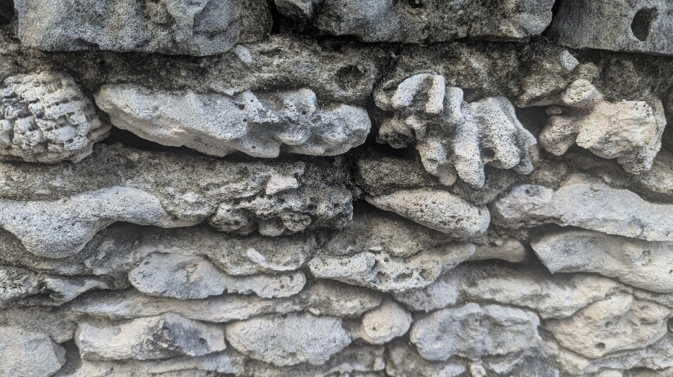

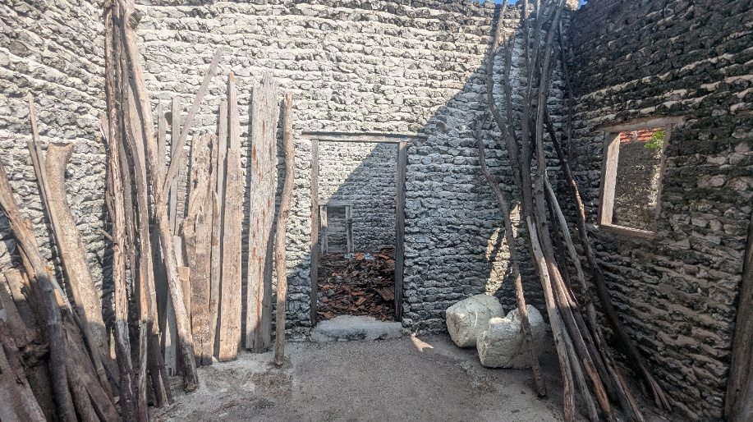

Ish, one of the scientists on board gave us a guided tour, interestingly starting with a whole pile of concrete sewage pipes. Nearly all the Islands now have sewage systems, paid for by the tourist taxes. The hope now is that that money can be used towards conservation projects.
We saw the school and the cemetery. The cemetery is walled and when it gets full, the graves and gravestones will be covered in sand and more graves will go on top.
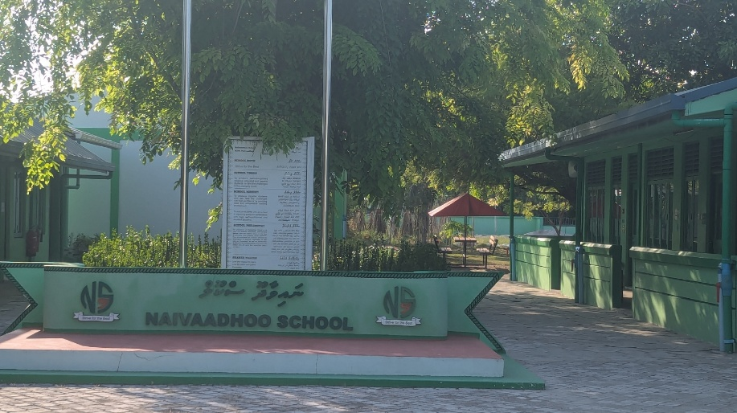

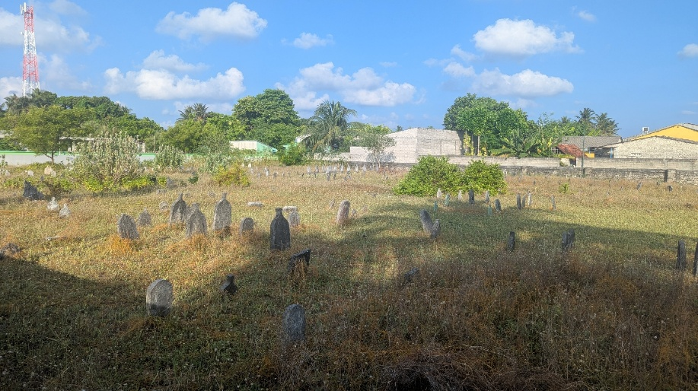

It was hot, beyond hot. We walked the little streets lined with little houses and popped out the other side.
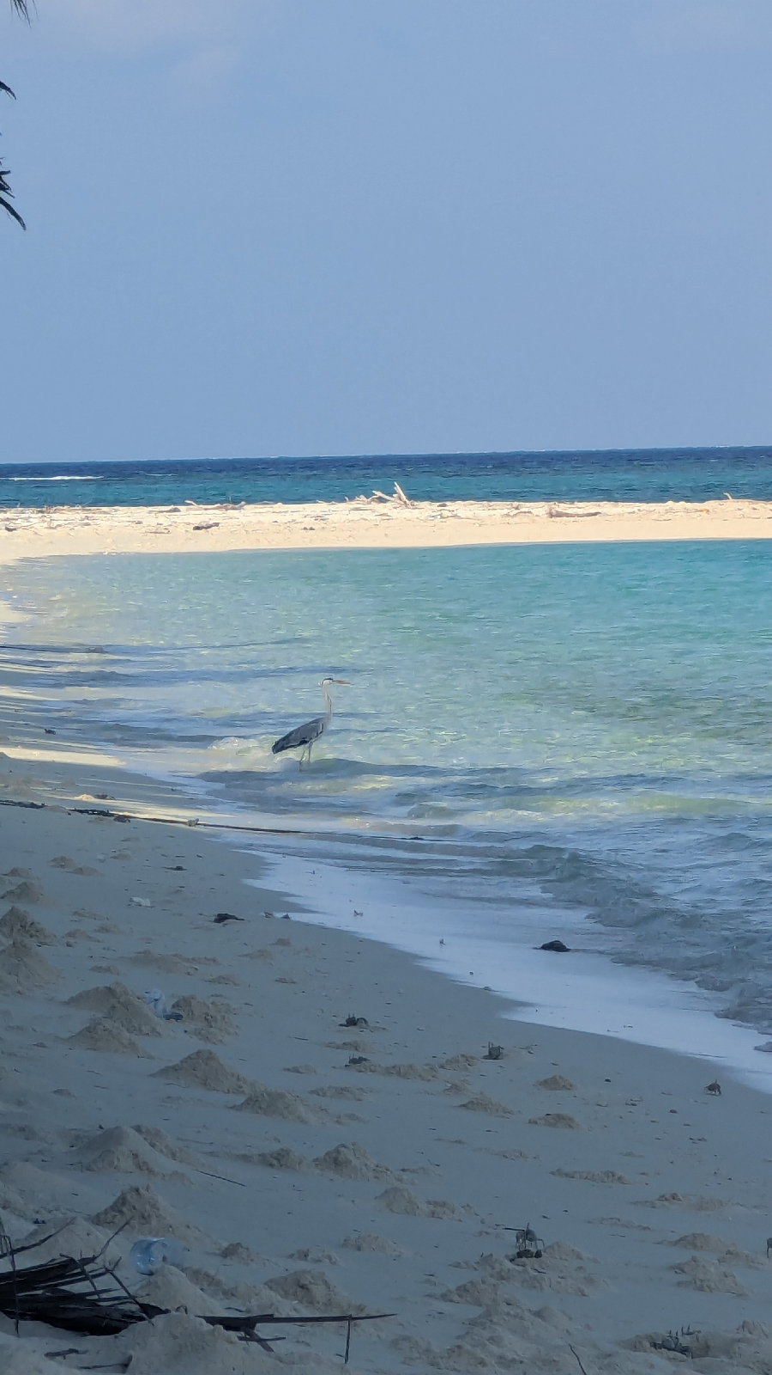

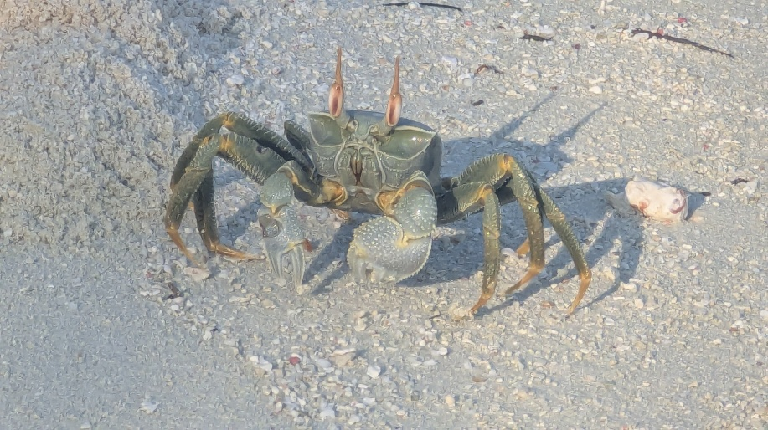

The main high street nothing more than a track.
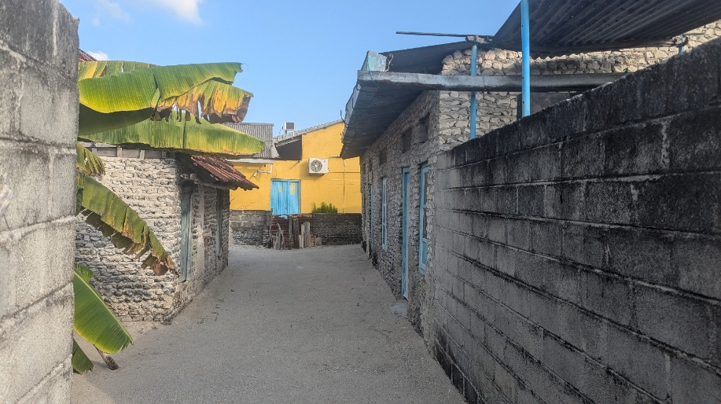

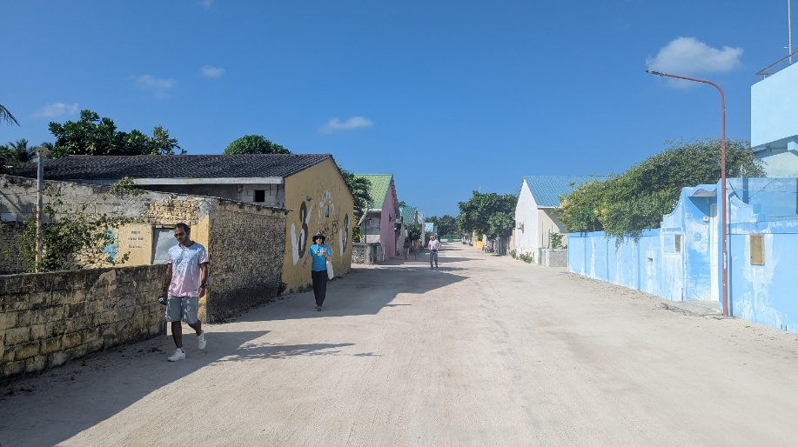

Every street was swept, as it is every morning. There can’t be loads to do so that forms an important part of the day and appeared to be quite a social activity with a group of people all sweeping the same bit.
We found a shop ! The Aircon was amazing and I nearly climbed into the fridge. Stocked up on some snacks, conscious that us all spending a few dollars would be welcomed. Except it wasn’t and there seemed to be some disharmony at the tills. It was a pain for them converting Maldivian money to dollars. Next time I find a shop on an Island, I’m going to ask them if they want me to buy something or if they would prefer that I didn’t and just left quietly ( possibly still after trying to get in the fridge )
The kerfuffle in the shop had made us late back to the boat and we scurried as fast as overheated bodies will allow.
Basically just got in the cold shower which is never cold with all my clothes on and kicked shoes off with great relief.
We set off and stopped after an hour for a snorkel.

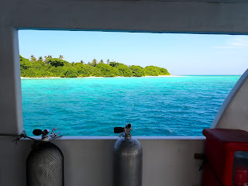

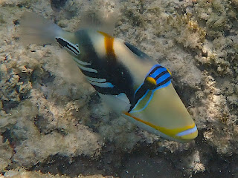

Picasso Triggerfish

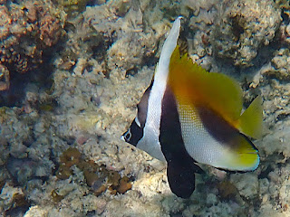

Masked Bannerfish

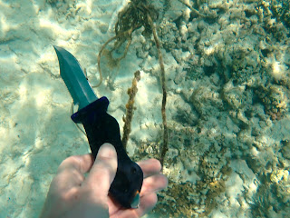

My amazing knife
I used my amazing knife to cut some rope, maybe preventing some little turtle getting tangled. I also cut my finger aswell and then swam with my hand wrapped tightly around that finger with visions of sharks all heading towards me.
Then the rest of the day was watching. I set up camp on the front seat until I realised the sun was on it, so ingeniously turned my cabin windows into my lookout.
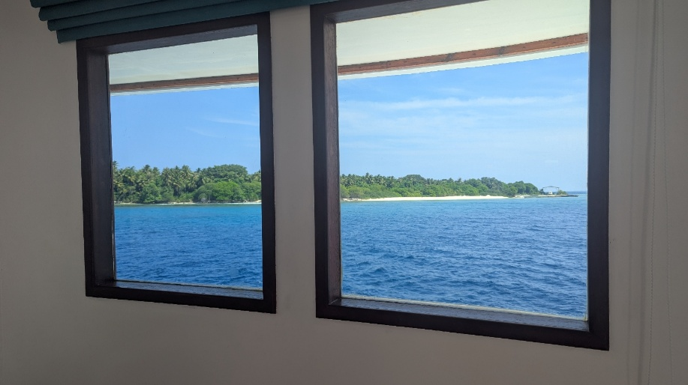
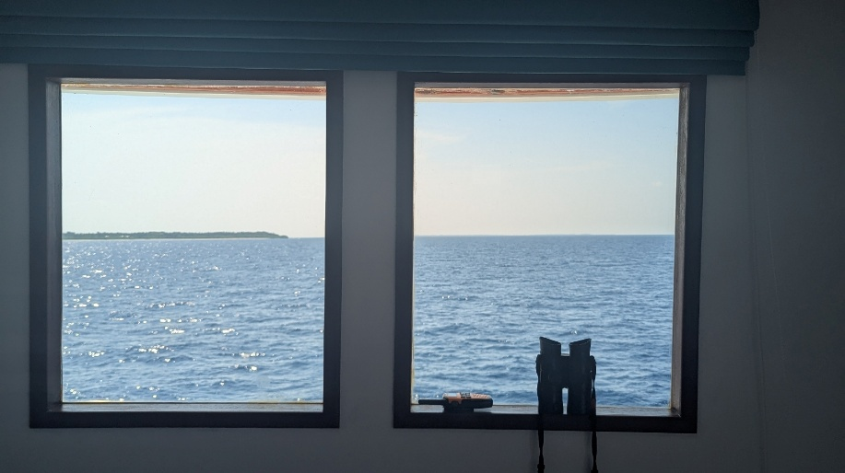

It was a different day, the sun was less beaty down and there was some cloud cover which gave a welcome change, but the humidity was the most intense I have felt anywhere in the world. It was nearly suffocating and really dense. As we changed direction the wind was welcome.
Not many sightings, Spinners and Bottlenose.

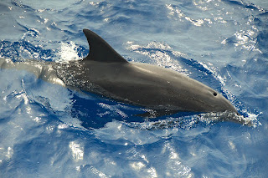

This meant way fewer photos to sort which gave me more time to just sit, until I decided I would start on Seabirds to fill the non Whale sighting time.

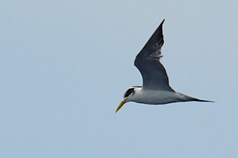

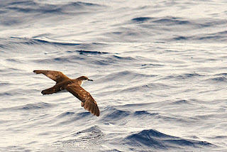

I sat watching at the front for 5 hours ! It’s like a time warp, broken up by getting a coffee or nipping up to the top watch deck to catch any gossip.
I did get busted on my radio duties ! I was in my cabin having a wee ! The radio was on my bed. Chaz came through "can you still see your dolphins ?" Oh my god, failing, I didn't even know we were on any dolphins... Asked Chaz to bear with and dashed out the front, Jim Jim ! Can we still see dolphins ? Jim said no. In my calm voice on the radio " that's a negative" Chaz was none the wiser I knew nothing about them let alone if we could still see them.
We were right out in a deep channel around 2000 metres deep, so deep in fact that all the Whales must have just been at the bottom of it.
We anchored in an Atoll with only one small channel between the reef to get in. I could feel the Captain’s concentration as we navigated slowly through it.
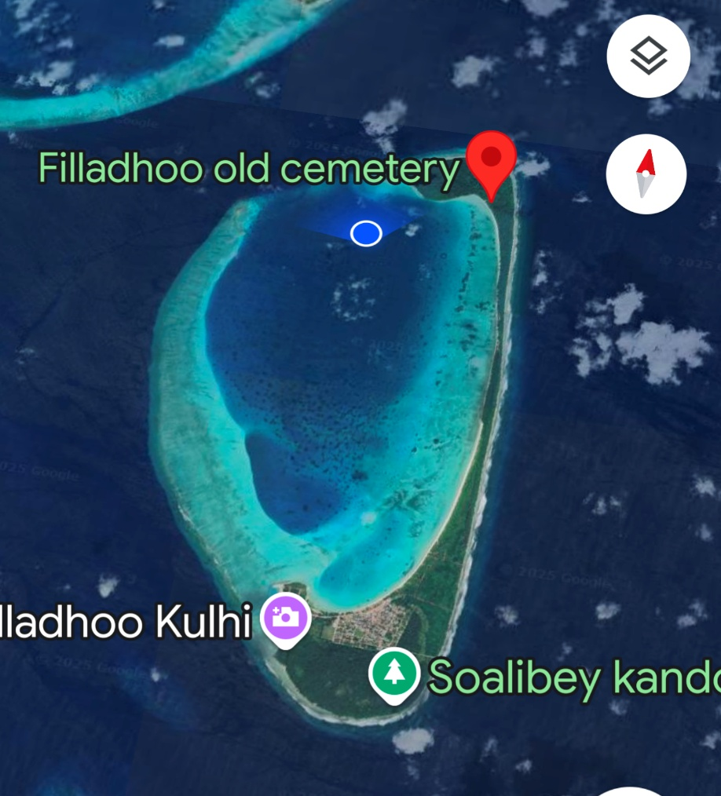

That’s probably not true and all his equipment probably meant he’d nipped to the loo and the boat was on autopilot.
Lots of lightening around us once it was dark. No second snorkel and no talk tonight which meant a lovely long time before dinner.
Saturday 26th April

The day began with a shipwreck snorkel ! It was amazing. The ship ran aground 60 years ago on these treacherous reefs. The islanders heard alarm bells all night but we’re to afraid to go and look. By the morning the ship was there but all the crew had gone, they’d found a lifeboat and got the hell out of there.
When I knew it was a shipwreck, I thought maybe a small boat, but as we approached, it was an eerie feeling, I didn’t know how it was going to look, would a big shadow just loom out of the depths, would it be a disappointment ?
It looked like the Titanic ! Well it did to me, it was huge.

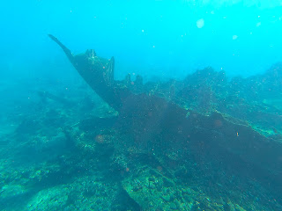

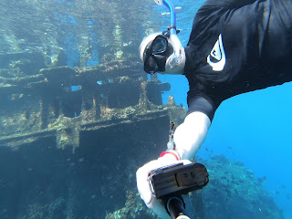

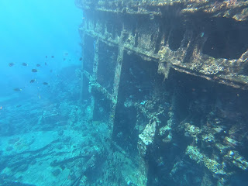

We spent ages going around and around, the old engine house rises up out of the water and the shell of the hull sits lost to the sand and the fish.
I’ve been looking for seaslugs to photograph and here was my first. A tiny little 1 cm long very strange thing. With tentacle bits at the front and a strange body. I was so happy to capture it on my new camera.

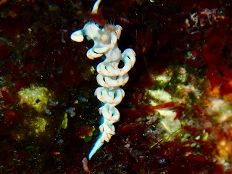

Next we set off in search of more Whales in the deep channel to the East of the Northern most top of the Atolls.

It's rare to get to 10.30 without a sighting, and as the boat turned we knew something had been spotted, unfortunately not from my front seat, it gets a bit competitive, but anyway Chaz telling the Captain to turn the boat means something’s up ahead. A huge group of Pilot Whales with one poor large male who had been in the wars, it must have been a propeller. Huge white scarring on his head and a terrible tear on the end of his back. It must have been horrendous for him, but all healed and he seemed to be managing ok.

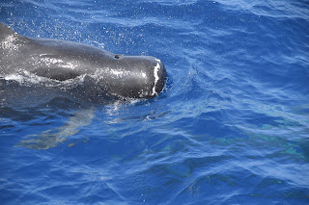

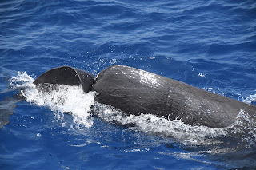

As they hung around for quite a while, the dingy drama happened, 30 seconds warning and a scramble with the hydrophone and the go pro. We are so low to the surface and the Whales are twice the size of the dingy and it feels like something out of Moby Dick. Seven, yes seven of them were heading straight for us side on which was perfect for what we wanted to do. The hydrophone picked up some great audio and I managed to get some footage aswell.

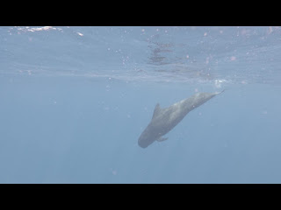

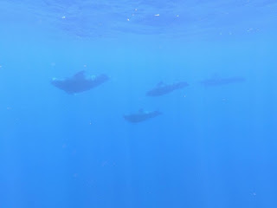

We ended up with a second dingy mission later in the day to get sounds of the spinner dolphins. We had just got this happening as we were being called back to the big boat that was now steaming towards us to meet us and save time. Ish wasn’t happy that we had to leave at the best bit. But nature isn’t always cooperative at the right time !

So 2 hours of the dingy, the heat was once again incredible and it absolutely wipes you out. 4 cold glasses of water, some electrolytes and a cold shower were much needed.

Finally, and more sedately, a snorkel by a deserted island. It’s privately owned but we accidentally fell onto the beach.

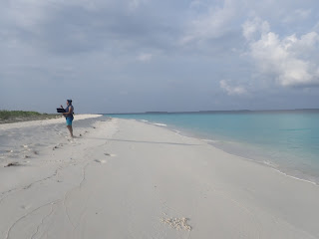

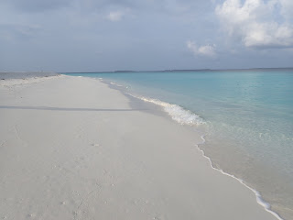

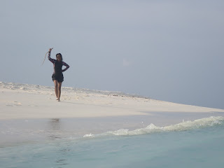

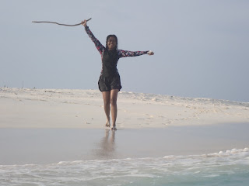

Very early night needed !

Sunday 27th April

Watched a Seaplane take off while I had my morning coffee. Funny little thing on its watery runway. Give me a boat anyday.

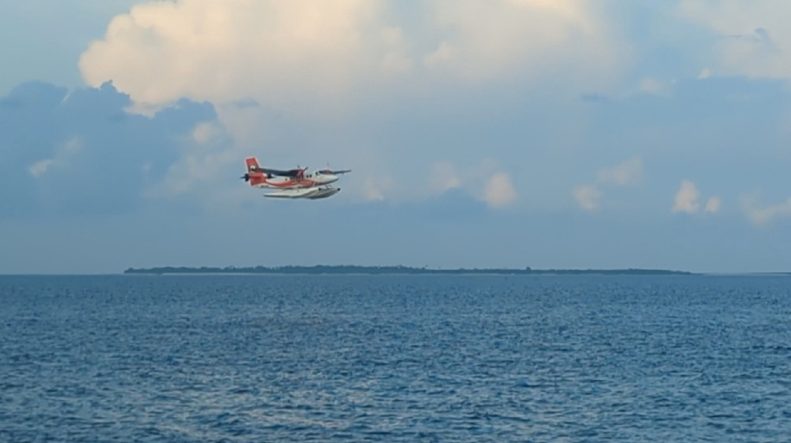

Morning snorkel was a bit dramatic with a strong current that changed direction and everyone had to get back on the Dhoni. The Dhoni Captain was worried about the tide going out and the Dhoni being too close to the reef with a strong drift.
So we all got back on and moved to another spot. The current was apparent as soon as I was in, if I just lay still face down it was like flying across the reef. The water was really clear and the fish were plentiful. Saw an Eagle Ray and a new Wrass. A Queen Coris.

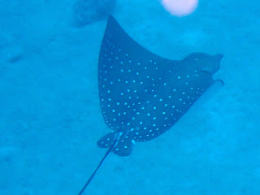

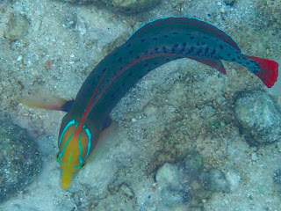

A few people struggled in the stronger current, not sure why, it’s only strong if you are fighting against it ! Which would mean you were trying to go the wrong way. I've never understood people who can't follow simple directions.
Off we went again into a storm ! The sea and sky so black but oddly makes it easier to see any Whale blows.
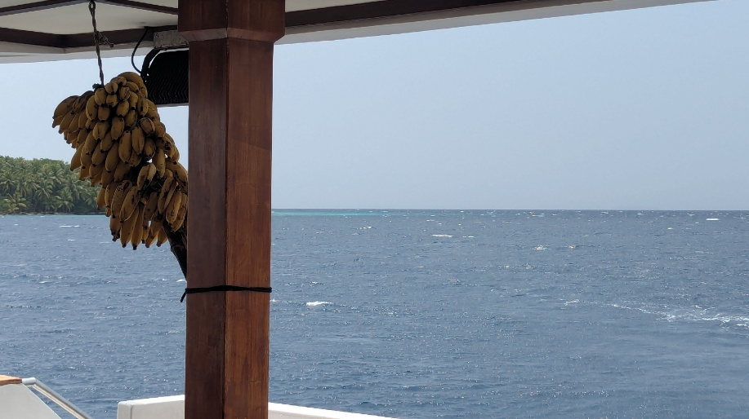
Then the rain came… Top deck gets shut off as it’s too slippery so everyone congregated at my front seat and I wasn’t sure how I felt about this, considering I don’t even share my crisps with my colleagues, this was very hard to deal with !!
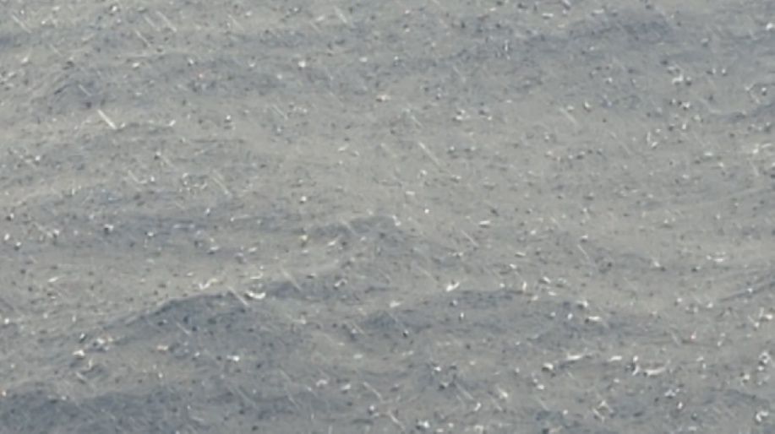

Most of the day was steaming across a dark sea with thunder and lightening all around, still not overly happy that everyone was on my front seat.
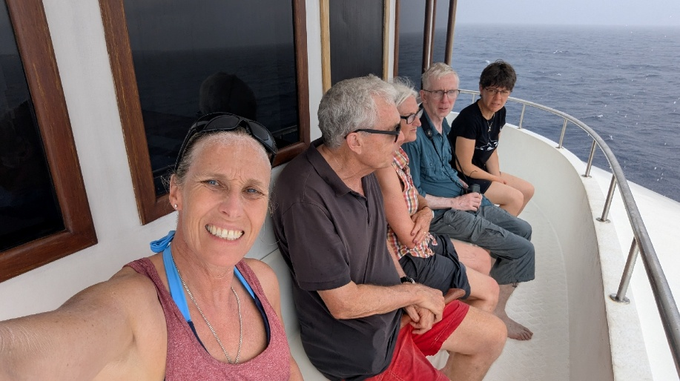
Second snorkel, this was amazing. Totally different kind of reef. Like a big field with deep furrows every few metres, so as I flew across it, it was a trench of sand a couple of metres wide and then a raised coral strip, running parallel. The side of each trench had become new habitat for coral and it was an amazing array of colours and textures.
First of all thought I found a bright green Seaslug and spent ages trying to get a photo.
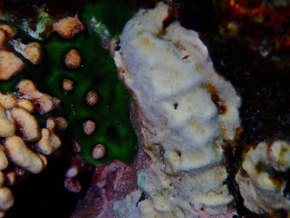

Then I was distracted by Sarah – one of the others on trip, obviously, not just a random Maldivian who happened to be snorkelling off their Island ( and called Sarah ? )- waving me over as she had found 2 Octopus – Octopii, is that right, no idea.
Well, this is where my snorkel went a bit haywire and I lost everyone. I was so engrossed with these Octopus that I was there 30 minutes. One was more shy and his background was pink and white, so he was pink and white.
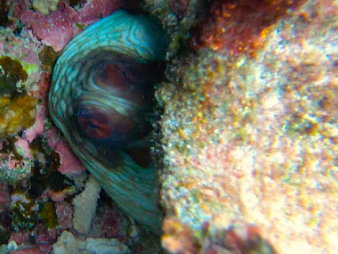
The other one was a bit more cautiously inquisitive. As I swam towards him, he retreated into his safe crevice. As I turned away he popped up to the top of his rock, barely visible.

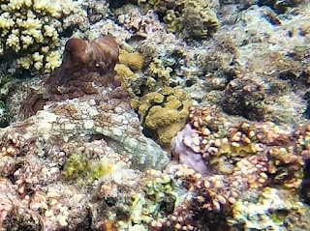

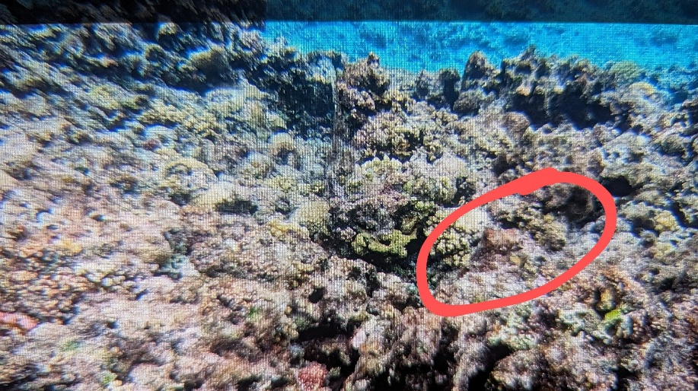
As I swam back he popped down again. I was literally playing hide and seek with an Octopus. Each time I swam back he let me get closer before he retreated. We did this a few times, until he didn’t retreat. My reassuring Octopus thoughts were getting through to him. I often wish I could tell an animal that I would be the last person ever to hurt them, just to save them that initial fear until they trust you.
Eventually he stayed on top of his rock and I was able to get some really interesting photos. 2 of them only a few seconds apart, you can see the colour change.

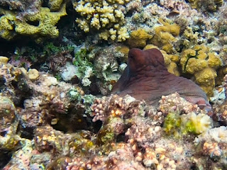

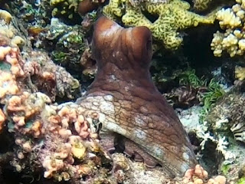

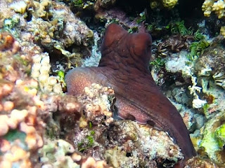

When he’d had enough, he went back into his crevice and started using his tentacles to pull bits of coral in, so he could be hidden and safe for a rest.

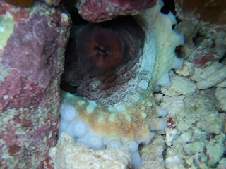

Those moments with him were amazing and that connection when it’s just the 2 of you can only be understood by someone who has experienced that with a wild animal. Albeit for just a few moments.
I reluctantly left them and couldn’t see anyone ! No people, no boat, just a reef and a big ocean. So I kicked my fins as fast as I could going with the current so shifting pretty well, over the sand trenches and the raised coral, sometimes the swell meant that my tummy was dangerously skimming the coral, and realised I was being dragged into the shallower surf, moved out a bit so I was a bit deeper, still hooning along like a boy racer on a reef, only to have to screech to a halt as I spotted a young Giant Moray, I say young because the markings were exactly the same as the huge Giant Morays I have seen before, but he was smaller and slimmer, doing his best to look menacing as he waved his head around outside his chosen hiding place. I knew I was late, but I had to stop and get pictures of him.
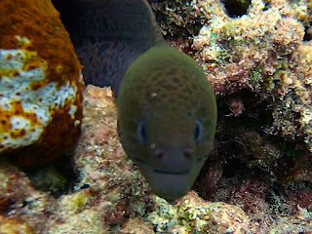

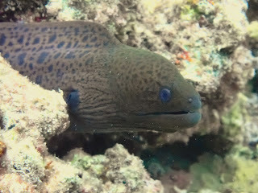

I got back into the filter lane and carried on across my furrowed motorway. Damn it, had to pull into a layby full of beautiful Butterfly fish, one I hadn’t seen before, cursing them crossing my path, my journey was delayed again.

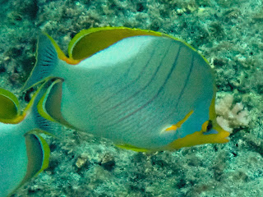

Yellowhead Butterflyfish

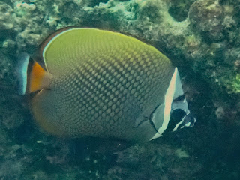

Collared Butterflyfish

Then I really had to go. Oh my god, now there was a Batfish, and being with a turtle expert on board the trip, I know that Batfish love turtle poo, looked left into the adjoining coral reef traffic and there was the turtle, also apparently late for work as he shot across the junction at a speed I didn’t know turtles could do, totally cut me up, closely followed by the bat fish.
Surely now I had covered miles to catch up, nope, the Dive boat which had thankfully come into sight was now heading straight for me to pick me up ! I swam as fast as I could to reach it worried that everyone was on board and waiting for me. Instead I got onto an empty boat and worried even more that they had already taken everyone back to the big boat and had had to come back out, perhaps once people realised I wasn’t there.
This wasn’t the case I realised with relief, as the main group were still in the water, but the Dhoni Captain wasn’t happy with me being so far away. If you are at the back, you have a duty to keep up and if you are at the front, you have a duty to drop back, so theoretically the group stays together. So I apologised profusely to him as he waved his arms in exasperation at everyone being spread out over a huge distance !
I quickly forgot about this because I was so exhilarated from my amazing snorkel, as people clamber back onto the boat everyone shares what they saw and there’s excitement all round. I told of my octopus, but not all of it, because you can’t explain those trusted moments really, they are just a heartwarming experience that can only be felt and not conveyed.
On that basis, and I mentioned it before, that I have some of my father's ashes with me. We shared a trip on this same boat in 2018 and I owe all my passion for wildlife to both him and my mum ! It has felt right that I scatter some of his ashes here on an Ocean he loved. So with a beautiful sunset happening and my amazing encounter with my Octopus, I secretly went back to my cabin, got my little screw top pot, wrapped it in a t-shirt and sneaked to the back of the boat where I sent some of Clive to go and meet my Octopus, they wouldn't know what to make of him, and he would probably recite stories of seeing 27 Octopus. A bit of a standing joke after we saw 26 Blue Whales in Monteray Bay and each time we heard him recite the story, there were more and more, the last count I heard was 47 !!
I made sure I got the wind direction right and tipped some of my little pot into the Ocean where the contents floated back towards my beautiful reef and my 2 Octopus.
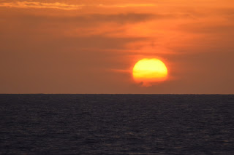

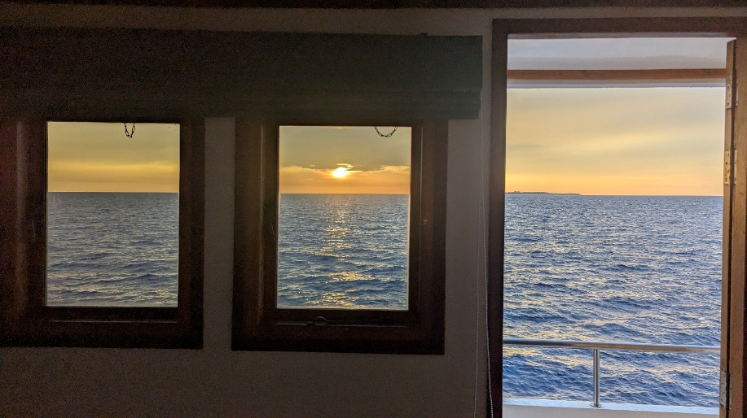
So 2 incredible snorkels today and a beautiful day on a dark tropical stormy sea.
I couldn’t wait to get back to go through all my photos, and then was late AGAIN, to the evening talk, which was a brilliant talk from Isha about the turtle conservation work that she does.
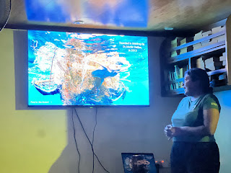

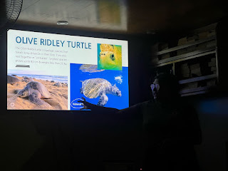

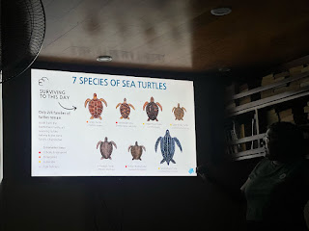

A truly educational and special day.
Monday 28th April
Snorkel news.
There’s a lot to do once you’ve jumped onto the Dhoni from the big boat.
Everything is stored in a crate under your seat and you then get ready there every time. Wetsuit boots go on, my knife gets strapped to my leg. Mask and snorkel next, there is a bottle of spray with fairy liquid in it. Spray into mask and rub it all over the glass. This stops it fogging up. Mine did still fog up a few days ago, but the voice of experience Sue Anderson told me to smear toothpaste all over the inside surface .. it worked !
So you spray the fairy liquid stuff but don’t dip the mask in the bucket to rinse, splash water into mask and throw over edge… this goes back to when people spat in their mask ! Nice !
People wear lots of different things snorkelling. I wear long gym bottoms and a rashy top, really just to cover me from the sun, but it's also semi sporty and looks like a wetsuit and kind of matches the activity.
I don't think I will dress like this.
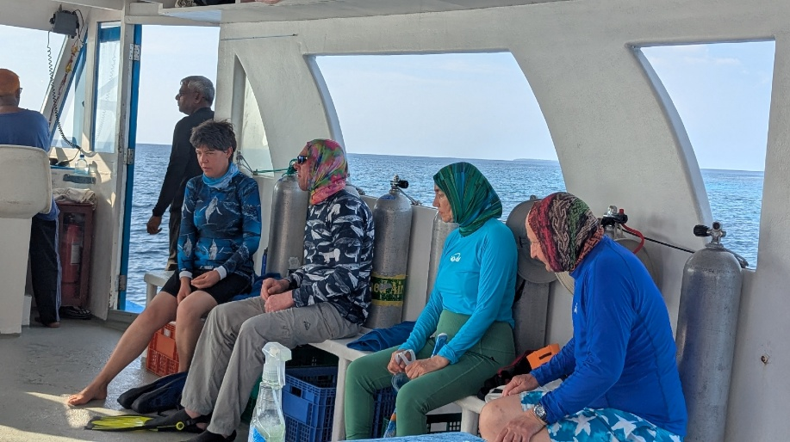

Although good for keeping sun off head and neck so I get it. I just don't ever want to wear it.
Then we have a briefing as to which way we’ll go, left shoulder to the island and drift along the reef.
Then put fins on
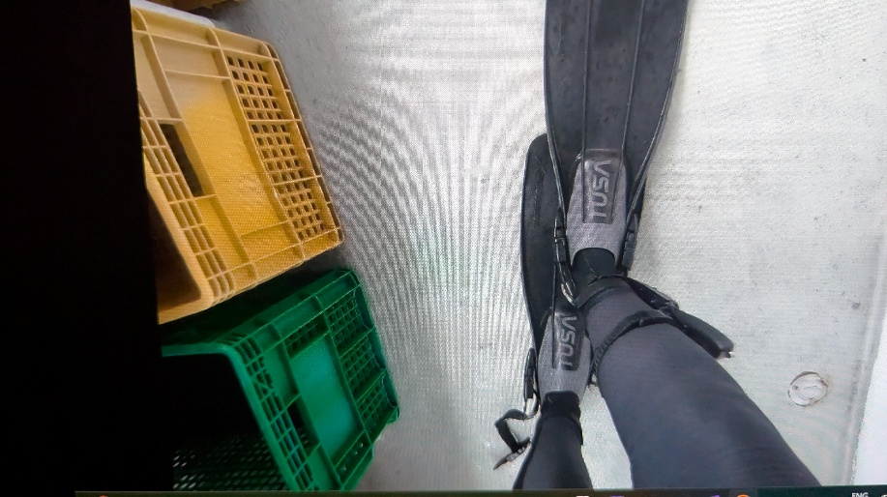

Then you jump in and bumble around the reef and see what you see. It's different every time.
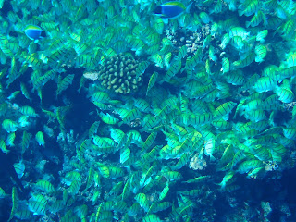

Shoal of Convict Sturgeonfish

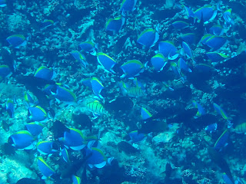

Lots of Dorys

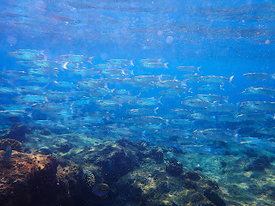

Fussiliers
When you’ve had enough, then stick your hand up and the Dhoni will come and get you. Rear propeller is exposed so no-one's allowed to go to the back of the boat.
Except this evening, a few of us were already on the Dhoni and a group of Indo Pacific Dolphins came drifting by… Somehow Paul had managed to be near them and was accepted into their pod and they all swam off together. Right place, right time. Hate him. Paul later sent me the photo of his encounter with them.
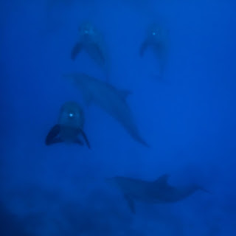

For some reason while we were all getting ready, Jan walked over and hung her towel right in front of Sarah, thought nothing of it and just walked off. People never cease to amaze me. Sarah just peeped out from behind it a bit bewildered.
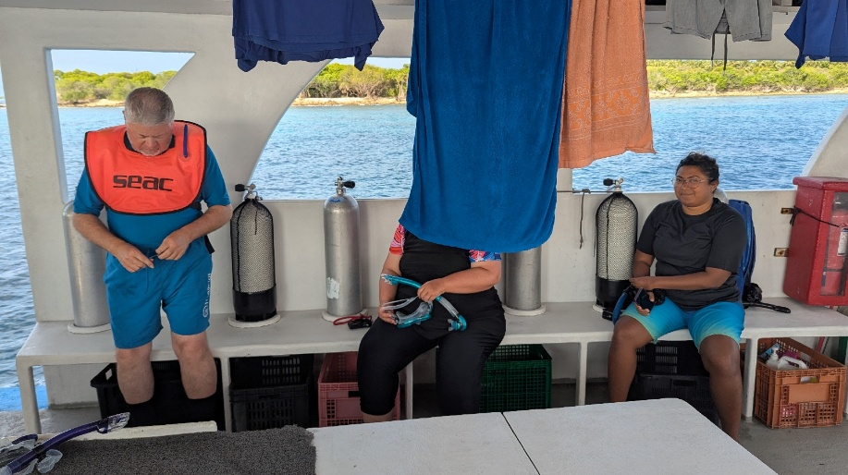

At Lunchtime, a group of Spinners were around us and we went off in the dingy to basically slowly stalk them. As we jumped onto the dingy, Jan, who seems a bit of a fruit cake, went to step onto the dingy, as she did, the boat rolled and I watched Jan in slow motion, miss the dingy and land in the water. I shouted "Man Overboard" loudly, which wasn’t really necessary as all the crew were right there and she only needed to swim 2 feet to the ladder at the back of the big boat. Once we all knew she was ok, it was then one of the funniest things I have ever seen.
Poor Jan. Not Happy…..
Pretty happy on my boat really.
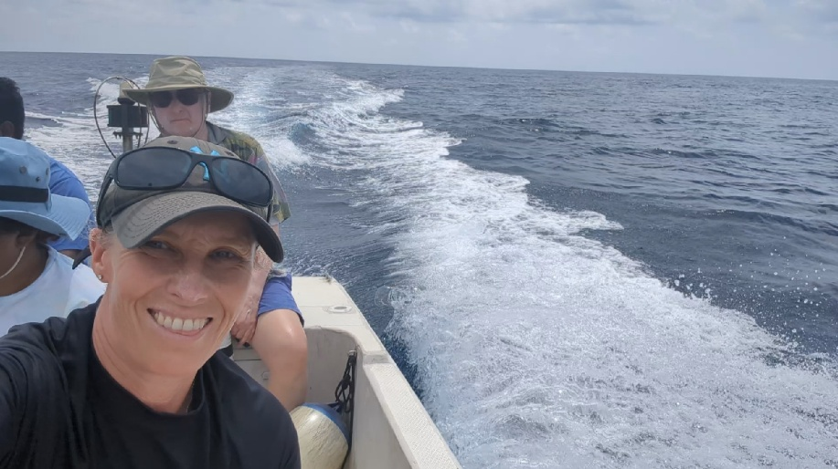

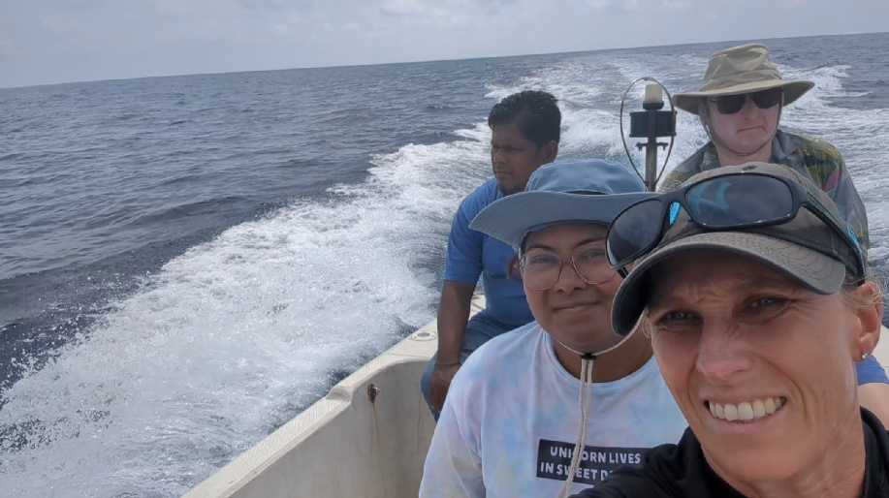

We missed lunch and had a separate dingy crew lunch when we got back.
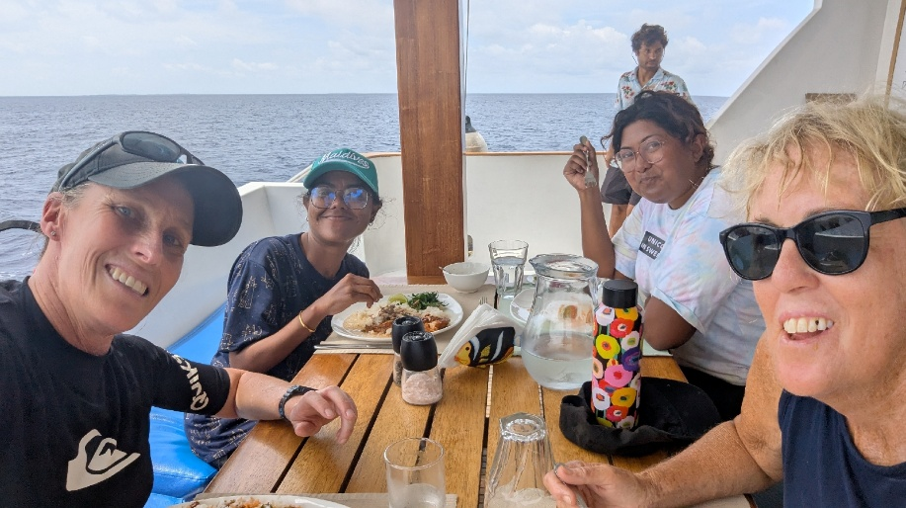

Quiet day for sightings, we crossed the Atoll to the other side and did start seeing things. There’s a deep ledge about a mile off the islands and that’s where so many thing feed on Squid. A few Rissos came by followed by sightings of Dwarf Sperm Whales, I love all Cetaceans but these really do lack personality and generally just log at the top before diving and that’s all you see, an upside down surfboard on the surface with a long back and a fin. And then they’re not there anymore. But anyway, they are a Whale !
That’s about it for today. A talk and dinner to go yet, and hopefully an early night. I have no idea how I will sleep when I get home without the gentle rocking of the boat !
Tuesday 29th April
A flat sea finally ! And a better sunrise. We had a visit to a nearby island, the Island where our Captain lives and he arranged a tour to the Mangroves. First we were greeted by the people of the Island and presented with a gift and we all had a coconut to drink.
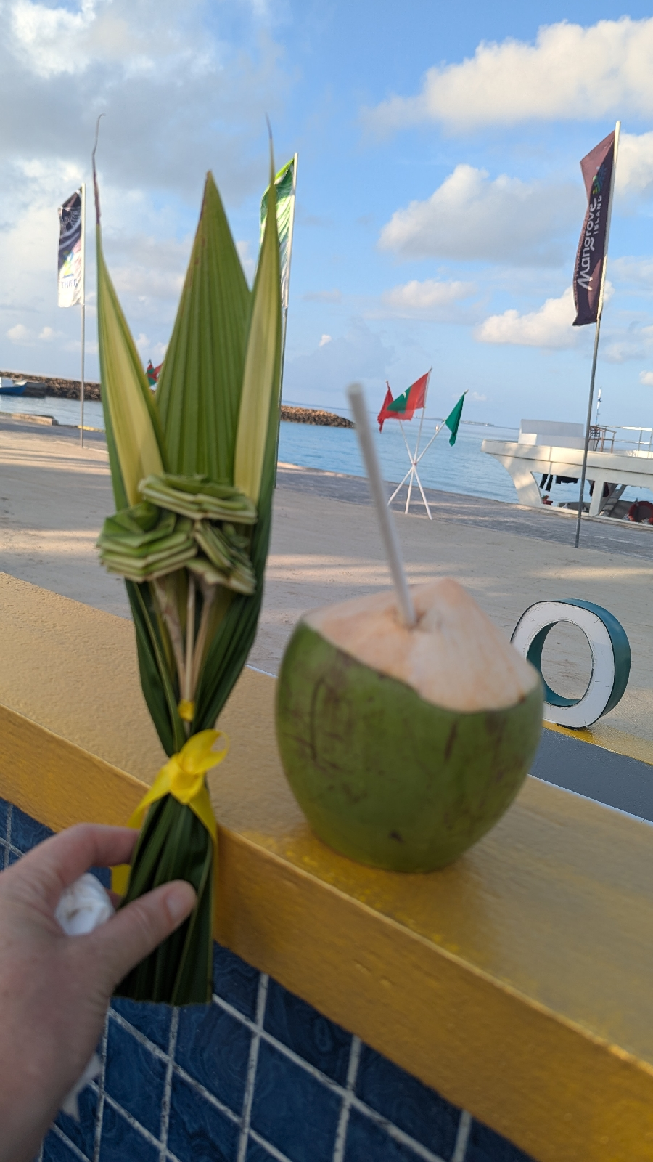

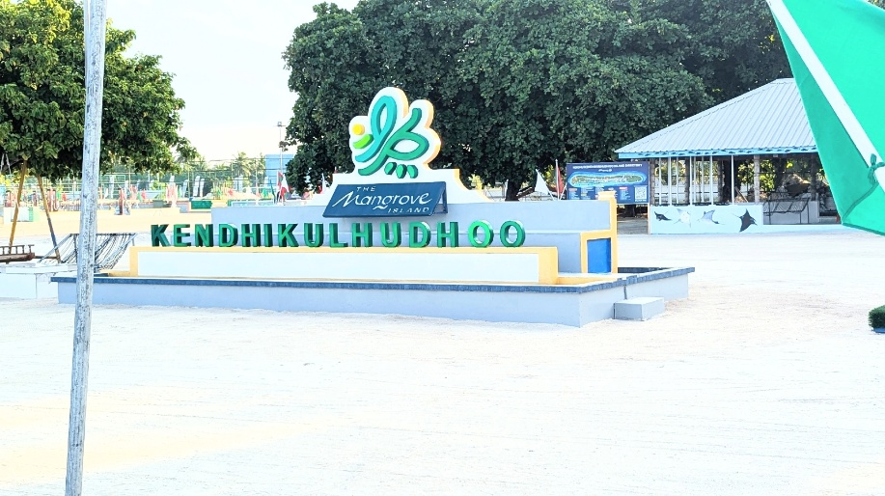

They were so welcoming and friendly and a vast contrast to the previous Island. Our transport was a flat bed truck and in we all clambered.
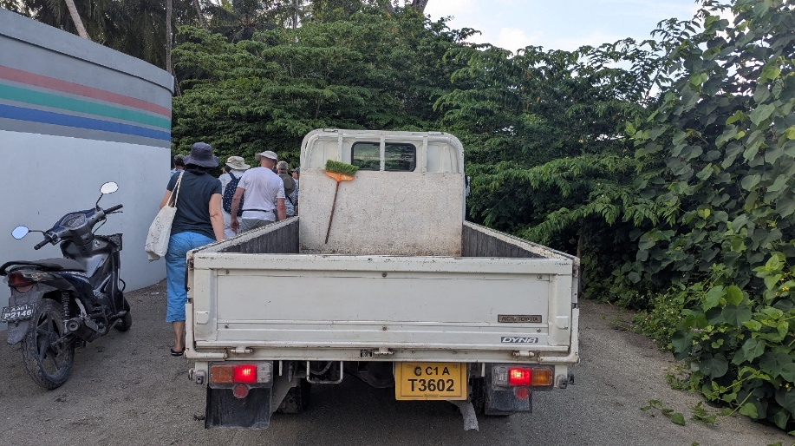

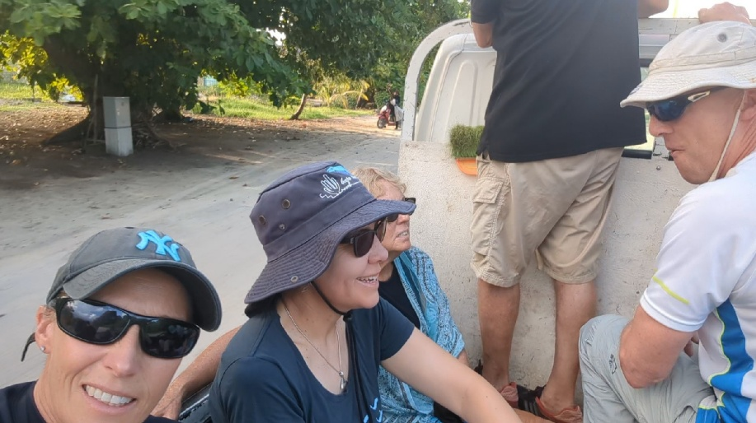

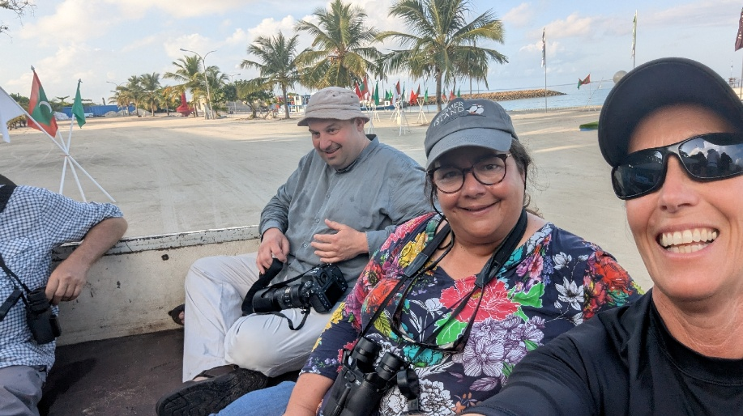
For me this was fun, for others, not so much.
The only frustration was all the time this was taking when the Ocean was right there and flat and calm !! Anyway, it was a great excursion and they’ve built some boardwalks that put you right in the middle of the Mangroves.
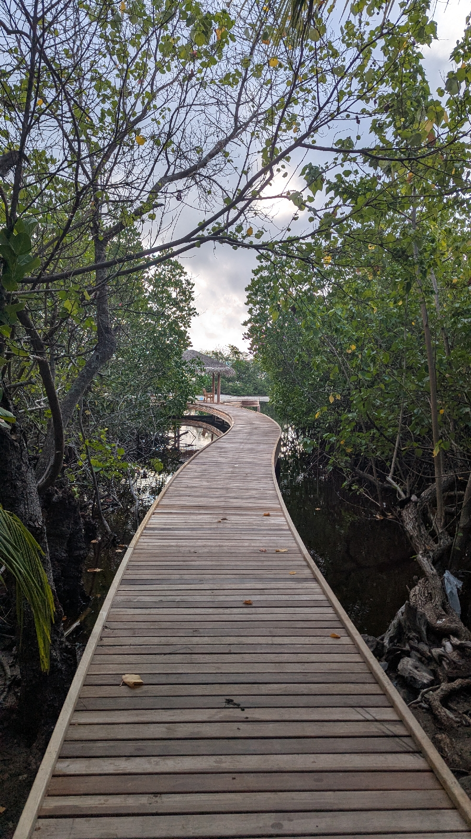

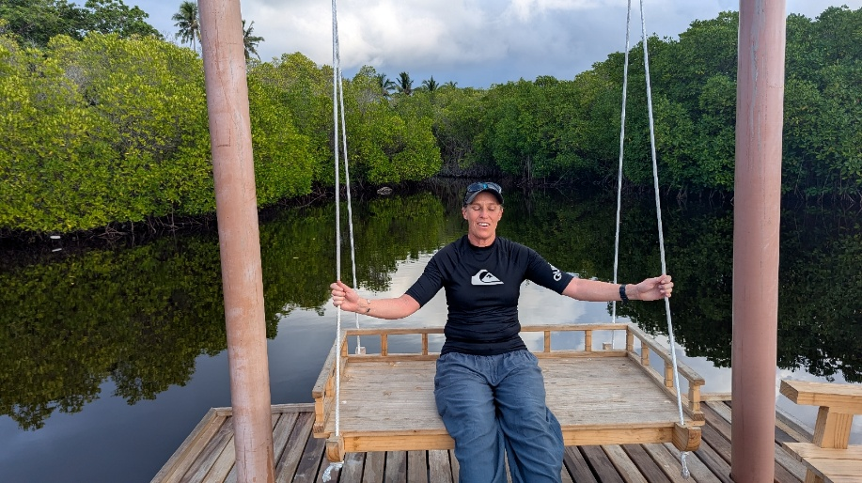
Jan took this photo of me, last time Jan took photos of me, there were no photos ! So this one with my eyes shut is an improvement on asking Jan to take a photo of me...
On the way back Chaz suggested I would want to go on the back of one of the moped with one of the islanders – yeah I do ! Leapt off truck and onto moped !
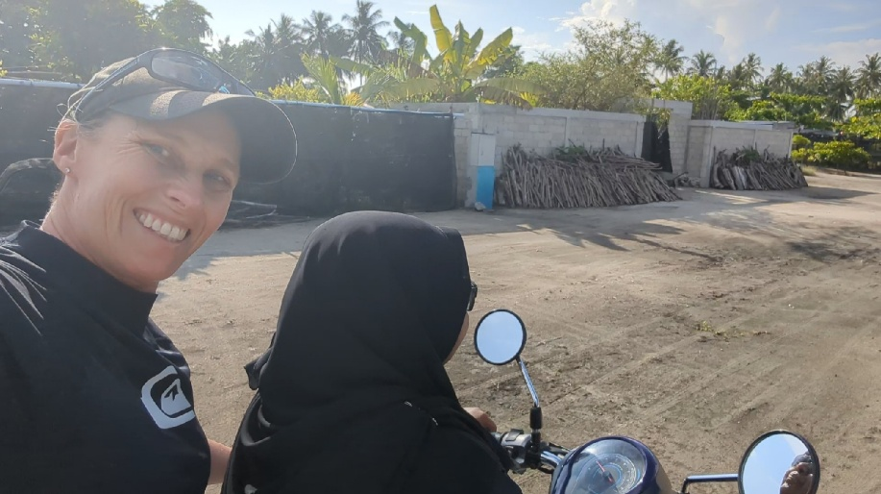

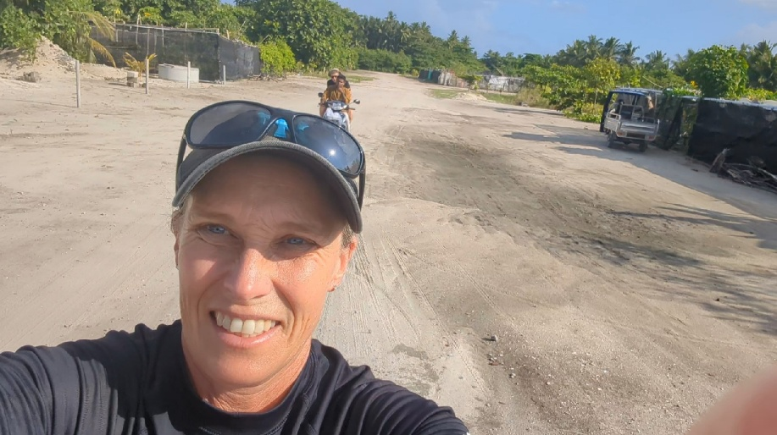

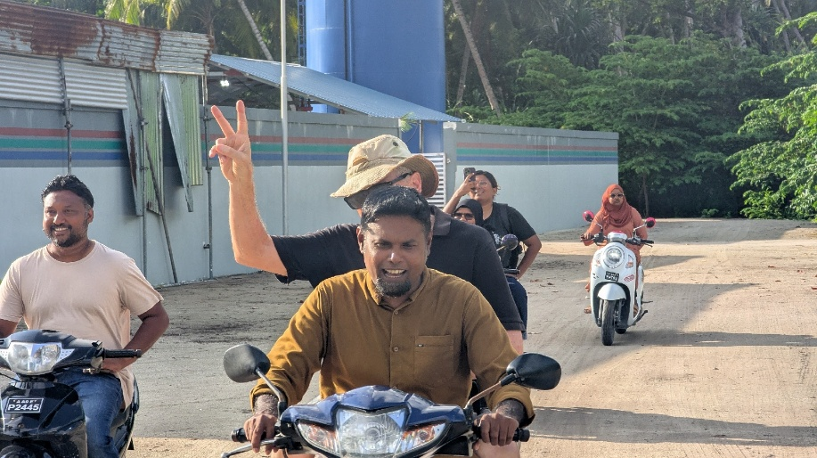

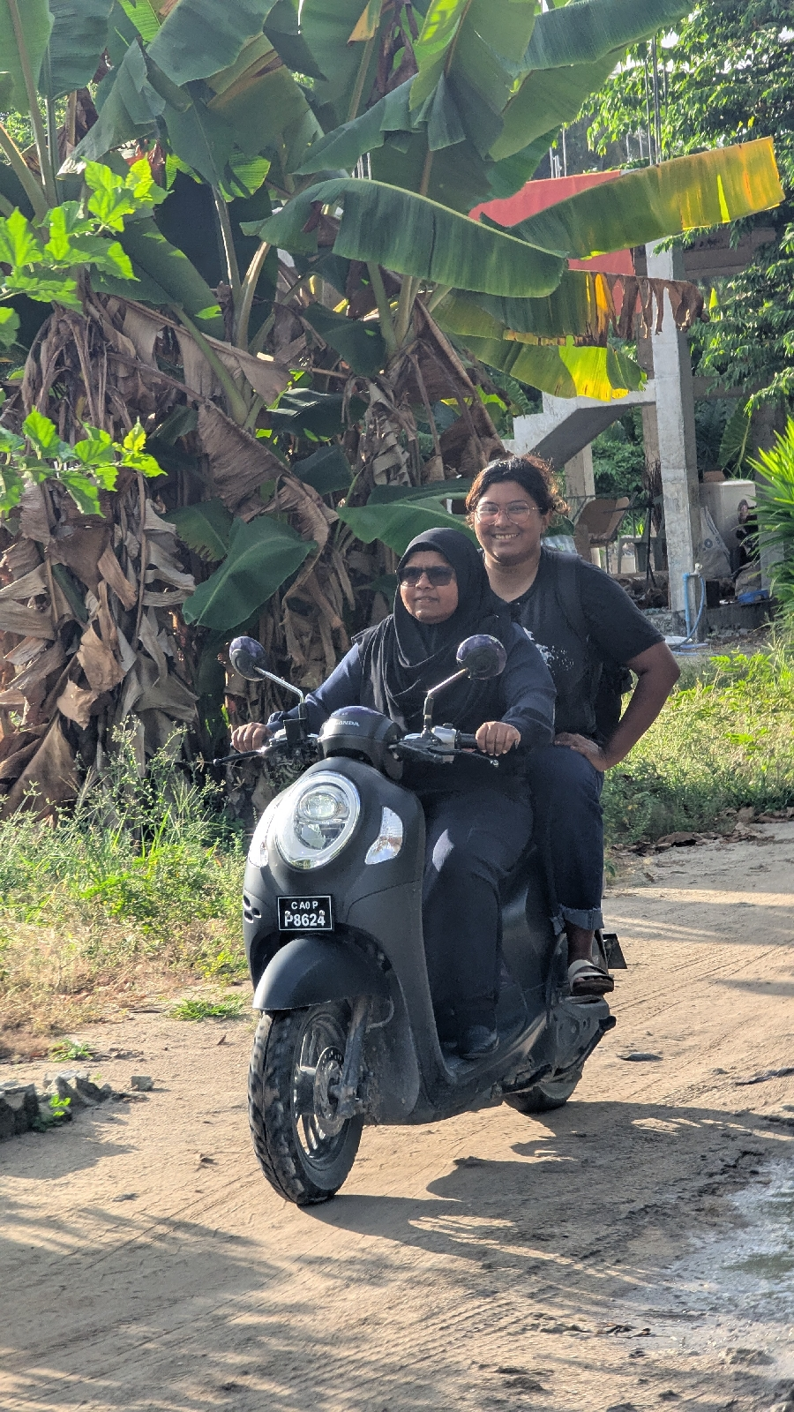

This was fun whizzing across the island !
Some of the houses were built of coral and some are of bricks, sand dredged up and mixed with cement and then left in the rain for a year to wash all the salt out and then they can be used to build houses.
A 2 bedroom apartment will sell for £31k – wow.
Back on boat and we got going asap. It was hot at the front so I sat with a towel covering my legs and Jim sat inside his cabin, watching from the front windows. Chinese whispers started on the radio. I heard “ 90 degrees left large dorsal” what Chaz had said was “90 degrees left Dwarf Sperm !!” I preferred my version but had to tell everyone to stop looking for a tall dorsal and instead look for the very small upside down non charismatic surfboard ! Poor Dwarf Sperm Whale, it’s not his fault he’s a bit dull. We felt like he'd failed his audition, so we carried on, I have a good feeling about Blue Whales today and am desperate to have some calm sea photos of them as opposed to the choppiness of Monteray Bay.
The view from the front of the boat is just wonderful and a real mindfulness elongated moment that I want to etch into my mind permanently.
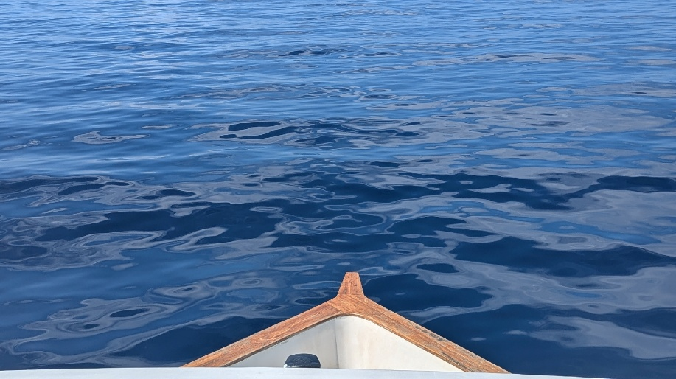

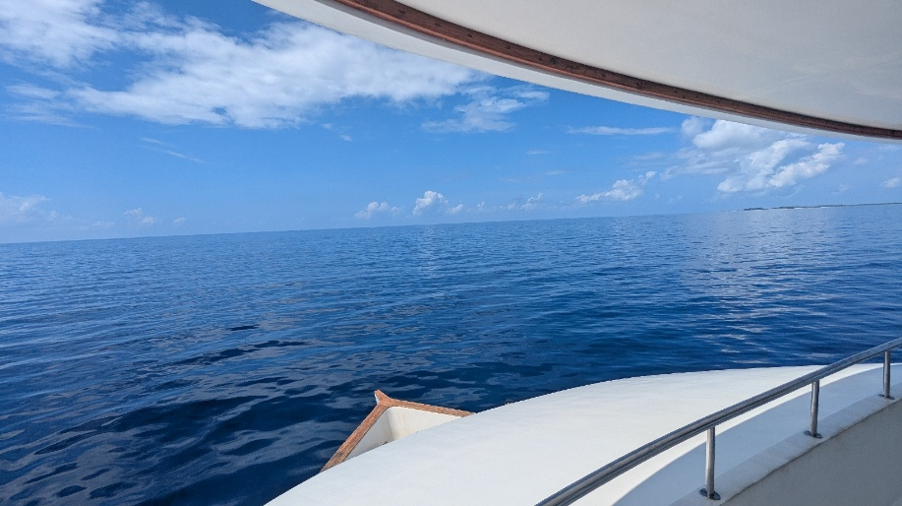

11 o clock is Juice Time, and Siphul brings around some sort of delicious juice everyday.
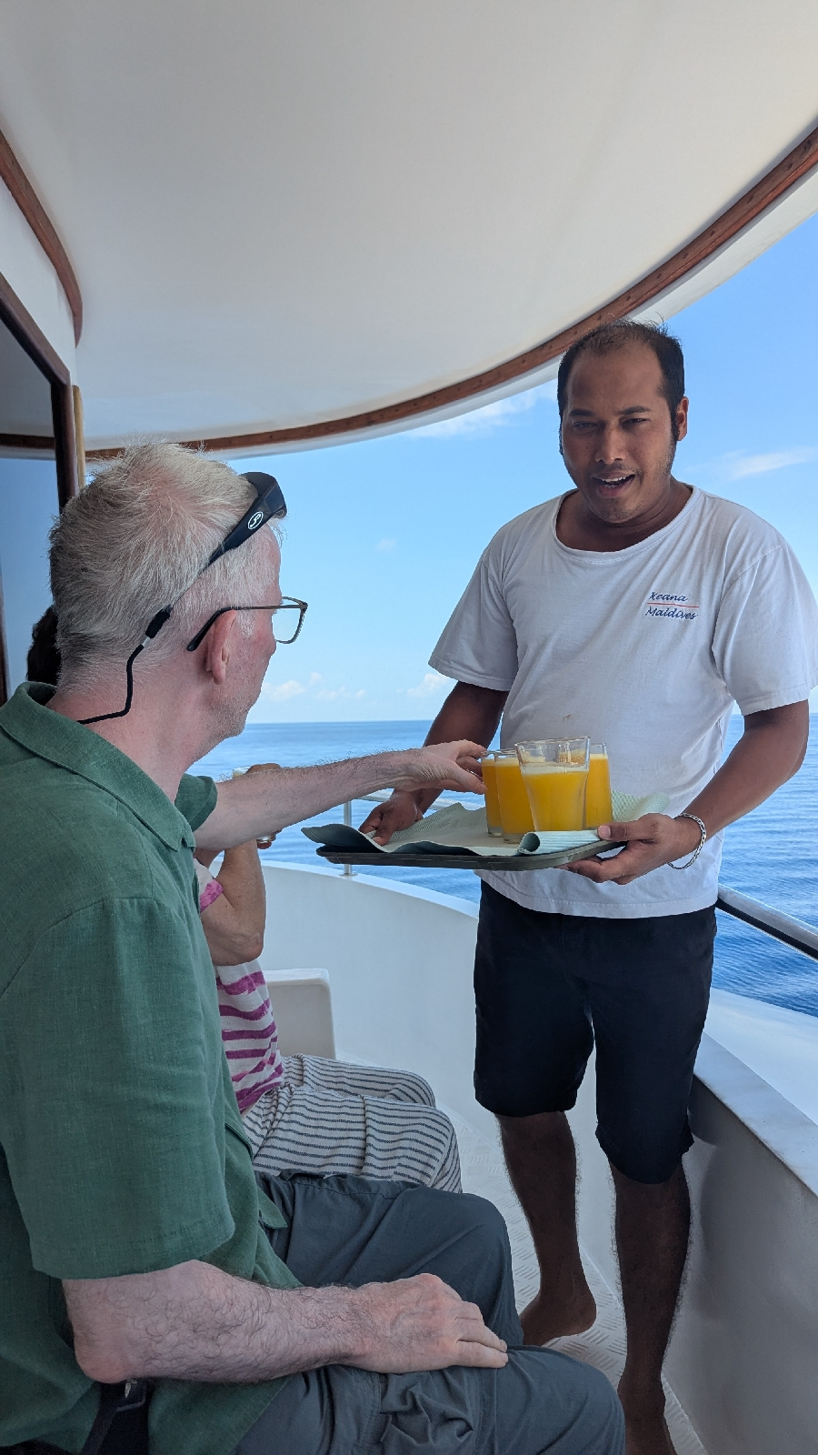

We had waiter service to our front watch deck.
That was the rest of the day basically, mirror calm water over deep water along the shelf where squid are and theoretically larger cetaceans feeding.
There was some excitement with taller dorsals up ahead and took us ages to work out they were in fact Rissos and not the Orca I was willing them to be.
I had an excellent view of a Blue Whales back, far off on the horizon, but by the time we reached it, it had morphed into a flotilla of ocean junk, netting and wood. We slowed as we went past to make sure nothing was entangled.
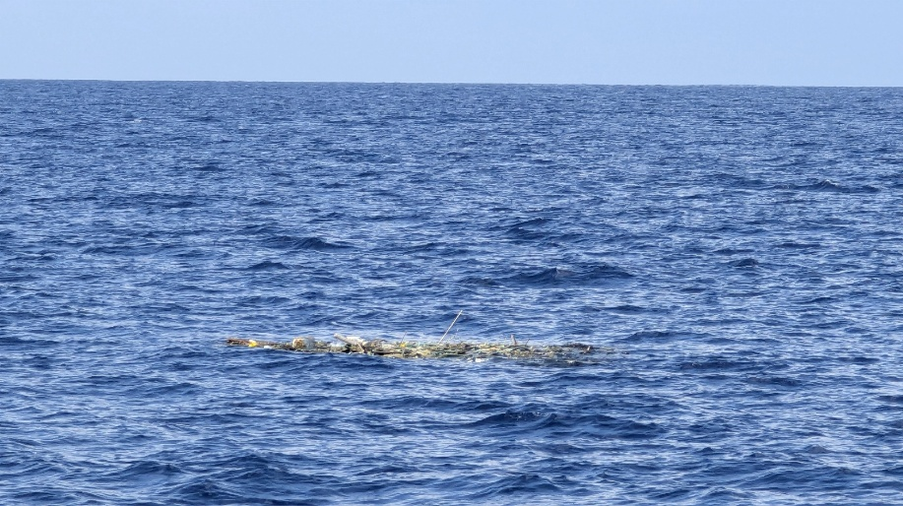
It was an easy mistake to make !
So, quiet again on sightings, but still a wonderful day at sea.
Some lovely Spinners came in as we anchored. This was how calm the water was and if you look closely he's got a bite from a Cookie cutter shark !
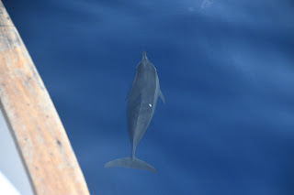

We had a snorkel at the end of the day, beautifully clear water which gave great background for photos, but it also means that the water has no nutrients in it !

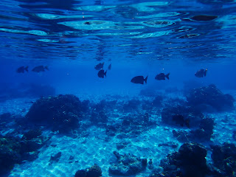

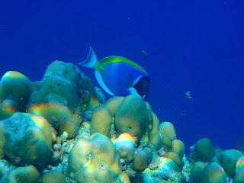

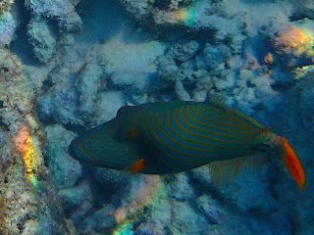

Orange Striped Triggerfish

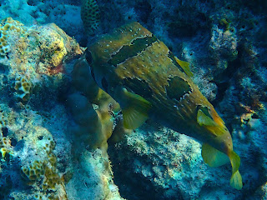

Blotched Porcupinefish

The sun is always setting when we return from our late snorkel, it showed the boat off nicely.

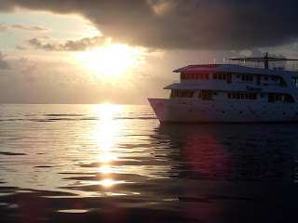

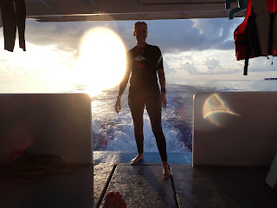

We had an evening talk on the Monsoon seasons and how these affect nutrients, feeding, migrations, birds nesting, and all sorts !
There is talk tomorrow of a few people diving, which we can request to do. I am perfectly happy watching for Whales and snorkelling, plus Jan is going diving and that worries me somewhat !
Wednesday 30th April
A few people had opted for a dive which the boat is happy to accommodate, it’s really Whale watching and snorkelling but with all the equipment to hand it gives divers the opportunity if they want it. I have dived but also find it a bit of a faff…. ! Big heavy tanks, and lots of things to check and going so deep you’ll basically die if something happens. Then you have to stop on the way up and hang around to equalise so your body doesn’t blow up, plus, on top of all that, it’s dark ! This is no use to someone who likes taking photos ! So, in case anyone was wondering, no I didn’t dive.
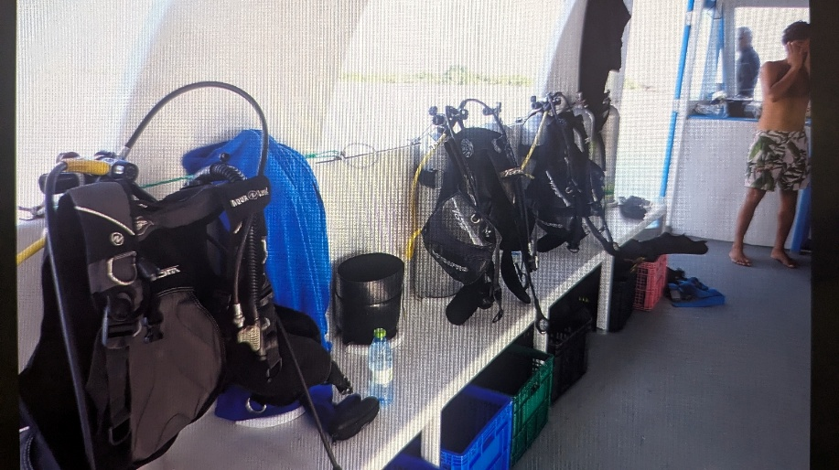
Faff, alot of Faff.
Morning snorkel was a known area for turtles, as soon as we got in the water I noticed a Batfish and having learnt from Ishas talk on turtles Batfish like Green turtle poo and sure enough, I spotted a beautiful Green Turtle tucked under a rock, she came out and headed for the surface and off we went on a little ocean journey together. The shell was perfect, unlike some of the hawksbills whose shells end up with algae on and quite frankly they look a mess, whereas here we had a very well presented Green Turtle with a very smart shell.
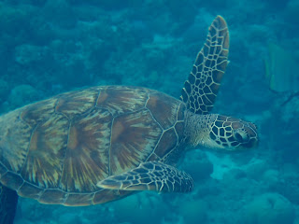

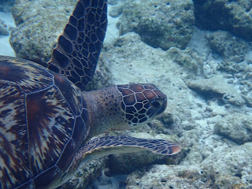

I stayed with her for ages, I think it was a female because it was a very short tail which we also learnt from the talk the other night. I wanted to get the ID photos that ISH wanted. You get one of the top of the head and one of each side. The platelet markings on ethebhead are individual to each animal. I did manage to get these photos, then as I was watching, the Green Turtle Played tag with a Hawksbill going the other way, so I about turned and stalked him to get the ID photos. Around 5000 individual Hawksbills are already recorded in the Maldives so ISH will be able to tell me if it’s a turtle already recorded or if it’s a new one. It’s good having a sense of purpose to a snorkel, either cutting rope or fishing gearear form the coral, or taking ID photos of turtles !
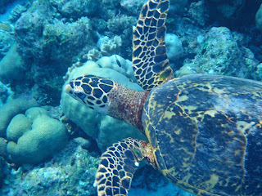

Hawksbill
There were also a few new fish which gets addictive aswell.
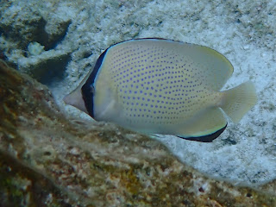

Spotted Butterflyfish

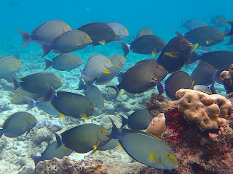

I’d dived down a few times to get the ID photos and could feel that my ears were full of water quite badly and I couldn’t hear properly. Figured this would correct itself through the day.
Once we were back on the boat someone pointed out Anton, Anton had been one of the divers and Anton was hopping up and down on one leg with his head on the side. Figured it was just some sort of strange German ritual and carried on with my breakfast, until Jim pointed out that Anton was getting water out of his ears !! Now I was very interested and asked him to please demonstrate again . Then I copied, hopping hard on my right foot with head tilted to the right, there was suddenly this release of water from inside my head and I felt it coming out of my ear !! It was the funniest thing, and I was so relieved. The one morning I was worried I had water inside my head for the rest of my life and bingo, a great demo from Anton to resolve it !

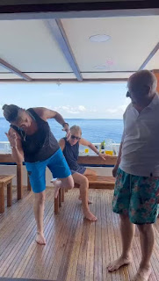

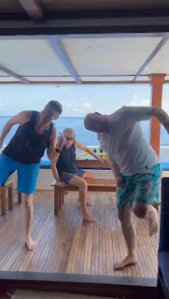

The rest of the day was travelling and spotting. It was a good team effort with lots of eyes and the radio being busy. I mainly reported sightings of rubbish that was whale shaped ! But even a report of a glint up ahead becomes part of a bigger story if someone sees a fin 10 minutes later. It’s fun piecing it all together and then as we get nearer and nearer trying to identify the mysterious cetaceous object !
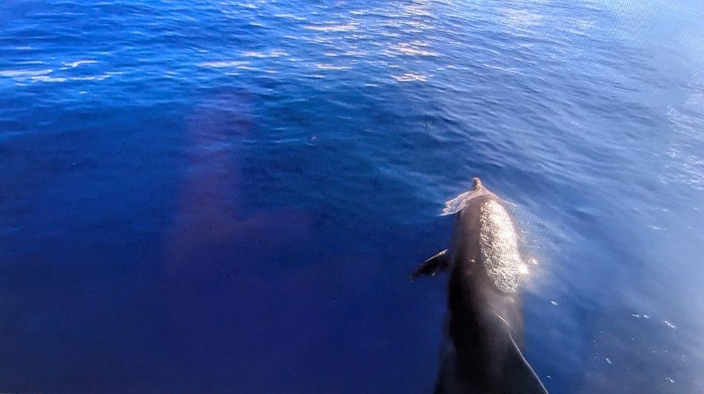

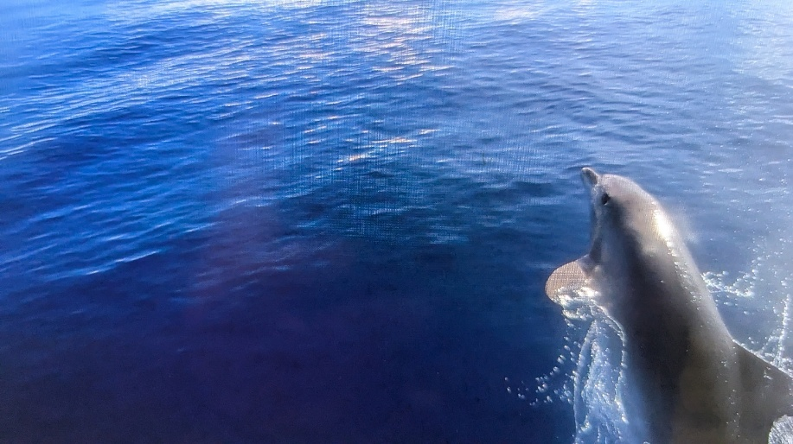

Had some great Bottlenose Bowriding but I had the angle of the Go Pro wrong which was annoying, they were so clear and right beneath me !
We also did a couple of dingy dashes and agreed that these have got far more efficient. We each have our place to sit.Ish sits in the middle to balance me and Naasaad swapping sides. The hydrophone cable can't be touched otherwise the microphone picks up the noise, we don't talk for the same reason and I have got better at getting the go pro in at the right time and angle, so between us we manage to get some useful clips of audio and film ! It's still baking though on the dingy so I now wet my snorkel top, and put it on wet. This helps me stay cool alot longer.
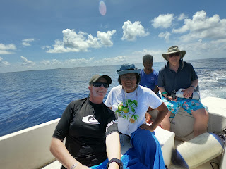
Also being covered in zinc helps the situation.
It was quiet for a couple of hours but then we had 3 hours of pretty constant sightings, so snorkelling got knocked on the head as we carried on in search of bigger fish ! I really want to see False Killer Whales, well and real Killer Whales for that matter and I so wanted to see the Blue Whales, but we still have 2 whole days and it may still happen.
We anchored late and the sun was already setting.
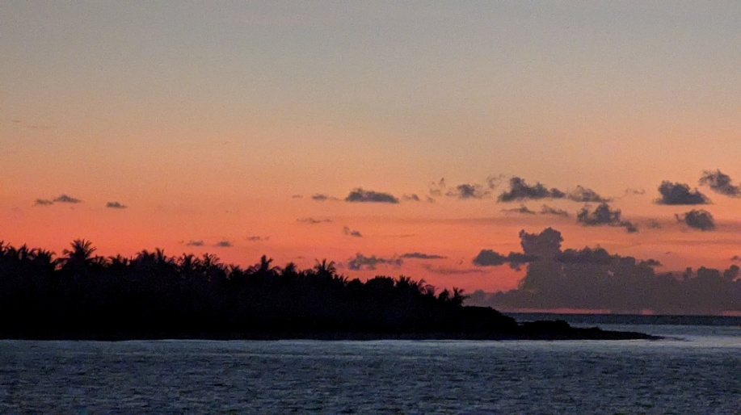

Thursday 1st May

Its only 7am, I’ve been up since 5.30 and had a beautiful large pod of Spinners just very gently making their way back into the Atolls after a long nights hunting and feeding.

So they come back in to rest during the day and it’s where we rested in the shelter of the islands that form the Atoll. Like a tag team.
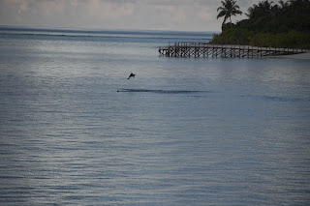

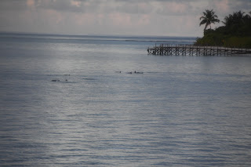

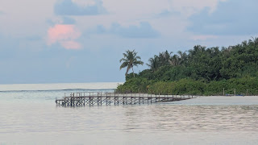

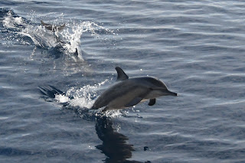

As we headed out I spotted a single larger fin and radioed up to Chas now positioned on top deck. It’s funny how I’ve got to know behaviours and having just seen the spinners and their little fins and in a big group, it’s immediately obvious that as a lone being it’s very likely to be a Bottlenose.
So 2 spots for me already !!
Spinners at 6.20 and Bottlenose at 7am.
We’re now onto something else as we come out of the Atolls... This is exciting, I love it when the radio is busy and it’s one after the other !!
Spinners just off the reef as we left Atoll but they were right into the sun so we left them.
Then Jim decided to play another game of ispy !! Yesterday’s was W and took me ages to get Water !!!
My 4th sighting was splashing off to the right but then they disappeared so we left them.
And now 5th sighting at 8am radioed to Chas we had splashing, he didn’t reply, asked him if he’d heard it, he said he had been distracted. Ok so then we wanted to know what he was distracted by... A log and a Sailfish – advised him that my sighting was better ! He had to agree !!!
9.30am splashing as we approached island.

6th sighting
Immediately to the left of those very active, and what turned out to be a very large pod of Bottlenose, were a group of Pilot Whales, then immediately a splashing raft of Frazier’s came in on the right, they stay in a tight huddle as they hurtle along, so it’s a tight group of low splashes making them easy to distinguish from others at a distance. Well not easy but different !

2 hours we spent with this lot ! It felt like 10 minutes. I try to think of different ways to capture them, so sometimes it’s the big camera on the surface, sometimes it’s the go pro videoing them on the bow.

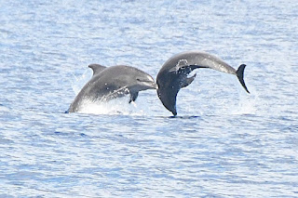

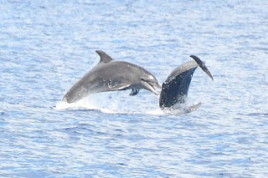

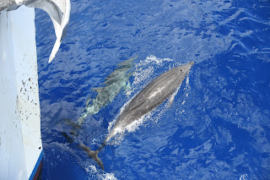

Bottlenose

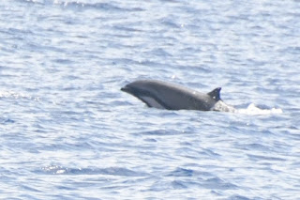

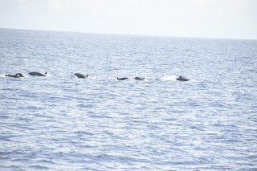
Frazier's.

We had a snorkel mainly to cool everyone down. Massive cracks of thunder and raining while under the water.

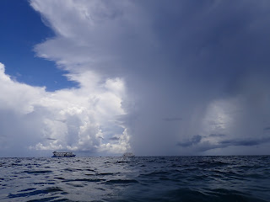

It was Chazs Wife Sue's birthday today and various things had been made or gathered from around the boat for her birthday.
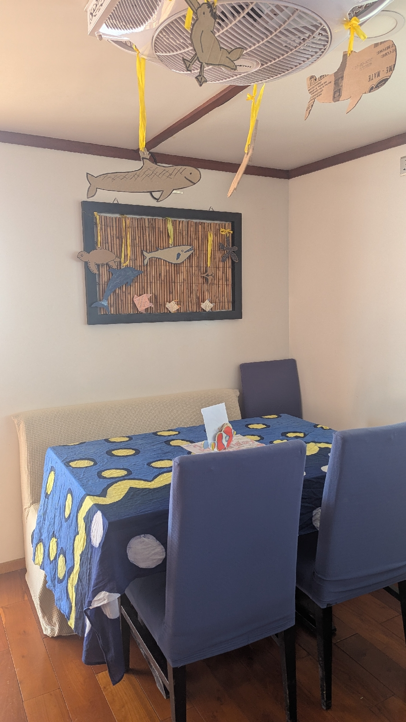
We had afternoon tea and the chefs had made a cake.

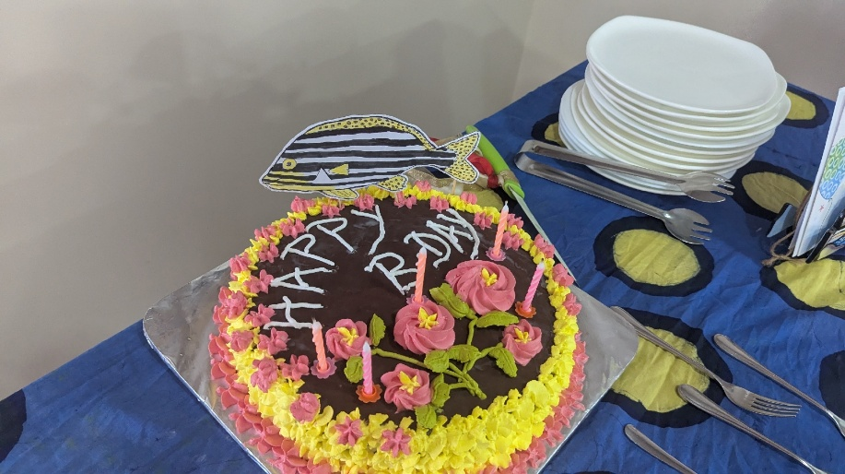

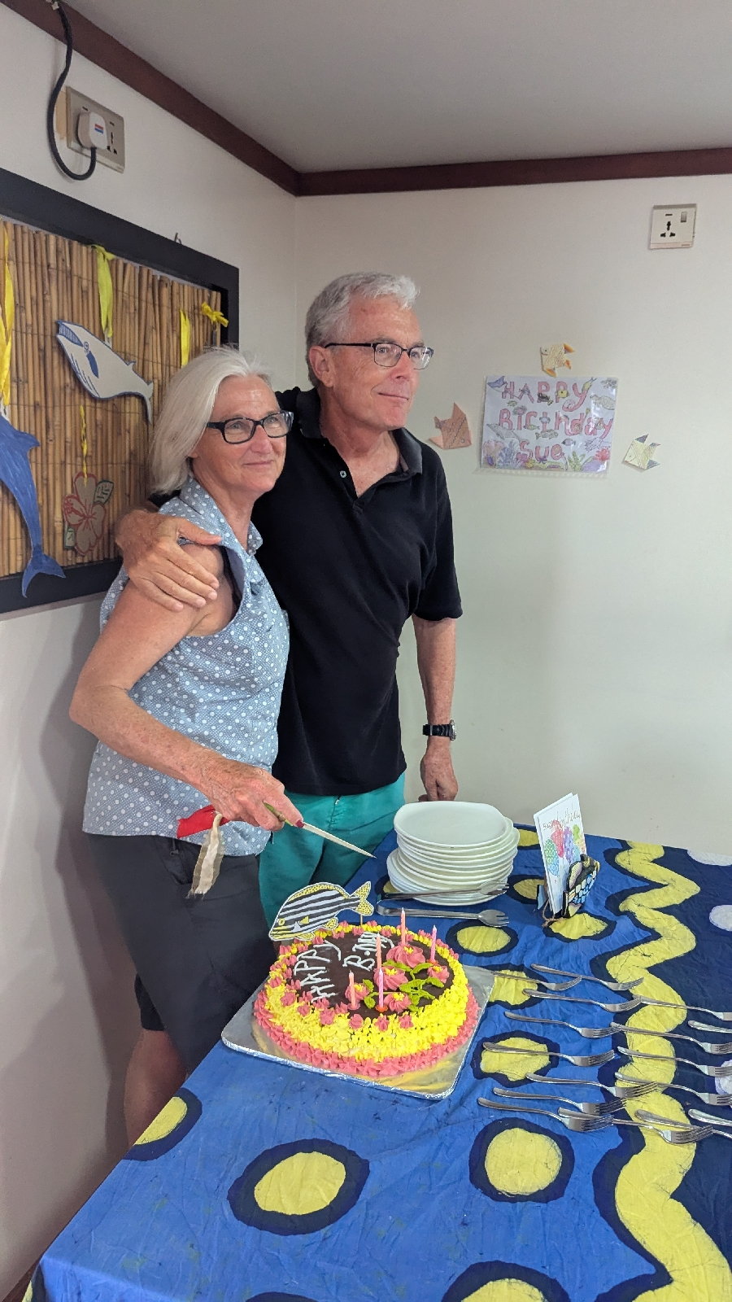

I got to fly a drone ! Now I want one !

After talk and dinner I sat with the girls in our office and all shared various files of photos videos and audio stuff.

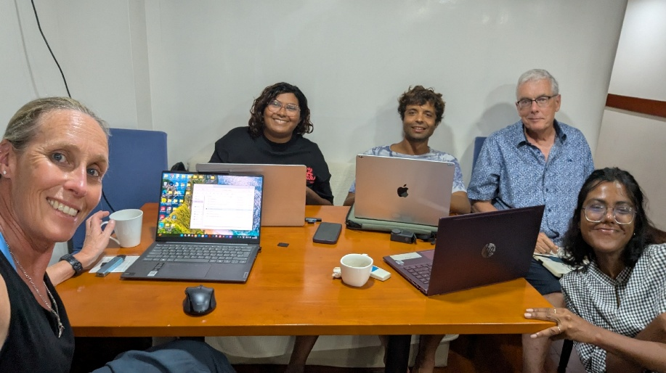
Last day tomorrow !
Friday May 2nd
We had an incredible last day. We revisited the snorkel site we had been to yesterday because it was so pretty.
The best coral we have seen and a true underwater world full of life and colour.
Every snorkel always has its highlights and even an average snorkel has a purpose. I’m building a catalogue of reef fish photos, so I either see something I need to photograph to add to my collection or I see something I want a better photo then I already have.
So in case anyone thinks I just bob around aimlessly at the surface, I don’t ! I’m very busy ! Duck diving really helps and catching sight of a solid bit of rock to hang onto really helps to keep me down in position to take a photo.
I’ve watched Chas many times, and he dives straight down and then stays at that angle head first meaning you can still kick your fins to stay down. The moment you turn the right way up, there’s no way of stopping yourself going straight back up.
So I’ve been practising things that will help the photos.
Anyway, back to the coral, so normally I’m stalking fish, but this coral was so pretty and we had the sunlight aswell. I identified a ‘stage’ so a bit of coral sitting in the sunlight, and then I just stayed there and waited to see who would star in my coral production.
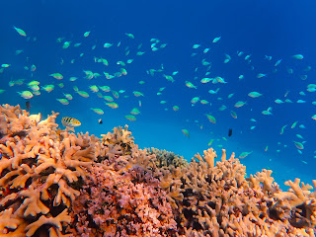

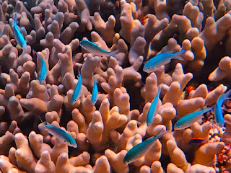

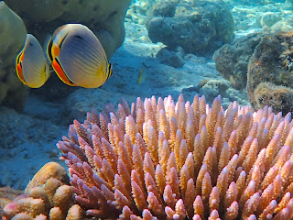

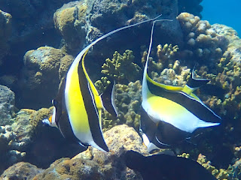

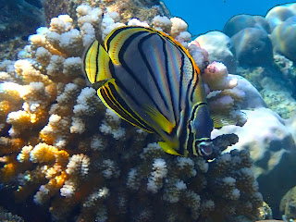

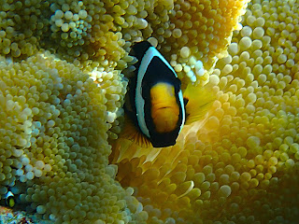

It was all so colourful and warm and addictive that we snorkelled for an unprecedented amount of time, an hour and a half !
So breakfast was really late at 10 o clock ! Then we still had a full days watching to do and I had no interest in packing at all, I just wanted my last full day.
The water kept getting calmer and calmer, Chas stopped the boat, we always know that if he asks the Captain to stop immediately, then he’s seen a Dwarf Sperm Whale, it was 400 metres away and as I stood up to look at it, both myself and Judith spotted another fin right alongside the boat. After waiting around 10 minutes a second Dwarf Sperm Whale appeared behind us. There is always a relief when a brief sighting you’ve seen yourself, turns into a sighting that everyone then sees . Just so a) you don’t think you’ve gone mad and b) people believe you !!
Juice Time came and went, watermelon and my favourite and it’s so hot everywhere that somehow watermelon is more thirst quenching than water. Most holidays people are obsessed with being in the sun, these trips, you kind of do everything you can to stay out of the sun. Even 15 minutes on the bow when the dolphins come in can bring on heat stroke.
So, front watch deck, me and Jim saw a big splash way off on the horizon at 11 o clock.
It was so obvious I was happy to call it straight away, kept my eyes on it and as we got nearer the large dorsal fins of Pilot Whales appeared, they don’t tend to splash, instead you see a glistening body in the sunlight, but they often travel with Bottlenose Dolphins, and that’s what the splash was.
So, I’d got photos of Pilots, there’s only so many Pilot fins you can have, I’d also got the photos of the badly injured Pilot, so I needed to do something else. The Go Pro is no good unless things are very very close and even then it makes them small, so I decided to just video with my phone. I am so pleased I did and got one of the best little video clips I’ve ever got of animals. Really pleased with it.
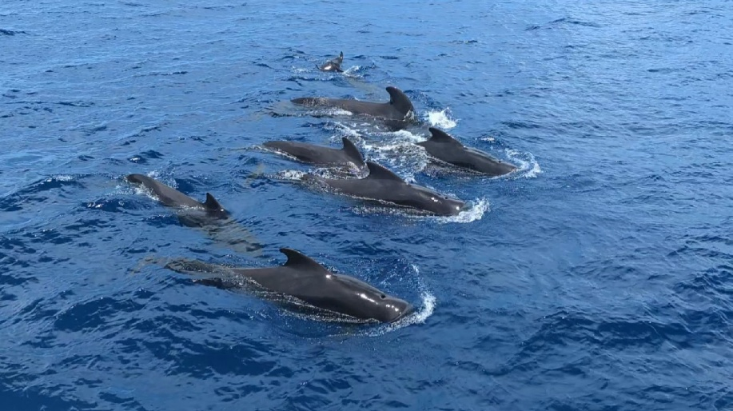

This particular group of Pilots were just so placid and so curious and so obliging. Time after time they swam towards the boat, turned on their sides to look at us, or all dived at the same time, then came around again.
So you could plan shots and plan videos. Although it’s great being on the bow and so close to them, the angle for photos is better on the first deck up. Everyone else had gone to the bow, Michelle and I stayed where we were and found ourselves holding our breath as we videoed, keeping phones and camera as steady as we could, then at the end of each Pilot performance, when they had dived down, we breathed again and laughed at our video taking efforts !
It was an honour that they gave us so much of their time, and I was secretly enjoying them more because I had seen them first, all the way out on the horizon !
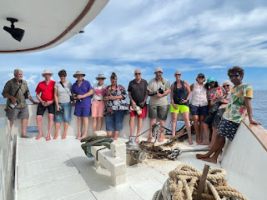

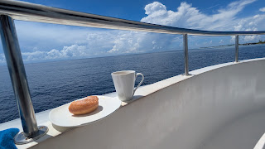

Onwards we ploughed towards Male, and finally after 2 weeks exploring the Northern Atolls, we found 4 beaked Whales. Chaz saw 4 fins, I saw 2 clearly and they are always so far away. Then they dive for around 20 minutes and you just wait for them to pop up again, hopefully alot nearer, but often further away or the same distance, so they are really annoying to get photos of aswell as a positive ID. Probably Cuviers Beaked Whales.
Afternoon tea was nice as we had a wedding anniversary cake for Jim and Michelle. They didn't want any fuss but it was too late as Sue had asked the Chef to make a cake !
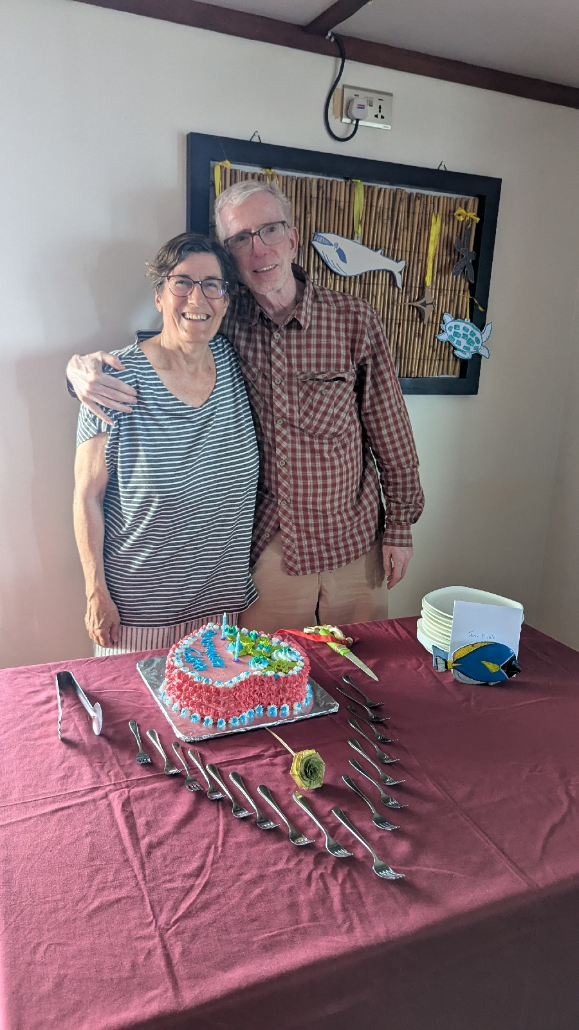

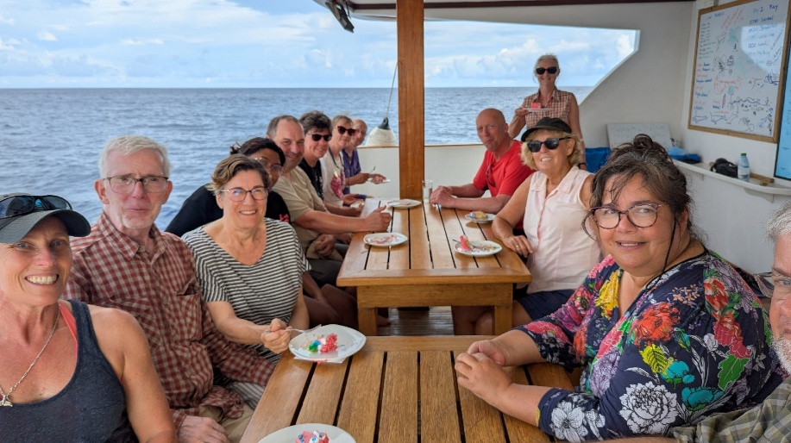

Boat traffic by now was alot busier as we neared Male, it's an ugly place, all industrial. As part of an Atoll it's just a particularly large Island that is the Capital of the Maldives and houses Government buildings and the airport and Schools etc, and of course a lot of people live here. The buildings are ugly with highrises providing alot of social housing.
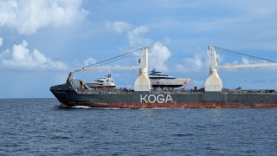

So basically you want to get off a plane and get the hell out of there .
But unfortunately we were at the end of our trip and we moored up in the harbour to have our final evening.
Got packing out the way, then we all sat in the lounge and had a recap of the whole trip.
There had been 144 sightings. So someone spotting a fin or a splash, near or far that led to a positive ID. 10 different species
Spinner
Striped
Frazier's
Indo Pacific Bottlenose
Common Bottlenose
Rough Toothed Dolphins
Pilot Whales
Dwarf Sperm Whales
Beaked Whales ( probably Cuviers )
Can NOT remember the 10th at all.
So it was a great trip
I have photos of the Data entries Chas makes, time, sea state, weather, position etc. Chaz has been doing this for 3 years.
We thanked all the Crew and had all put money in an envelope for them as a tip. Thanked Sue and Chas for making the trip so great.
Oh no, then there was a sad moment and the girls had to leave the boat, no need for them to spend the night, they were back home in Male, so the dingy took them and their bags. They had been so much fun and I'm sure we'll stay in touch.
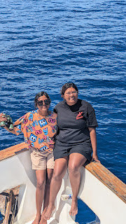

A final dinner and a quiz !! I'd asked Sue to do a quiz ! 10 questions, all from Chas's presentations ! At which point Jan admitted she sometimes had a nap during these !
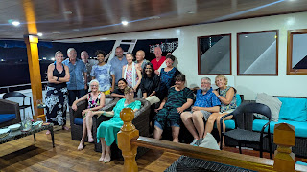

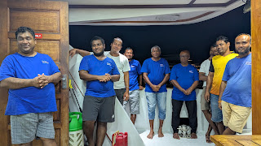

Thank you Keana for being the most wonderful home for 2 weeks, and thank you Sue and Chas. Can't wait until the next trip.

