THURSDAY 19TH SEPTEMBER
Re writing this as lost the whole blog so for a while there will be gaps in days until I can redo it !
Boarded Mermaid 1 in Benoa Bali. The first day is like going into the big brother house and you spend the whole time saying Hi I'm Jo, What's your name !
Settled into cabins which are lovely.
Just going to put first sunrise photo here as it will be the title photo.
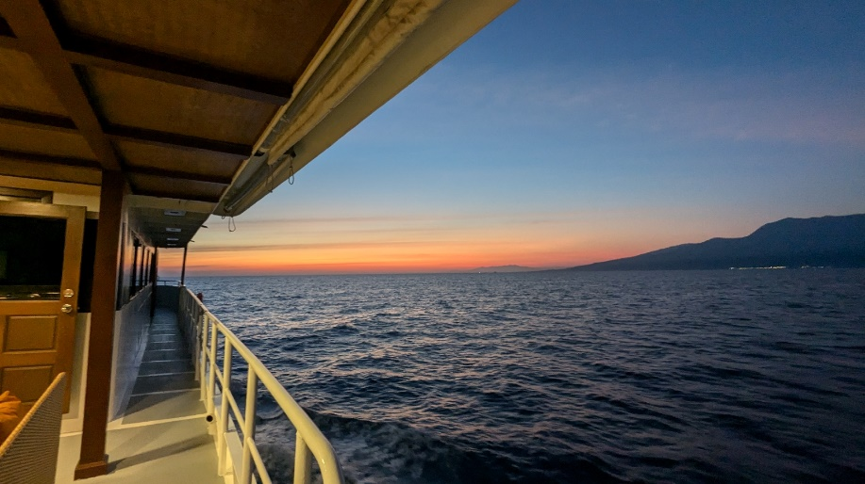
Cabin
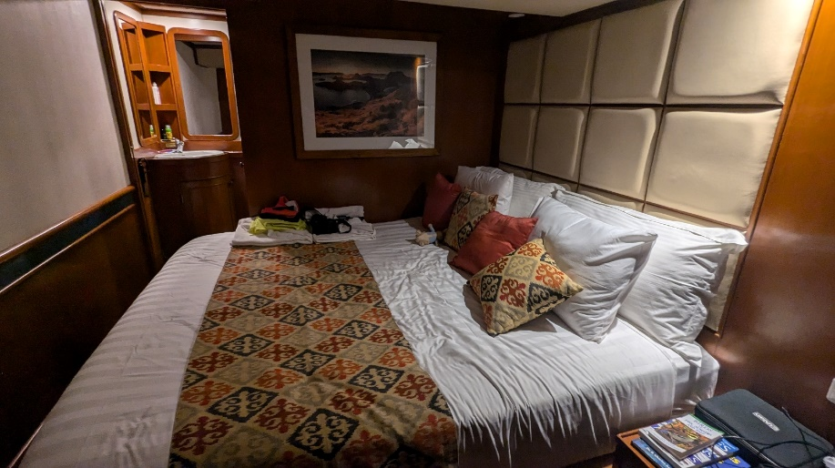

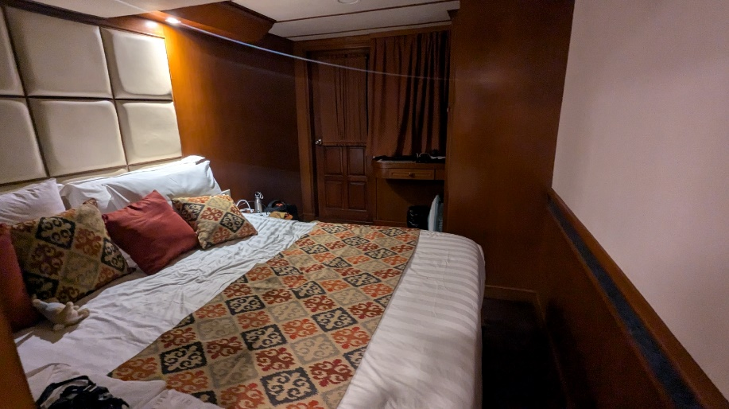

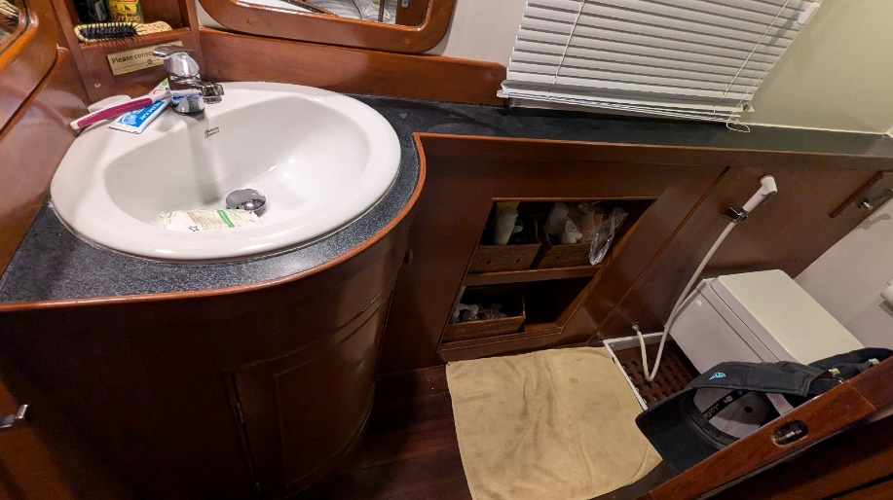

Then we had a safety briefing. I was particularly interested in the Man Overboard etiquette. If you see someone go overboard you don't move, you watch the person and you throw them a lifering as quickly as you can, then you call for help, then that person calls for help and then the next person... Then a whole load of people are running a round the boat calling for help. No. If you are the second person you tell a crew member who will get a message immediately to the Captain. I decided I would try to be the first person....

We were travelling up the Straight between Bali and Lombok, known as The Wallace line. Incredibly rolly ! We travelled all night and finished up at the top of Lombok.

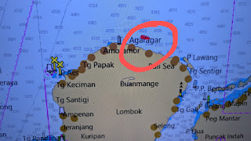

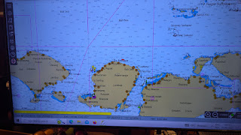

FRIDAY 20TH SEPTEMBER
I always get up really early on these trips just to appreciate every second and get every sunrise and have a few moments of no people. It's a beautiful boat with a large dining and kitchen area and a great coffee machine !

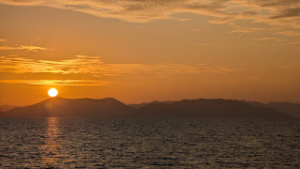

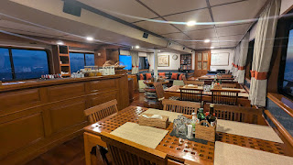

Coffee on the top deck didn’t disappoint.
There is a mini breakfast at 5:30 for people up early, so you can get a coffee and a slice of toast.
Then really watching from the front of the boat starts. It was quiet and flat for really quite some time. Some people like to just sit and watch endlessly for hours, which I am also happy to do, but sometimes I can use that time to edit photos or videos or do some writing, you can always tell if someone’s spotted something, a cry goes up from the watch area, or the ships horn sounds. Then you can rush off with cameras.
This trip I have 2 camera bodies, I learnt this from Chaz on a previous trip. One has a long lens on it and if whatever species we have spotted then comes in really close, you can pick up a different camera with a shorter lens.
There have been times where Orca have come in close and I have my back to them changing a lens.
Even with no sightings, there seems to be a lot to do, going up to the top sun deck and waving binoculars around.
Getting coffee, editing stuff.
Eventually at 11:45 there was splashing and bodies up ahead. This is when its exciting, grabbing the camera, choosing which part of the boat to go to, which camera, should I take the phone to get a record shot, how do I carry all this ? etc etc
It turned out to be Melon Headed Whales ! This is a species that Clive had always wanted to see so I was very happy to be able to see them on his behalf.
We spent an hour with them milling around us – they upset the schedule as we were meant to be having a snorkel briefing – and lunch was delayed !
As we left the Melonheads, a small group of spotted dolphin came in, but they were not very interested in the boat and we moved on quickly.
Lunch doesn’t see Chas stop – he takes it to the front of the boat and keeps on watching.
I popped back and forth to my cabin, pegged some washing out.

BOAT NEWS
The main watch deck has a long seat at the front and a brilliant front view. The hardcore watchers tend to stay there all day and all sightings are recorded.

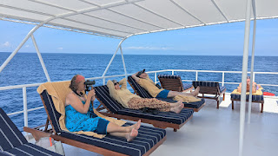

Or relax on the top sundeck !

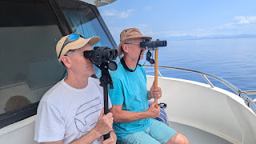

SNORKEL NEWS
I had all my equipment with me and proudly put my fins, my mask and snorkel into my amazing mesh equipment bag and walked 7 metres and took them all out again. Mesh bag went in cupboard and wasn't used again !
We were each allocated a crate, very happy I could get Number 7

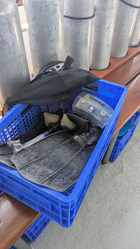

SNORKEL NEWS
Snorkel briefing
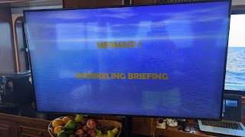

Our first snorkel was Moyo Island Sumbawa. I hadn't snorkelled since 2019 and it's always very slightly daunting that first time. I had also never gone out on dingys before. I had used a dive boat ( Dhoni ) that takes you from big boat to reefs, or had snorkelled off the shore.

Apparently the way to get in the water is to hold your mask and just merrily fall off backwards. Hmmm... I figured that if 77 year old Sue could do this seemingly effortlessly that I really ought to have a go. Rolled backwards, got water in my mask kicked my legs and spluttered my way away from the boat. I am sure I will look more professional next time.

Once your face is in the water, this amazing feeling washes over you. It's a whole new world full of colour and light and life dancing in the glittering rays of sun. My breathing immediately relaxed and I started taking it all in. I had my go pro and heard Angela (Divemaster) shout Seasnake ! Excellent, I have a snake obsession so to go and stalk a seasnake was amazing. Knowing this was a banded Sea Krait was daunting. It's incredibly venomous and I was more cautious than I needed to be. Although terribly venomous, their teeth are very small and are right at the back of their mouth so you'd only really get bitten on an ear lobe or a little finger. I should have got closer !

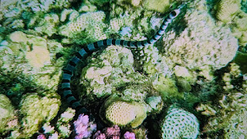

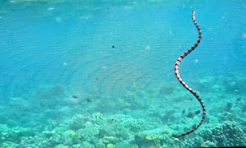

I'll do snippets of Snorkel news as I go along !

We watched for sightings later as we went along and were treated to a group of Melonheaded Whales. I had never seen these before and loved watching them. They have these amazing white lips and after I had trawled through about 300 photos I found 1 showing them.

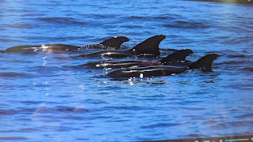

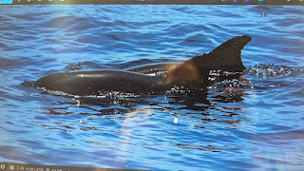

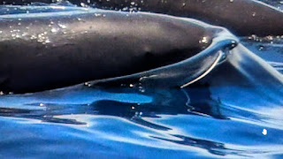

The evening was a sunset walk on Mayo Island, Sumbawa.
We got the dingys to the island and were met by the cutest girl standing on the steps.
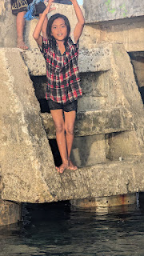

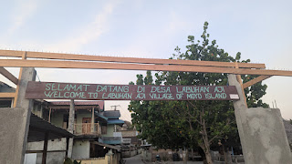

The village was incredibly humbling, we walked around and saw simple ways of living. Just huts really and a large floor space, but the kids were running around so happily playing with their toys. Animals were dotted everywhere and presumably provided food.
I stopped a goat eating a few plastic bags from a bin.

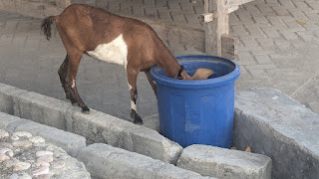

I checked the paw of one of the kittens who was limping and couldn't see any wound so I hope it was just a simple sprain.
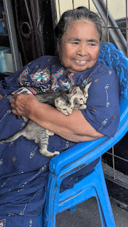

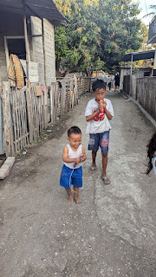

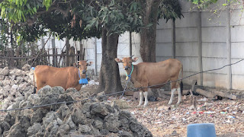

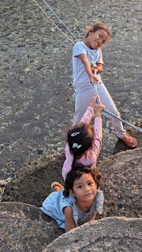

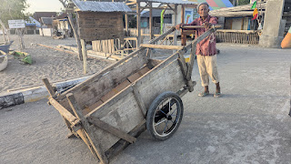

A group of girls were playing volleyball and we watched a rally of about 30 go back and forth over the net, we were all genuinely watching each move with bated breath and when it finished we all clapped and cheered.
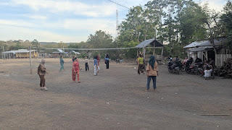

As we left the island we were treated to an amazing sunset and also great views of volcanos.

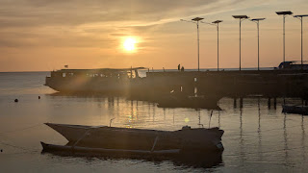

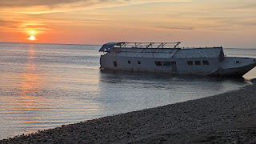

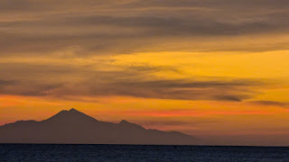

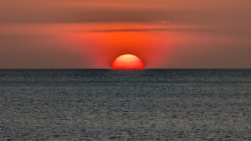

Before dinner we had a presentation from Chas and this evenings was Dolphins of Indonesia.

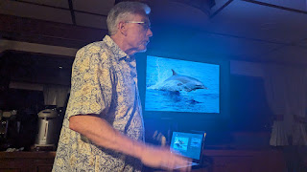

After dinner, Karen and I were talking about how you shout when you see something in the water. I find it a bit tense, like bingo ! The correct thing to do is shout the face of the clock. So 3o clock, if you've seen dolphins or a dorsal fin or a body roll and then everyone can get their eyes on it and the poor thing doesn't stand a chance of not being watched !

Anyway Karen and I were saying do we wait for a second sighting ourselves before calling or do we just call it.
Karen started to tell me a 'sighting calling' story and it started
Karen - when we went across The Bay of Biscay
Me - on the Pride of Bilbao by any chance ?
Mike - yes.... And as he carried on we knew where the conversation was going. Yes he said, with Clive Martin. Then he realised straight away and said, that's your dad isn't it !

It was such a lovely moment, and the chatted about him and said some really lovely things about his knowledge and humour amongst other things. It really was lovely and they were very kind about him

SATURDAY 21ST SEPTEMBER

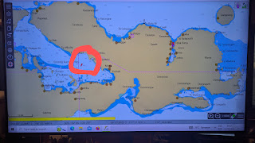

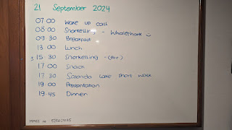

SNORKEL NEWS
Before each snorkel, we have a briefing which all feels very professional / like I am in a police underwater dive team !

It's really informative usually with a dive site map and also what to expect to see and how a current may be.
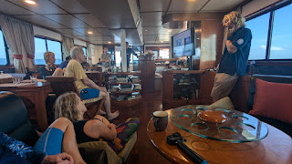

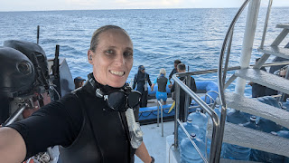

This morning's briefing was all about what to expect with the Whaleshark ! I was so excited at the chance to see one and as I dropped ( forwards - will perfect roll back later ) right there in front me was a huge shadow, pretty vertical in the water and she was feeding.

At first this was all a little bit touristy for me as she was feeding from that back of a boat. I learnt later that a local anchored fishing boat is there regularly and the Whaleshark knows this as they discard kind of shrimp soup !
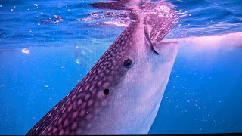

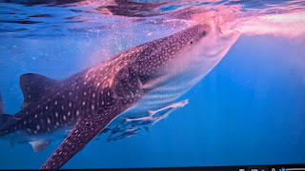

As other people drifted away, I realised that she kept doing a lap under the boat so I went and hid around the other side of the hull and stared down into the greeny blue abyss focused on the base of the hull of the boat. Then there she was in slow motion, gliding gracefully up towards the light, I had seen the rays of sun and knew she would pass right through them on her lap. Wildlife photography and filming is purely a hobby for me, but half the fun and challenge is setting the stage for wildlife and hoping they walk in and play their part.
She did, spectacularly.
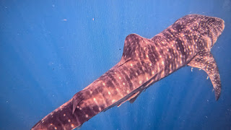

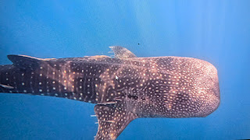

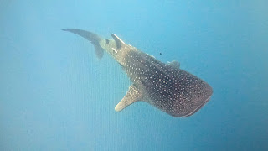

We travelled during the day and just milled around the boat. In the evening we went onto Satonda Island Sumbawa. A volcano with a lake in the middle.

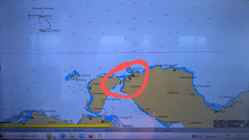

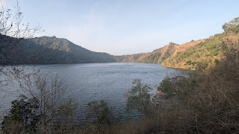

Far across the lake was a tree full of Fruit bats roosting. Jacob sent the drone over and it features on his video. Hundreds of them hanging from the branches.

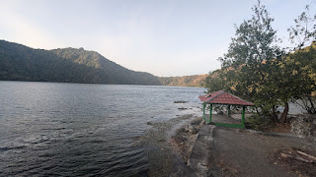
This Island really intrigued me, there was an old toilet block on the beach. Signs that had fallen down and no people on the island, so had it been set up for tourists and then nothing happened - what stopped it being more than a 'drop in to see a lake in a volcano' place ?

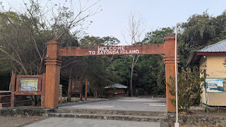

Once again a lovely sunset as we left and returned to the boat.

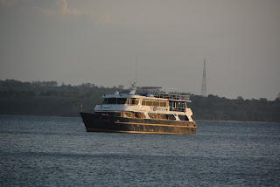

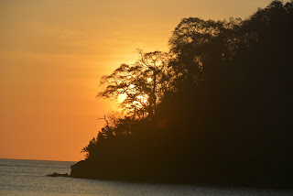

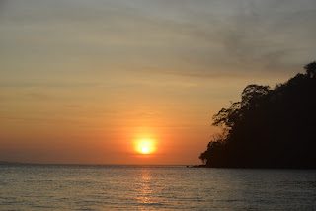

SUNDAY 22ND SEPTEMBER

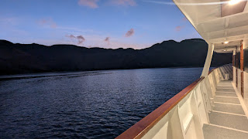

This mornings snorkel was Sangeang Volcano

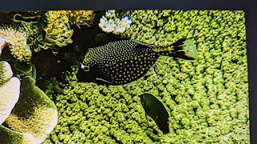

Male Spotted boxfish

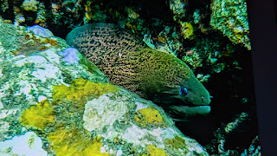

Giant Moray Eel

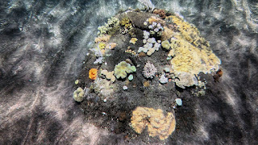

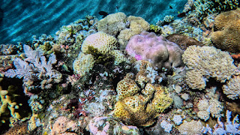

The bit that fascinated me was how each large volcanic rock had become its own little coral reef.

SNORKEL NEWS

All the crates lined up and the wet suits that are dipped in dettol to keep them fresh, are all hung up by the crew when we get back on the boat.
Ready for a snorkel with Chas.

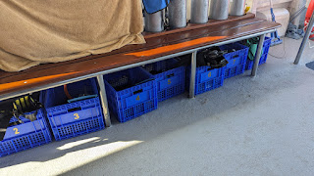

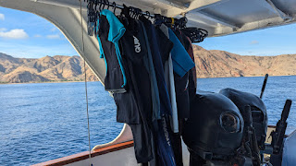

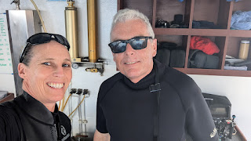

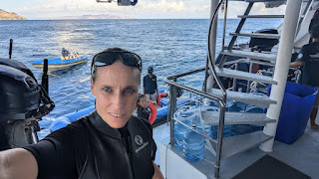

When we get back on the boat Anita is always waiting with a lovely refreshment. My favourite was the hot cinnamon tea.
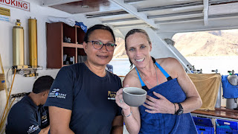

The day got going.

BOAT LIFE

People are dotted around the boat at different points.
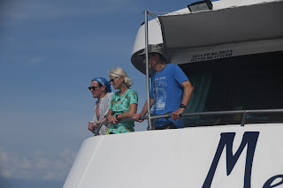

Sue, Richard and Thomas up on the watch deck

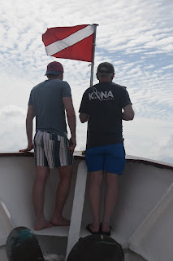

Father and Son David and Bryce up on the bow

When we have a sighting, Chas directs the boat as we follow whatever we have seen.

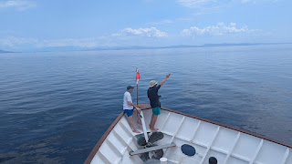

Washing has to be done ! We can peg things out on the boat rails to dry as we go along.

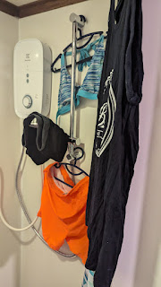

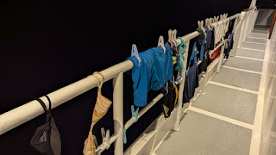

Lunch happened, its laid out across the bar top and we all help ourselves. Lots of choice with rice and veggies always available, so even if theres not a main veggie thing it's still ok.

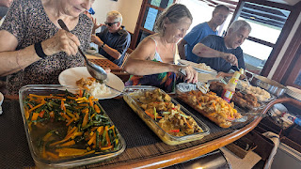

Sightings along the way were Spinners and Melonheads.

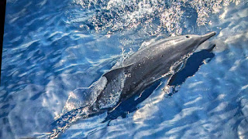

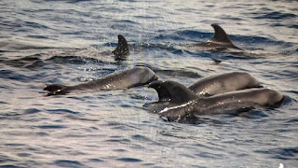

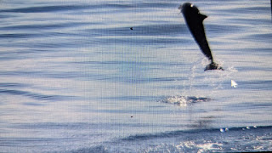

As we had come away from the volcano, we noticed a fire on the side, here we all had a debate. I thought it was just a fire but Sue and Richard thought it was Larva ! Turned out that Chas referred to the Lava field later on in the presentation and I had to apologise to them !

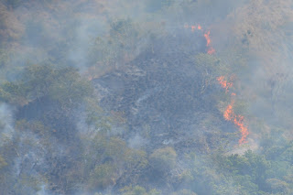

This made it all feel like such an adventure. I was editing stuff in my cabin and felt the boat slow - always indicates something has been spotted, went up to the watch deck and asked Jacob what it was, expecting Spinner dolphins which by now were becoming such a common sighting. Very seriously he said "Sperm Whales" he said my face was a picture, I just hadn't expected him to say that !

A blow had been spotted very far off on the horizon.

This was now so exciting and we positioned around the boat, I found the top sun deck the best place for this as you had a 360 view. There were 12 to 15 of them around us in this huge area in the shadow of the volcano.

The blow is typically on a diagonal off to the left as the Sperm Whale only has one nostril.

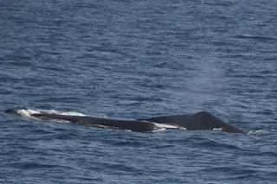

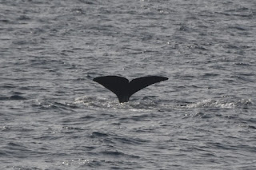

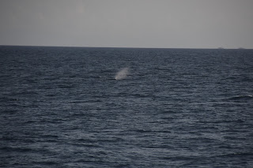

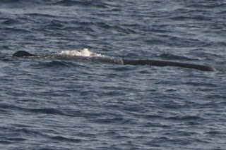

You don't get much to go on with only the head and small dorsal showing at the surface. As one dived, someone would shout that there was another blow somewhere else. I spent 2 hours shouting "6 o clock" as always seemed to spot the ones at the back of the boat.

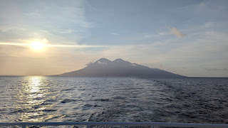

We'd spent the whole afternoon there.

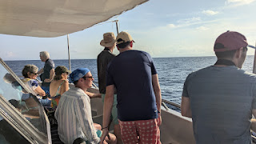

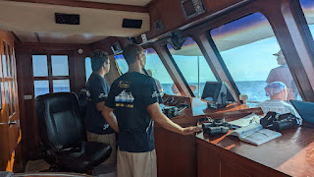

It was also nice for the crew to see, this trip is very different to their usual diving trips which is just ferrying divers to their next site and no-one really keeps an eye out for sightings.

Chas did a great presentation on Sperm Whales in the evening, explaining the Sonar and why their head is so huge. It's filled with oil, it got a bit complicated as to why, but that's why the head is so big, it also has the largest actual brain of any animal.

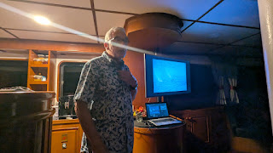

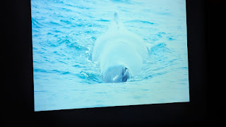

Photo clearly showing the single left nostril. Not my photo, I wasn't snorkelling right in the path of an oncoming Sperm Whale.

MONDAY 23RD SEPTEMBER 2024

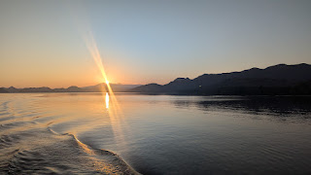

Two snorkels today. The first one was Batu Manco, we were now on the edge of Komodo National Park. This one had quite a swell and sometimes there were waves crashing above, but below the surface was just beautiful.

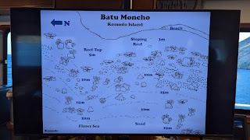

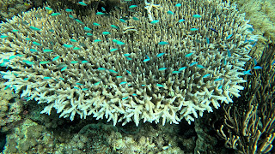

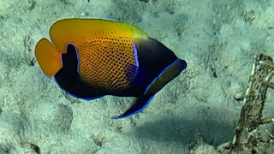

Majestic Angelfish

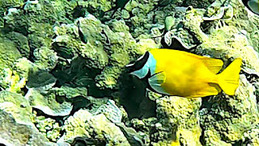

Fox Face Rabbitfish

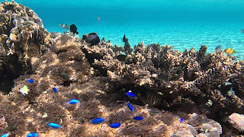

The colours and diversity of species was amazing.

BOATLIFE

My cabin was so comfortable to sit in and write and edit. I had taken the laptop upstairs one day and sat at dining table but it was actually more comfortable here and a beautiful view as we travelled along.

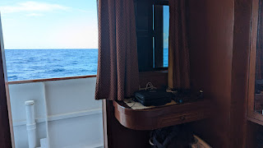

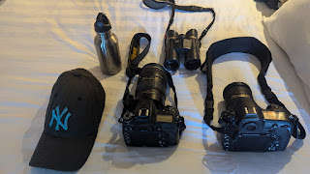

This is everything I had to take upstairs everyday ! Two cameras, one with short lens and one with long so I could switch easily between the two. Binoculars obviously essential.

The front main watch deck.
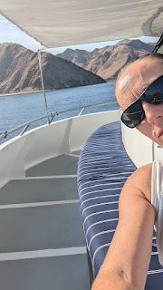

We also had an afternoon snorkel and lots and lots of turtles. We were now in The Lintah strait and the site was Tatawa Besar.

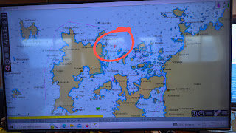

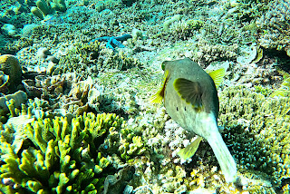

Porcupine Puffer Fish

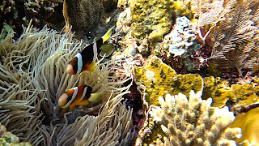

Clarks Anemone Fish

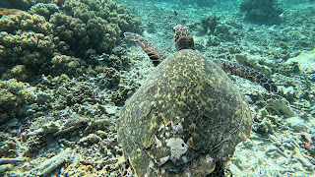

Hawksbill Turtle

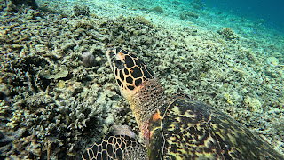

I was convinced this one had been attacked by a shark, but apparently its just colouration

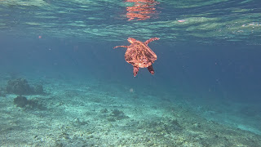

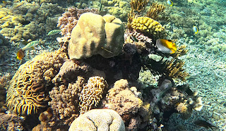

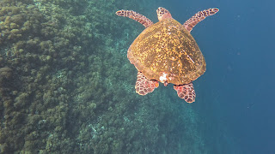

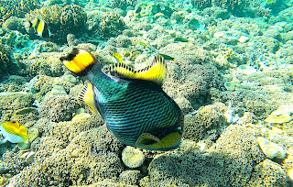

Titan Triggerfish

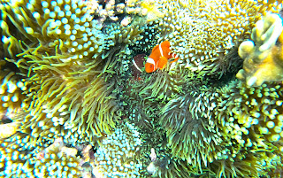

Nemo

I did get stung coming up from a turtle freedive - which was so much fun duck diving down to follow them.

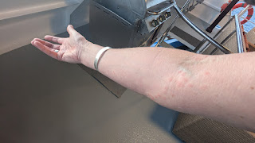

They did have some anti sting stuff on the boat but Sue kept on about rubbing pineapple on it and it apparently really works. I will try this next time.

ADD IN SIGHTINGS FROM THIS DAY

SNORKEL NEWS

Each time we finished a snorkel we would head back to the dingy and hang on to the ladder with one hand. You reach down and try and pull the fin strap from around your ankle. Often getting stuck on wetsuit boot, the next option was to undo the buckle but risk not having the loop to hold onto and dropping fin to bottom of Ocean. You then hand your fins up to the brilliant dingy crew and he would also take my GoPro from me, you stagger up the steps after the hour snorkel, I usually start feeling the cold at 40 minutes.

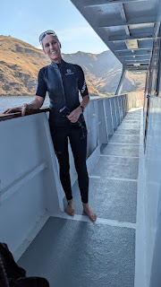

Karen had lent me her wetsuit body jacket which allowed me to always stay in longer than I would have been able to. It was always quite a relief to sit on the warm side of the dingy and crew would then hand you your designated and numbered water bottle. Mine was 7 matching my dive crate. You get surprisingly dehydrated breathing through a plastic tube and duck diving down.

After 2 lovely snorkels and sightings along the way. We headed to a bay that nestles between a whole load of Mangroves and islands. At sunset hundreds and thousands of bats leave the trees and fly across to the island. It was a spectacular site, what I should have done is ask Jacob what settings I should put my big camera on with the light fading. So only got a couple of phone photos.

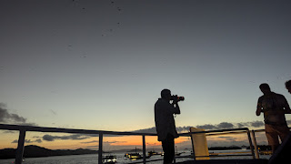

Chas photographing the bats

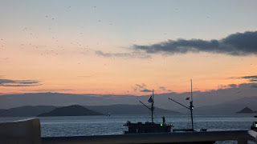

The skies just filled with bats.

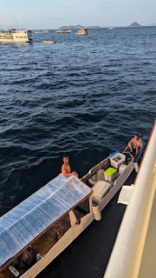

While we were there some locals pulled up alongside selling bits and bobs. I worried when they moored up against us and thought that maybe they were pirates. This was not the case and the boat crew give them leftover food which I thought was perfect and a much better option than being pirates.

TUESDAY 24TH SEPTEMBER

As we set off away from bat place where we had stayed overnight, the sunrise was beautiful.

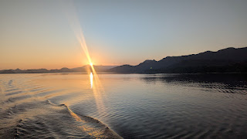

All the sunrises in this volcanic region were so picturesque.

We didnt have far to go and anchored again just outside Rinca Island to go and see the Komodo Dragons.

First dingy setting off
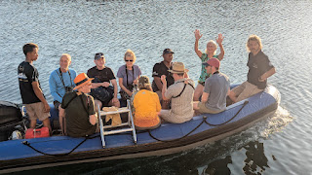

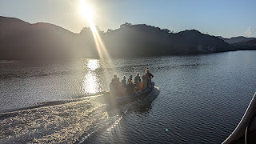

As we entered the Island around the jetty were Archer fish which I found extra fascinating as I had only just watched a David Attenborough documentary about them. They sit under the Mangroves and shoot jets of water at unsuspecting bugs on leaves. Then they eat them once they fall in the water !

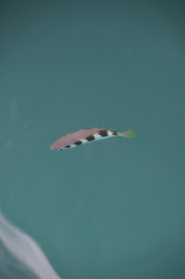
There is also a huge statue of the Dragons.

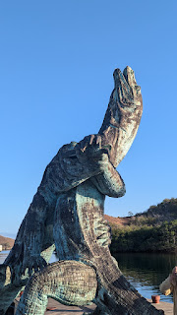

Entrance to the Heritage Site.
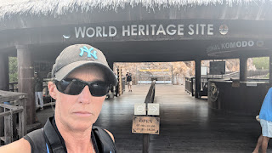

I was much more excited to be there than this photo suggests..... At first I thought it was going to be a bit touristy as we walked a long raised walkway above the dragons. Our guides educated us along the way. There are 3000 dragons with 1500 on this Island. The largest is 2.96 meters and weighs 70kg. They catch them regularly to weigh them and mark them.

We headed towards the vistor centre and museum and then went out some low metal gates to walk amongst them. This was all a little bit surreal. The gates didn't need to be high because once they reach 4 years old they stay on the ground. When the babies are young, they are prey to their cannibalistic older hunting Dragons so climbing trees is essential.

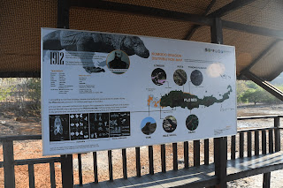

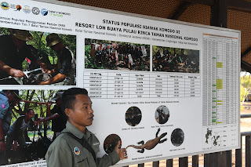

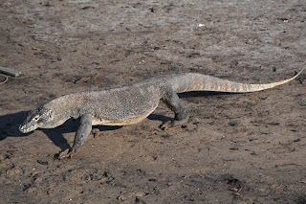

From the walkway

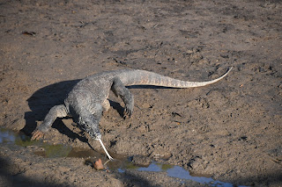

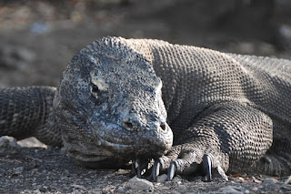

The females dig a nest that's 2.5 meters deep ! and lay between 21 and 30 eggs. She stays with them from September to December and then covers them all up and leaves them to fend for themselves.

We walked up quite a steep hill and had a great view from the top over the island and could see the boat.
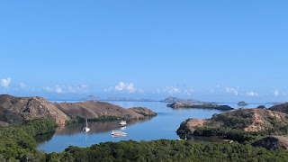

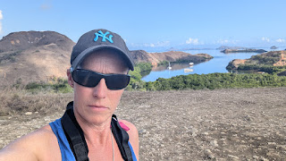

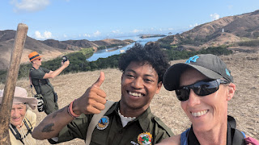

As we walked back down it was pretty precarious with loose shingle - you have to wear trainers on this Island, no flips allowed ! We popped into the museum and were so grateful for the aircon. It was pretty bloody hot outside. They have a skeleton of a Dragon.

Along the way we passed deer and wild boar, all prey to the Dragons. I was a bit worried about one deer who had a huge slice from a dragons claw on its side.

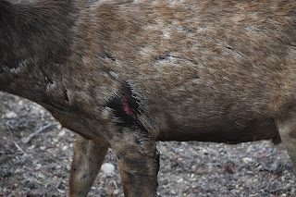

Also followed an amazing trail of a tail.

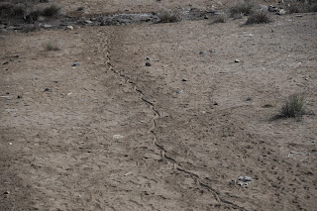

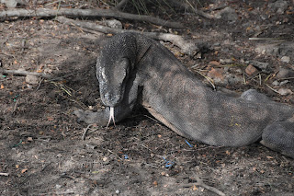

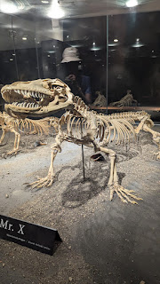

Back to the dingys and a curious Macqaque wandered along the railings towards me. Then he instantly didn't want me there !

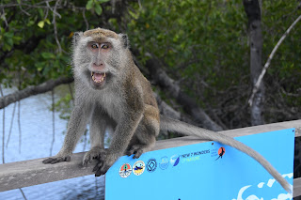

Chas and Angela stayed behind, Chas had randomly bumped into people he knew !

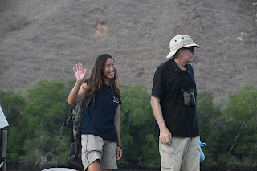

As we left Rinca we watched the monkeys on the beach and I'd seen a cow on the way in.

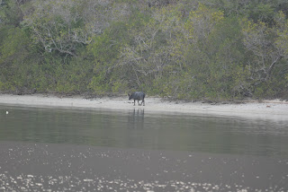

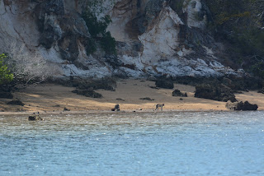

The afternoon was then incredible. We had cruised along keeping watch.

ADD SIGHTINGS IN HERE FOR 24TH

We'd stopped just off an Island. still in the Lintah Strait and the island was Mawan. Angela had had a tip off from a Dive friend that the Manta were around the island. The dingys took off to do a rekkie which made me think it wasn't a usual or planned stop so they needed to go and check the reef and the currents.

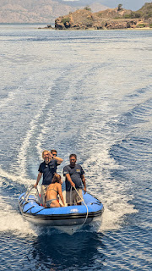

Because it wasn't a usual stop, there was no briefing prepared, so this briefing was done with the actual island behind Yurik !

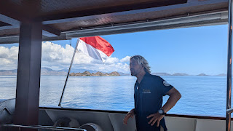

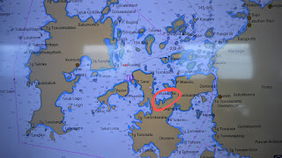

So over we headed.

The moment we got in the water we were surrounded by Manta, right there - including a melanistic one. They have individual markings underneath and there is a society that asks for any sighting photographs to be sent to them.

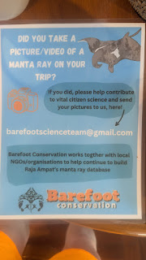

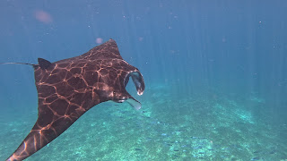

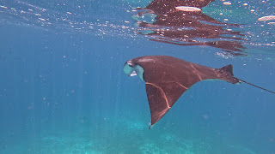

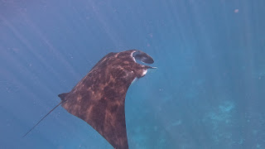

I had the Go Pro running from the off and was so pleased with the video I got, it was like it was choreographed, as one swam past gracefully and off to the right another would just come into shot, 4 times that happened and the video will barely need editing.

The buzz and the excitement from everyone was amazing.

SNORKEL NEWS

We are so lucky that every time we get in the water, the Divemaster checks the current and they all have a life ring with them. If someone wants to they can just hang on and be dragged along. Patsy struggled a lot with Arthritis and often did that. It also made it easy to see where everyone was when you popped your head up to make sure you were at least somewhere near the group. So whilst there was plenty of ocean and you could go off and explore, you could always see the others.

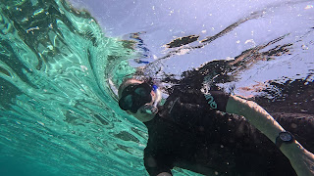

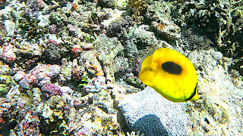

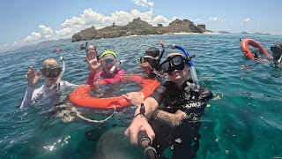

Silly photo of Patsy Sue Richard the Divemaster and me ! Richard had swum over asking if we were having a party.

What an amazing morning with Dragons and Manta.

ADD SIGHTINGS AFTERNOON OF 24TH

BOAT LIFE

I have to mention the food and Bryce ! we spent a lot of the time joking about how much food we were eating and immediately 20 minutes after eating we were always hungry again ! We kept bumping into each other sneaking back to the bar top where there were always cookies and these amazing chocolate bars. We would comment to each other as we sat and watched for sighting, must be time to eat again. The afternoon tea today was extra special with some warm donuts !

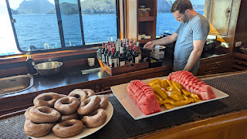

There was also a great coffee machine for espressos or coffees. Soft drinks were also complimentary and I loved a cold can of sprite each evening which was great as I would have no bar bill ! Wine was $30 dollars a bottle and can of beer was $3.00 so if you stuck to a beer each evening it wouldn't be that bad. It was the wine that bumped it up.

Also on the boat it was great watching the crew, the anchor went up and down a few times during the day, as it came back up, the huge rope was coiled neatly and the anchor sat in a channel at the side ready to be pushed in. I also found the coil of rope comfortable to stand on when watching dolphins down on the bow.

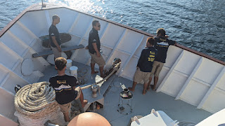

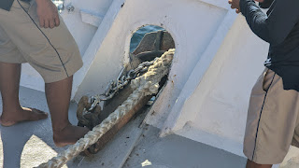

We then headed off to Padar Island where you can watch a stunning sunset after walking up a million steps.
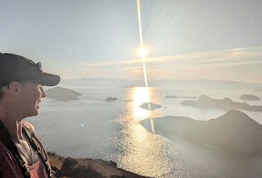

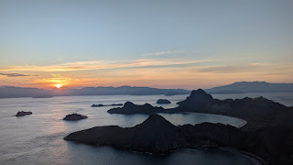

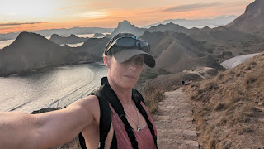

Once we were back at the bottom, there were deer on the beach ! One was enjoying some coconuts, who knew deer ate coconuts. She also had young with her.

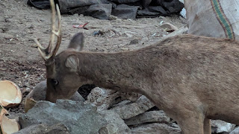

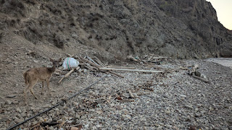

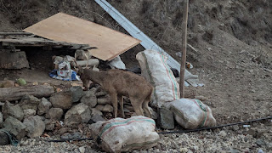

The other side of the jetty, mum had got down onto the beach and was calling to encourage her young to come down. It was such a heartbreaking little noise and I was urging him to clamber down. It sounded like a mewing kitten.

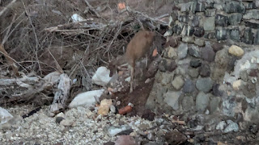

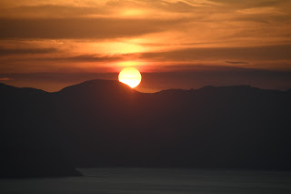

The evening was a fascinating presentation on Corals. This made us all look at corals totally differently the next day.
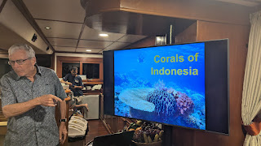

WEDNESDAY 25TH SEPTEMBER 2024

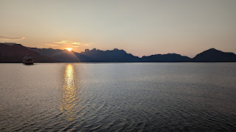

I loved the start of my days with Sunrise and always enjoyed my coffee at the back of the boat.
If anyone was wondering, this is how I look having my coffee at the back of the boat....

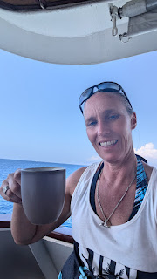

We were now at Komodo Island itself and off to see the dragons for a second time. This Island was definitely more touristy. Rinca is considered the slightly more upmarket way to see the dragons. People will fly in by helicopter - do a tour in the midday sun ???? and leave again.

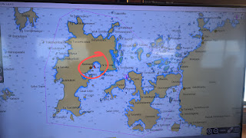

We met our guide and wandered off.

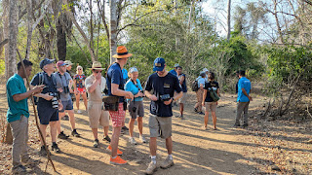

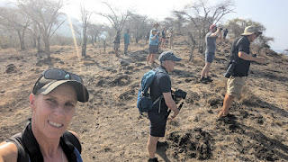

We went past a Dragons nest

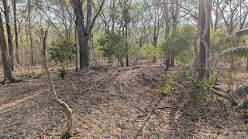

It was absolutely baking again ! There was a point in the path where you could opt out of climbing the hill. A few people did that. Sue, Sue and Richard. The rest of us carried on with our binoculars. I had really wanted a photo with the sea in the background and was happy to find a dragon at the top of the hill giving me that opportunity.

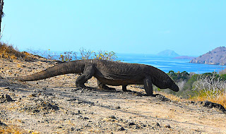

As we came back down the perilously steep path and headed towards the beach, I started to eye up the beach itself and desperately wanted the beach photos. Our group had ground to a halt and were bumbling around. I could see another group walking along the beach path and could see a dragon ambling along behind them, so I drifted off and joined their group ! No-one noticed as I mingled around and then drifted back from them to get the angles I wanted. Everyone else may be happy with photos that have 57 people in the background. I am not !

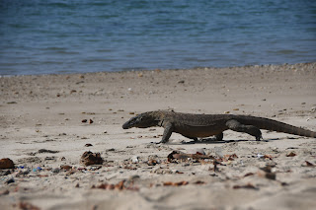

By now I was probably far from my group and they would be looking for me, but I didn't care and was having too much fun.

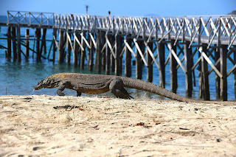

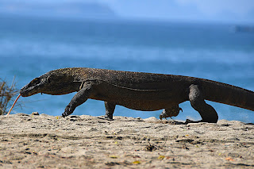
Found a smaller younger one who explored a tree.

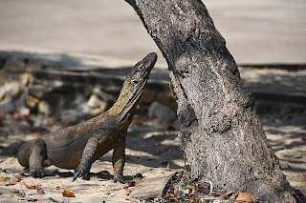

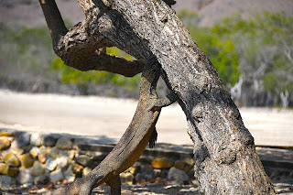

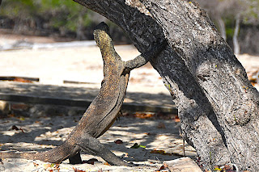

This was much better and I was happy to have my photos.

We also fitted in snorkels. The first dive site was Siabah Besar still in the Lintah Strait, Komodo National Park.

Briefing from Angela, warned to all stay together here as it's a popular site and there were lots of boats there, but actually it wasn't that bad, although a bit odd seeing other people in our patch of water. Confusing when you popped up to check where our group was.

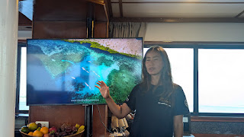

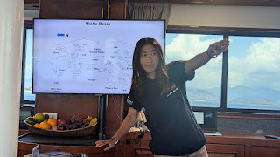

Stalked a Giant Pufferfish around. Not the description, it's actual name.

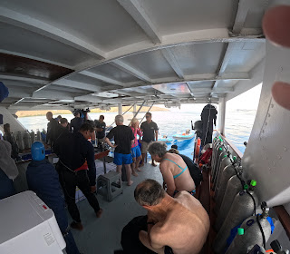

Everyone getting ready on the dive deck

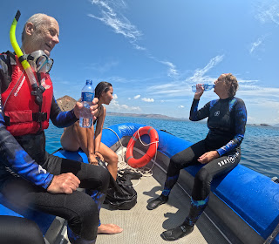

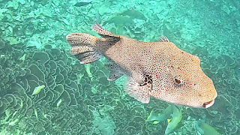

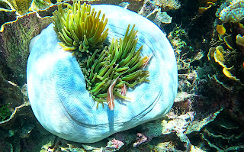

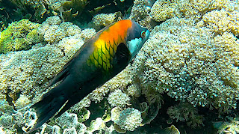

Lunch was always so welcome - especially for me and Bryce !

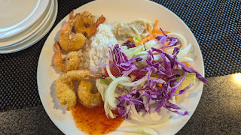

LIST OF SIGHTINGS HERE

The afternoon snorkel was a totally different experience and the site was called Shot Gun ! We were to find out why.

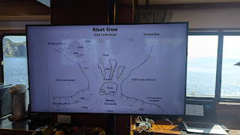

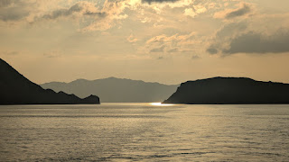

It was a channel between 2 islands so the current potential was huge and hard to know which way it would go. The dingys took us over and off we went. We would start one side, then drift through channel over "The Hole" a huge deep crater below the surface - stupidly didn't get a photo. Off I went pottering around watching things, found a Moray to play with and a large Grouper.

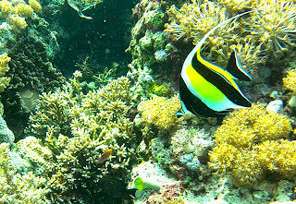

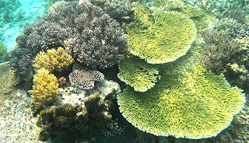

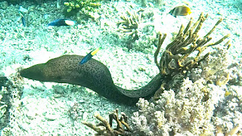

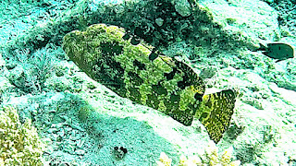

Realised the current had changed but lots of the others were well along and through the channel, so I kicked as hard as I could against the current, went over The Hole took me 10 minutes to cover a few meters ! Popped my head up and had to laugh as the remaining few had jumped on a dingy and got a lift through the current to the other side.

I found Angela and Jacob out across the very deep bit and swam over doing my stylish snorkelling swim which involves kicking legs, holding go pro in one hand and then using the other arm to do front crawl !

As I got there Jacob was waffling on about a Titan Triggerfish and a nest. I thought he was reciting an old story as he dives a lot.

Off I went back to the coral away from the drop off, annoyingly they then had a manta come through but never mind, I had had quite a good quota of manta.

Looked up and a Titan Triggerfish was rushing at me at 100mph straight for my face. I know they are capable of taking a divers finger off and really causing some damage, So i flipped onto my back with my mask in the water and there she was, still coming at me. I kicked my flipper hard in front of my face by way of defense and she would drop back a bit. Then with a huge turn of pace she would spin round and come at me again. Each time I defended myself with my fins.

It was getting a bit relentless ! and I suddenly decided to think logically instead of defensively and kicked until I was some distance away. That was what she wanted and she finally left me alone.

Really cross I didn't film it though !

I popped my head up and could see Mike heading straight for her nest. Swam over to tell him, Mike snorkels with a lifejacket as he is really cautious in the water after a near drowning experience so he was the last person I wanted to panic in the water and best he avoided Mrs Furious.

Karen his wife however was way across and heading back right over that spot. I swam to warn her then realised that she had got past. Found out later this wasn't the case and she had turned to find the triggerfish attacking her elbow.

As if this wasn't enough drama, the current had now really picked up and we were whooshed back through the channel between the 2 islands, if you turned to swim against it you couldn't ! so going with it was the only option and we flew along ! It was exhilarating face down like flying over coral canyons.

And that's why that site is called Shot Gun ! Angela was so excited we had got to see the reason why.

As we chitter chattered our way back onto the boat reciting our adventures, the sun was setting in the channel behind us.

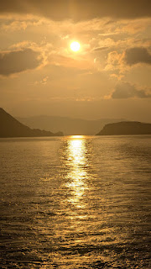

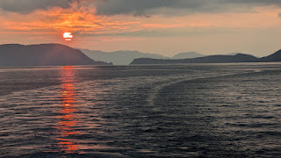

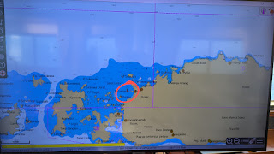

We were now all taking much more note of the coral and Chas had explained how what looked so beautiful down there, was actually like a warzone with corals competing for sunlight. This shows best with the table corals and you can see how others muscle in to share the light.

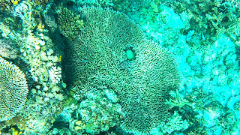

We had also had a talk about Featherstars. I had thought these were pretty ferns waving in the current ! They weren't - they are starfish ! Morning and evening they climb up to a high piece of coral attach themselves and have their share of food.

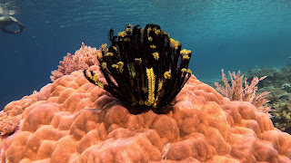

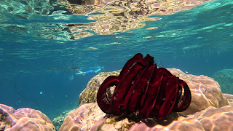

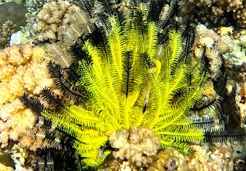

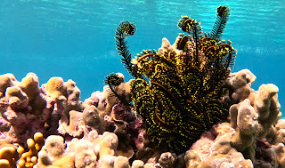

THURSDAYS AWFUL REALISATION

If you are reading this for the 1st time, I just lost the entire thing ! On the last day, but have notes and photos and will rewrite when back on Bali on laptop. This I have now done thankfully ! It took about 5 hours to rewrite and was grateful for notes, photos and Angela's Dive Chart records to refer to for info.

If you've been following it then Thursday and Friday will appear below as I only just wrote it this morning so can rattle out again quickly.

THURSDAY 26TH SEPTEMBER

What a day ! After an amazing snorkel around an island.

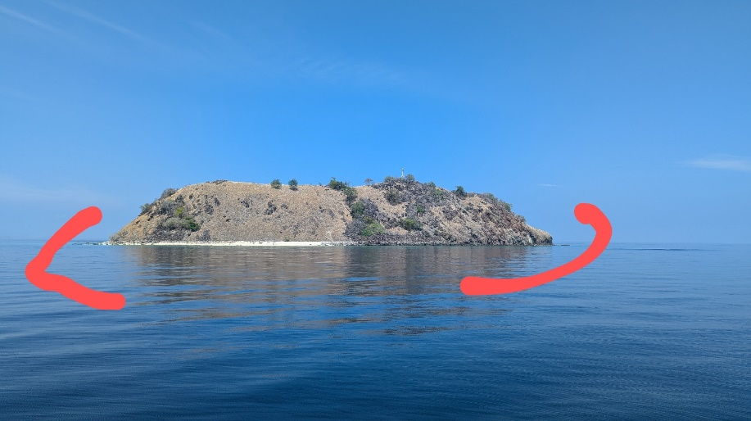

We headed off with Pantropical Bottlenose behind us looking especially beautiful on the mirror flat surface.

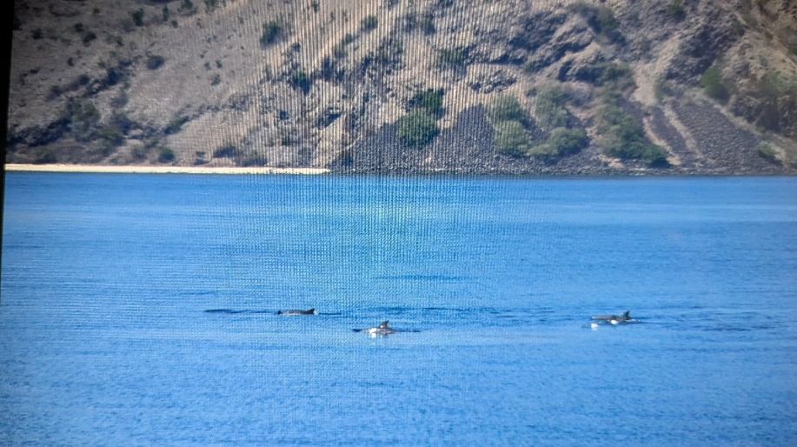

Off we went and quickly came across an Omuras Whale. I had never even heard of it until this trip and it was mentioned in Chas' presentation one evening. It was a morning I had decided to sit up the front and was with Mike who ended up being absolutely on fire for the whole day, being the first to spot many things which is secretly a bit of a buzz. I was there when he spotted a glistening back and a roll and my first thought was a Minke Whale which turned out to not be such a bad one. They are very similar and the same family.

We then got to play the Whale game, one of my favourites where the whale dives and you all position at different locations around the boat and have to shout out the clock face location when it pops up.

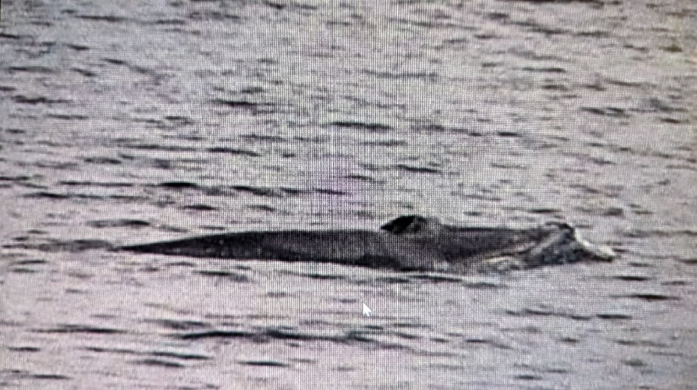

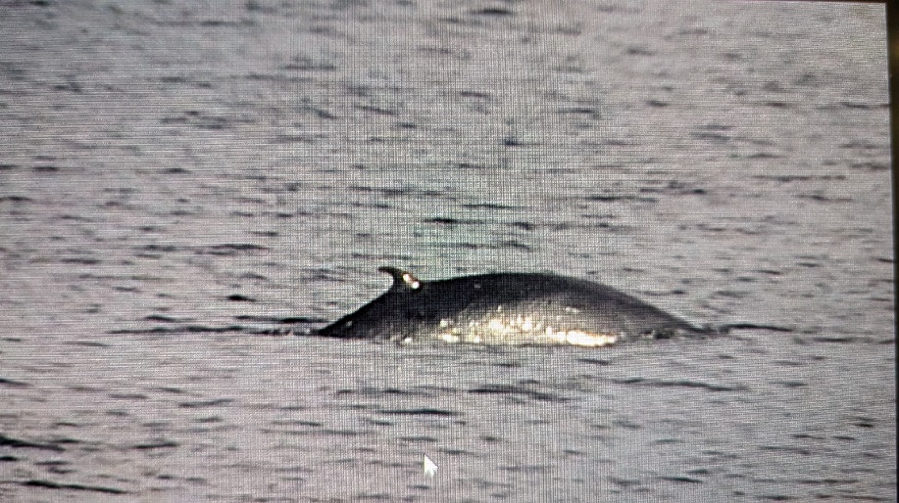

During the day I was popping back to my cabin with my door open watching my ocean world go by editing and writing which I just really enjoy as a hobby.
Another shout and the boat slowed and this time it was Melonheaded Whales.

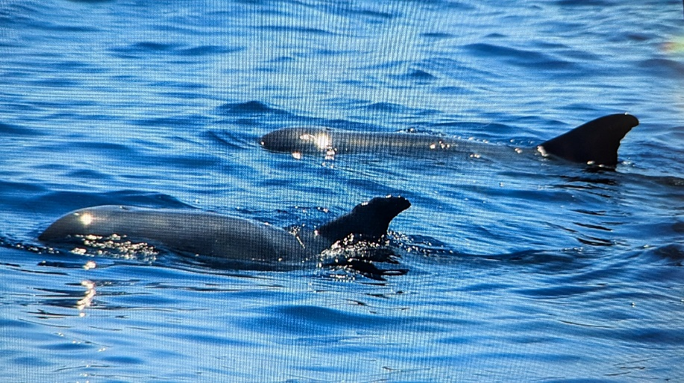
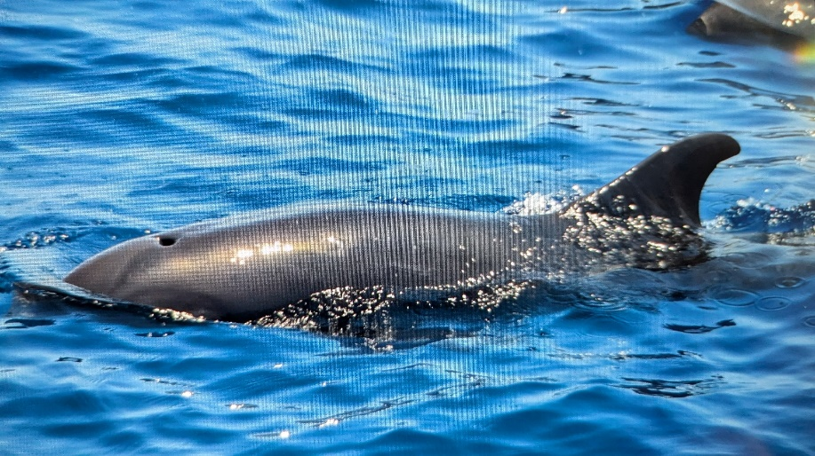

They were joined by a group of Spinners who didn't stay long and decided they had somewhere far more important to be and had to get there fast.

SPINNERS LEAVING FAST
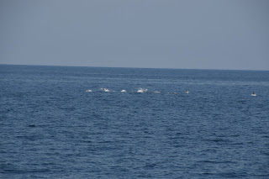

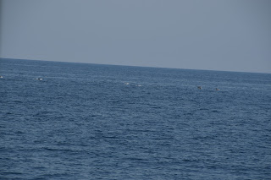

Then along came some Pantropical Spotted Dolphins. Really pretty and a much shorter rostrum than the Spinners.

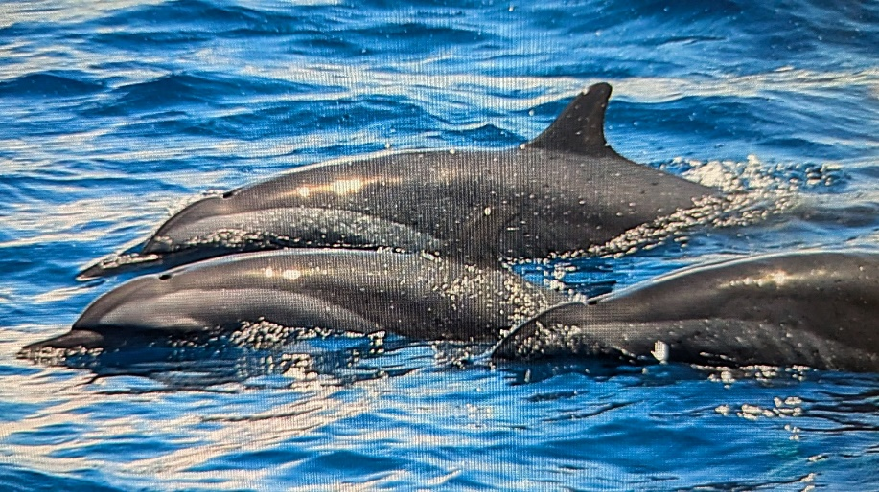

Back to cabin to keep writing and editing and a group of Rissos appeared, they have pale scratchy heads from the scars of rake marks where the males fight.

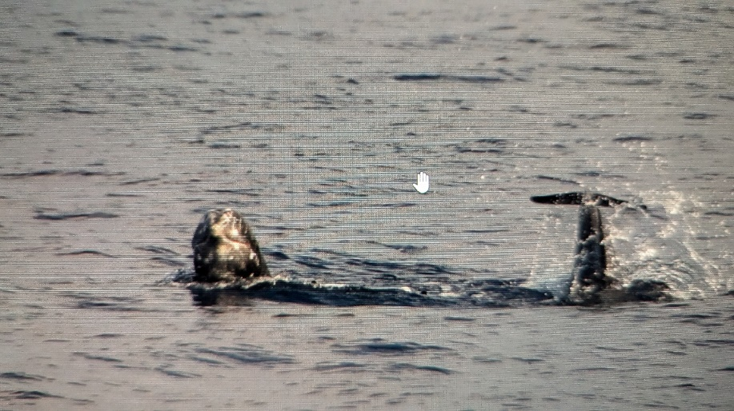

Coming straight at us.
At the same time a Dwarf Sperm Whale appeared - they tend to sit in the pretty silvery streaks of light or different current and look like an upside down surfboard ! Annoyingly no photo.
Back to cabin, getting behind now, the more I sorted photos the more photos I was taking with all the sightings !

When I felt the boat slow again I nearly cursed ! For god's sake ! I have photos to sort !
Risso's again and this time they played a silly game of tail sticking up. No idea why they do this and as it's directed exactly at us you have to wonder if it's some form of communication.

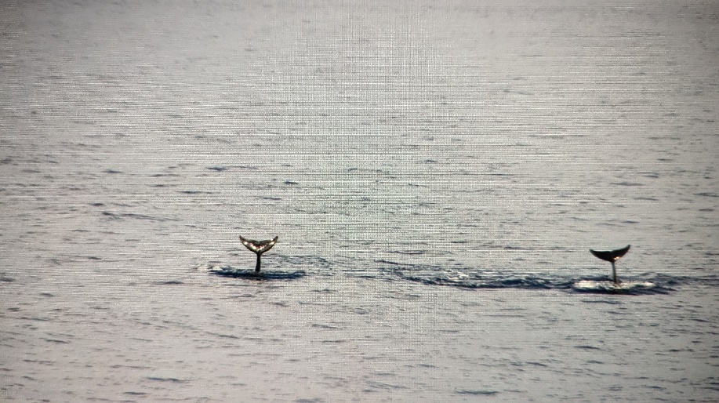

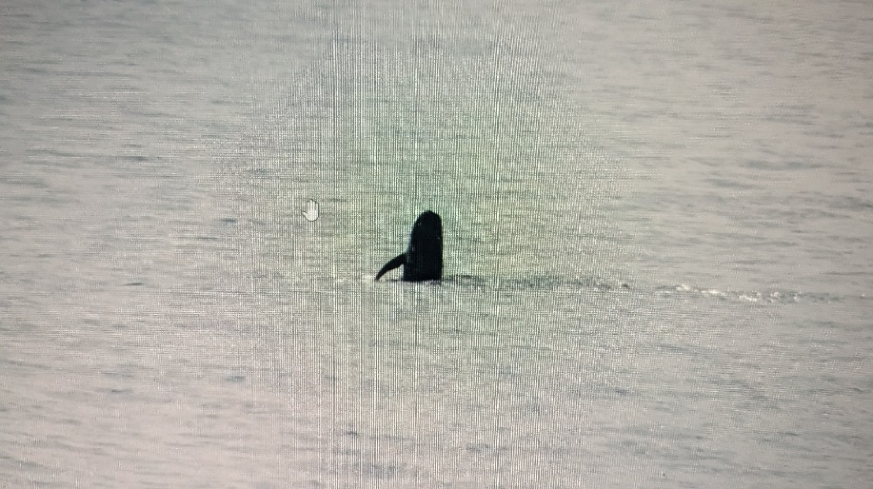

It had been an amazing day and the light was starting to go but Mother Nature had one more surprise in-store. Not 1 but 4 beaked Whales ahead. You don't see much and can't identify them until you see the head. So each time they surfaced ( after we had played the Whale clock face game again ) David and I were clicking hundreds of photos to try and catch one of the head. Jacob sent the drone up and got some good footage to confirm they were Cuviers beaked Whales. Each time they dived we set a timer as they can go down for 30 to 40 minutes. Sue gave a shout at 6 o clock which was much nearer than the first time and we were able to get more footage. As a finale, one of them breached 3 times, unusual for them.

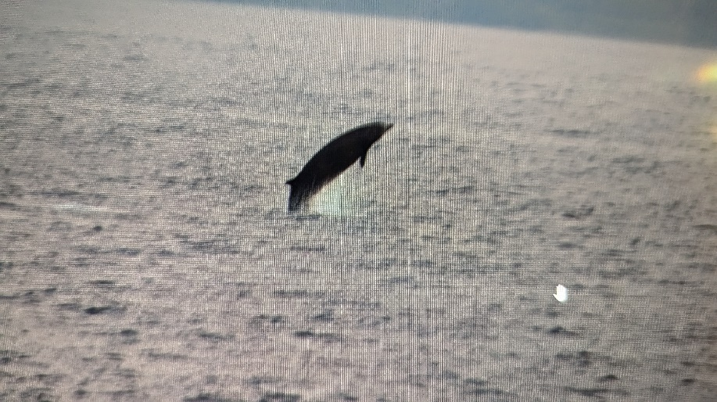

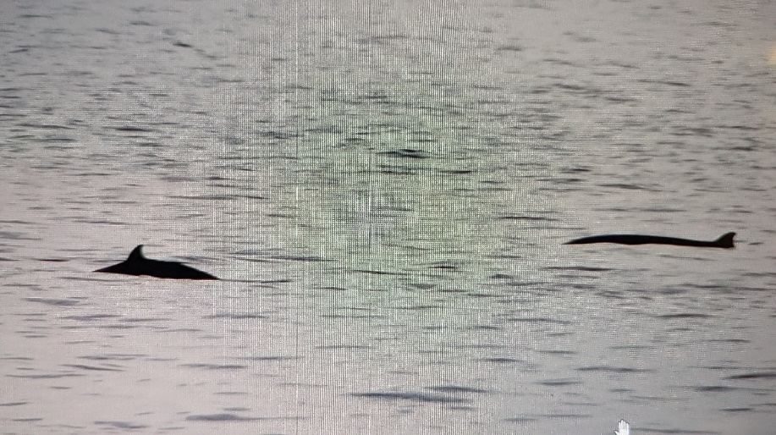

We all clapped and cheered as we had to leave with the light failing. A spectacular sunset ended the day.

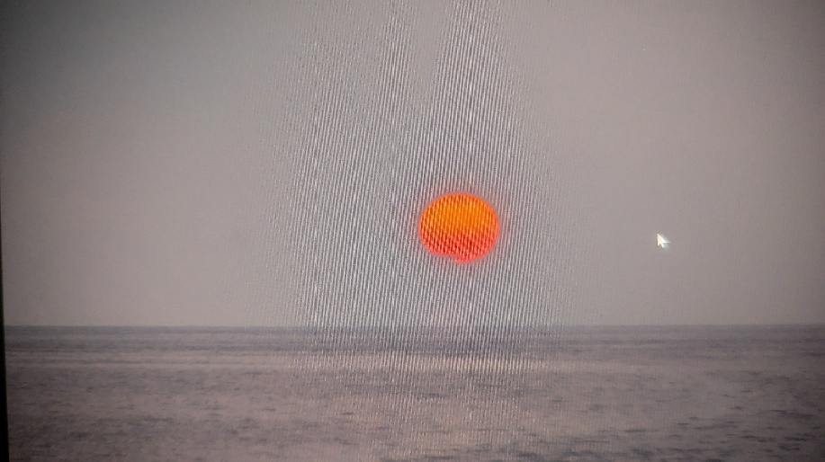

The evenings presentation was about Alfred Wallace a famous explorer and general science person. He questioned the evolution of life. He travelled to the Amazon and collected hundreds and hundreds of samples of lots of things. Got on a boat after 4 years to take samples back to UK boat caught fire and he lost the lost the lot. He survived 10 days at sea before they got picked up, but all the samples were gone. ( I knew how he felt after losing my whole blog this morning ) Off he went again, this time to Indonesia and studied lots of species of birds and animals. He realised that to the left were certain types of species, so on the Asian side, but to the right things were much more Australasian. He realised that that divide happened between Bali and Lombok, where we travelled the first night in a very Roly deep channel and because of that channel, things couldn't cross over and that line is now known as The Wallace Line. There is a statue of him in The Natural History Museum and an oil painting.

FRIDAY 27TH SEPTEMBER 2024

Not so much of sunrise this morning as we were in the shadow of Flores.

Snorkel at 7.30 in a very different bay, rocks and a bit sparse but water was so warm and crystal clear. Decided to film myself doing my amazing backwards roll !

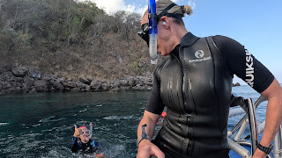

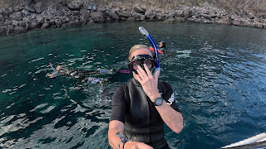

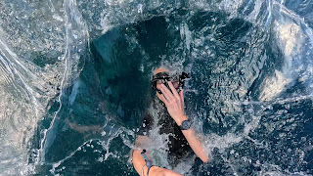

As there wasn't much to look at I decided to swim across the bay. Tucked my GoPro down my leg and off I went. I've been really stiff, I think from not doing exercise so it was lovely to have a good swim and I felt heaps easier afterwards.
I swam back to the big boat and hauled myself up like a beached whale.
A lovely local boat was off the back and it seems that we give them food, the same as the local lads that came alongside at the bat place.

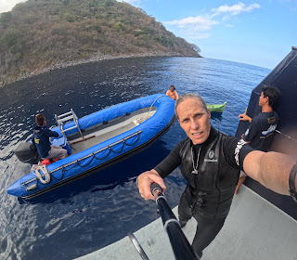

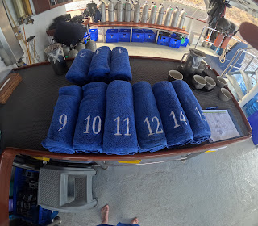

Our towels all lined up ready for after the snorkel. I came back early just to save the rush I always seem to be in !

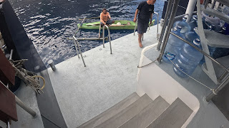

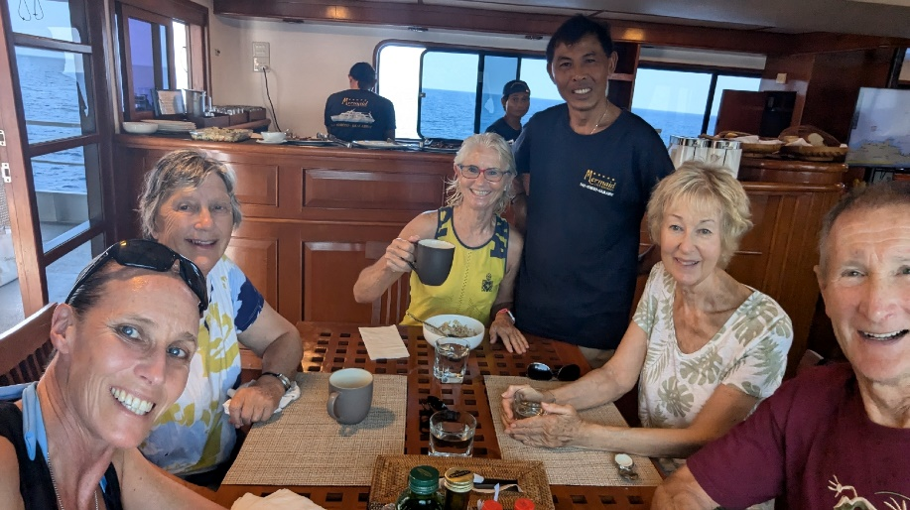

Breakfast. Always enjoy this after a snorkel and love my coffee afterwards sitting at the back of the boat writing.

Made the awful discovery this morning that my entire blog has disappeared !! Devastated about this and have contacted them to restore it but have made notes and have all my photos so will write it again on laptop when I get back to Bali and have WiFi.

The last evening was lovely, we were all asked for our 2 highlights from the trip, some people specified sightings, some the staff. My best 2 were my Triggerfish attack and I love the Whale Clock game when we are waiting for something to resurface. This trip was Sperm Whales, The Omuras Whale and finally the Beaked Whales

EPIC ADVENTURE TO GET A FLIGHT!

So.. we disembarked at 5am to have a 4 hour car ride to Endes Airport. Up and over and around huge volcano ranges, really twisty and turny and definitely couldn't look down and read or type !! All very relieved to get to Endes Airport, only to establish that flight to the west end of Flores has been cancelled ! So we are all loitering around making a plan.

Seemingly the best option is to drive 11 hours to get to the airport that is open and race against a cloud of volcanic ash.

Now booked on flight tomorrow morning to Bali. Mermaid boats have been amazing and booked us all a room once we complete this 11 hour drive.

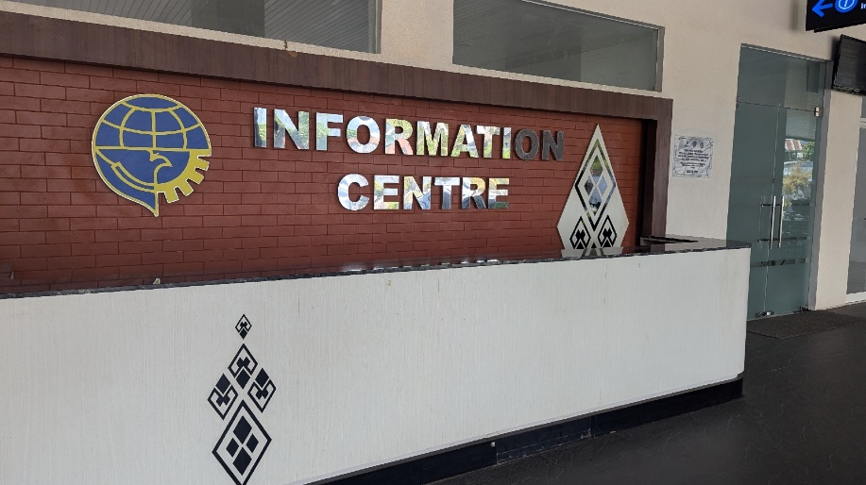

Helpful !!
Off we set at 12 midday. 15 minutes in and got a road closure !
We stopped after an hour so drivers could have lunch.. absolutely gorgeous spot called Bluestone.
Somehow 3 of our 4 cars are together and we have a lovely table altogether for lunch. It's amazing black sand.

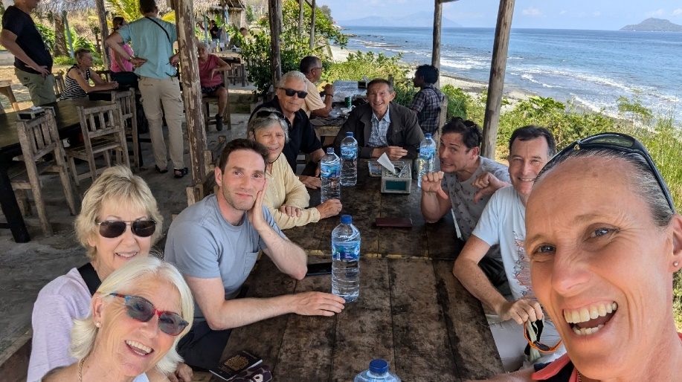

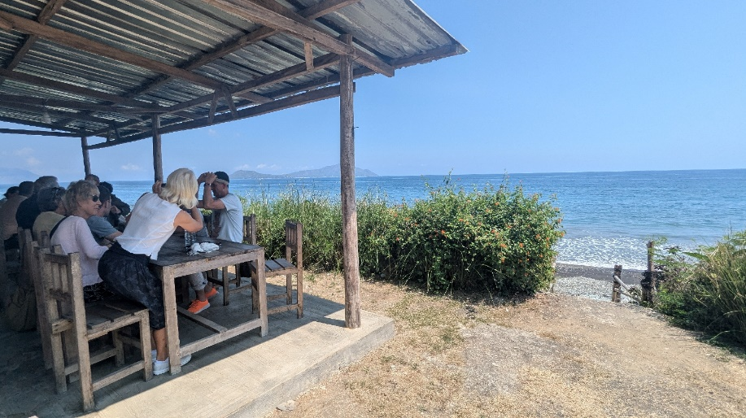

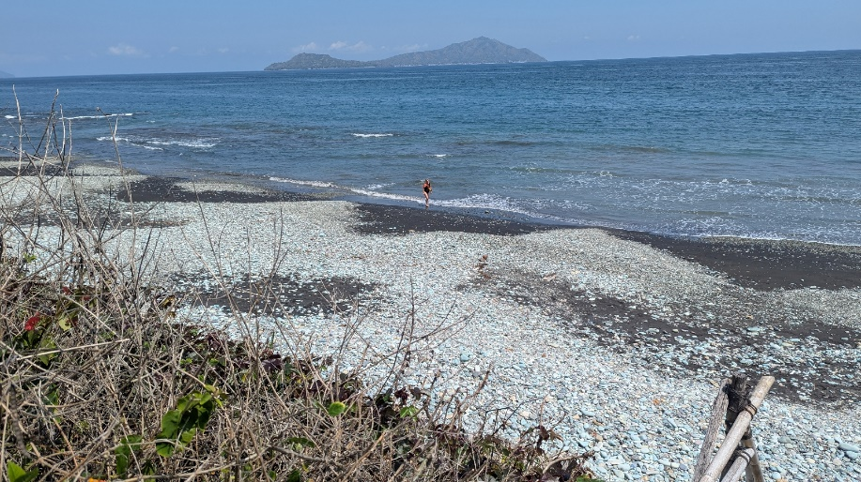

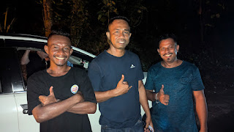
Then we drove for 4 hours, pulled into layby for a wee stop and once again found the others !
Our amazing drivers

Fuel stop
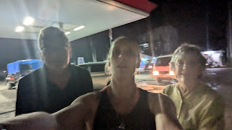

Bit more driving. Scenery was actually really interesting, from giant bamboo 5 inches wide and about 50 metres tall, little villages flew by with dogs at the edge of the roads and kids milling around.
We were now about 7 hours into the journey and stopped for coffee. This time Sue Richard and Patsy caught us up.

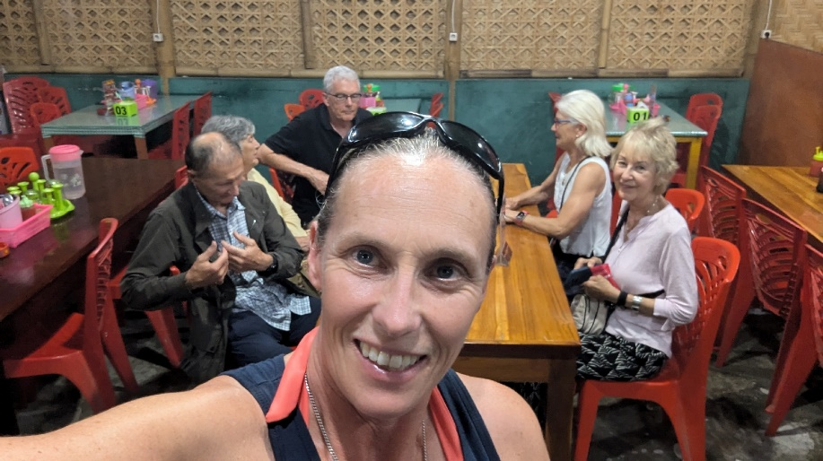

We had had frequent visits to ATMs to take out cash as will need to pay taxi driver 5million Indonesian money. Each ATM had a limit and we just got out what we could and are building up reserves along the way. It's about £100 each.

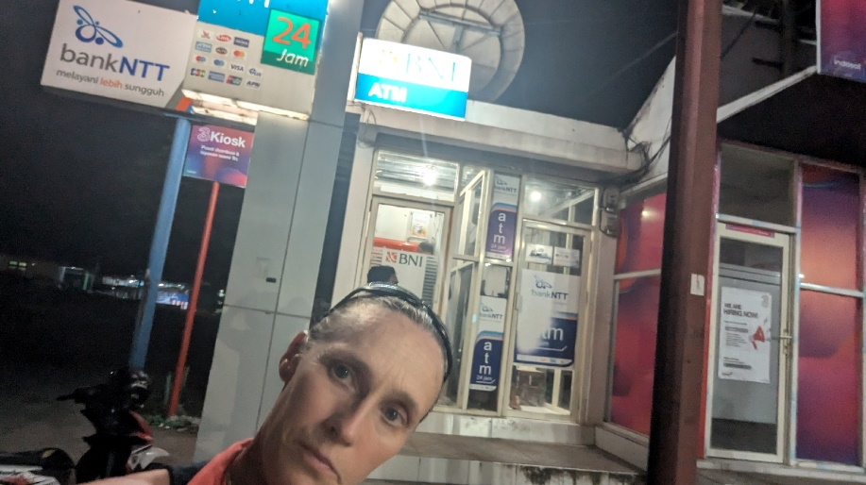

It's now 9pm. We left the closed airport at 11.30 this morning !
Just trying to find a good stop before final couple of hours of driving. I'm actually enjoying the whole adventure ! I feel like the end will feel like finishing a trail run or a Marathon, it's going to be a huge achievement.

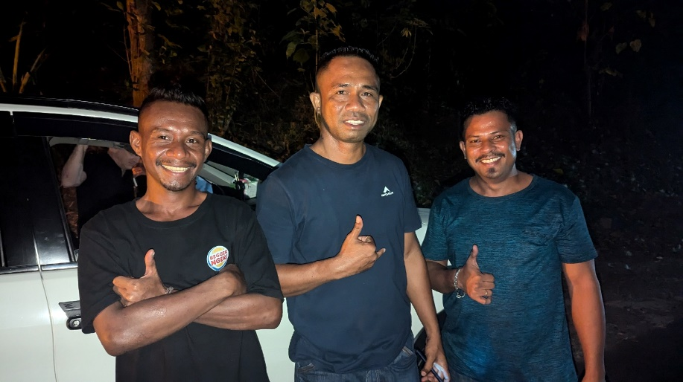

These guys were just unreal and I have no idea how they did that drive.
At one point we wanted to eat and tried 4 different places.
Although they were shut, these girls at one restaurant wanted a photo and to know my Instagram !

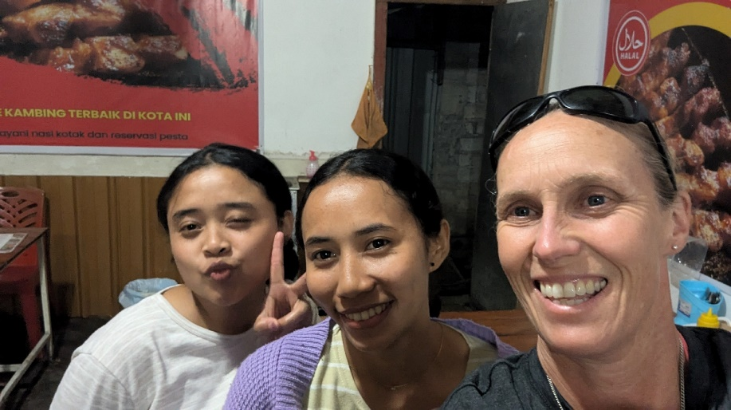

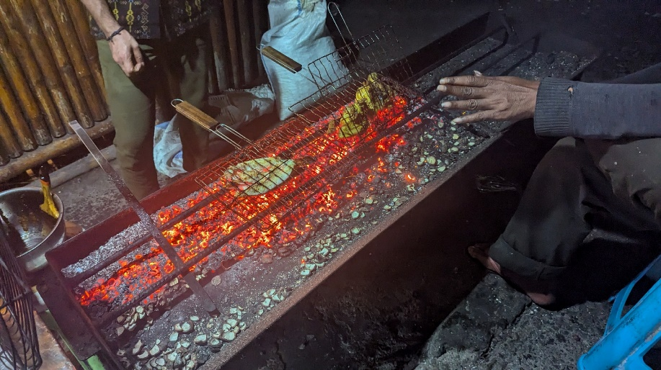

I found Coral Trout looking stunning under ice in a display - it went onto the BBQ and was delicious.
Then we had final 2 hours to go. We drove through mud all over the road and hoped like hell the car didn't get stuck.
We finally finally made it after being up for 24 hours and driving for 20 of those hours. 550km through volcanic bendy windy roads up to altitudes that made your ears pop and water bottles suction in !
We were so relieved to be at the hotel. Sue and I shared a room, not that we needed to as it was only £40 for the room. It had just made it easier for Mermaid to book the rooms.
This is the map of the drive. It took 14 hours with stops and coffees for the drivers and we'd already done 4 hours from Maumere to Ende.

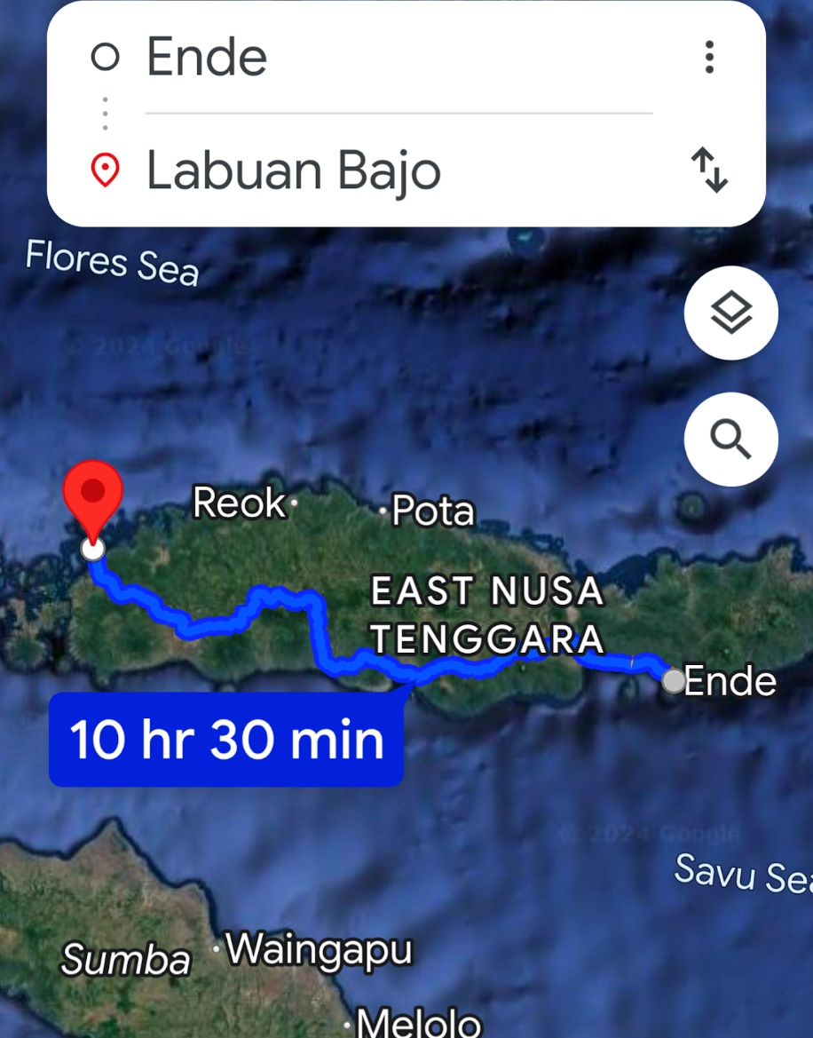

This is how the roads were as you spiralled up and down volcanos on hairpin roads.

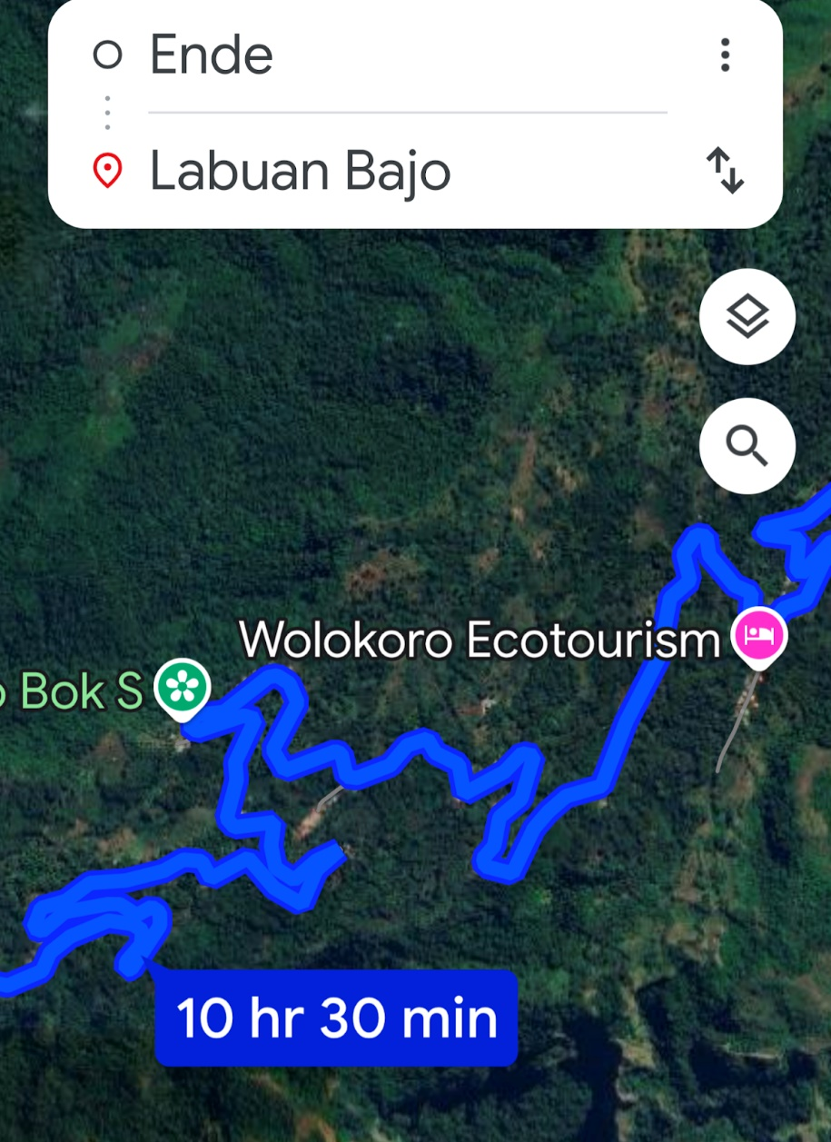

Slept for 3 and half hours and went down to breakfast and to say goodbye to Sue Patsy and Richard who were on an earlier flight to link with more time for an international flight.
It was a lovely hotel called Prima and would definitely use it again, but really feel that I saw way more of Flores than I had really wanted to.
We all got on the flight and we're grateful to be on it after such a mission to beat the ash cloud and get the hell out.
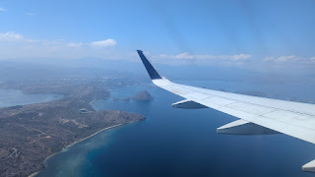

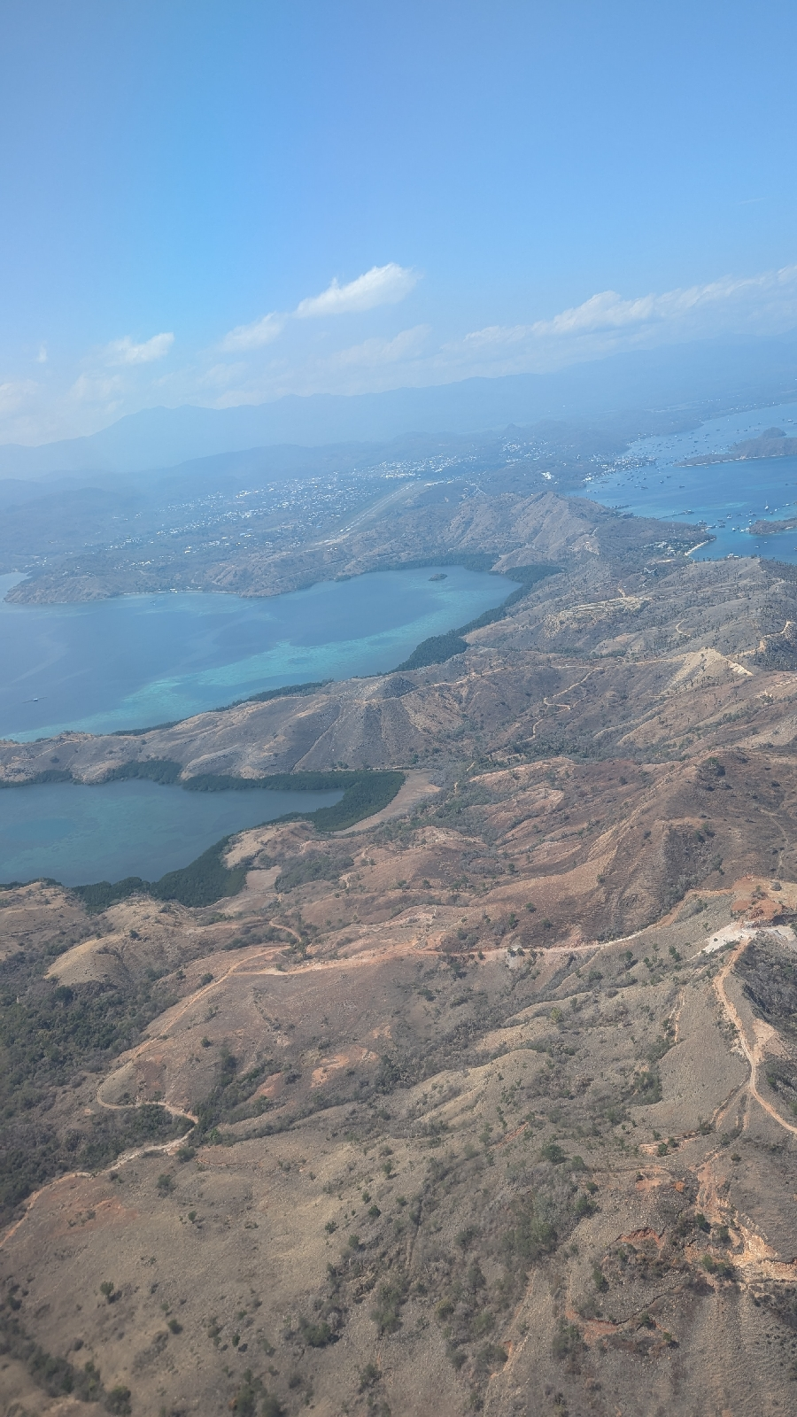

I did a lot of writing on the 45 minute flight, grabbed my luggage, said goodbye to everyone. I think Sue and Brice were my favourites. Found my driver who had helpfully messaged me where he would be and my sign.

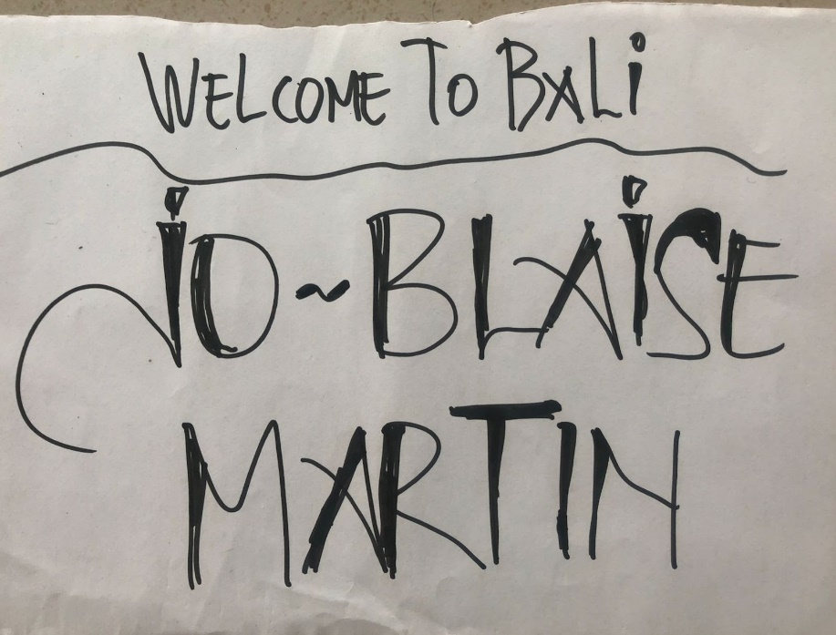

We got to hotel fast and by 12.50 I was by the pool. Double room, bit old and basic but really really fine for me for a couple of days. Royal Tunjung Bali Hotel and Villas.

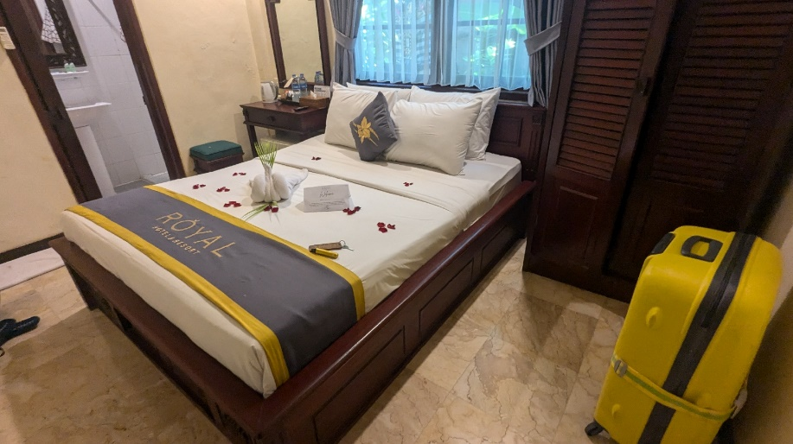

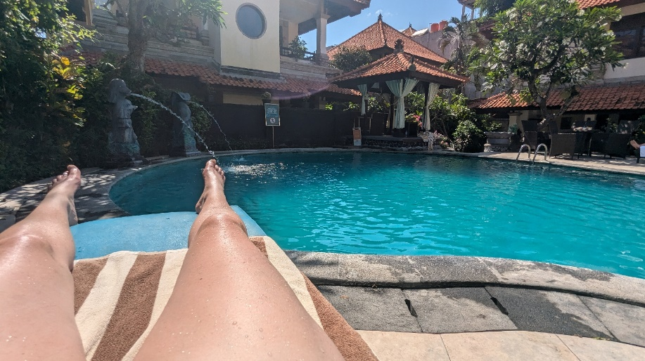

By the evening I was totally shattered, more than I have ever felt in my life. I slept for 11 hours !

This hotel has been a nice base just to chill and I sat re-writing my journal in lovely surroundings. Did a bit of shopping for some gifts and have rattled through the re-write so well, I still have time to sit by the pool with my book.

What an adventure it's been. I so hope anyone reading this has enjoyed it. I've loved writing it (twice !)

