South Africa Safari - June 2017
joblaisemartin
Dec 29, 2021
18 min read
Updated: Jan 7, 2022
South Africa June 30th 2017African Wildlife
The strangest thing about this journal is that each time on my iPad I choose a themed document to write my journal. The theme I always use which has only been noticeable this time is one called "African wildlife" and then I always replace the cover photo with my best 3 photos of whatever trip I am documenting. The three standard photos on the front of this template are a giraffes head, two elephants and some meerkats..... Already after day 1 I have the replicate photo of a giraffes head ! This is very boring information but after all the journals I have written it suddenly became relevant. I digress.
To start with, two long flights not particularly comfortable, both times trapped in the middle of economy rows like little sardines in a tin. We managed but we struggled. Unfriendly people sat on the end of your row are just a bore, cabin crew with no interest in the dietary requirements of scotch and gin, are also a bore. We ate, we watched tv, we did a quiz, we slept, we got neck ache, we got off. Here in Durban - stupid people push in front of you in border control queues, they try to be obnoxious, they attempt to out stare a Gemini and a Scorpio, they lose, and as we eventually sail through customs, they are left fuming, in front of customs officers, hopefully never to be granted entry into the country. We left the building. We got a taxi, we got to our hotel.
Putting random photo here as it's the first photo that shows on Blog !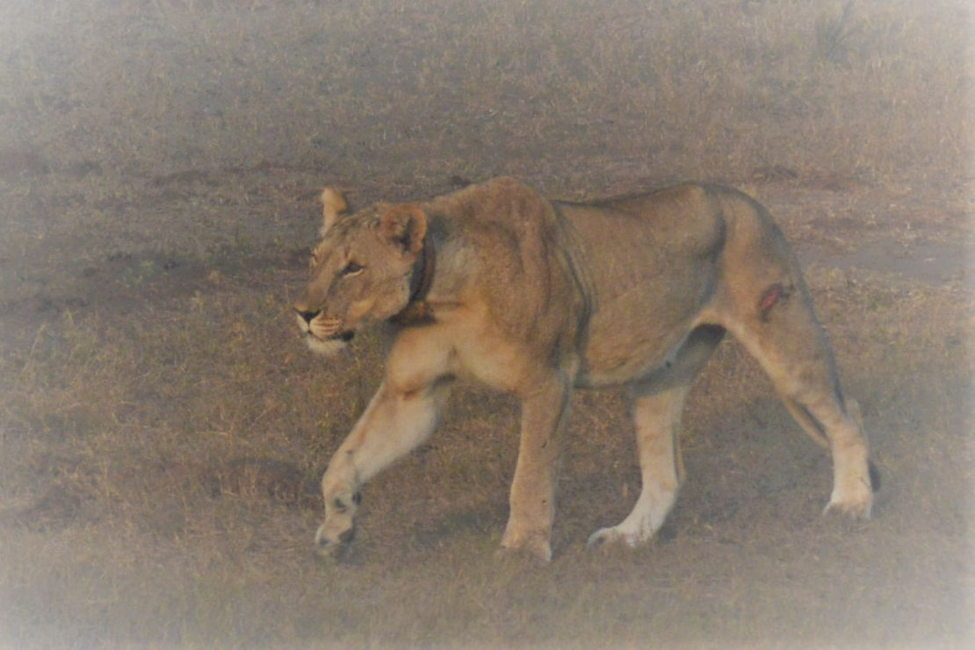
Against everyone's instructions, we decided to go shopping and with the palest skin in the whole of the land we stuck out like sore thumbs as we stuck close together, dodged dodgy looking groups of people, gathered our supplies and returned, somewhat relieved to have made it, back to our room. Not to be deterred, we walked, yes ladies and gentleman, in Durban, we walked 200 meters to Clive's hotel where we were greeted with a telling off and a reminder that here, people will think nothing of sticking a knife in your ribs in exchange for your mobile phone or money, not only were we told this by Clive but more than one local person..... Which is why Lucie then got told off by me for having walked distracted down the road with her bag open as she searched for something she probably didn't even need right at that moment. It did feel a little like you needed eyes in the back of your head, but an Armstrong is apparently immune to any normal danger that presents itself to the rest of the unwelcome white people on the streets of Durban. ￼ We were escorted by Clive along the seafront where he seemed to know everyone, as though he had lived here for the whole of his life.

- 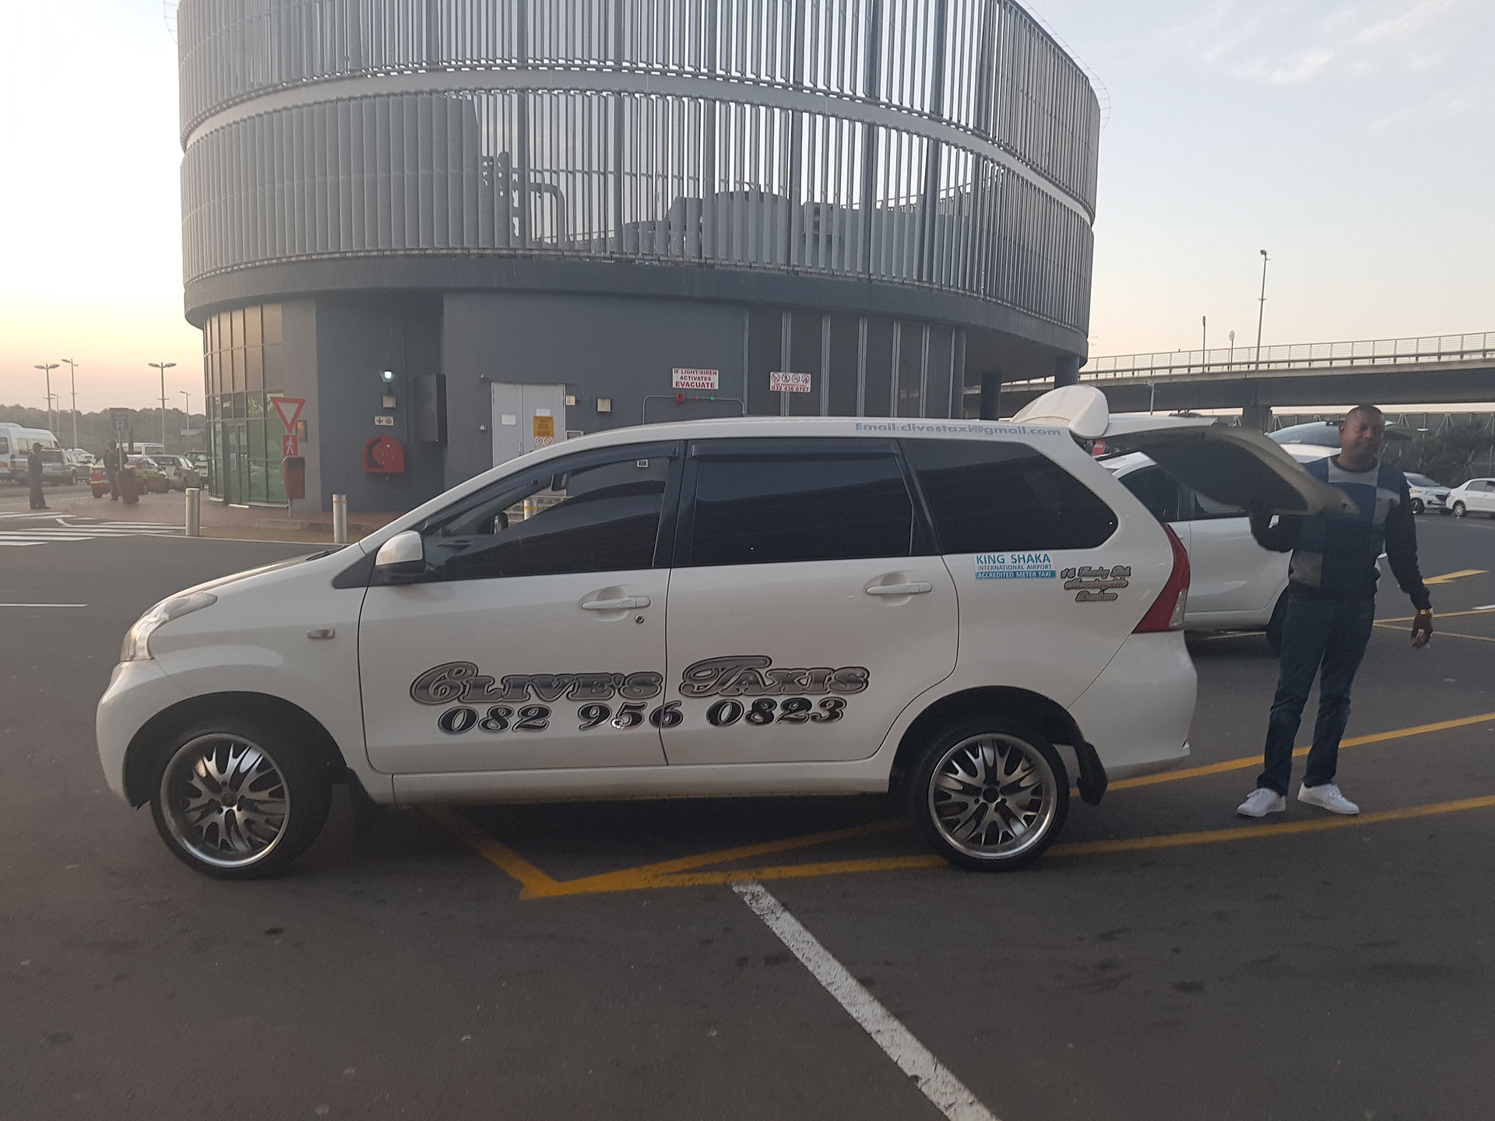
- 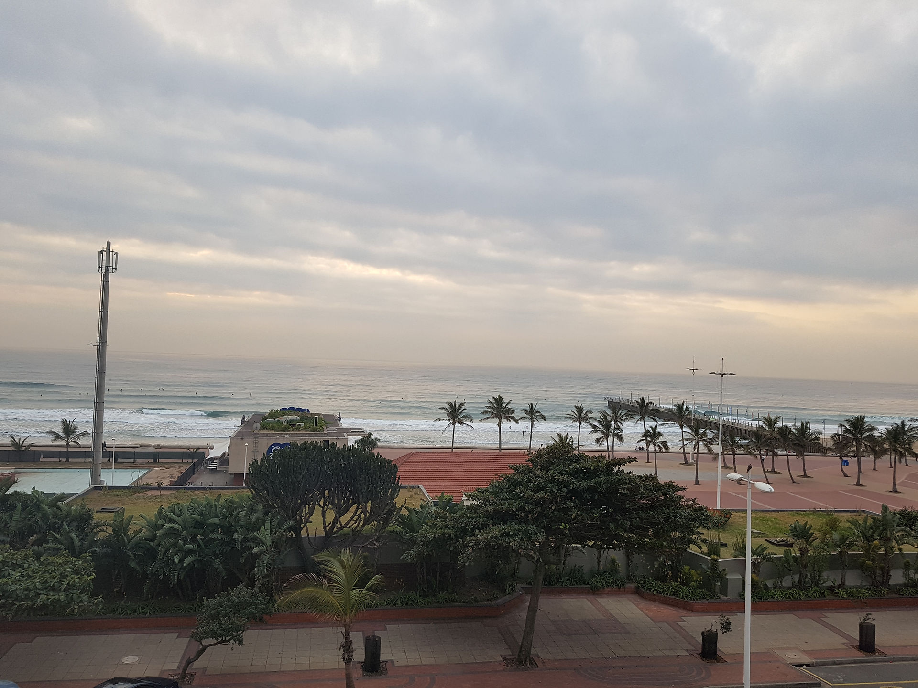
- 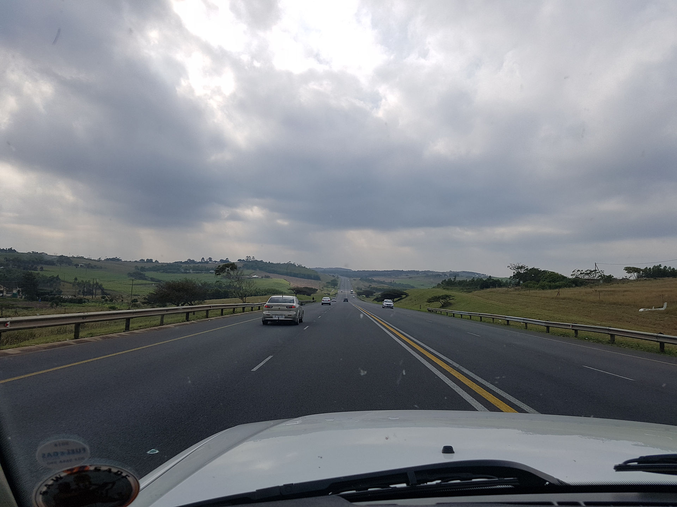

We had a lovely meal, surrounded by security guards which was ever so relaxing. Clive walked us back to our hotel via another drink in a place where they wore pink waistcoats. Finally we went to bed after organising suitcases and shopping. The sound of the sea was one thing, we incidentally had a great seaview and a balcony, the sound of people returning at 3am was something else, they seemed to be singing songs and playing who could do the best car alarm impression right outside our door. Normally I would confront these people. This was not the thing to do here. Woke at 6 to see if I could get sunrise but it was cloudy. The Dolphins milling around behind the surfers did however make up for this and it was great just watching them. We were collected at 9am and off￼ we trundled along lots of non busy roads about 3 hours north. We had a coffee stop, one where we refused to pay for the coffee because it was disgusting and ordered a latte from Wimpy instead, who knew that Wimpy still existed ?? Onwards and we reached our lodge at 1, had a quick tour round, dumped bags in rooms, Clive had paid a single supplement and had a great big double bed, we had a twin room !! So we laughed and pushed the beds together !!￼ Jeep arrived. Huge wagon with open sides, in we hopped and commuted 40 minutes to the game reserve. Once inside, it began. Our safari. We trundled along as Patrick our driver twisted and turned along various tracks as we looked eagerly for our big five. It's kind of ironic as none of us have much patience for people but with animals we could all sit for hours watching their behaviour etc. But Patrick was more used to normal tourists and no sooner had we stopped to look at something and just get the cameras sorted and aimed and focused and off we went again ! Anyway it was still fabulous, I will make a separate list, but we saw, black rhino, white rhino, giraffes, Impala, warthogs and many new birds. Again, barely the time to even grab ID photos. But definitely good to see so many. The reserve was huge and we only covered a small area as we were there later in the day. It was fun to be constantly watching and the anticipation of seeing stuff kept you constantly alert and the time whizzed by. We went back to the giraffes to try and get a sunset photo of them. We half managed it !￼

- 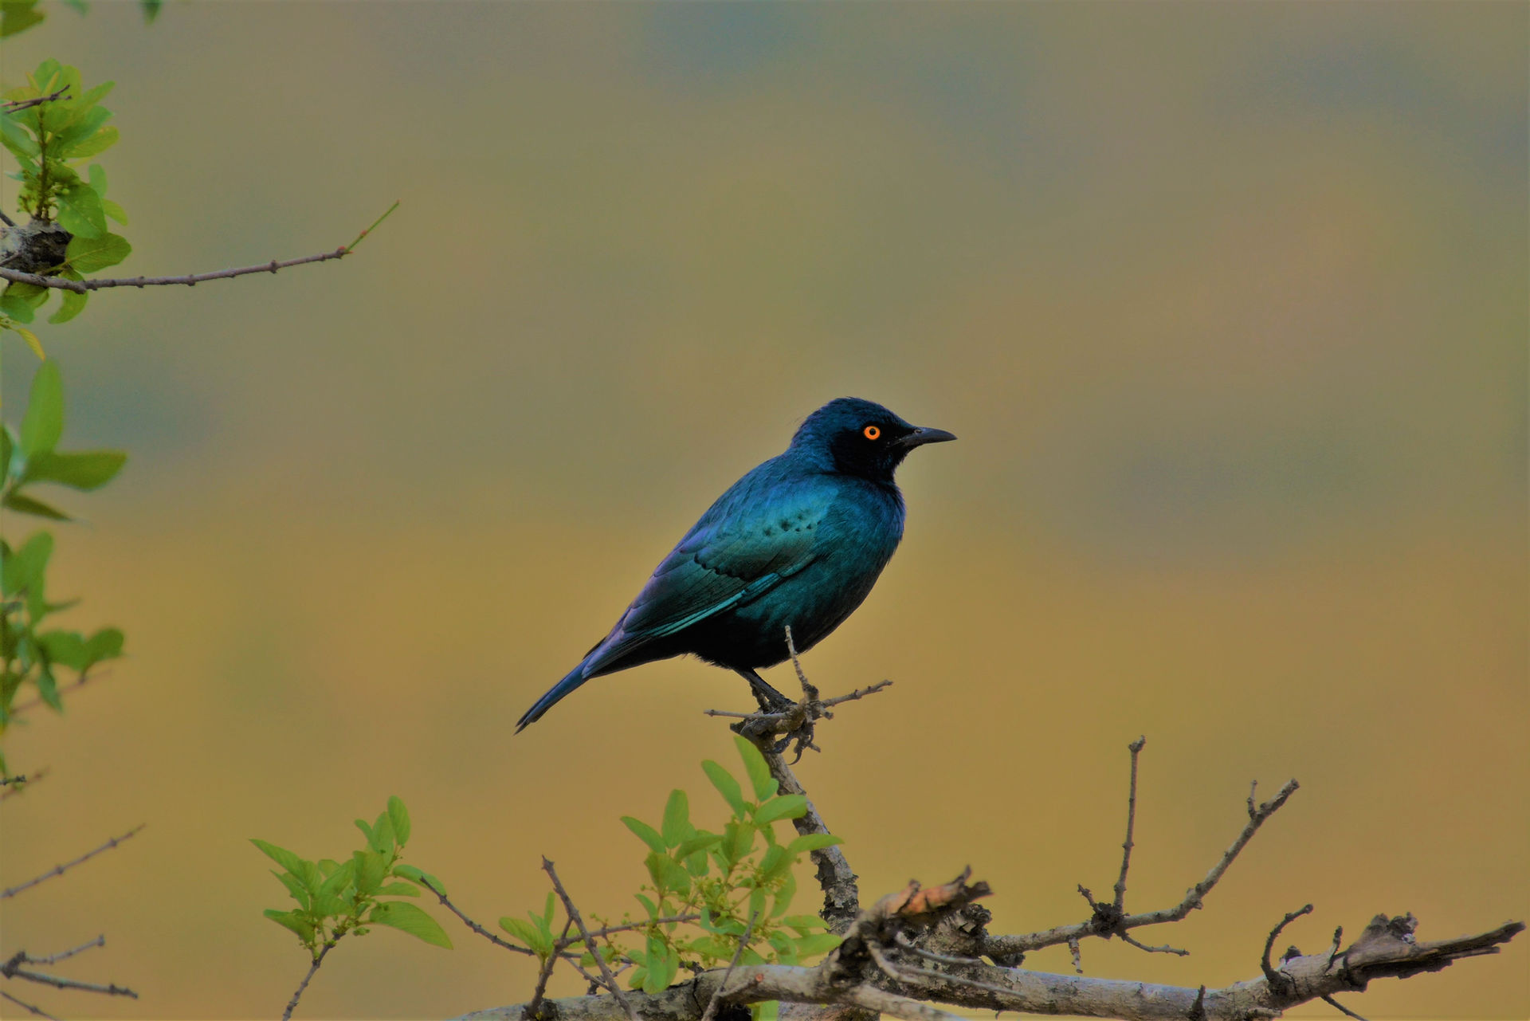
- 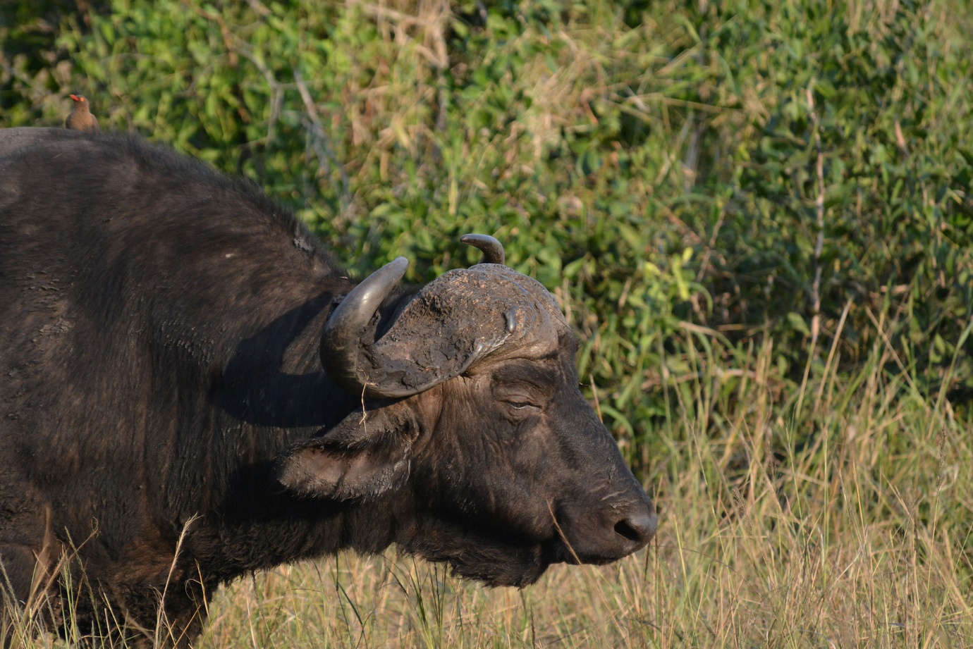
- 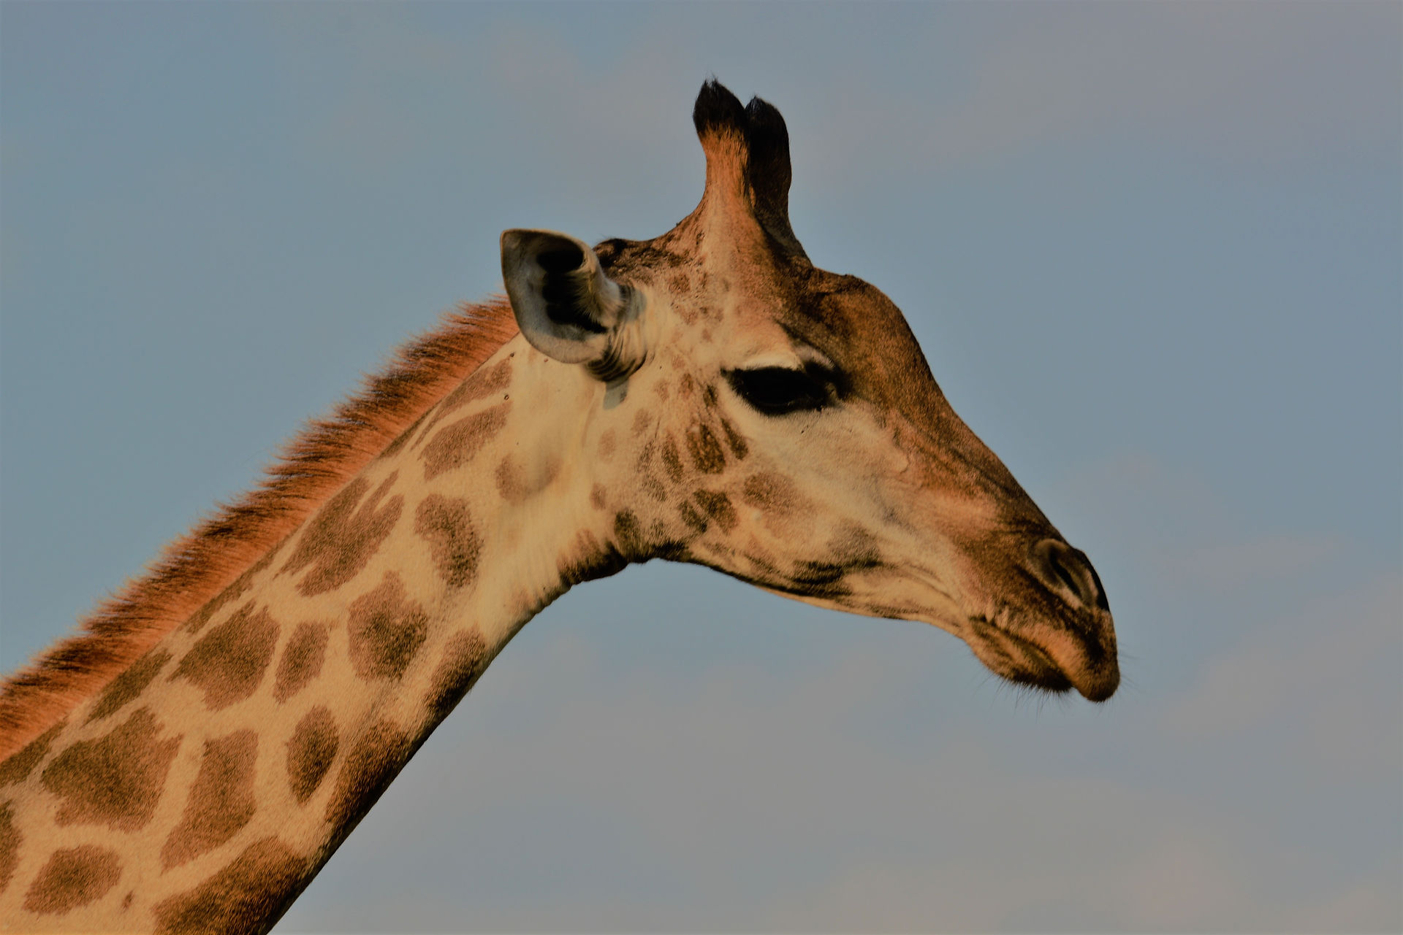
- 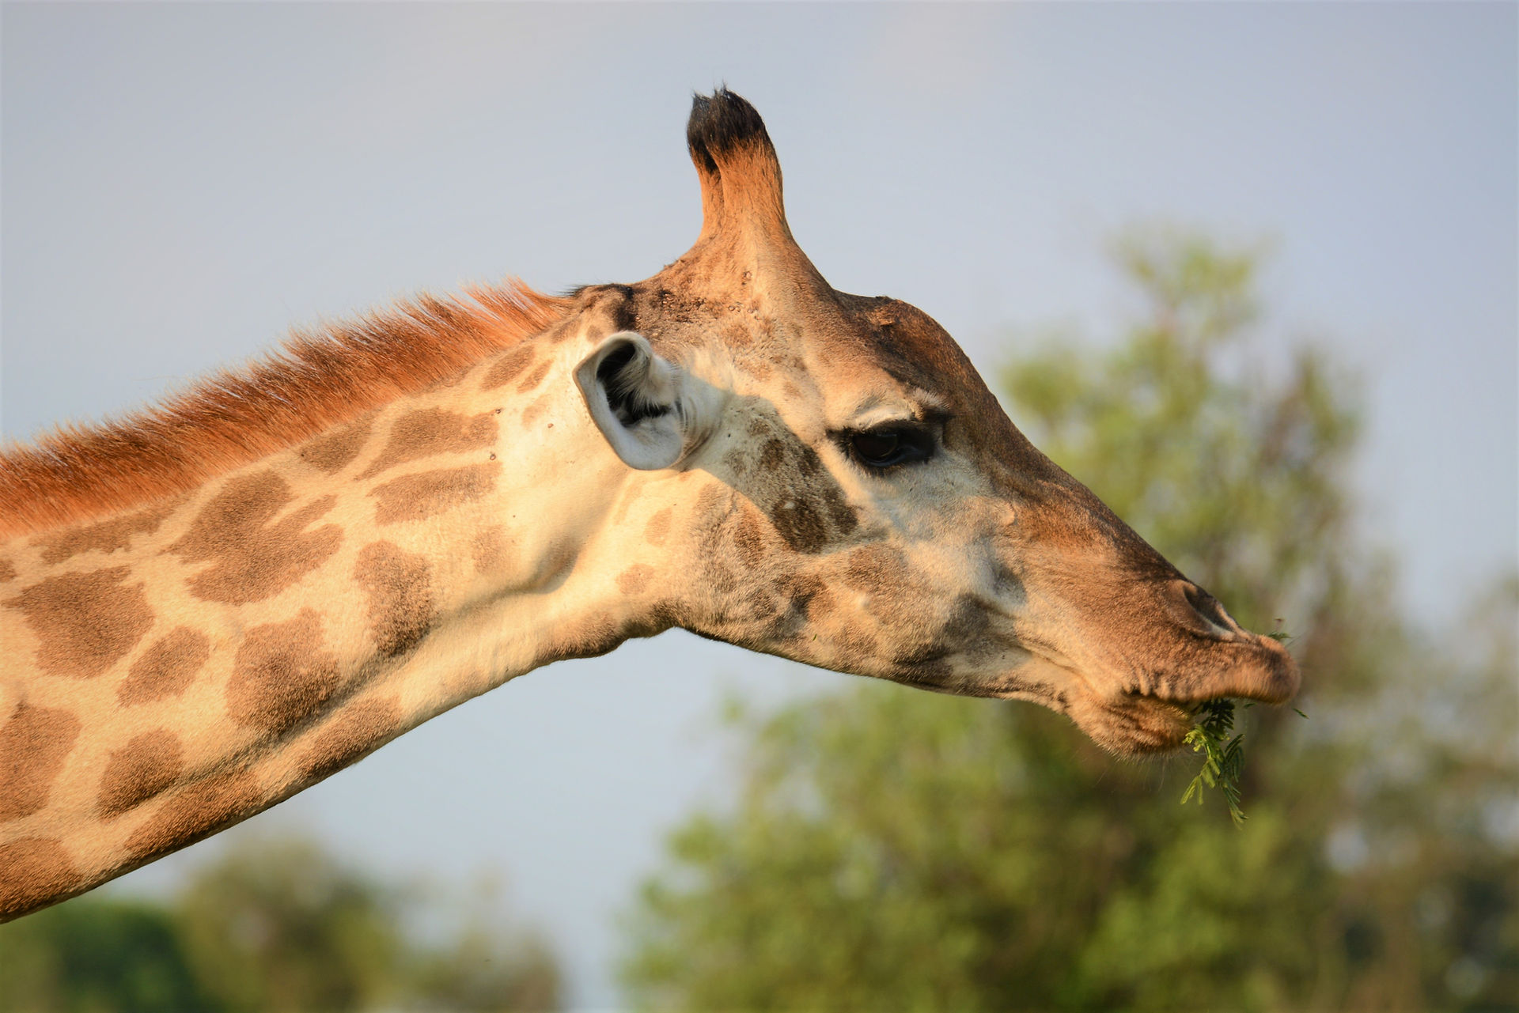
- 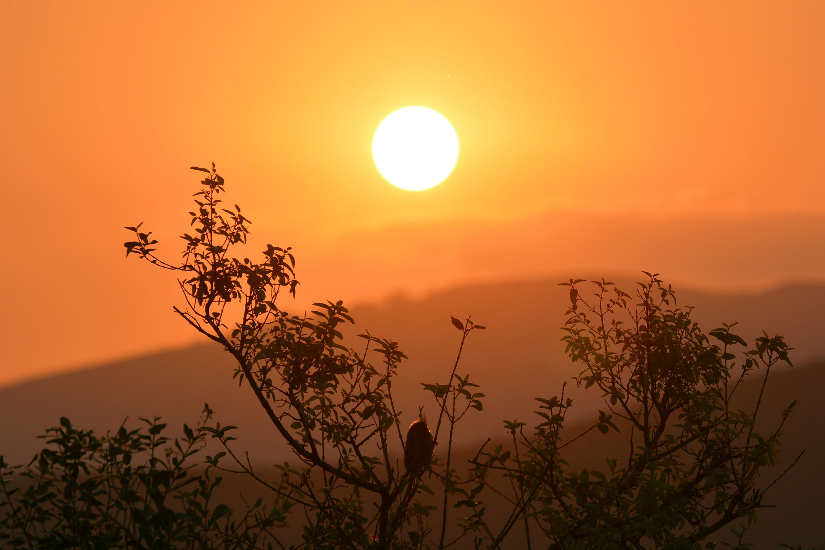
- 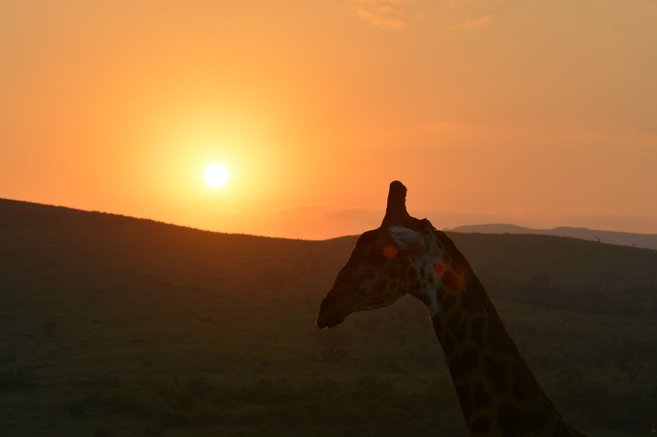
On the way back we made the massive mistake of wanting to go into the shop to buy some coffee and milk, this was some sort of local South African animal like carnage with queues so long at every til.
- 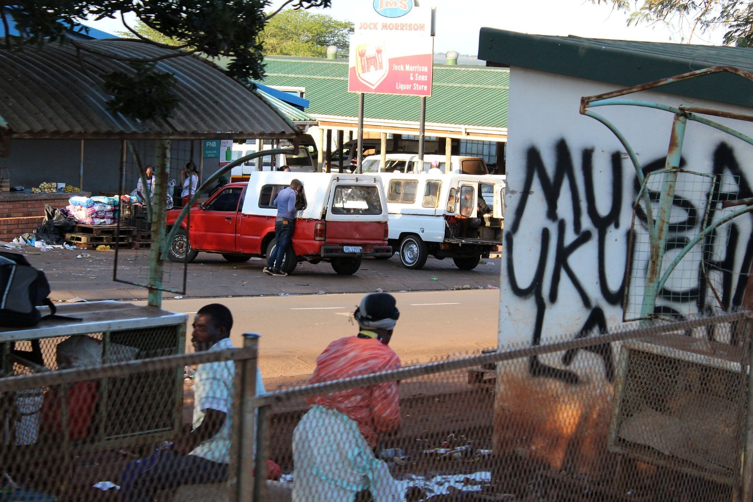

We are never going to go shopping again ever. After an eternity we escaped from the shop back to the jeep where Clive was guarding all our equipment. Back to base, it's a lovely escape with the noise of the bush all around. We sat at the bar in a row with our laptops and cameras and extracted the best of the worst photos.
- 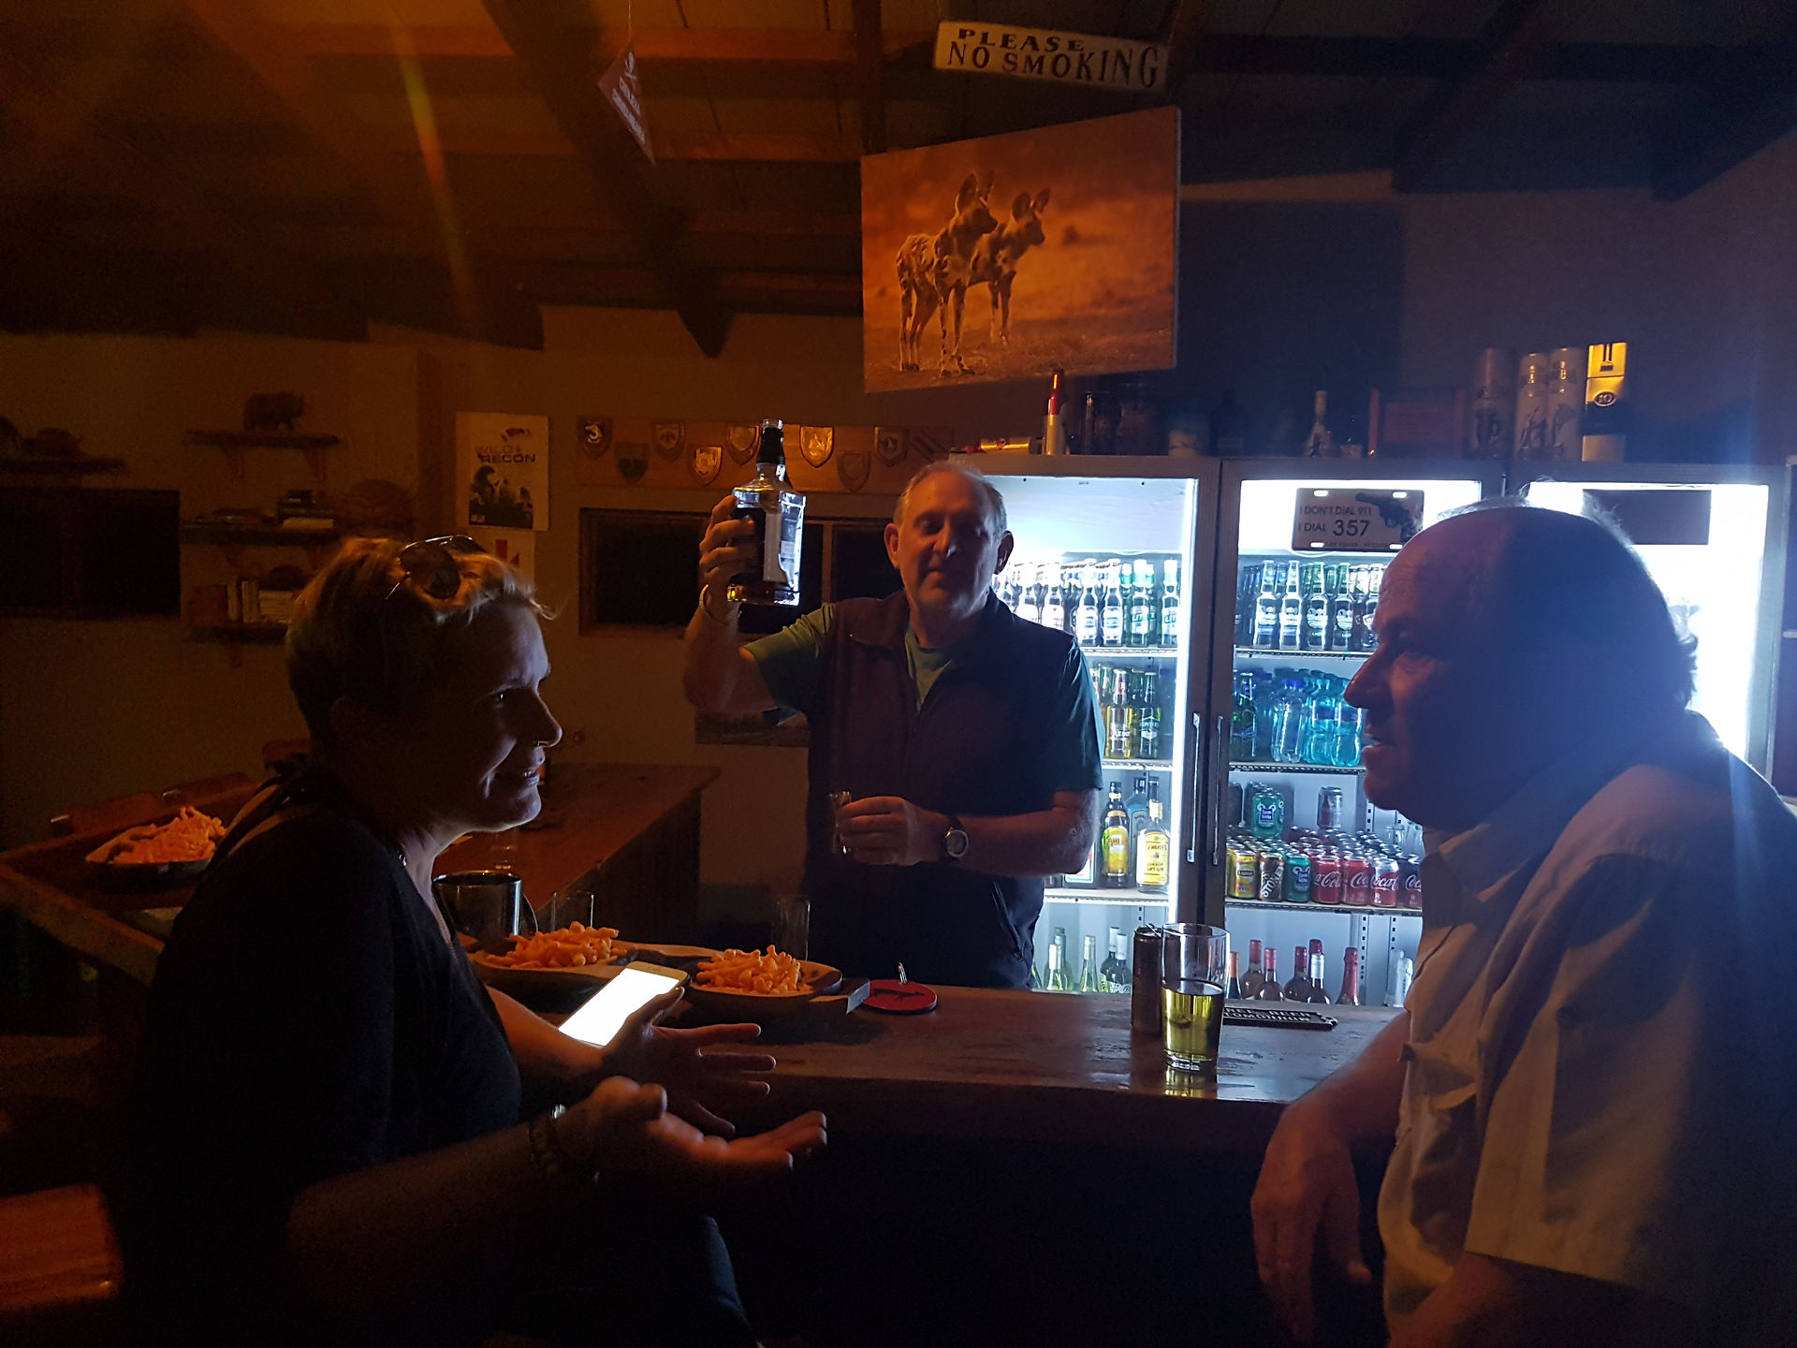
- 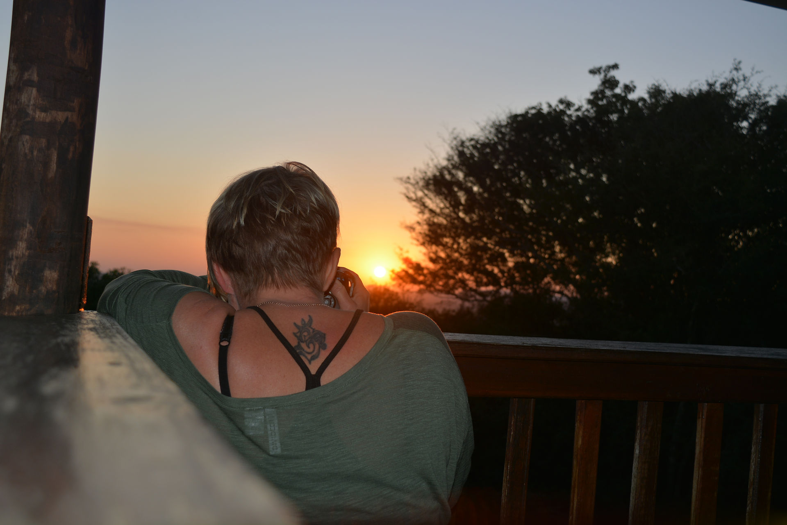
- 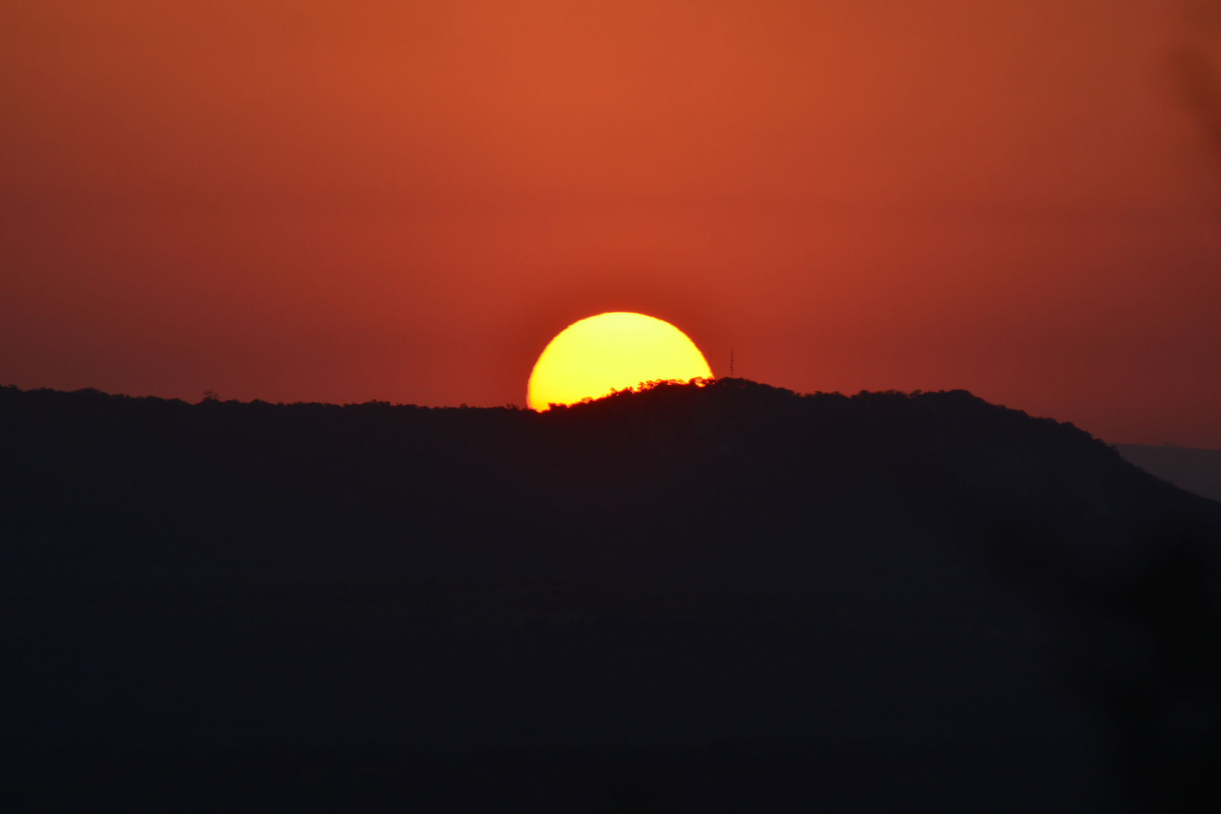
- 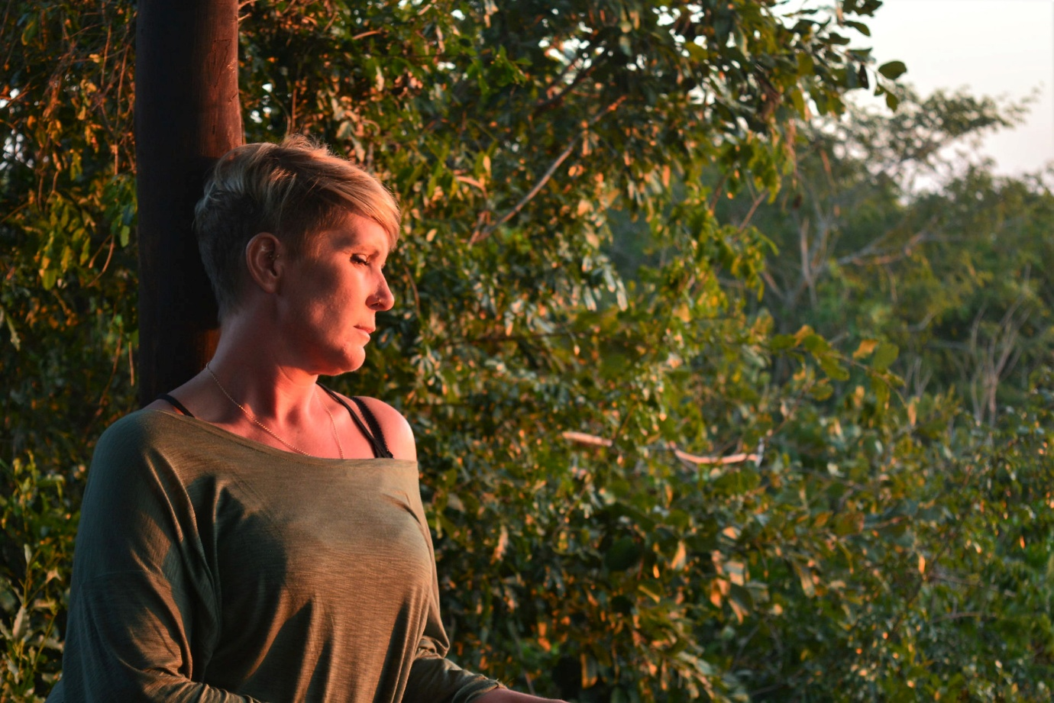
So frustrating trying to get the pictures you want and editing and making something out of nothing. The bar area is lovely, up above the trees and you can see for miles. Then after all the travelling and transferring to this lodge, we all opted for an early night. The lodges are lovely with plenty of space, bathroom has a big corner bath and a triangle shower and we have a veranda aswell.￼ Day 2 Breakfast at 7:30 which was lovely, cooked breakfast, cereal, juice. We had changed the time from leaving at 6am to 9, only because we couldn't see the advantage of being at the park especially as we wouldn't be there in time for sunrise anyway.we arrived at the park at 9:45 - the entrance only has a block of toilets and the barrier bit, nothing else, and definitely no latte facilities. So off we set again, cameras at the ready, herds of Impala were quite common, and the birds were great, we had a lovely Hoopoe and got good pictures.￼ Then we stumbled across baboons just filling the road along with a Kudu. Lucie tried the go pro out, at the time you have no idea what you are shooting. We were to find out later that it's actually great ! It has a wide angle lense and takes all the shake and noise out, really effective. The baboons trundled around the waterhole, all drinking from the same spot and the females carrying the babies on their back. As you pass cars on the tracks it seems to be the thing to do to wind down Windows and show off about what you have just been past or seen, almost like a card game, so a lion would probably trump a baboon. A herd of elephants may trump 2 lions. Anyway, we did pass a car and they had just seen 2 lions, the guy helpfully told us they were in front of the green tree. So we looked at the large hill covered in green trees and were really none the wiser ! Then one lifted its head and stood up, bit surreal really. There were 3 of them and they seemed to shuffle around a lot. Lying down, getting up, never quite facing the camera fully and just as you got the camera on them they lay down. But it was fabulous to watch them.

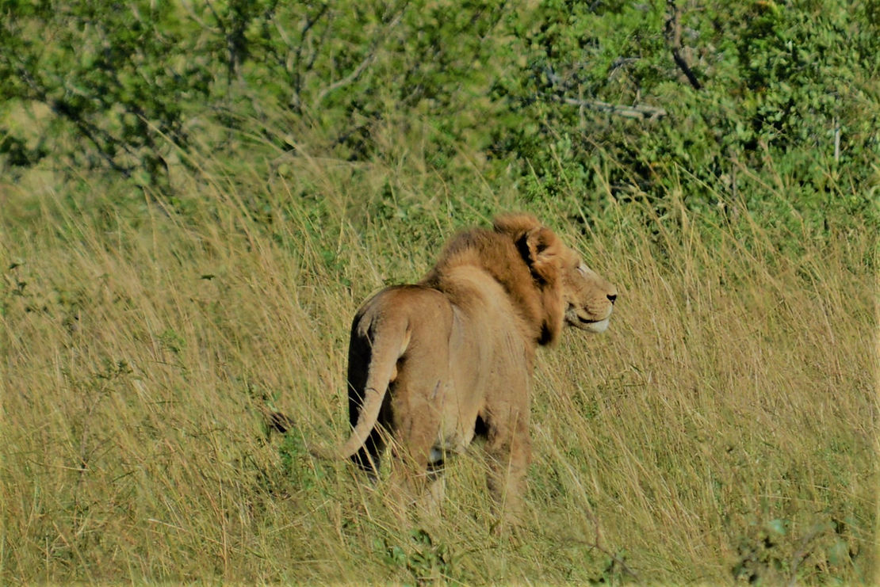

- 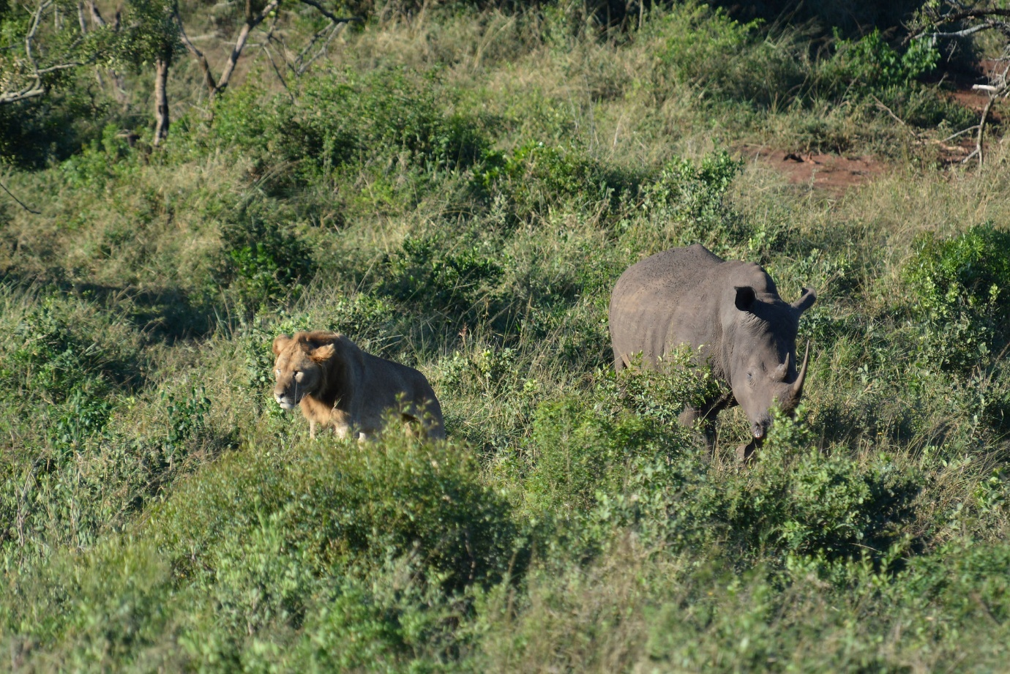
- 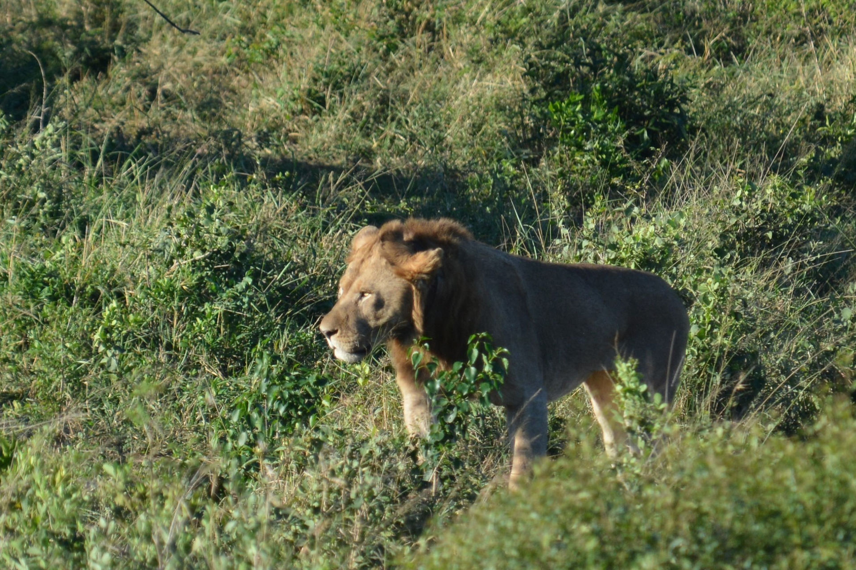
We had spoken to Patrick our driver about staying in one place for longer and not constantly re-starting the engine just as we had got cameras organised and he was much better today. We left the lions and trundled on round the tracks. Then it almost went in slow motion as we rounded a corner and there were 2 elephants, literally right in front of us. There were about 10 of them crossing the track, grabbing foliage as they went, they seemed to be really busy all the time and really strangely then disappeared off into the bush. It was odd how you could lose a herd of elephants quite so quickly.

- 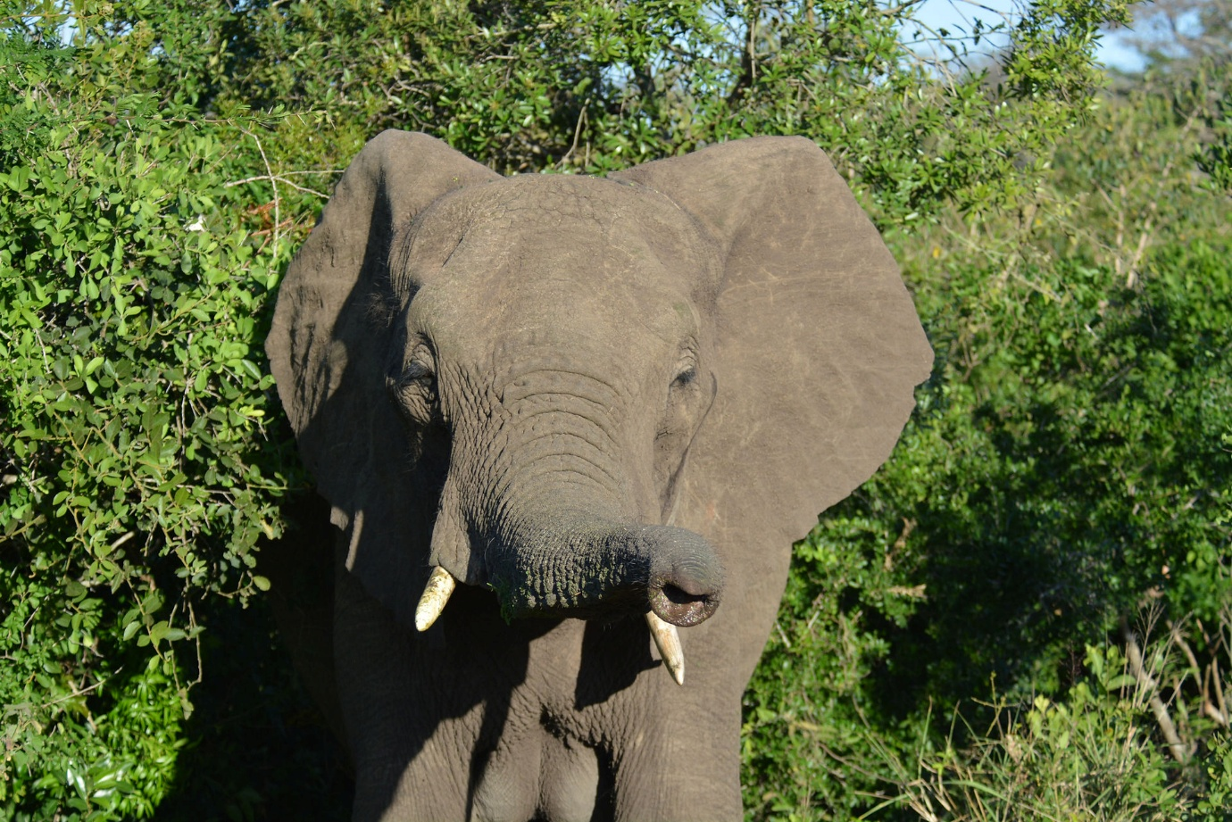
- 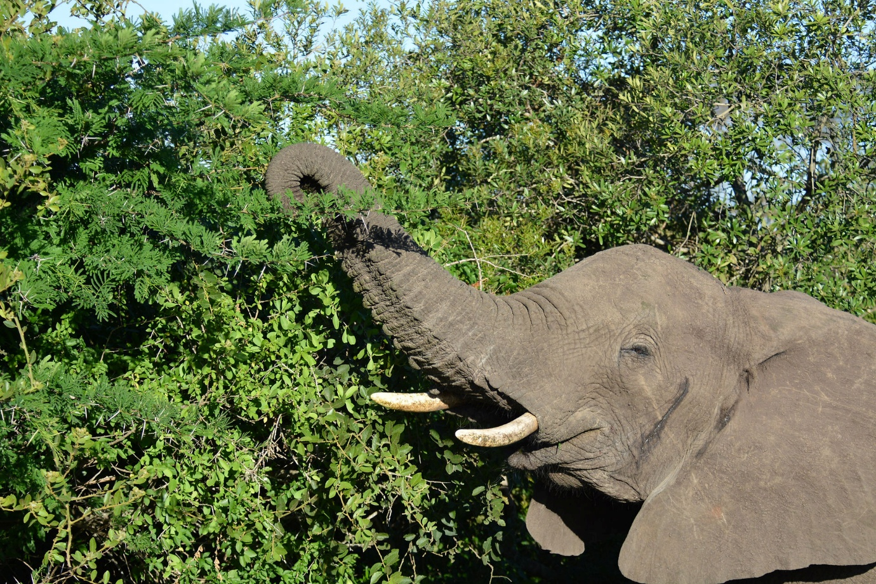
- 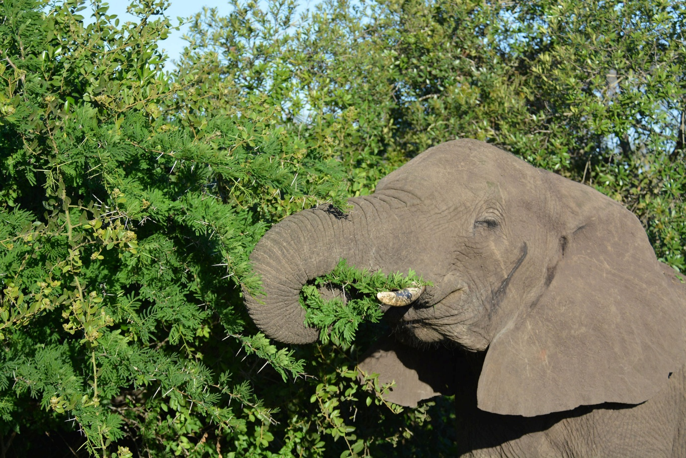
- 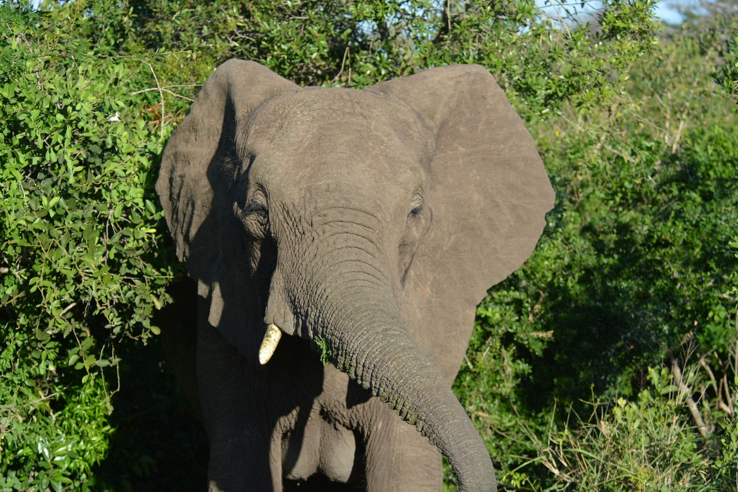
Then we had a toilet stop, you were allowed obviously to get out of the vehicles here which is a total no go on the rest of the reserve. But it seemed strange that actually the elephants or lions could just drift across the picnic area. Obviously they probably wouldn't because of the human presence, but it was just weird that it wasn't fenced off. There was a lake with a huge huge heron that impersonated a stork. It was a Goliath Heron. We also saw Egyptian geese. So now we only had one hour until our planned lunch at the Hilltop Restaurant. This plan was foiled ! We came across a large male elephant at a small watering hole. This was closely followed by lots and lots of others. They filled the road and either side aswell. The large male we had seen headed towards the herd, he was met by another Bull. Patrick knew the herd and knew to not let the Bull come round behind us, otherwise we would be stuck in the middle of them all. One female was particularly wary of us, and kept a steady pressure on us to keep moving backwards.
- 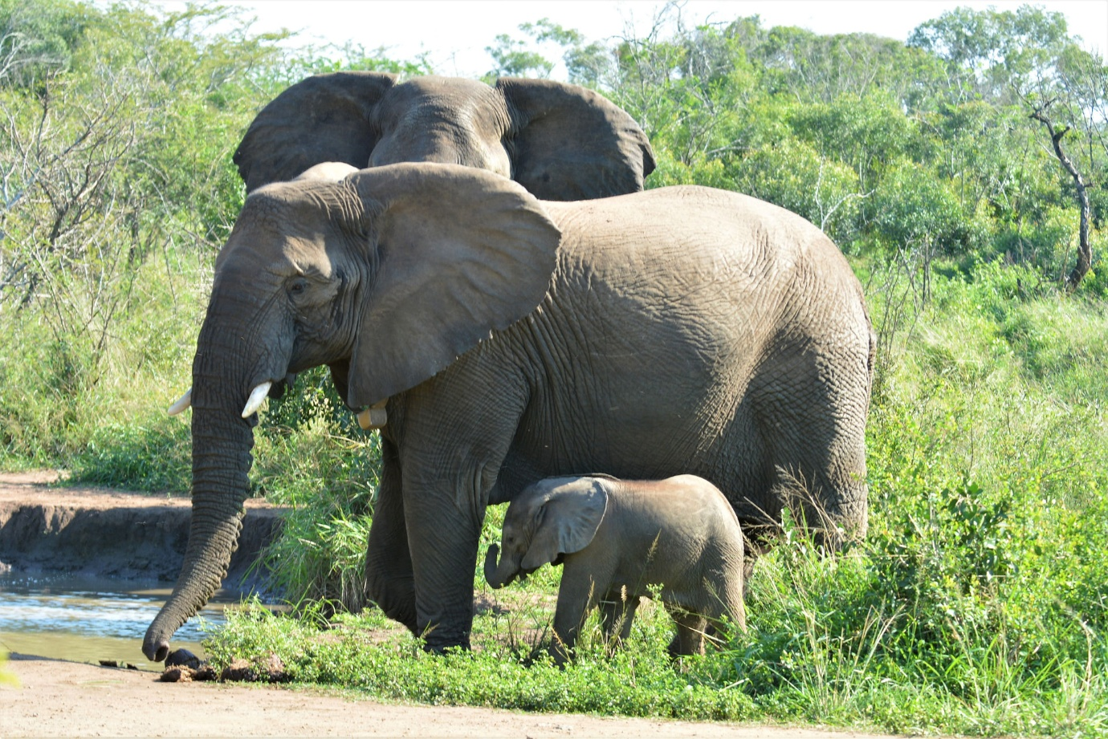
- 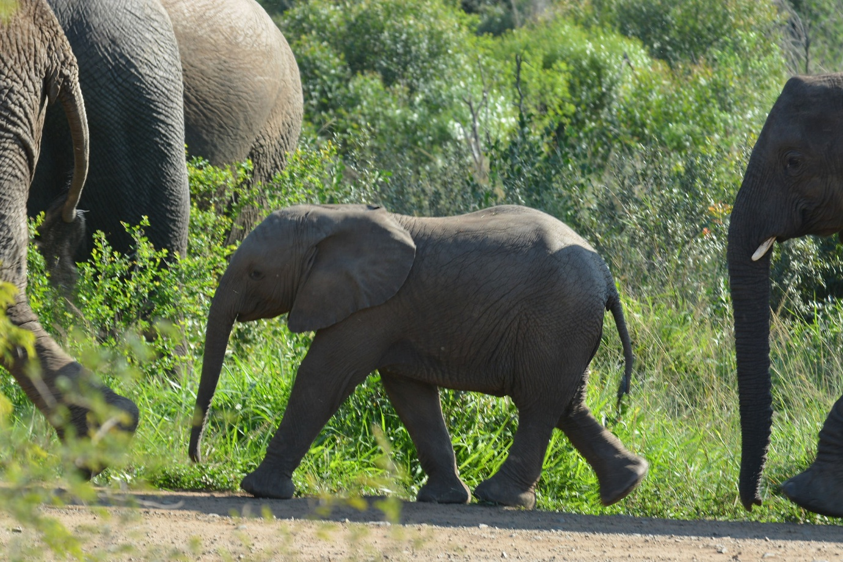
- 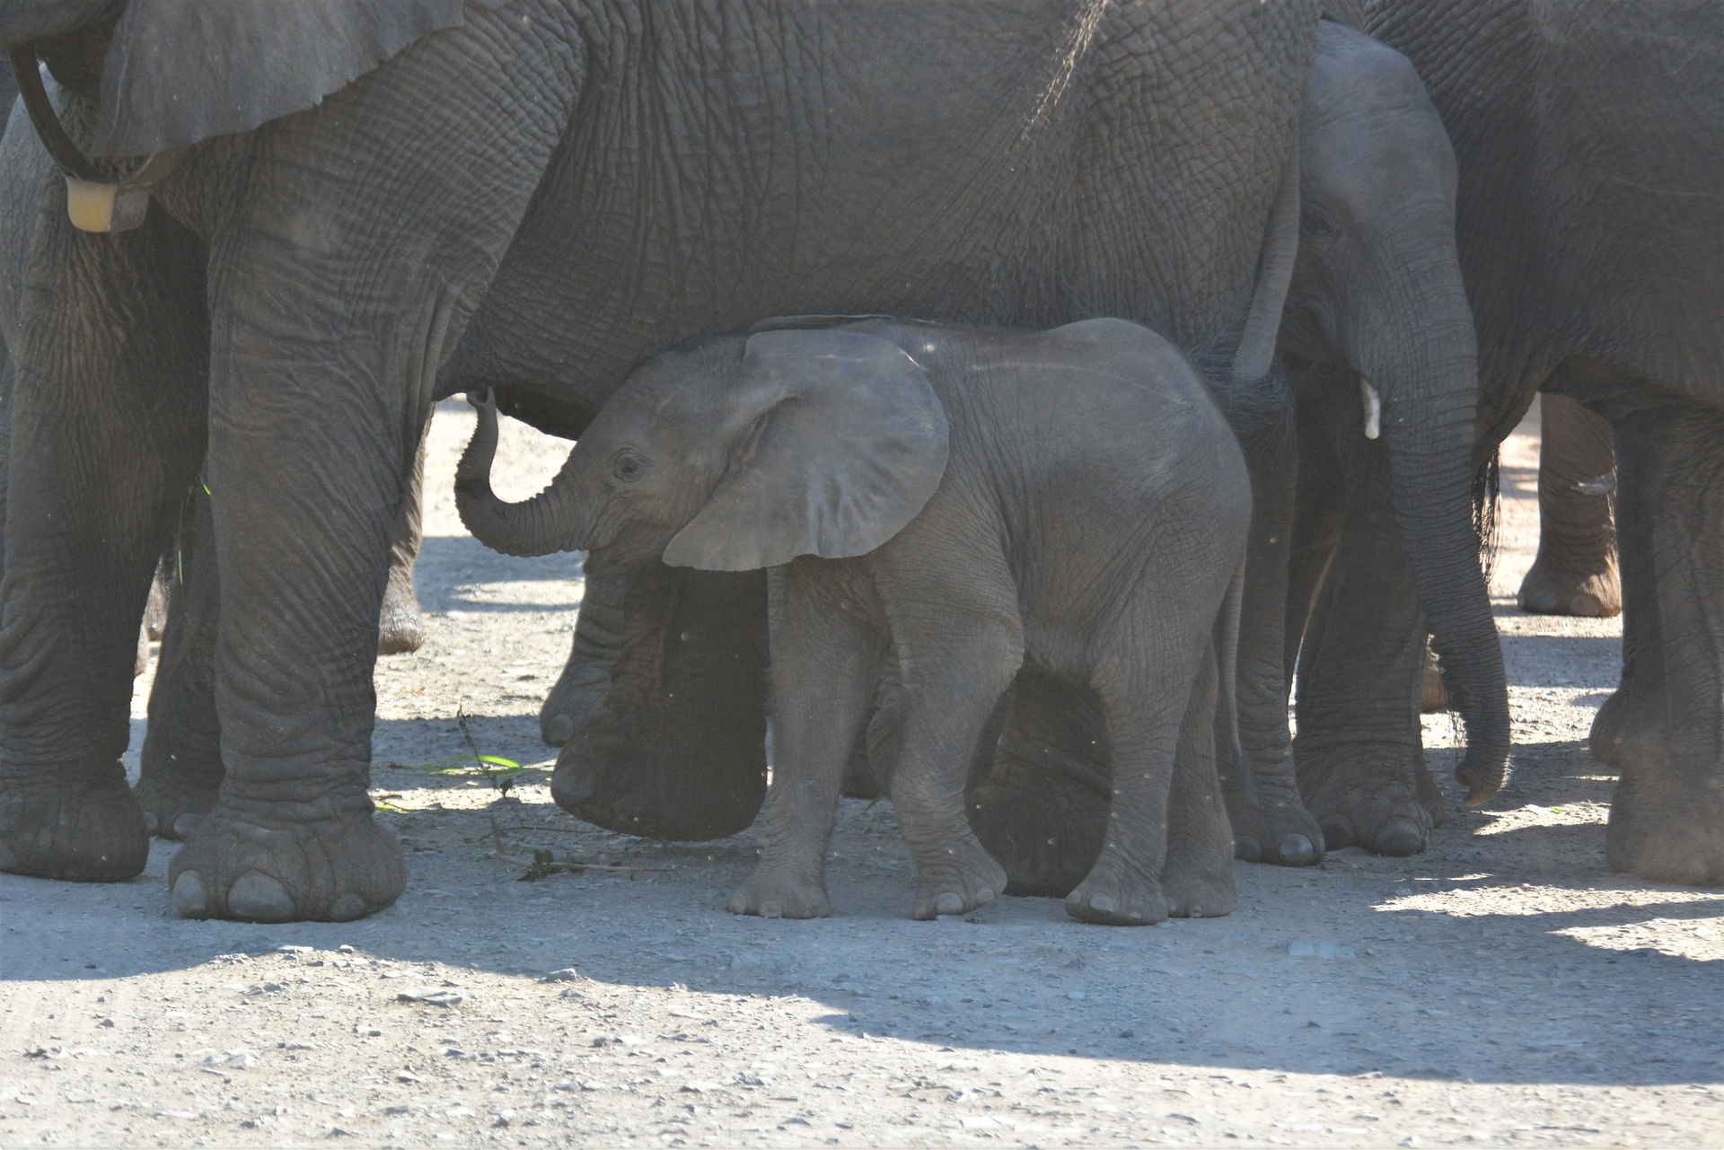
- 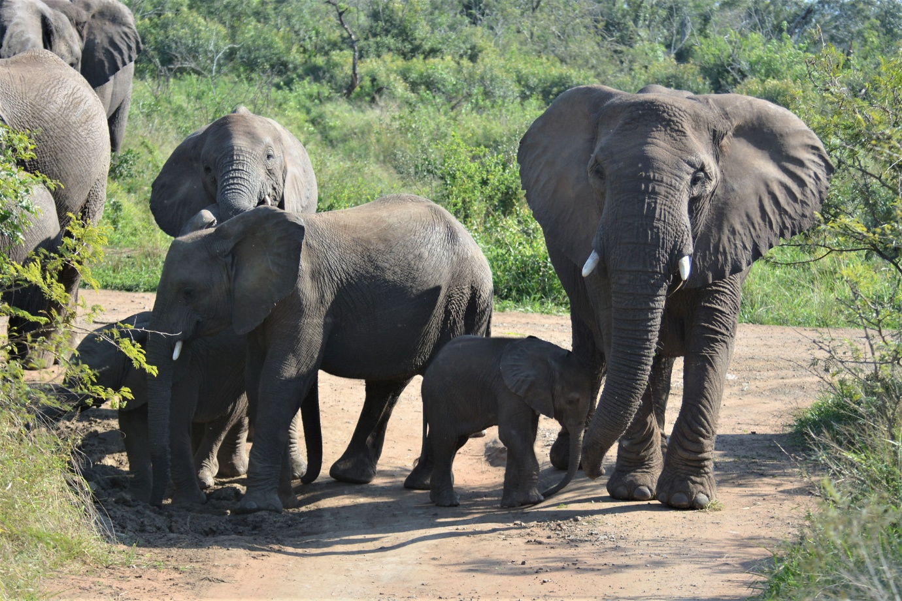
- 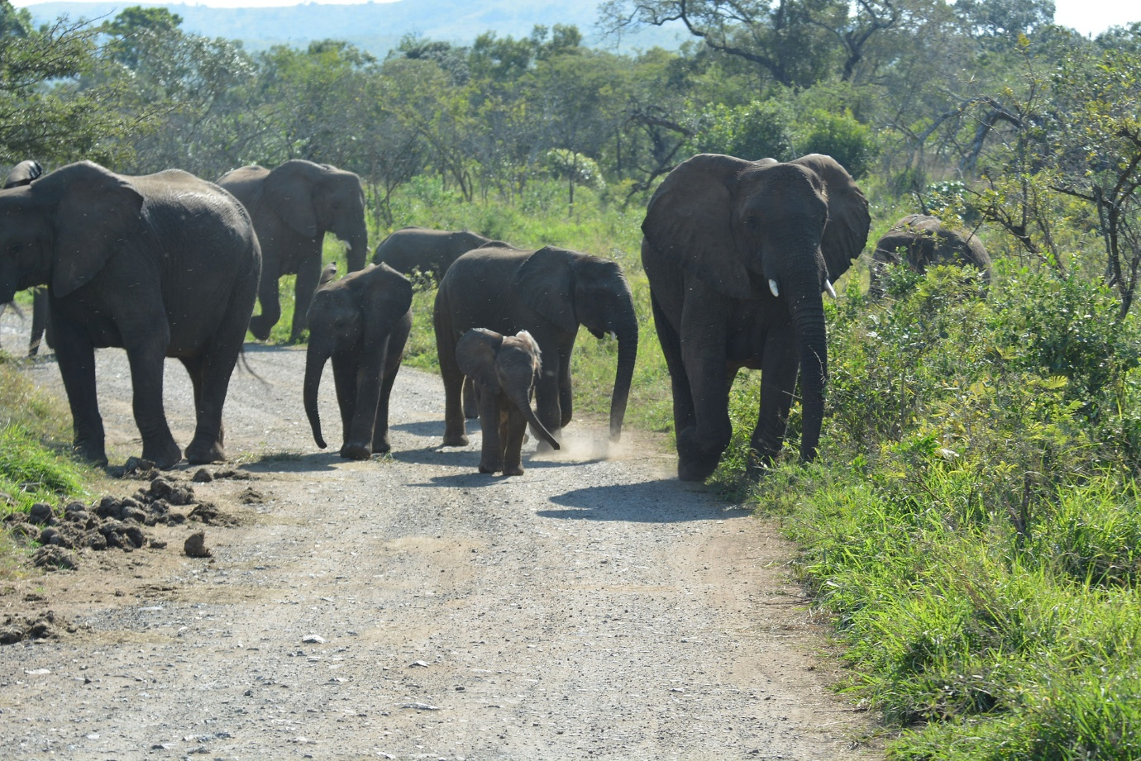
- 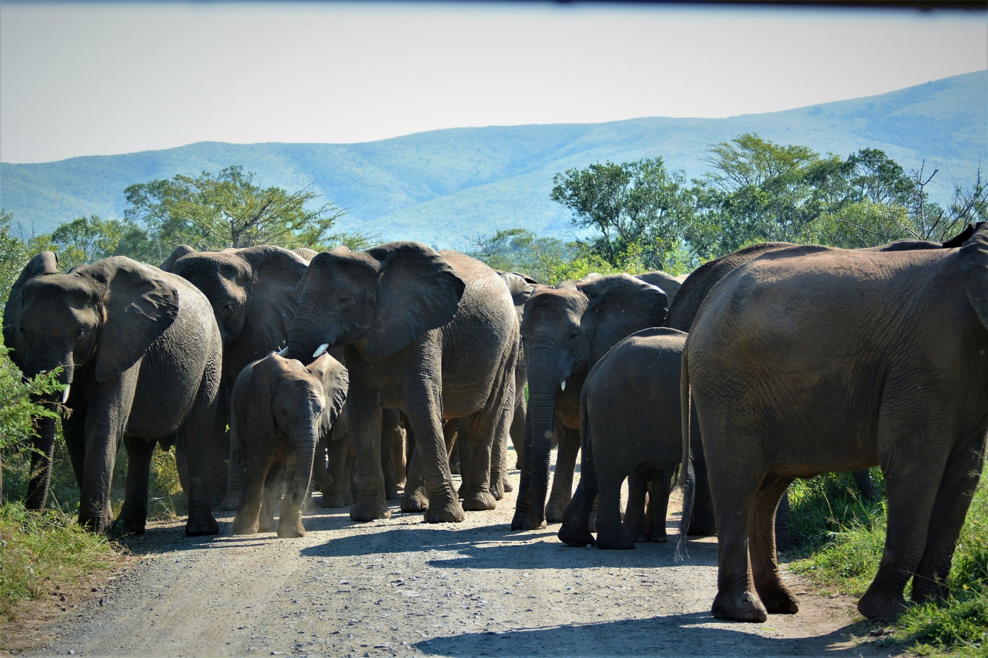
- 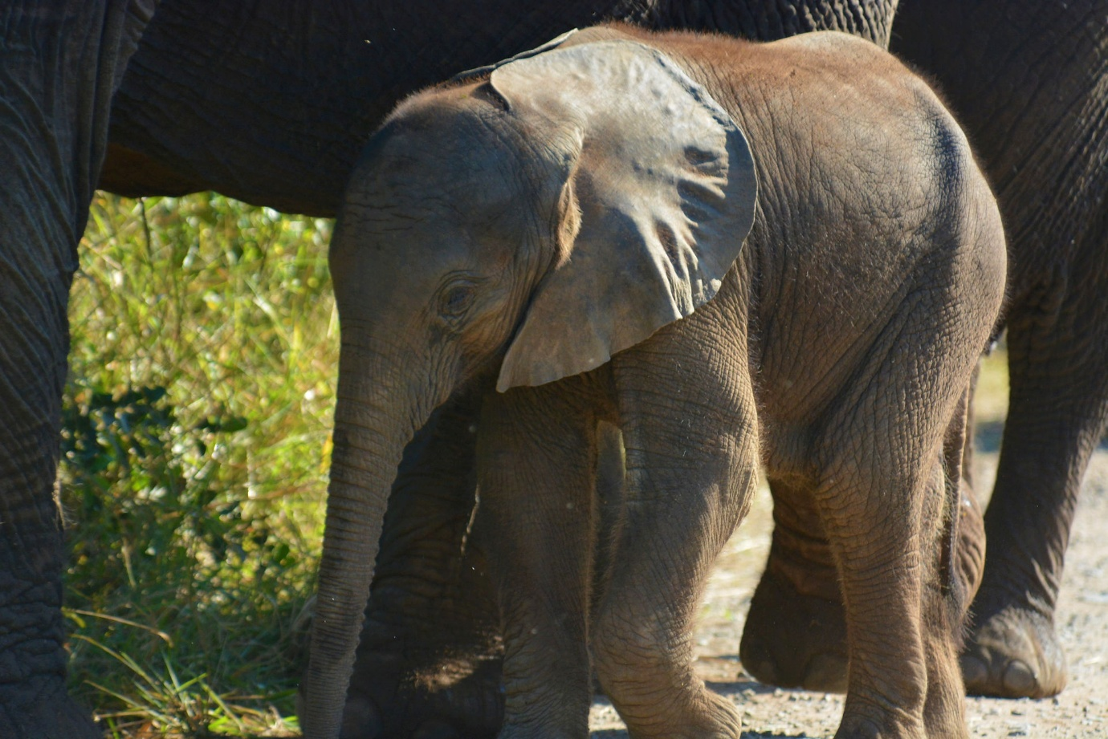
- 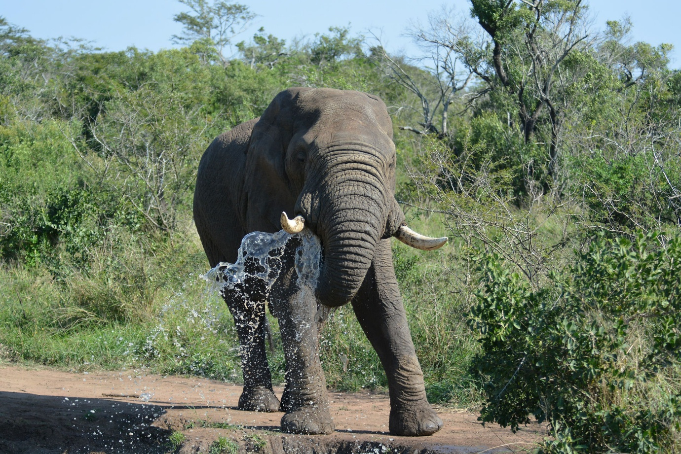
- 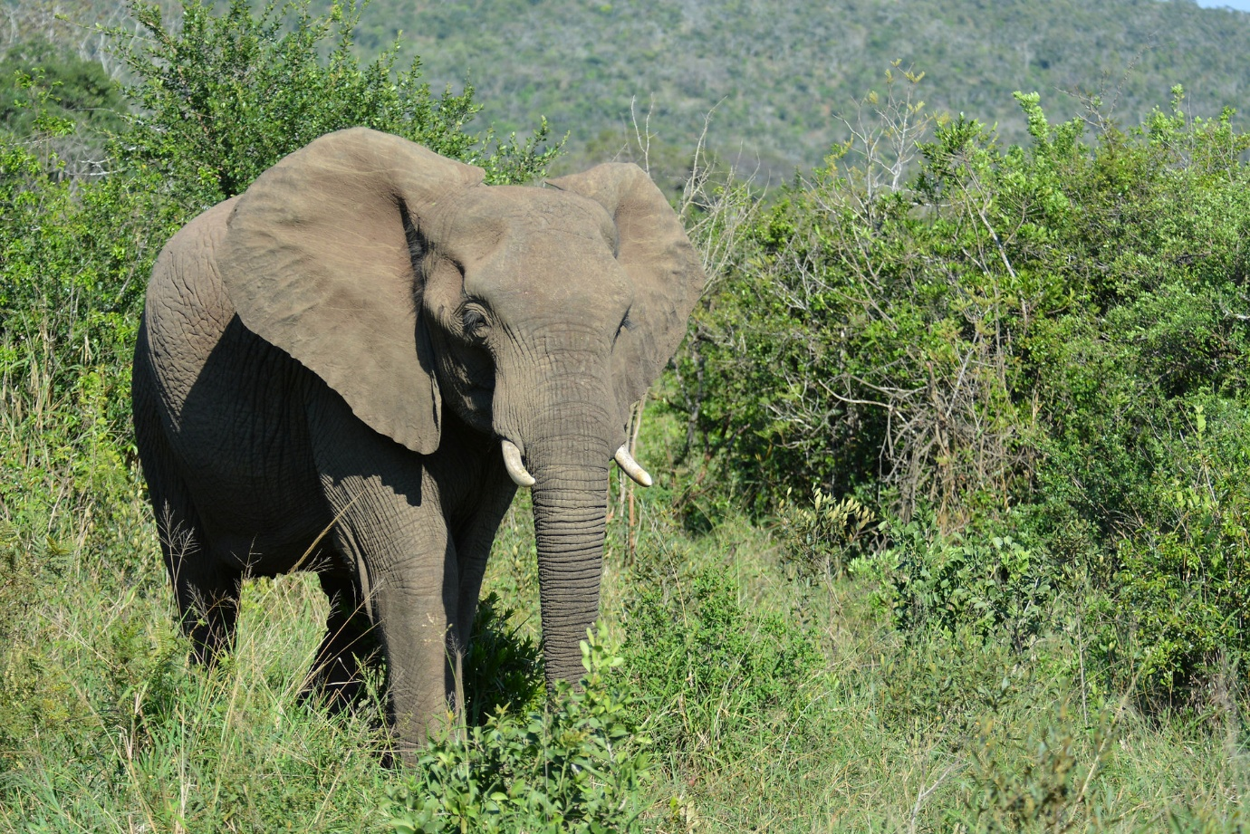
As we backed the truck up, there were 2 cars behind us also backing up. People can drive around the reserve them￼ selves in their own vehicles. We were definitely better off in the jeep, high up, lots of space. We passed one vehicle and I can't see how it would have been any fun at all, closed Windows and low down, rubbish for photos. Everyone just looked bored which I suppose you would be if you were there with no interest in animals ?? Anyway, back to the elephants. They were just fantastic. We sat for about an hour surrounded by about 70 or 80 of them. A couple of bulls and about 3 different families according to Patrick. One very young calf about 3 months and various other ages and sizes.

Lucie and Clive in the jeep stalking a whole herd of elephants.
- 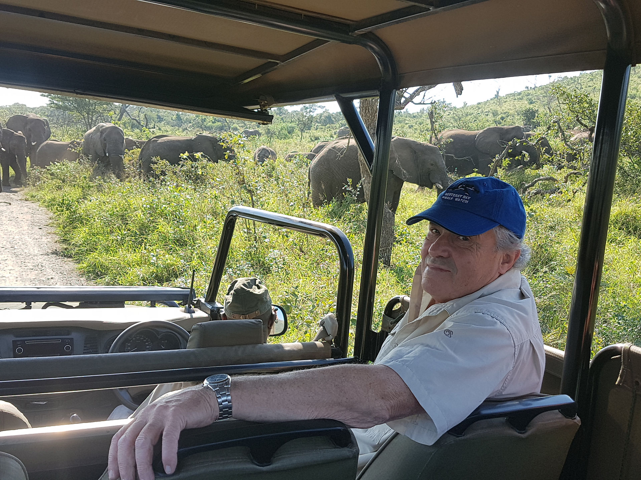
- 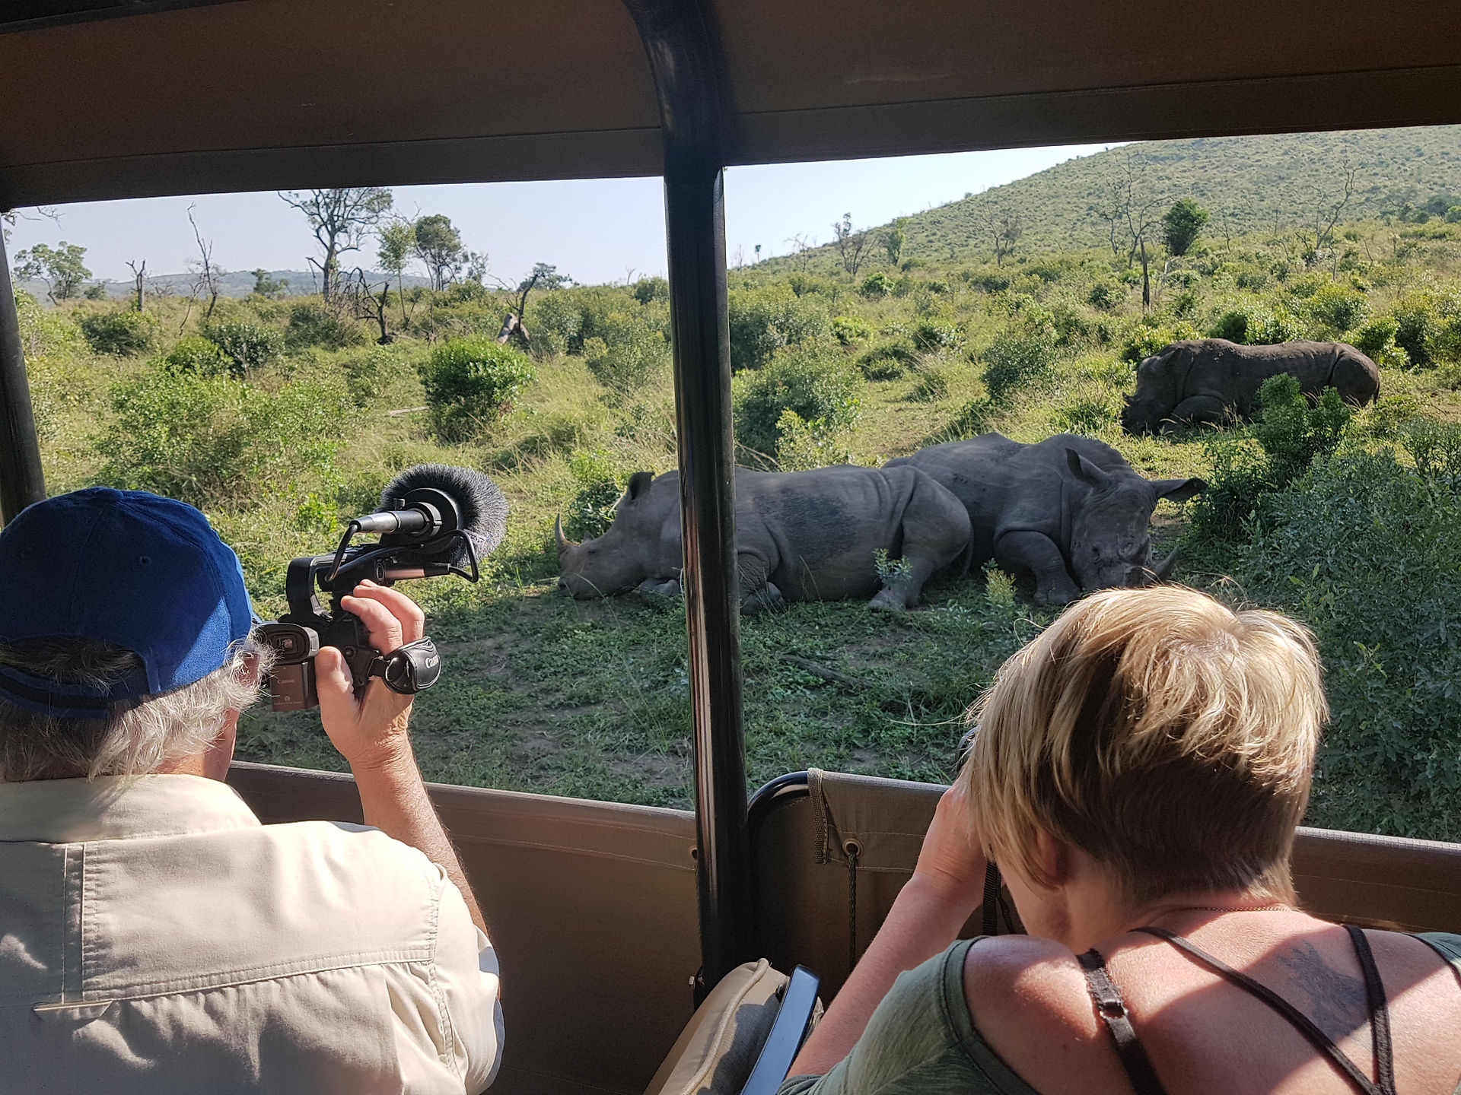
- 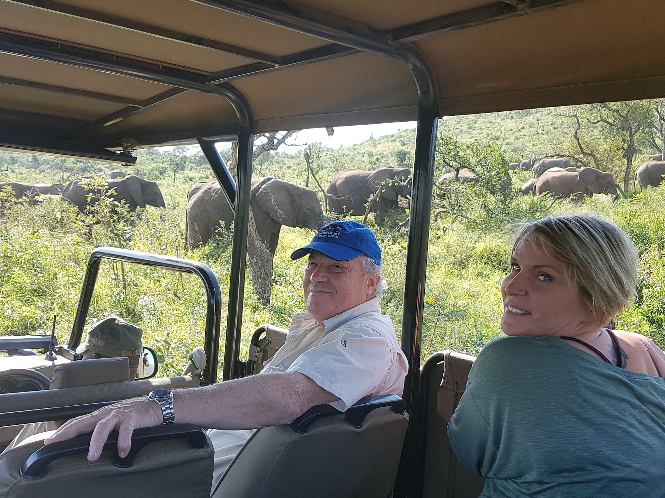
- 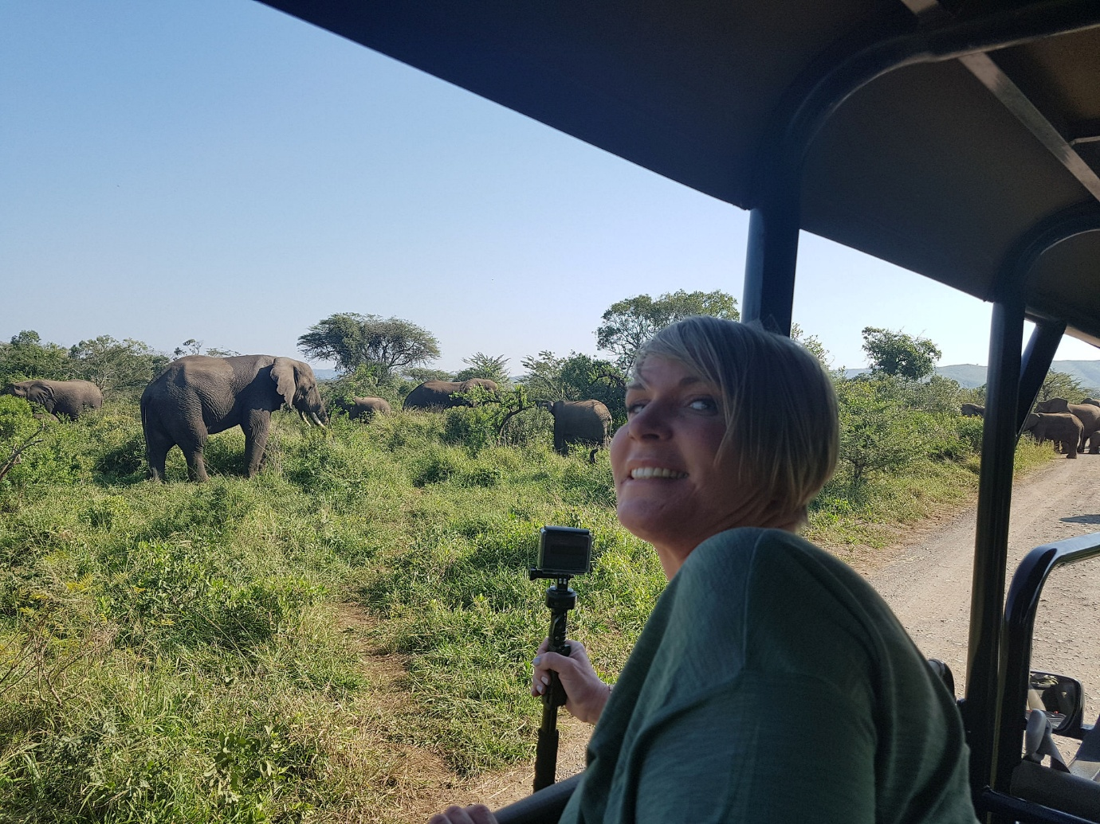
- 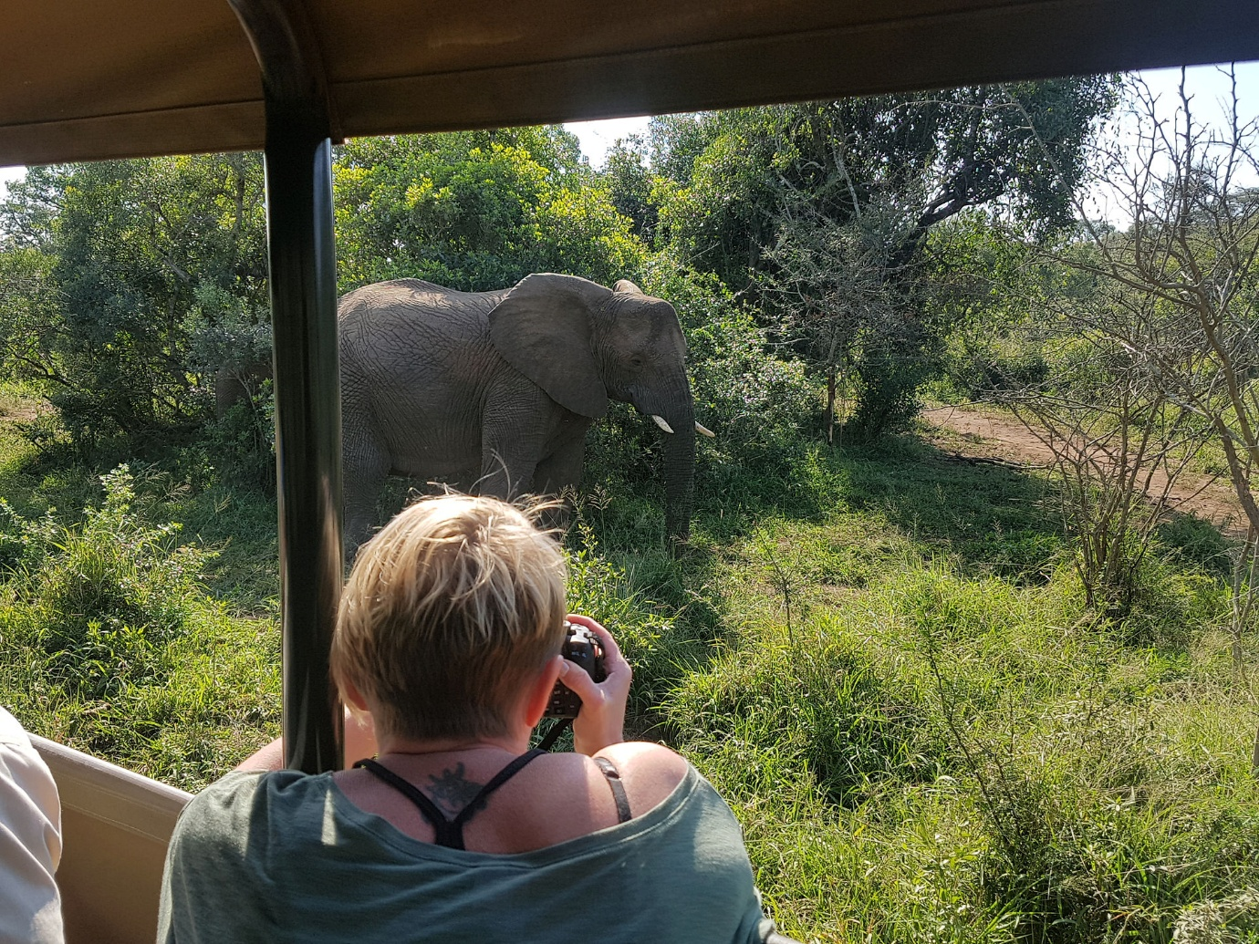
- 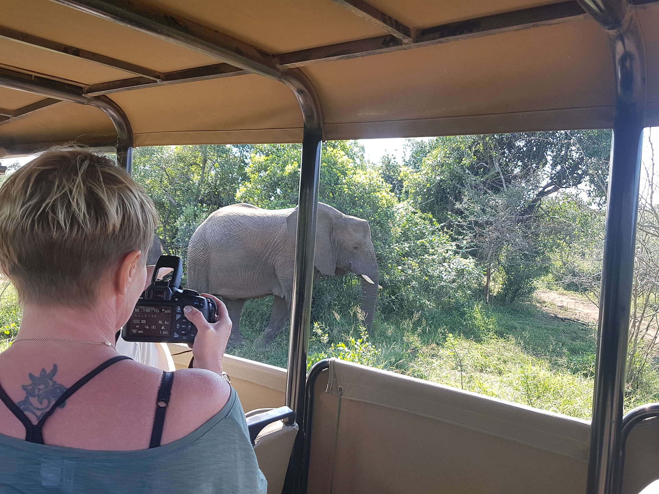
- 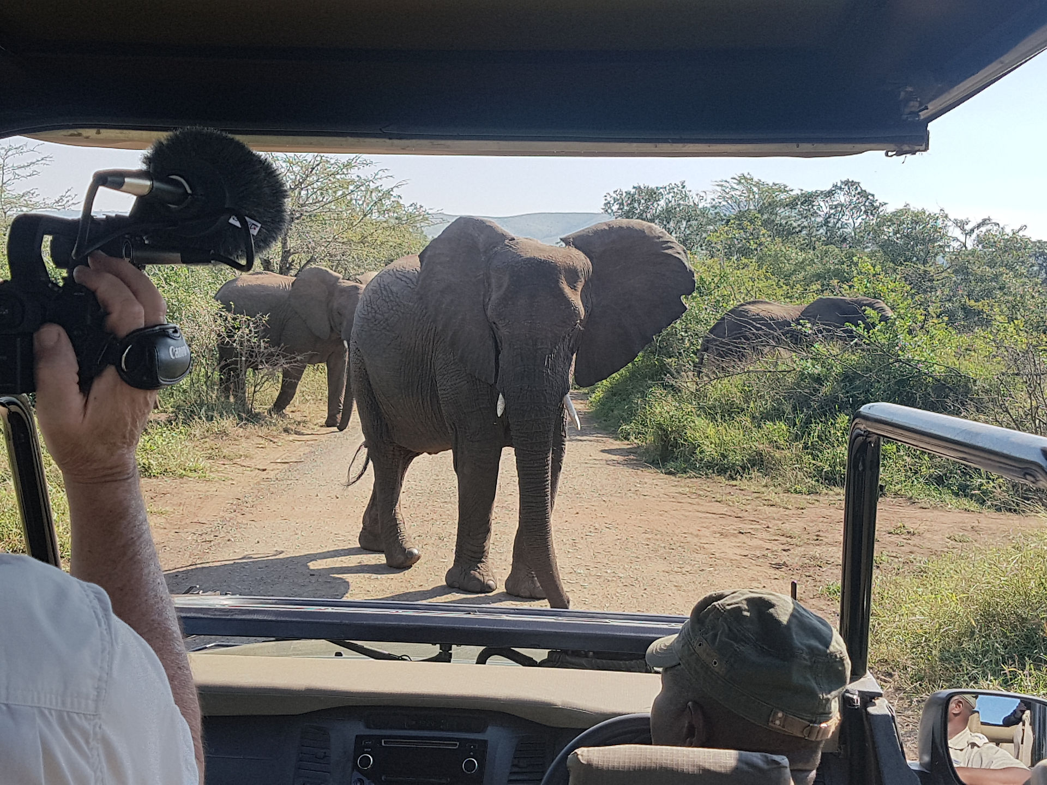
- 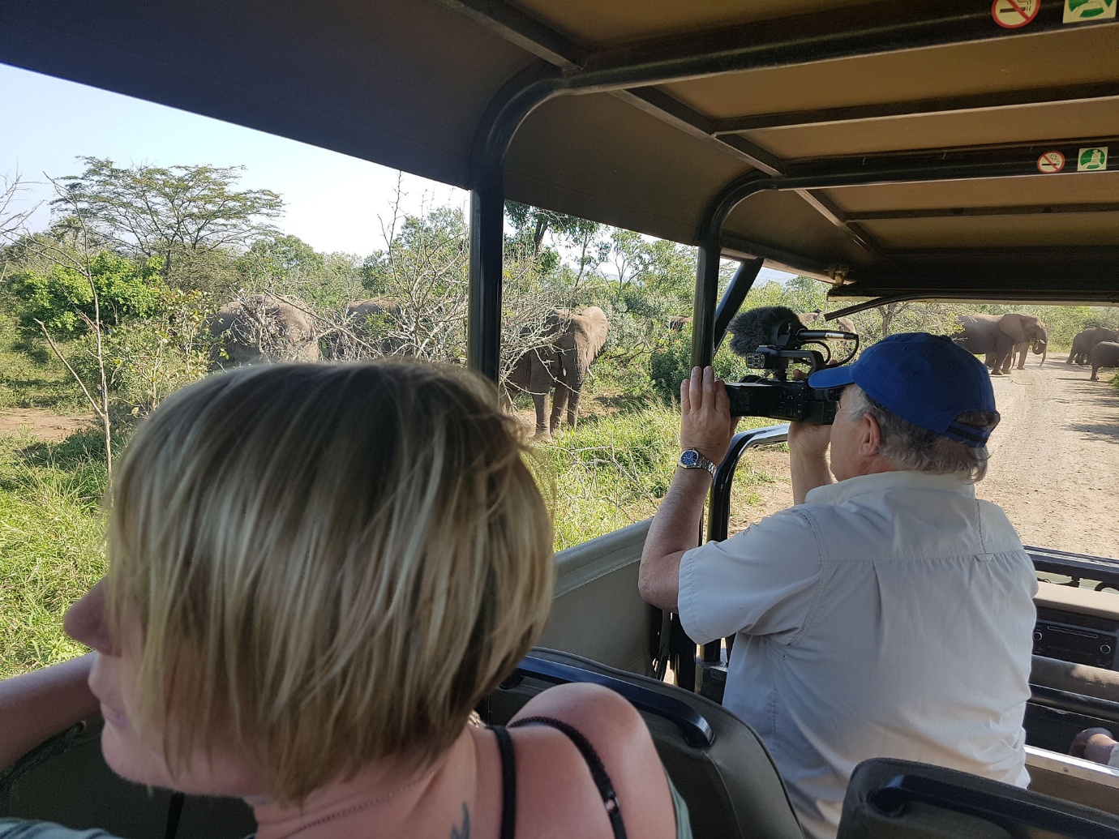
- 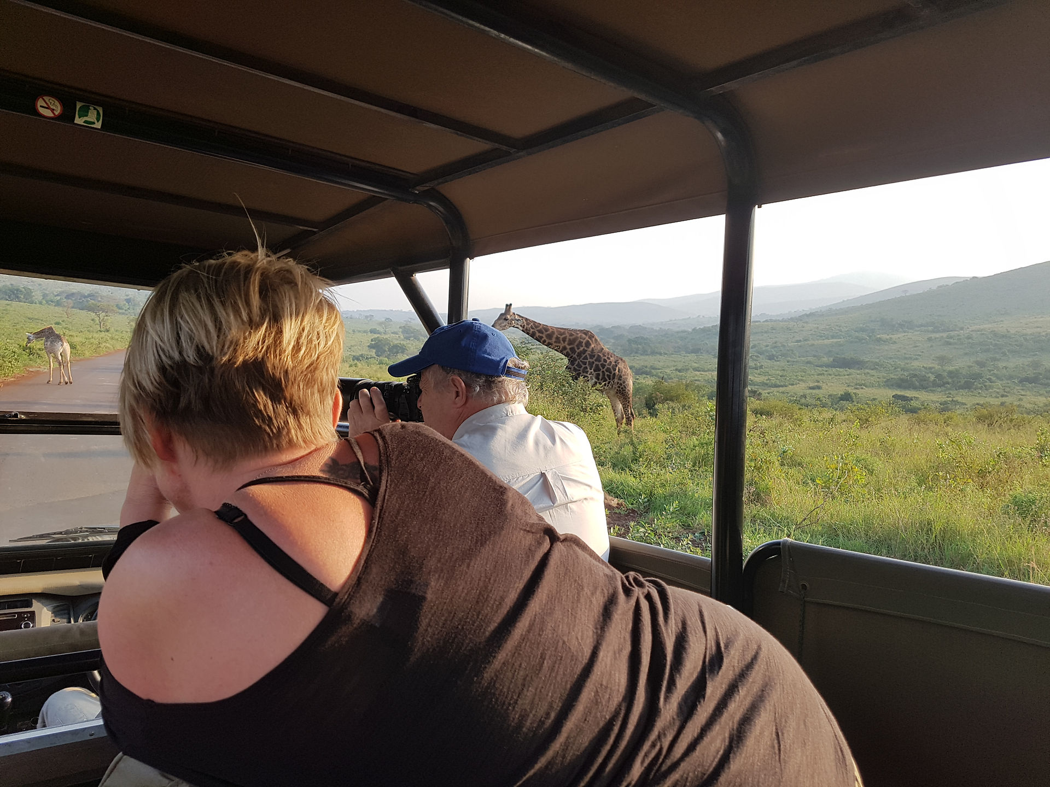
The young just potter around in amongst the adults oblivious to potential danger and oblivious to the fact that the female was so protective. Her warning signs were to walk directly at us and flap her ears, all the time, the calf walking next￼ to her. We got some great photos and videos and were actually then stuck until eventually the elephants cleared the road and we could carry on through on the way to the restaurant. ￼ 550 metres above sea level with wonderful views.

- 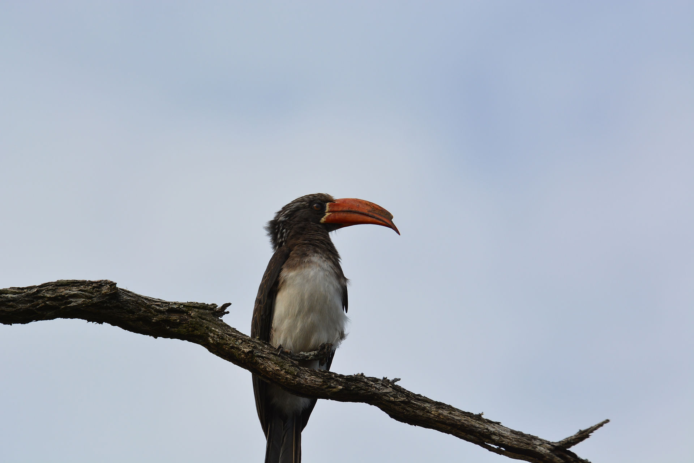
- 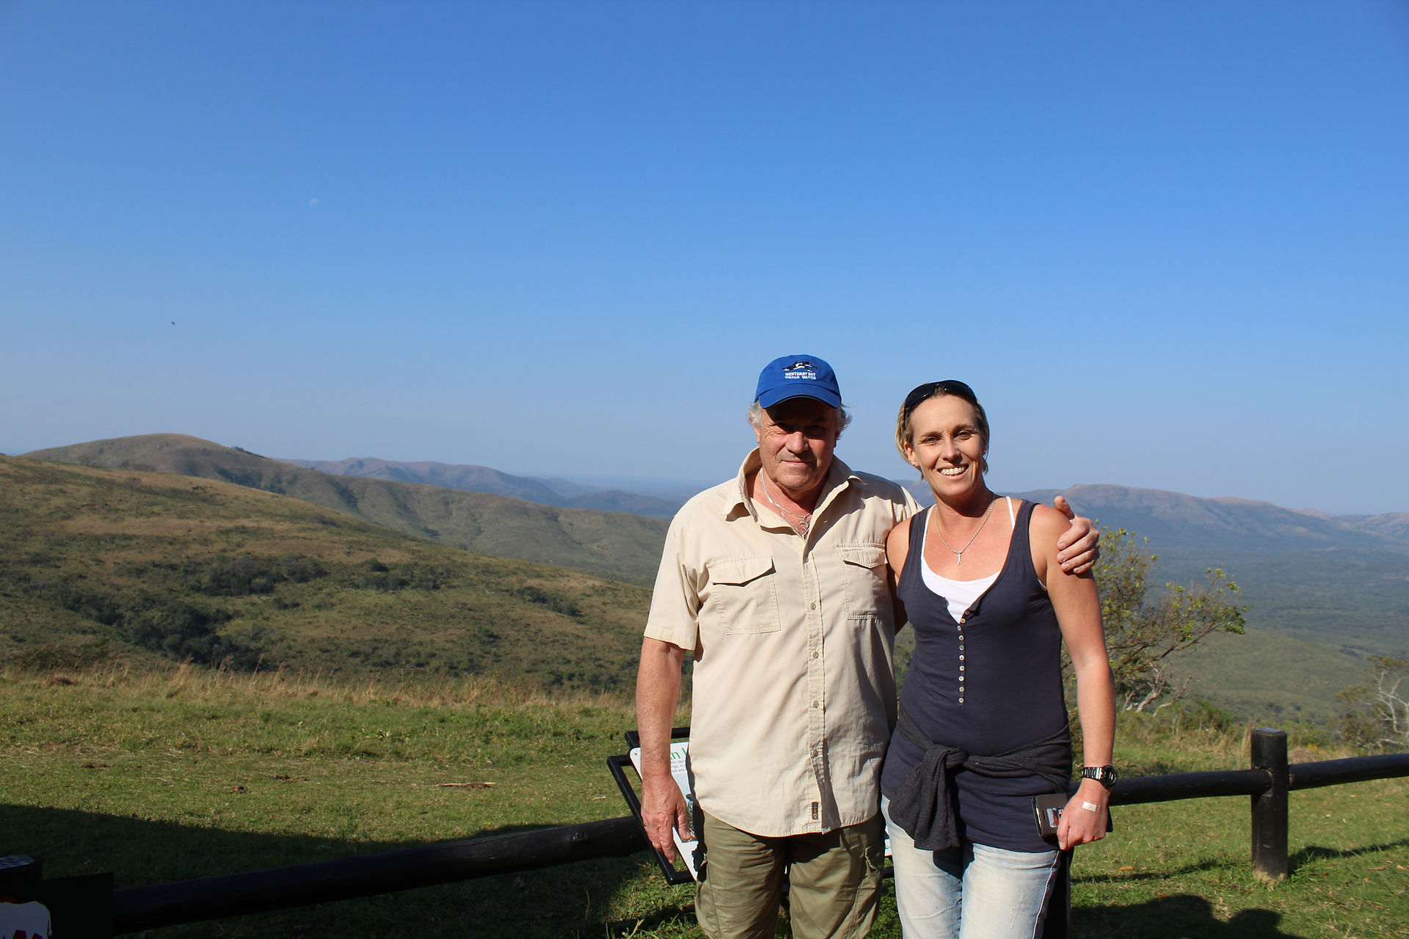
We sat outside￼ and immediately had to fend off monkeys ! As people left a table, they jumped straight up and emptied pack after pack of sugar into their mouths. We saw a hornbill - apparently a rarer hornbill crested hornbill. Lunch was toasted sandwiches and chips for 50 rand about £3.00 there was a shop up there and although an expensive place to buy a book, they did have a really good African Birdbook which I bought knowing it would be invaluable for the rest of the week. After lunch we decided that we were happy to go back to Umkumbe and have a longer afternoon and evening to sort photos and see the sunset. It's nice sitting at the bar and sorting through. Although however much I sorted I￼ still had a million elephant photos ! Anyway, we are gathering a few good ones between us. Dinner was a lovely hot pot with rice.
Day 3 - Tony drove us a couple of hours to Tembe Lodge, as we turned into the sliding gated reserve, it once again reminded us of The Walking Dead where they all live in gated complexes to be safe from the walkers. So in we drive to a wall of blank faces and no smiles, ok no worries, why would gate people smile ? Into reception to be met by the most gormless person I have ever met in my life, she just stared at me..... I don't have a massive amount of patience for these situations so asked her if she had any clue as to who we were ? Was she expecting anyone ? Did she have a frigging clue as to where she was working and had she ever encountered any form of human being ever before ? The answers to all of the above was a big fat no. So a situation that could have been - oh hi guys, this is the entrance to the reserve so if you are staying at Tembe Lodge you just need to drive down that track and you will be there, was in fact just a whole load of non communicative awkwardness. Clive speaking to the gorms in the gated entrance and the elephant skull that made the waiting more enjoyable.
- 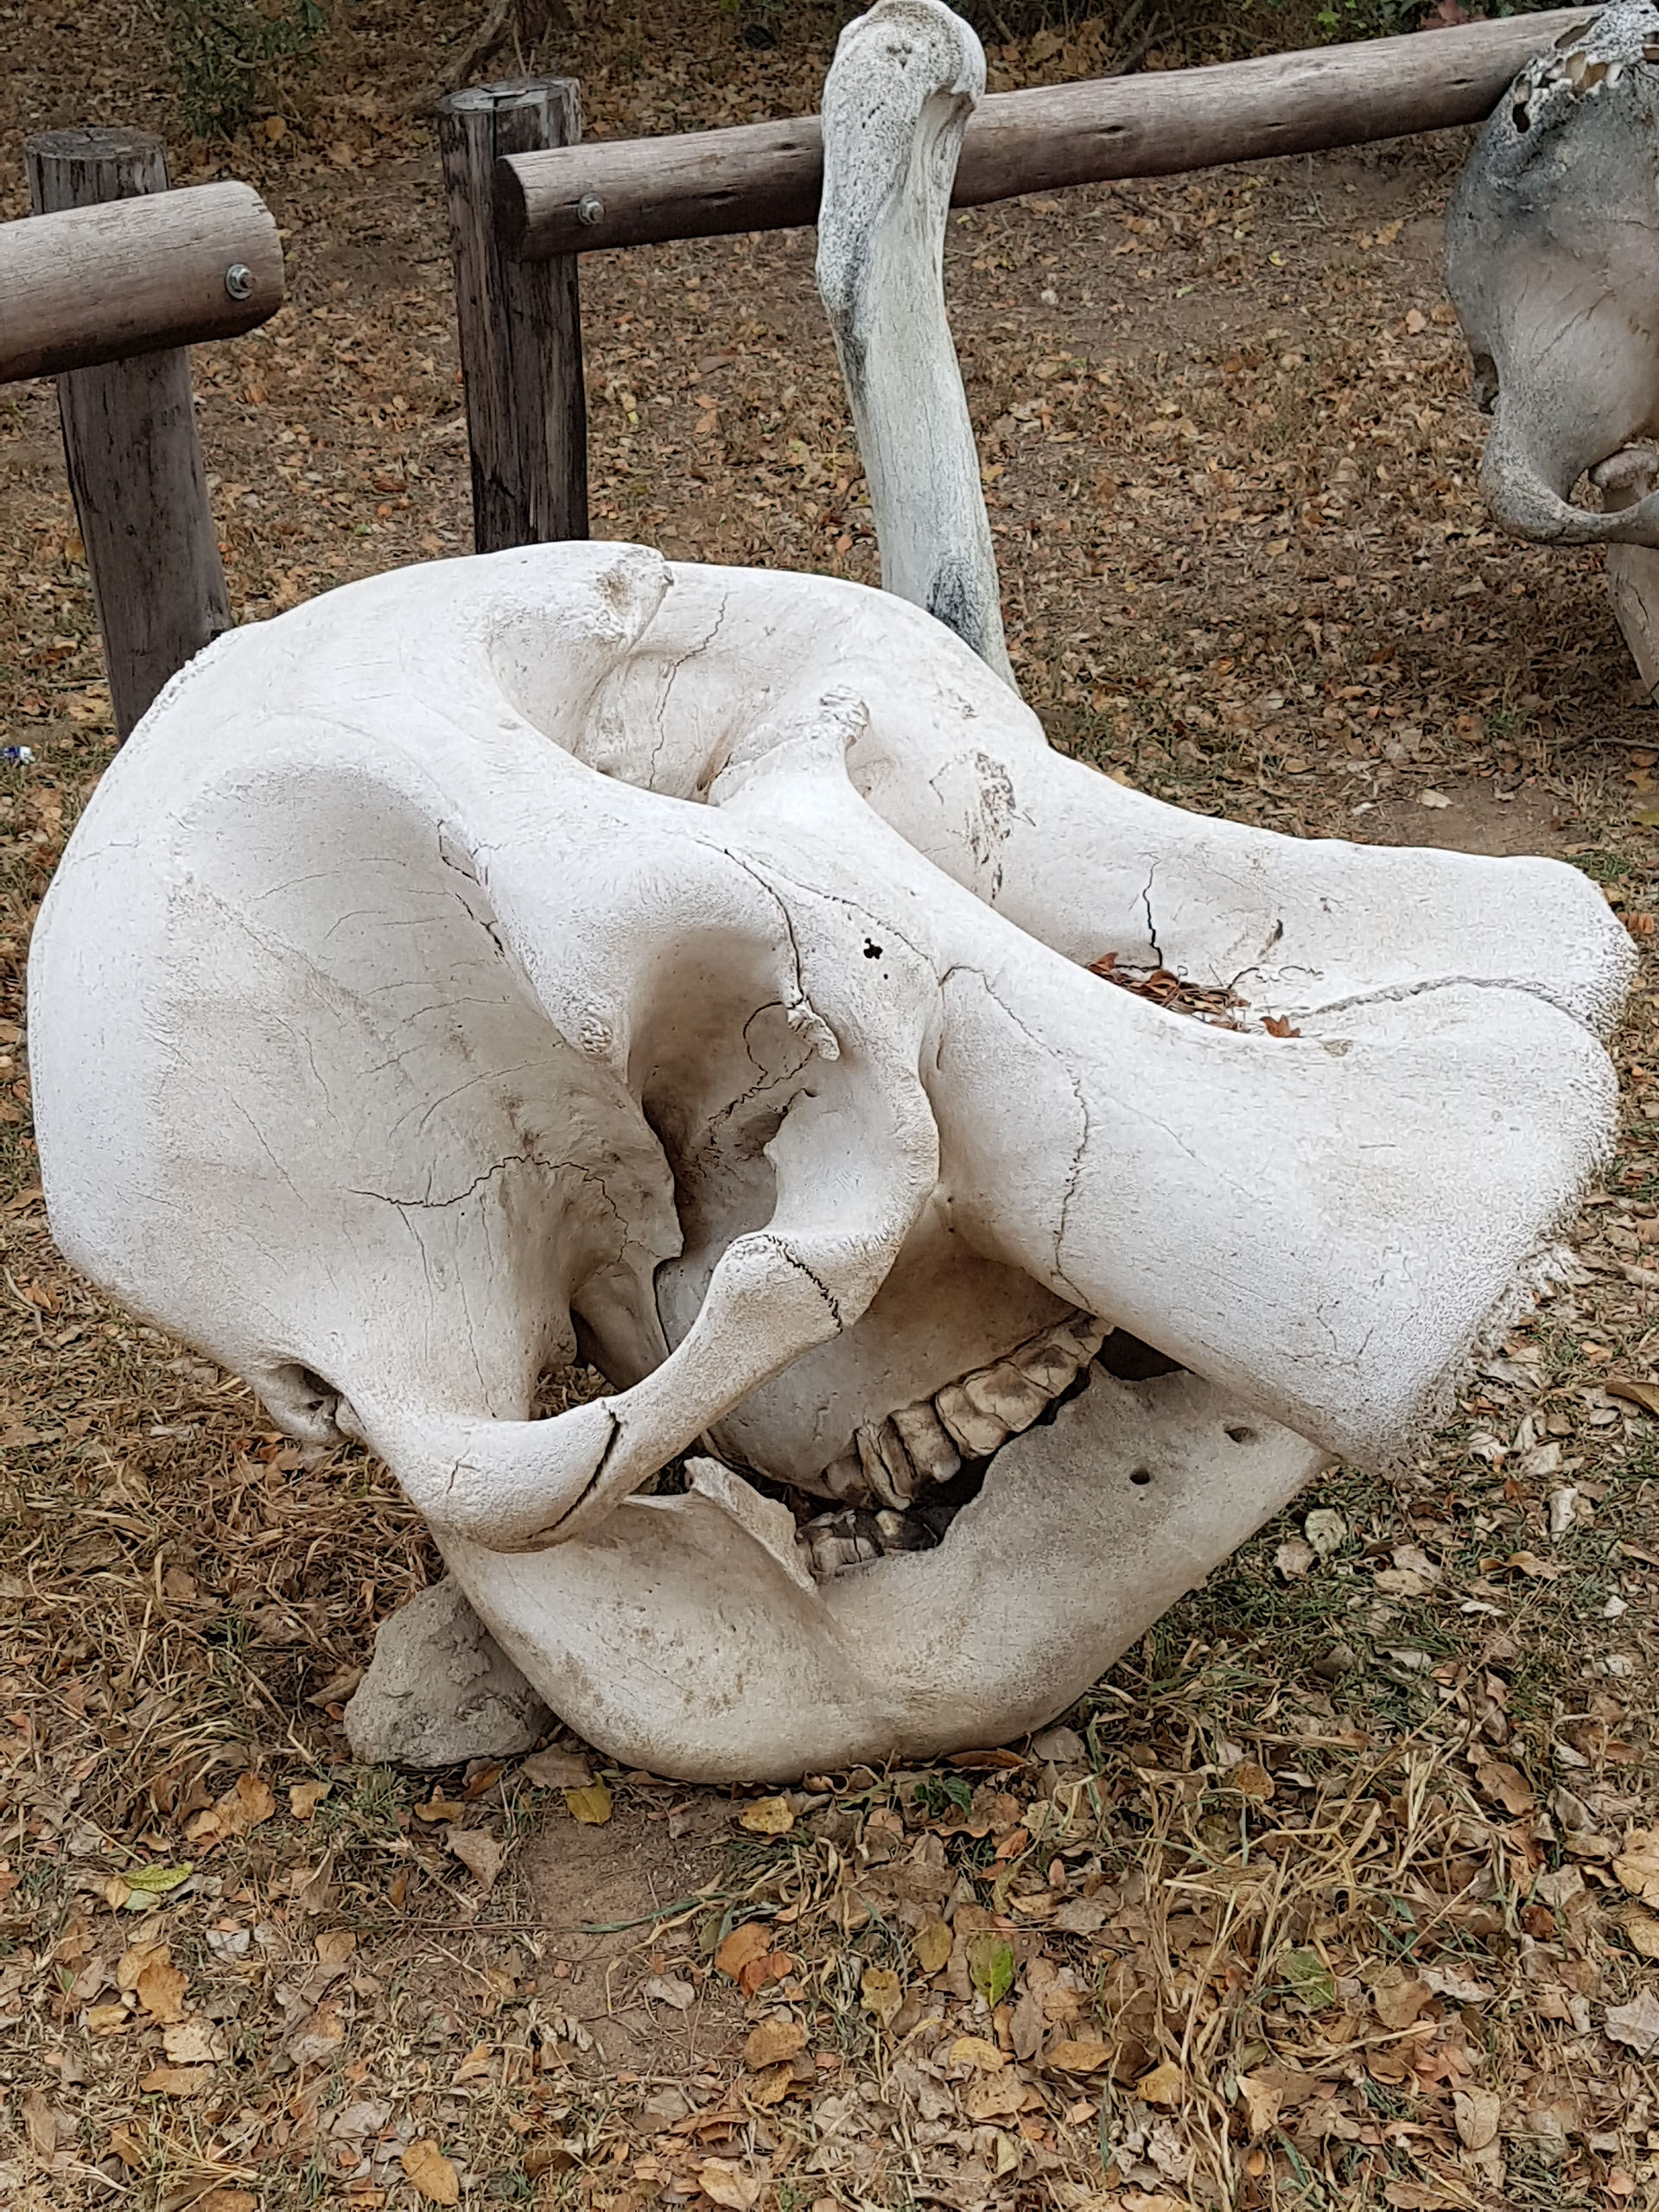
- 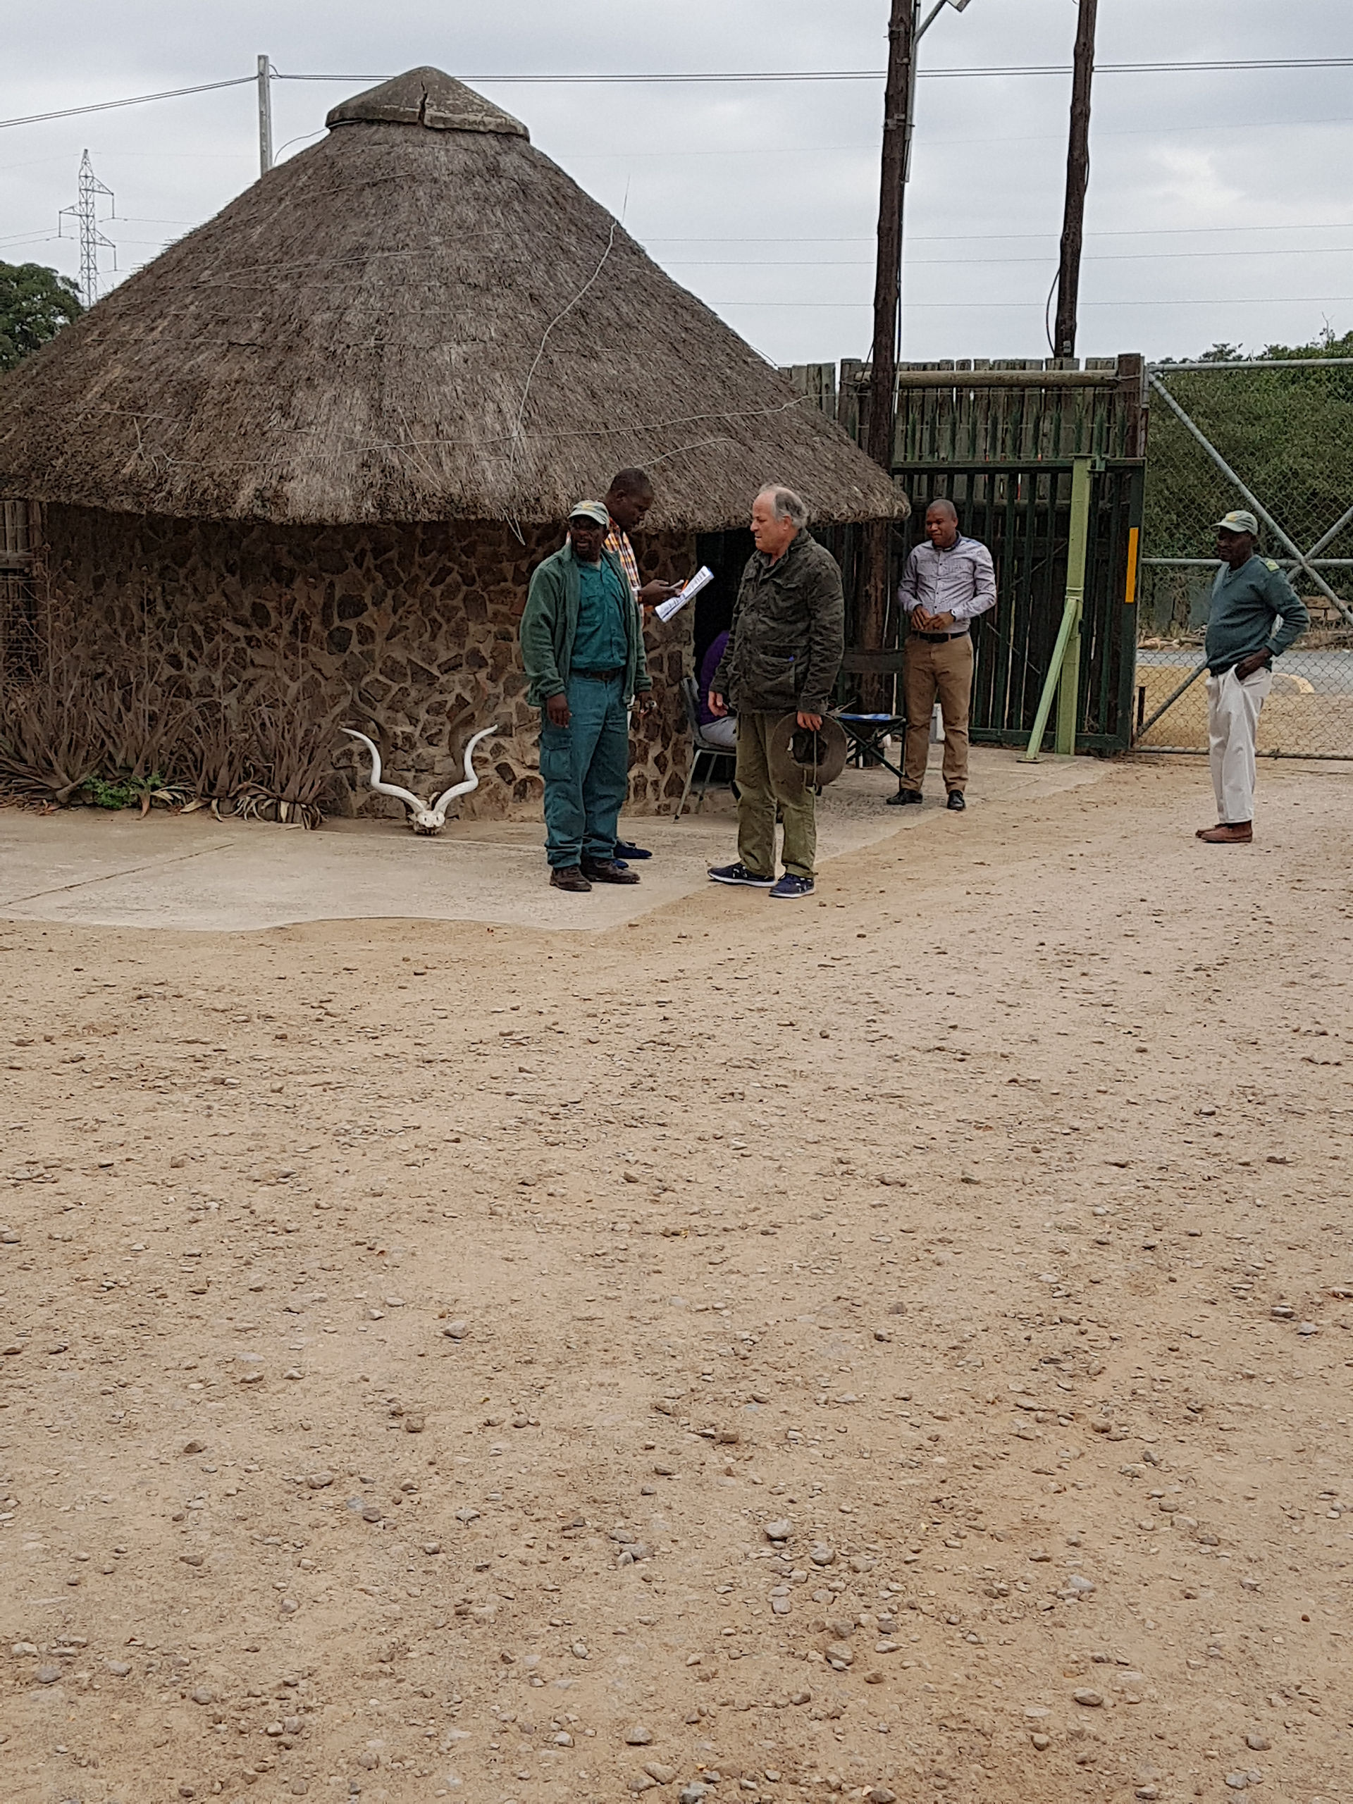
- 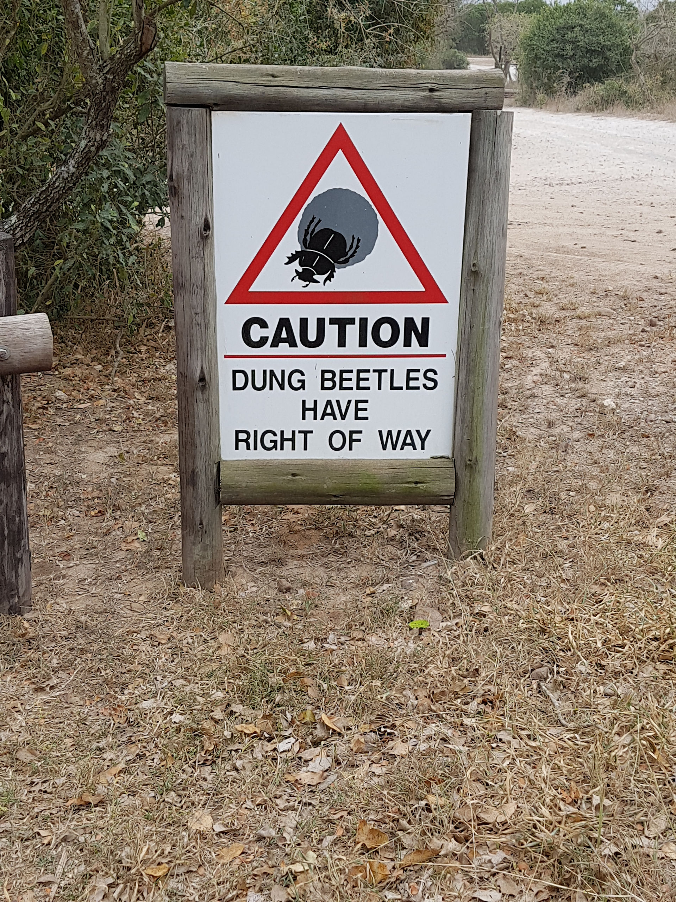
- 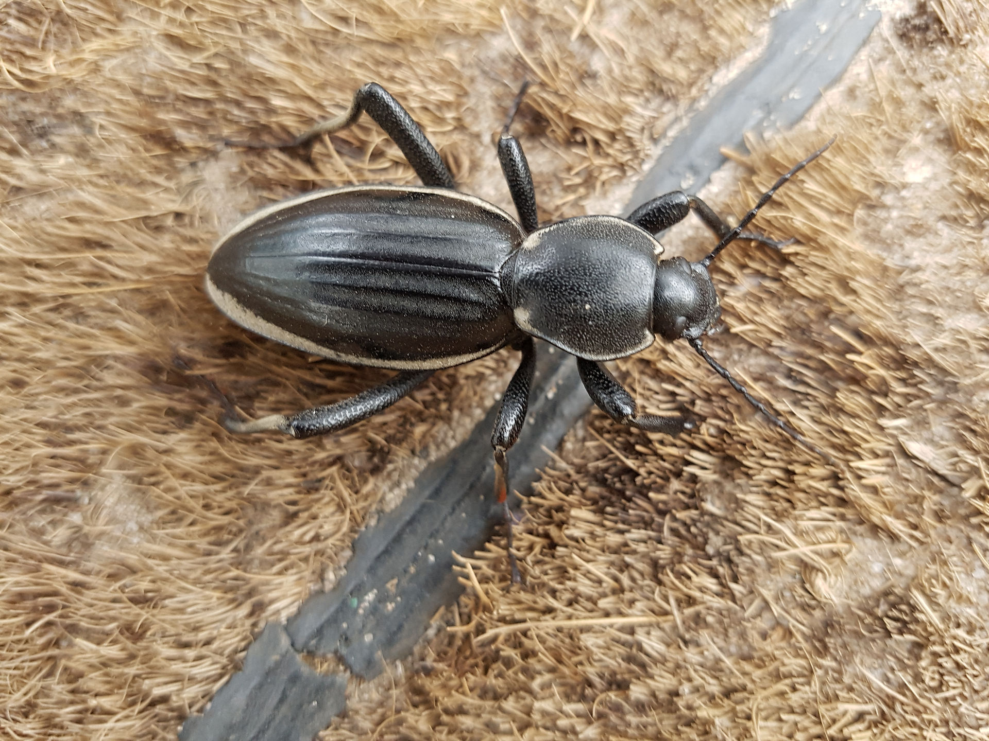
We wanted to keep Tony with us at least until we were sorted, although we are white, at least he is South African white and in with a little more of a chance. So, fed up with waiting for anything constructive to happen, we got back in our car and drove to Tembe Lodge with muttering so about how Tribes were going to get feedback on this bit of the trip, and Tony and I agreeing how much we hate inefficiency !! Once at Tembe Lodge reception, things were OK and we were greeted with smiles by people expecting us and checked in and had our cases carried to our room by random staff who emerged including the chef...... They carried our cases on their heads Our tent was fabulous, really cosy and lovely with an outside shower, a veranda, and right in the bush. We had some time to chill and then have lunch at 2 before a game drive at 3
- 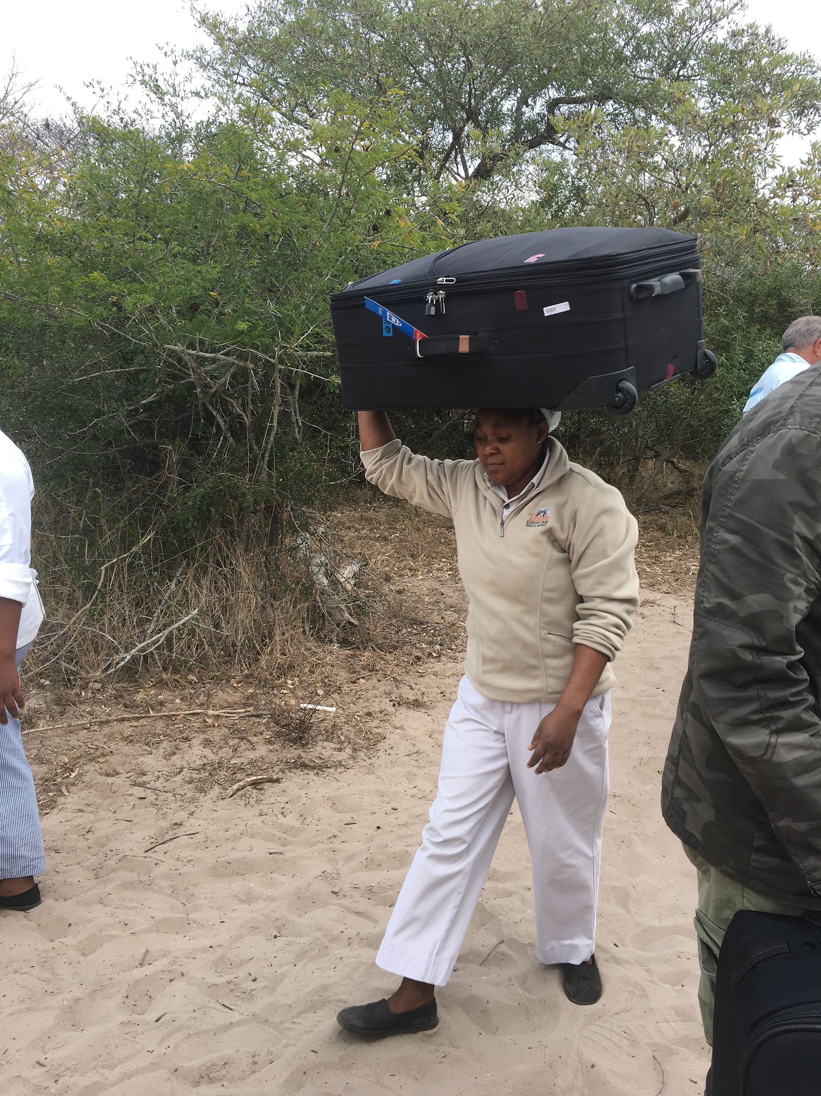
- 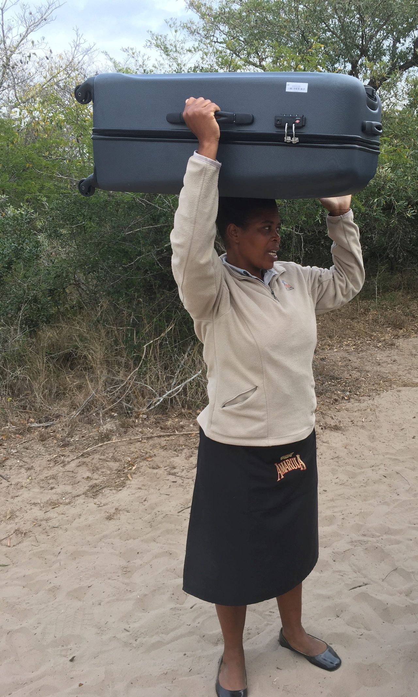
- 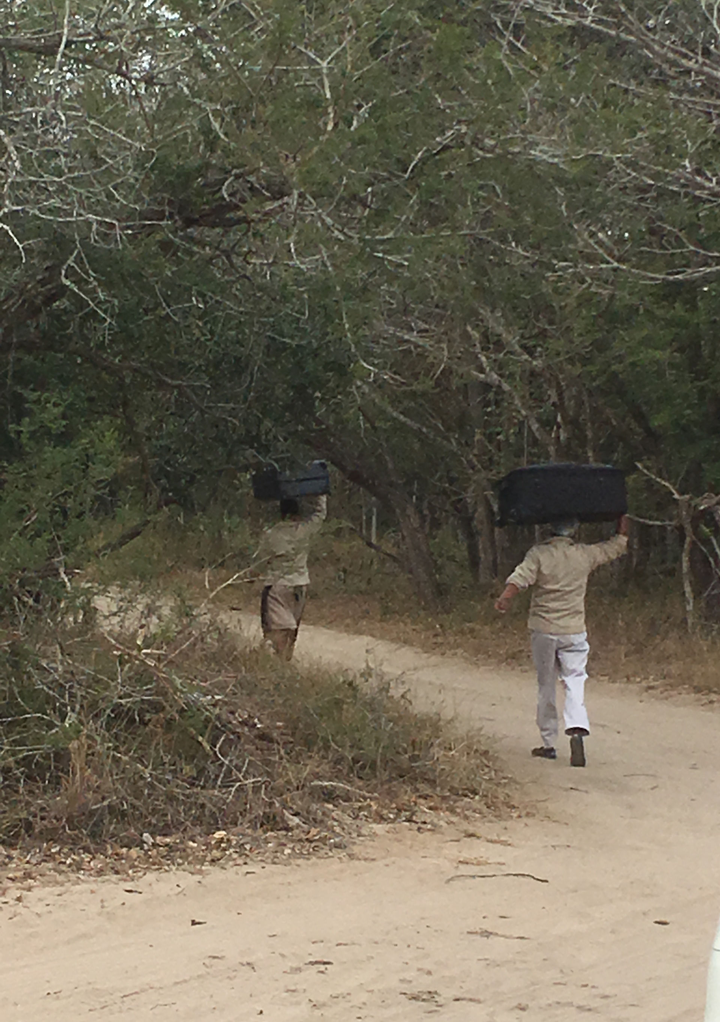
- 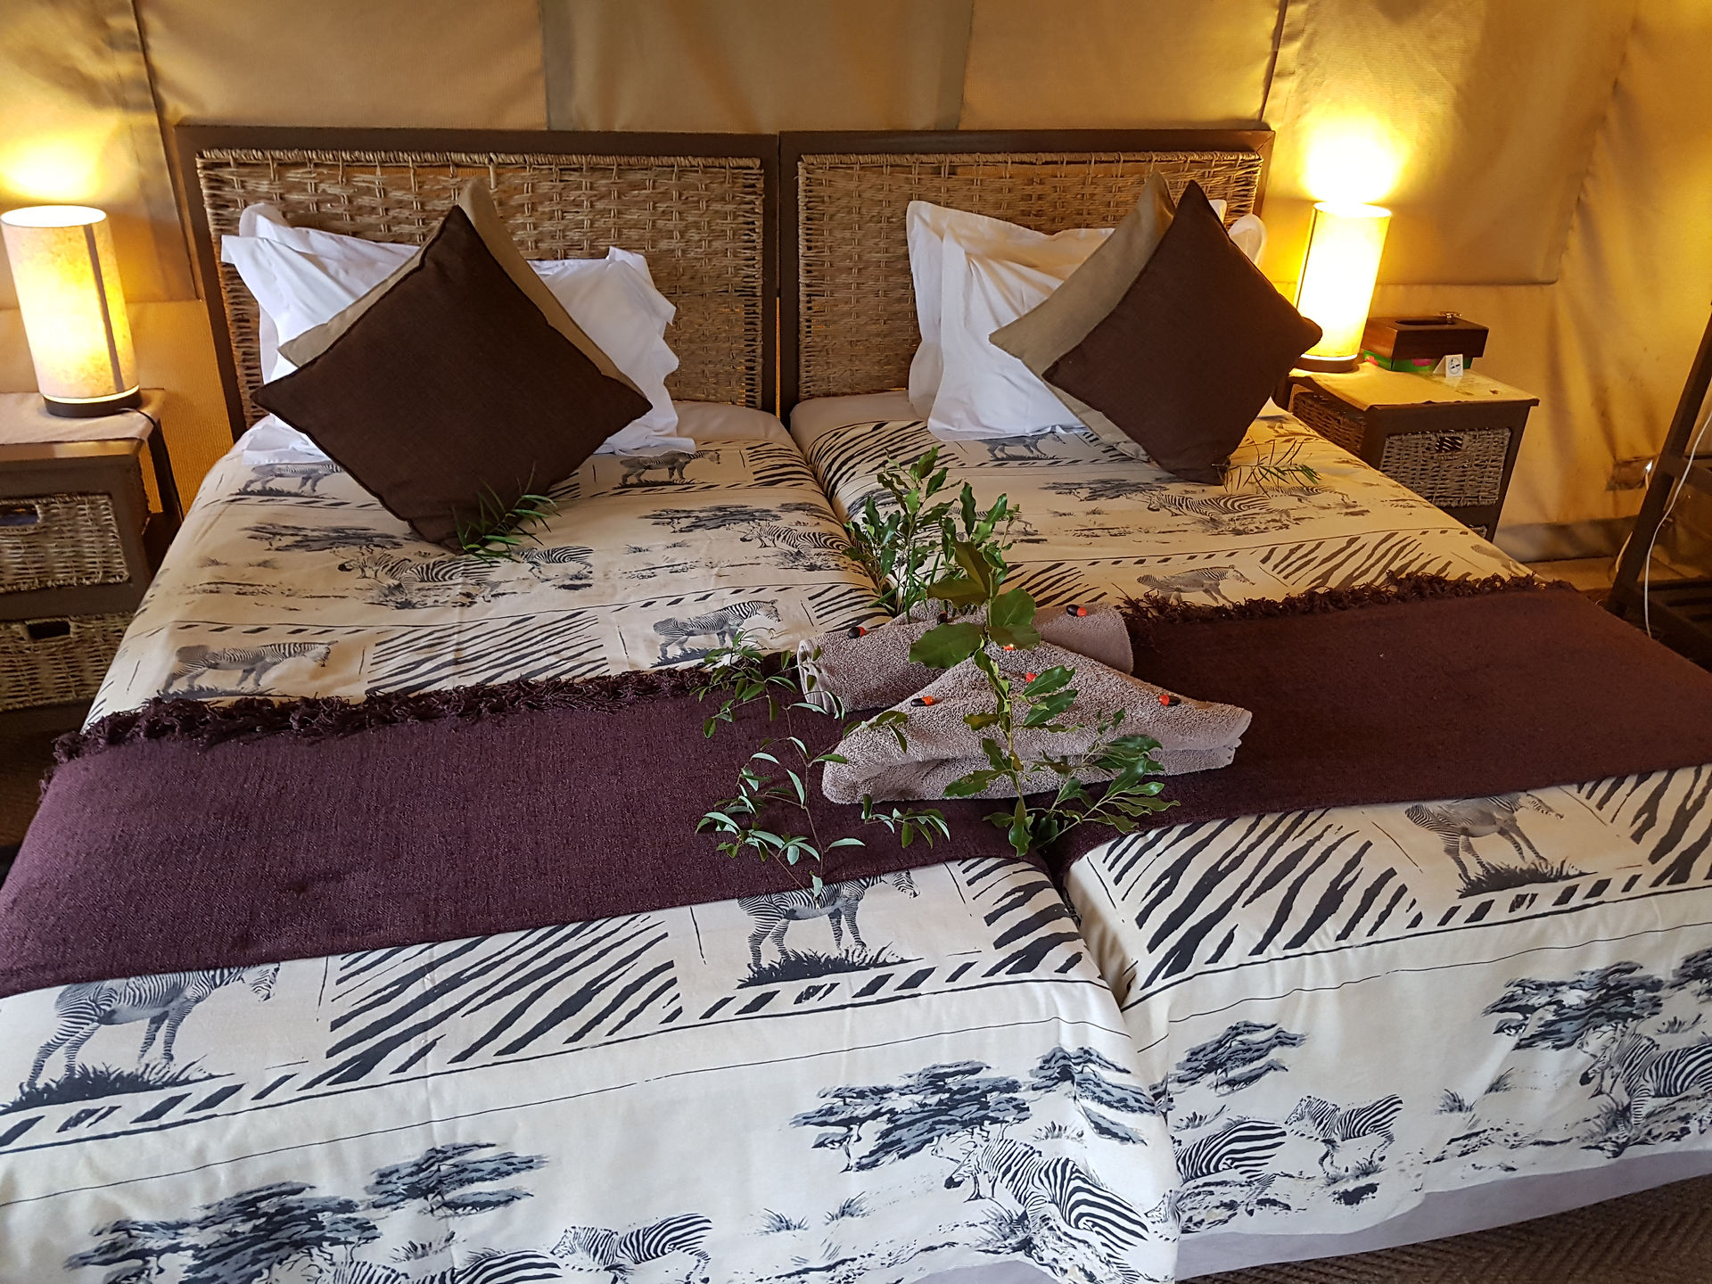
- 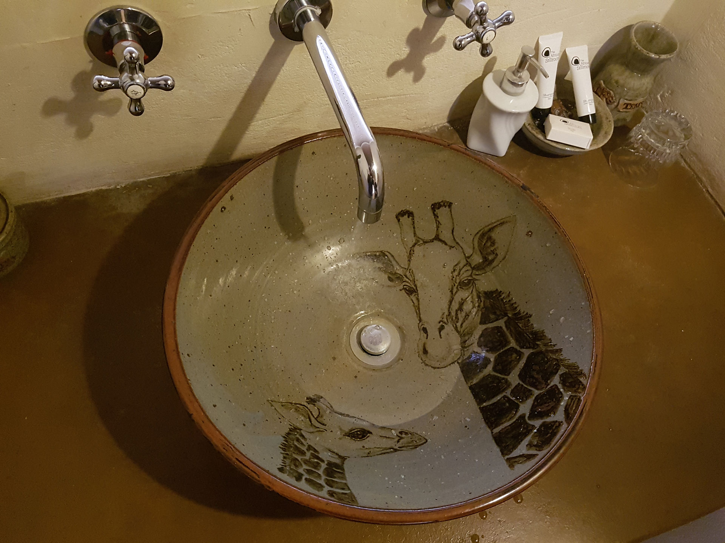
We had paid extra to have our own truck and not share with Pillocks which was great. It was lovely to hop in and be within the reserve in 2 minutes rather than driving 40 minutes to get there. Once in the reserve, a different type of bush, we had the chance to go to a watering hole that had a hide looking over it. Well....... This was heaven, it was fantastic. Our driver had warned us there would be lots of people there, but as we arrived, they all left !
- 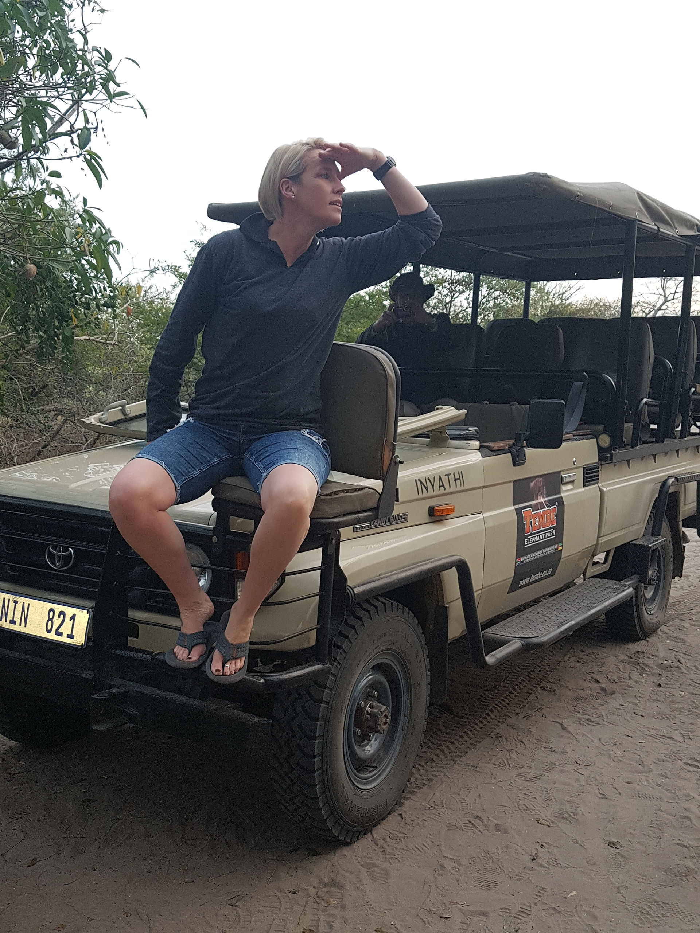
- 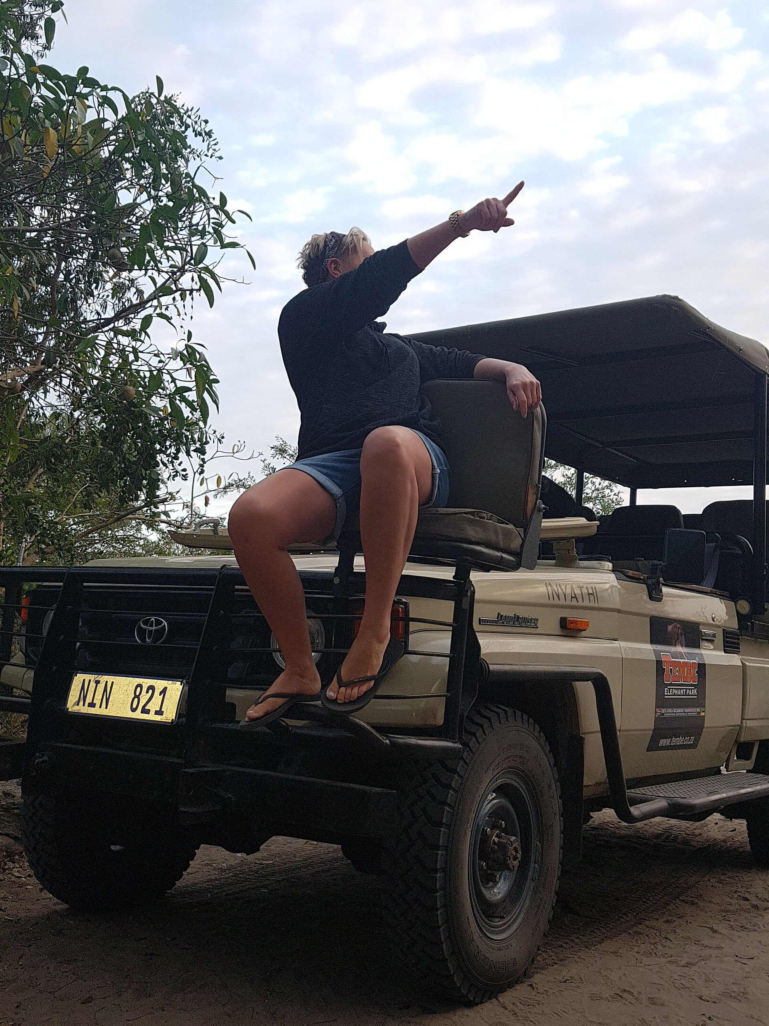
- 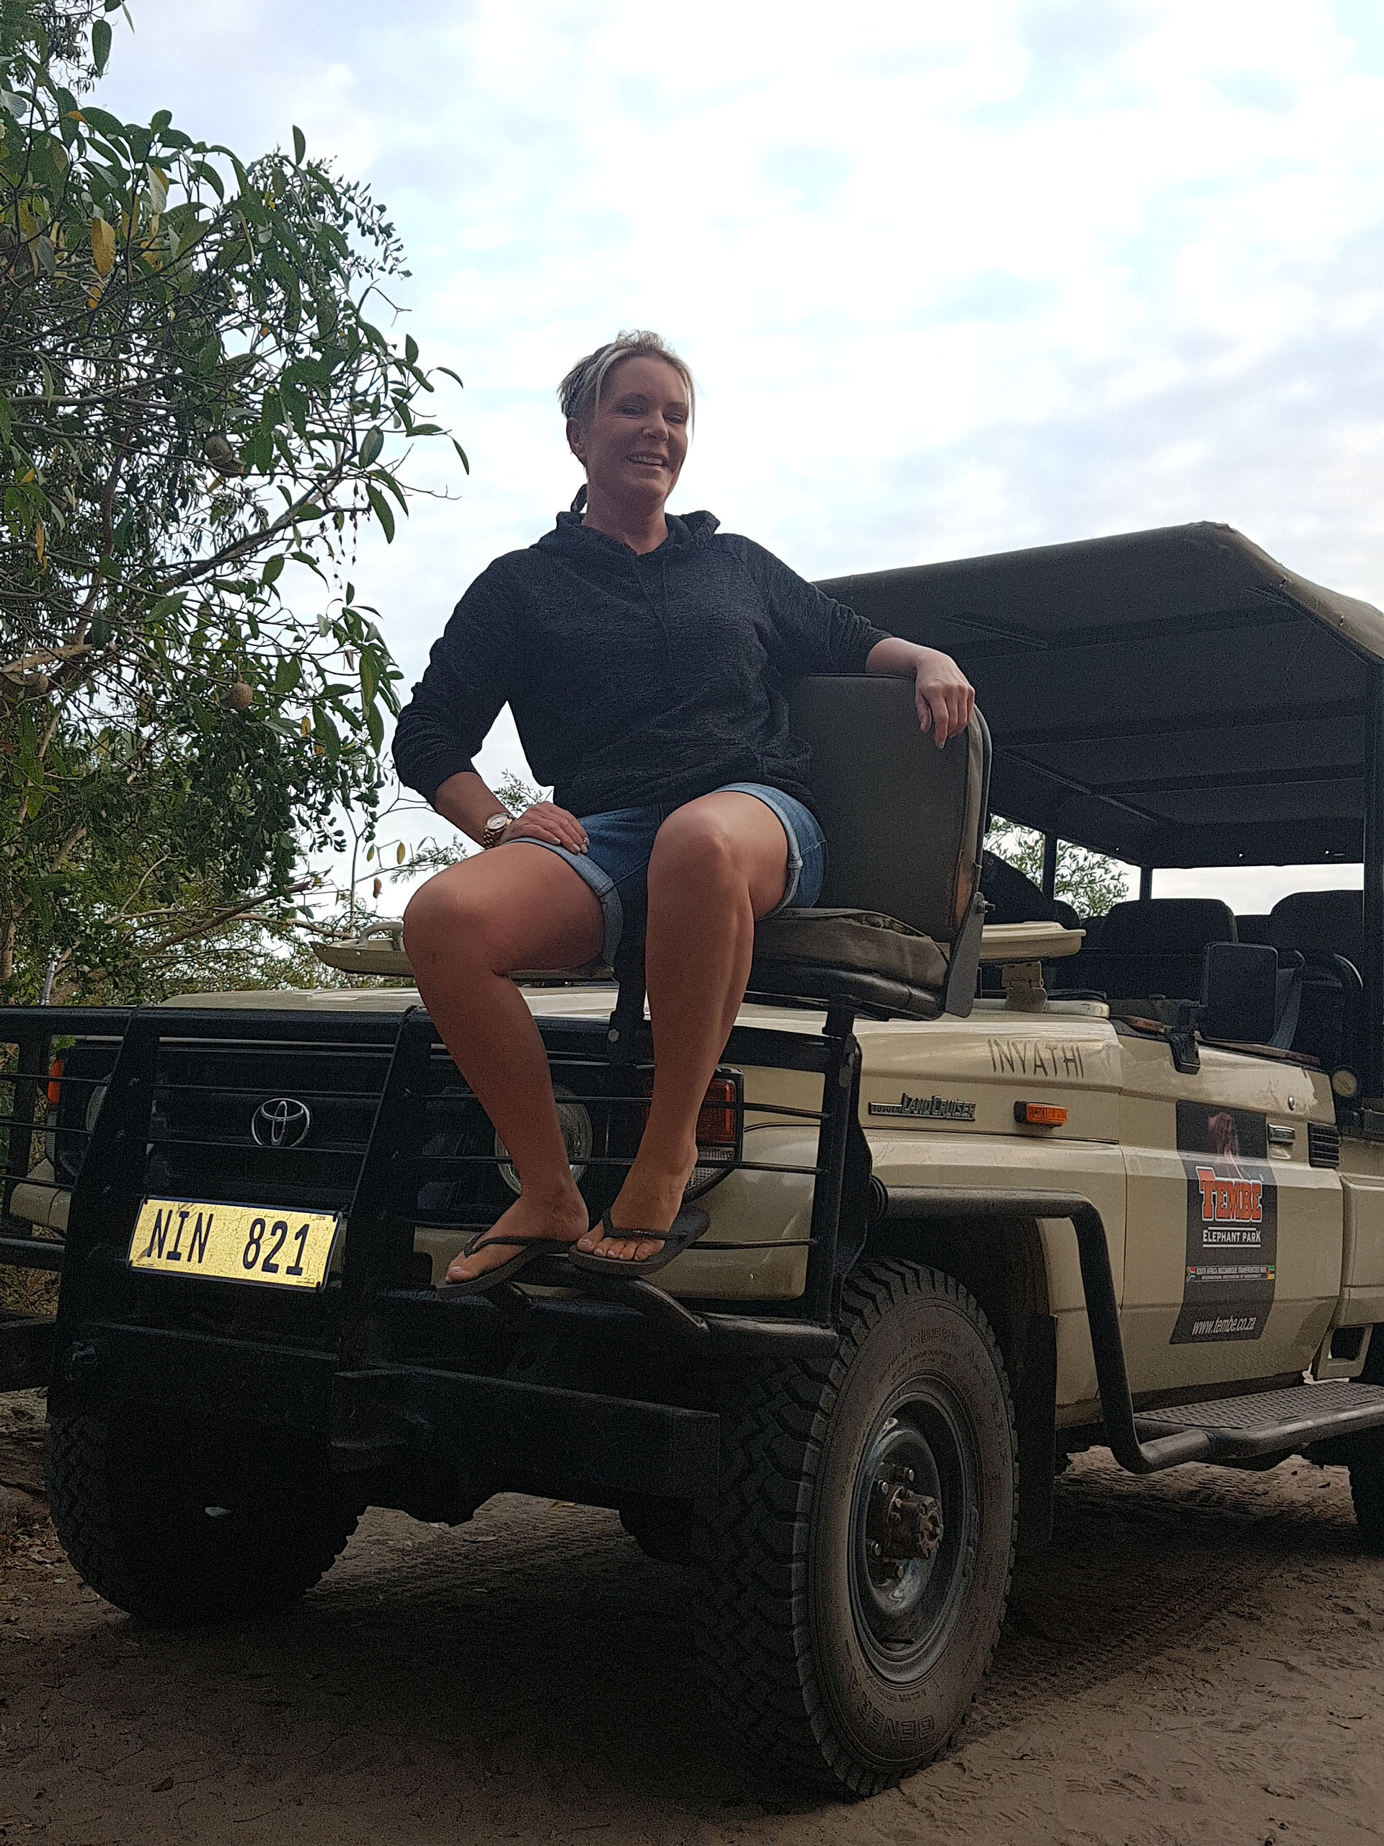
- 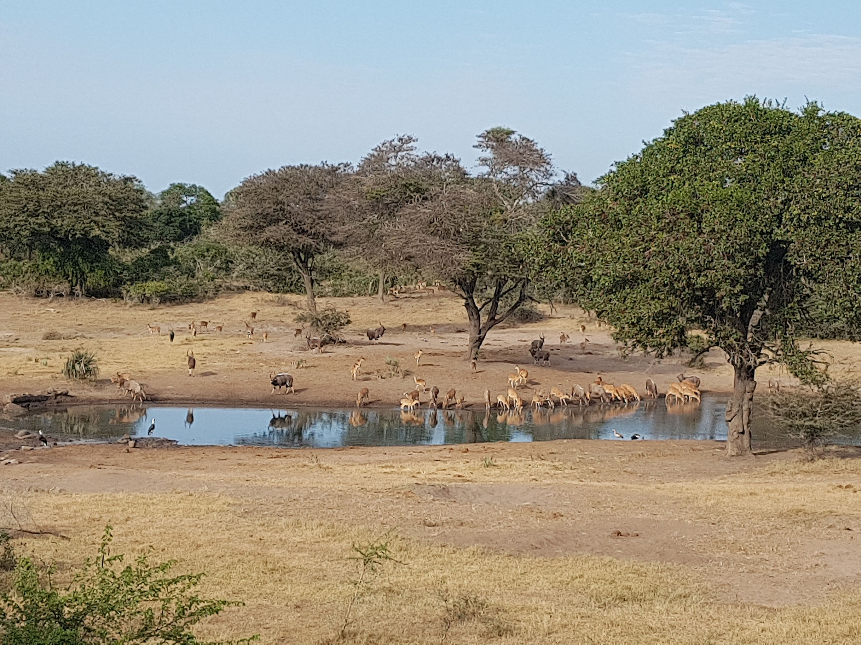
- 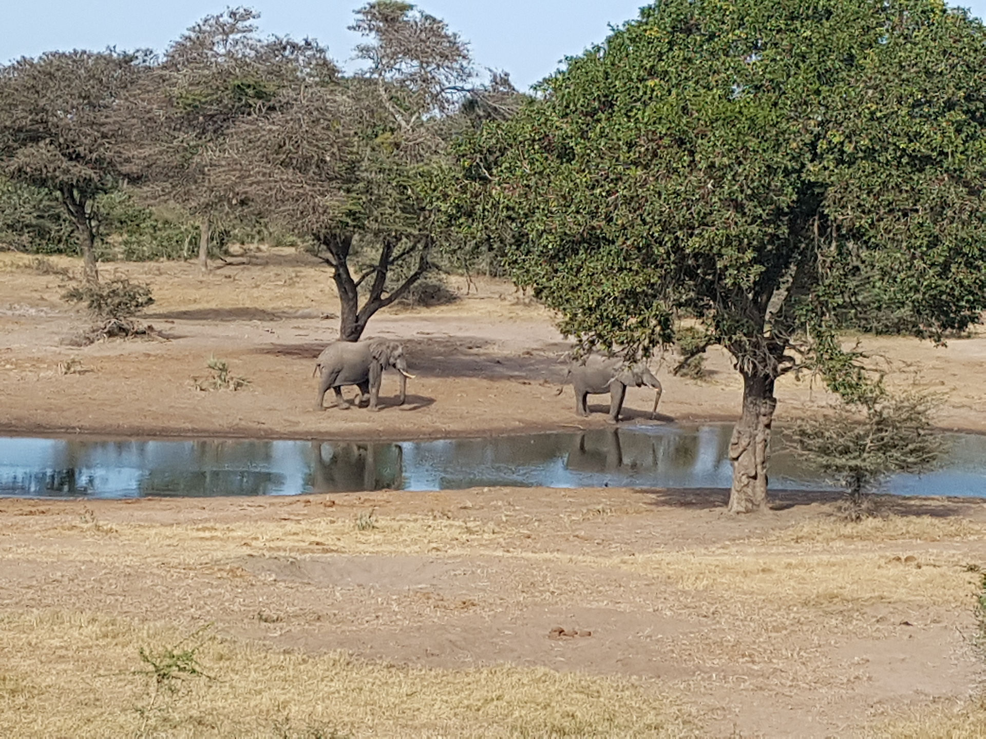
- 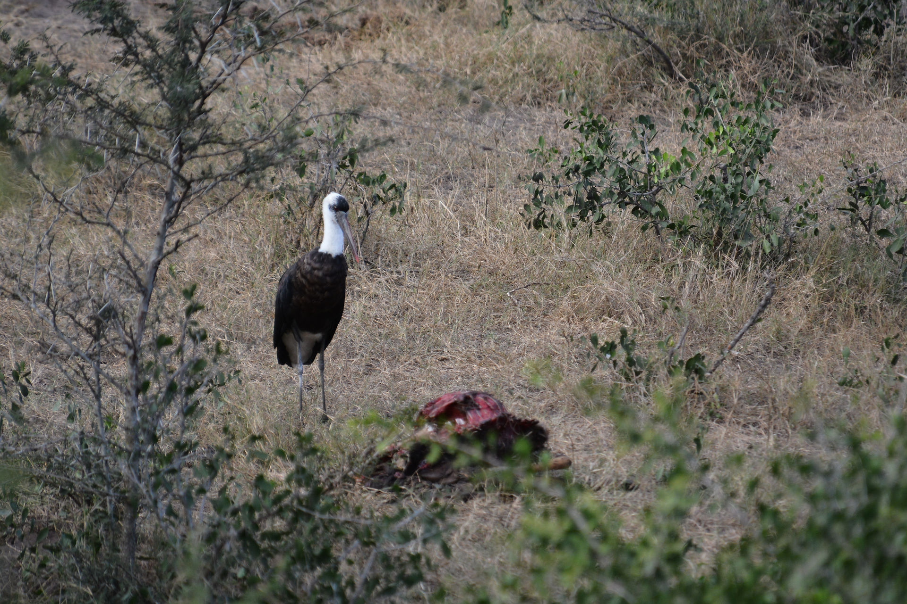
And we had a great view and had a seat at the front, just like I do at Arundal. Only this time, we were looking at a watering hole with one elephant, 2 woolly necked storks, a few Impala, a couple of Egyptian geese, a couple of waterbuck and 4 - yes 4 lions, a female with 3 young aged about 5 months according to our driver. Not only that but they had the carcus of an impala just off to the left of our view, annoyingly behind a bush, they had obviously just eaten and all lay flat out. Still the rest of the animals were wary of them.
- 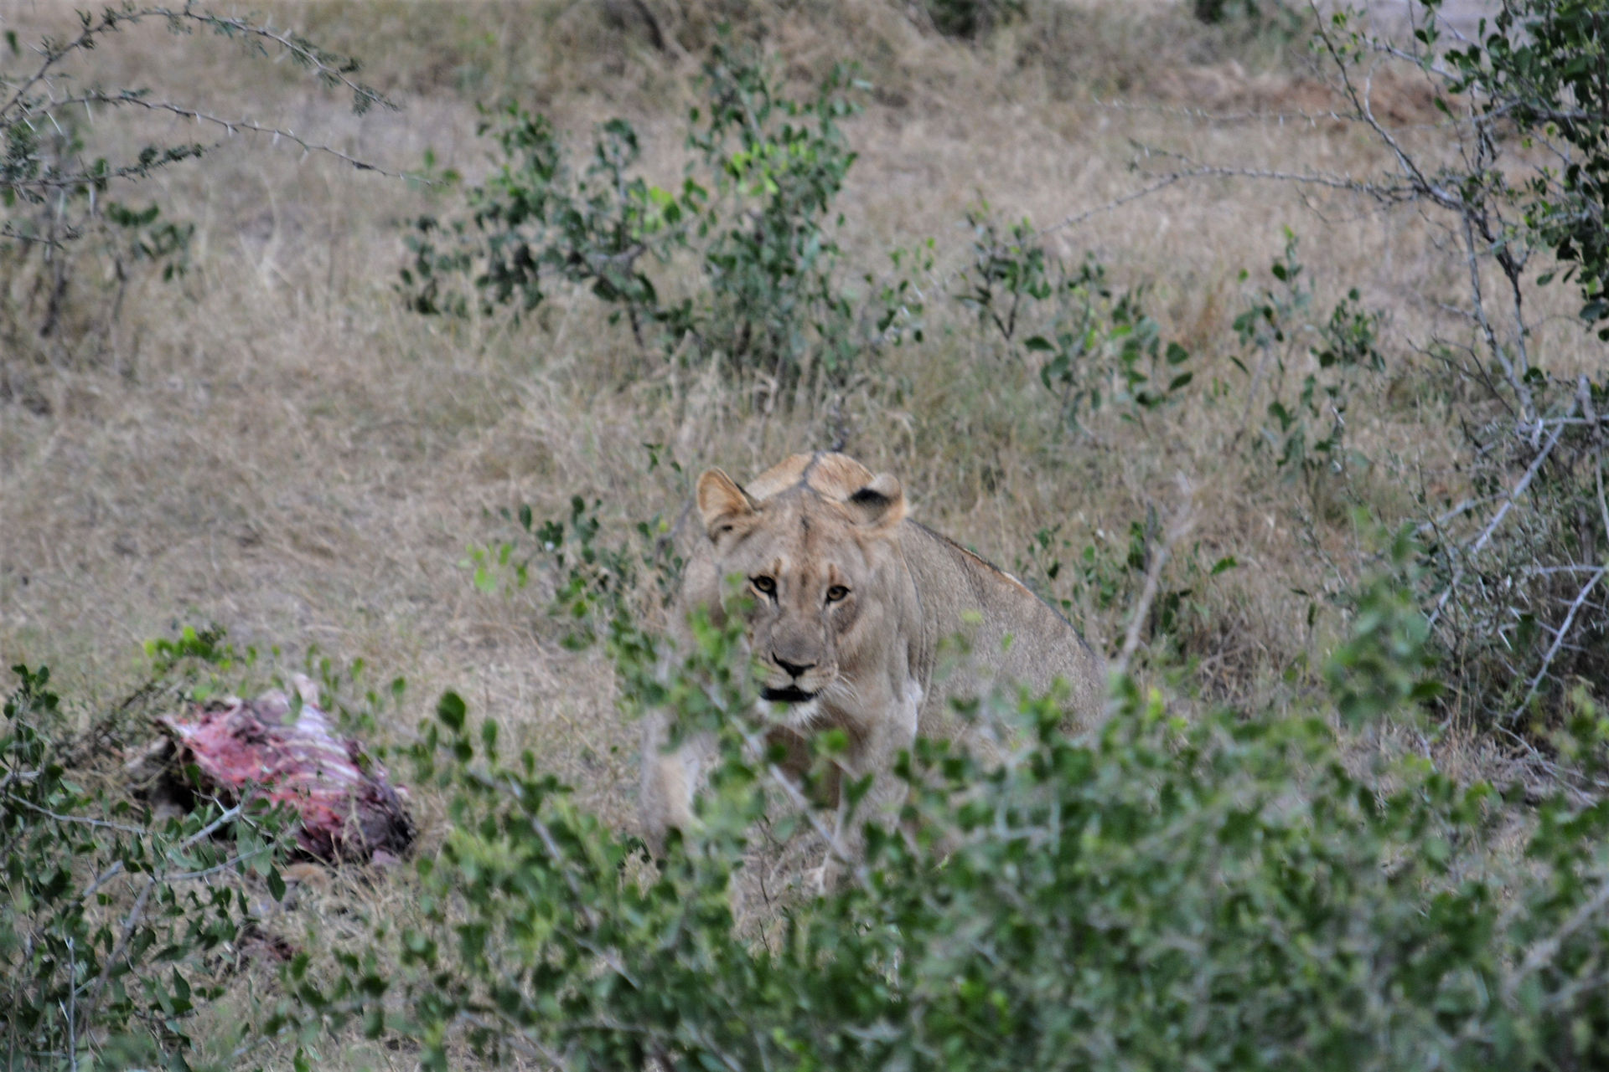
- 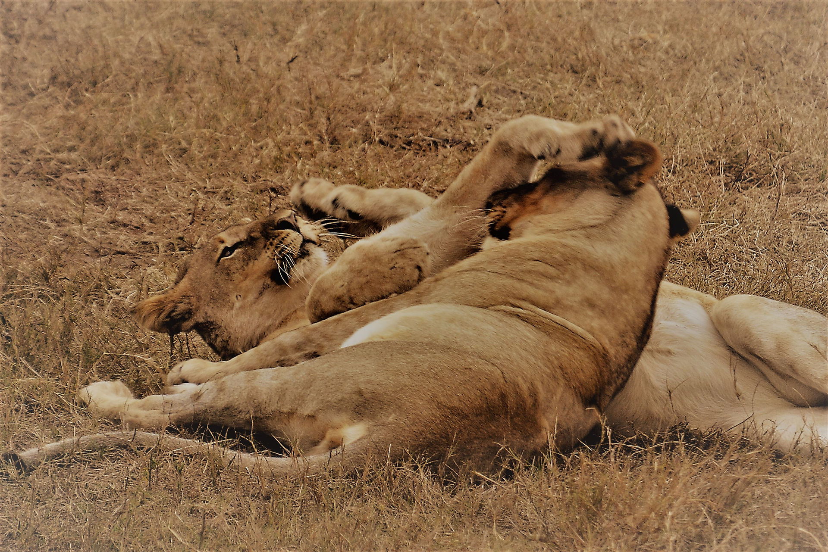
- 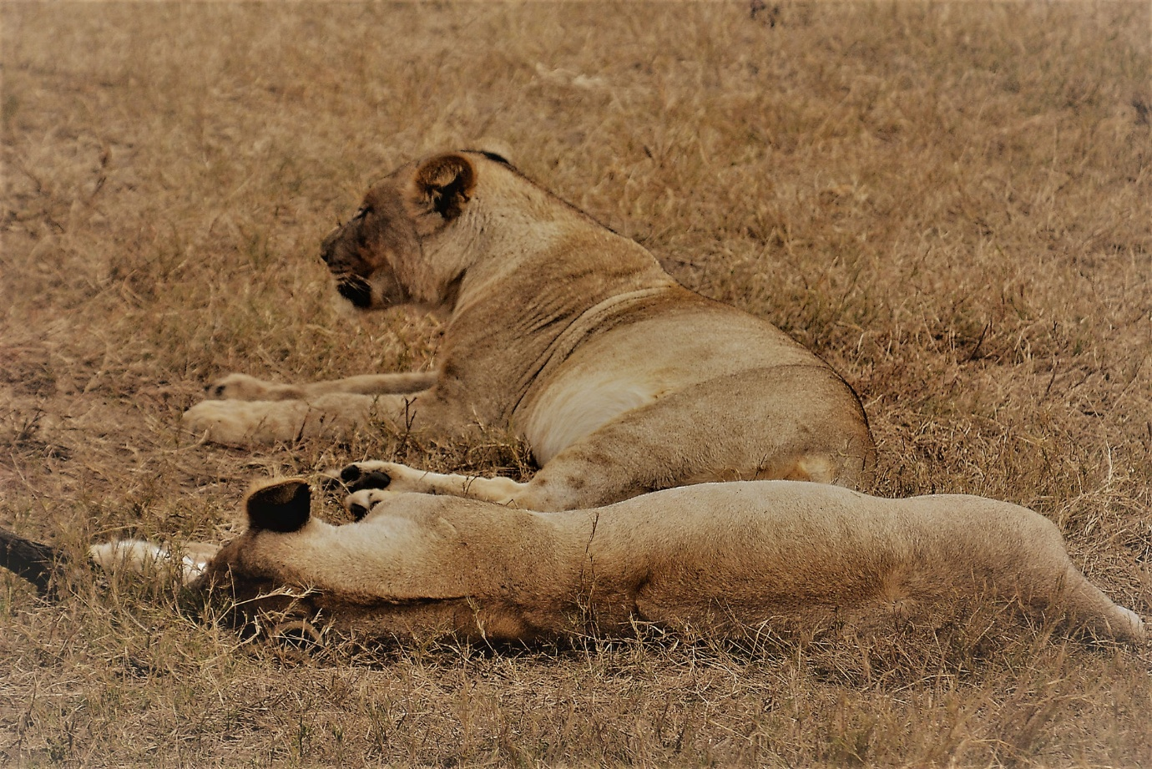
The elephant was hilarious as he sucked water from the inlet to the waterhole. It's a waterhole fed by a water tower, so instead of drinking from the water itself, he sucked the water from the source feeding it !
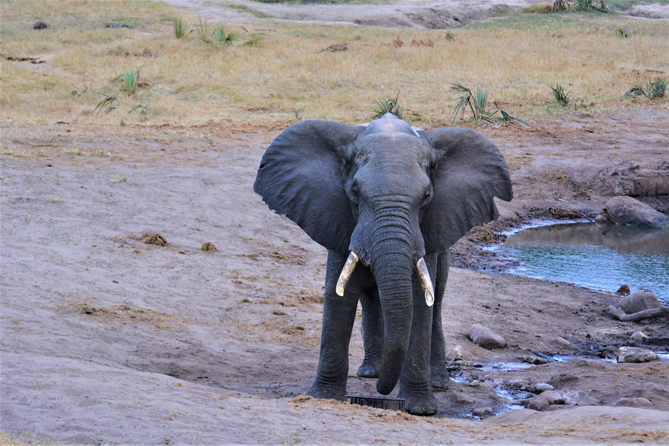

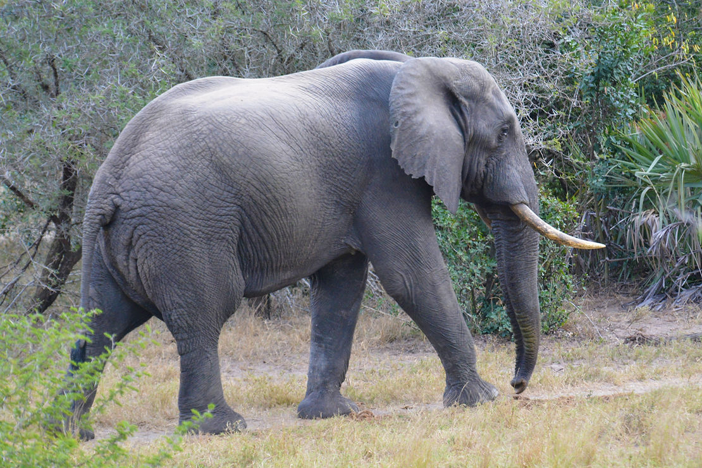
For ages he stood there, filling his trunk up and drinking, the lions moved occasionally and even went to the carcus to grab mouthfuls, before lying down again. Suddenly, stage right, entered another huge lone bull elephant, and as he meandered onto the scene, all the lions leapt up and ran into the bush on the left. New bull wandered towards existing bull who finally left his water inlet and exited stage left, followed by new bull. Now there were no elephants to be seen. So the lions re-appeared.￼ In the background the storks were still doing laps of the waterhole, the Egyptian geese were still muttering, the waterbuck were still building the courage to cross a path to the watering hole and the Impala were still sitting around the edge. Then the elephant came back into play and in tandem appeared from the bush on the left. Then separated off into different directions having agreed some sort of elephant dominance pact. By now the young lions who were in training for catching their own food were starting to be a bit more active with the carcus, grabbing random bits, including the tail, teasing each other and playing. Meanwhile in the background, the storks were getting braver and for some reason also getting nearer to the lions prize. Well........ The youngster thought that despite his hunger having been satisfied, he may toy with the idea of chasing a stork. So, we watched a stand off between the stork and the lion as it semi poised on its haunches...... And then couldn't be bothered..... And lay down again..... The stork was oblivious to the fact that it was very nearly a hunting experiment. Meanwhile, in the background, the elephant was still drinking....... Day 4￼ A light breakfast and then off we went on our morning game drive. Pottered around and got into some more open habitat and had some giraffe peering at us from behind some tall trees. Our guide / driver, Cosi, explained the difference in males and females. The horns on their heads are called ossicones. The females are more slender and have the hairs on the top. The males are thicker but no hair on the top. We saw a couple of buffalo but as we had seen so many previously at Hluhluwe we didn't need to stop for long.
- 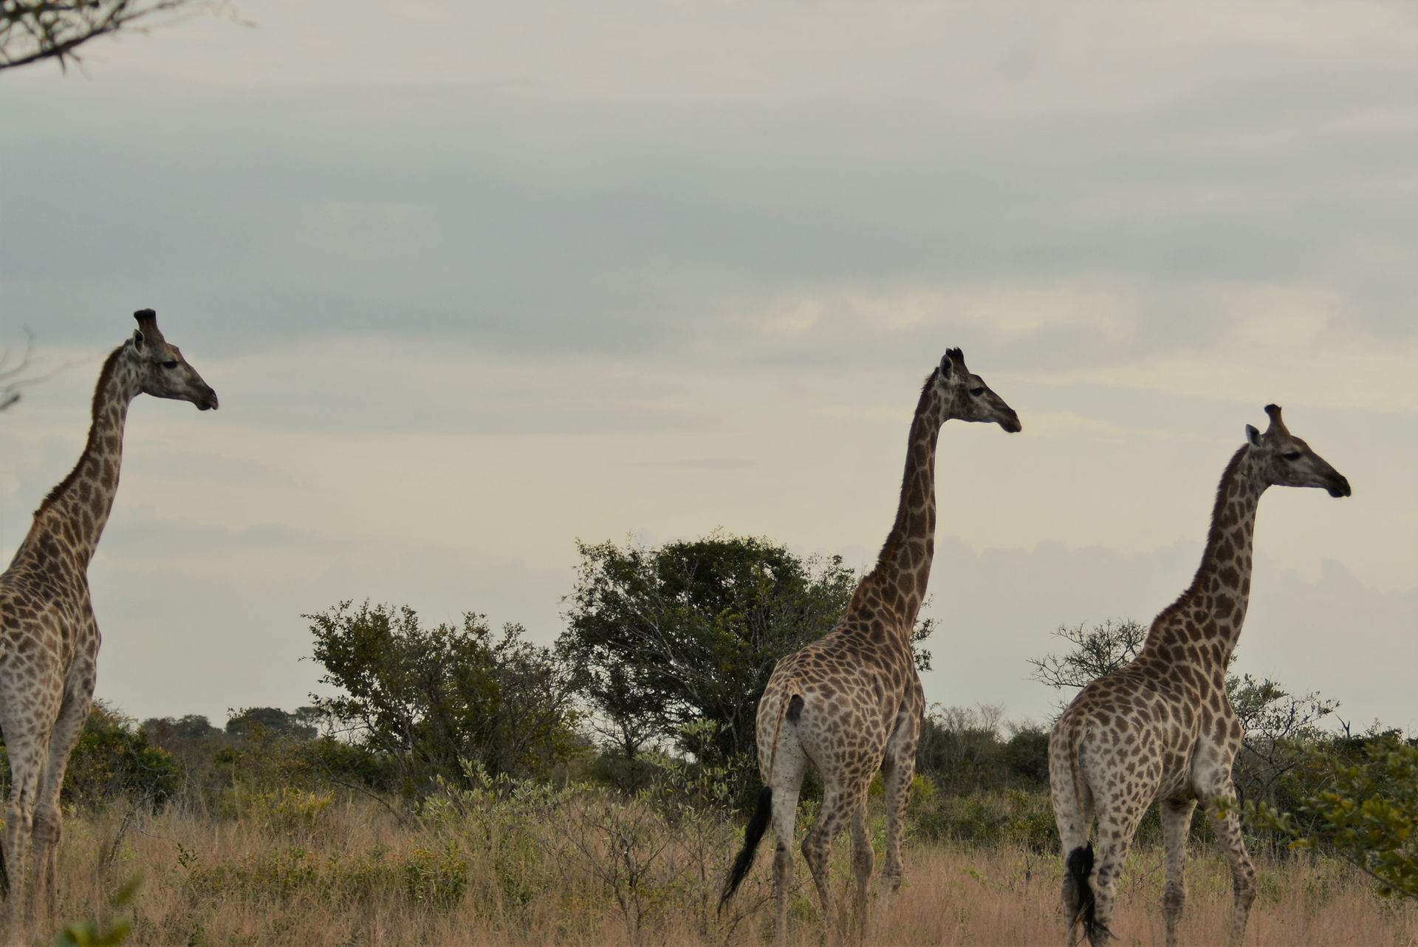
- 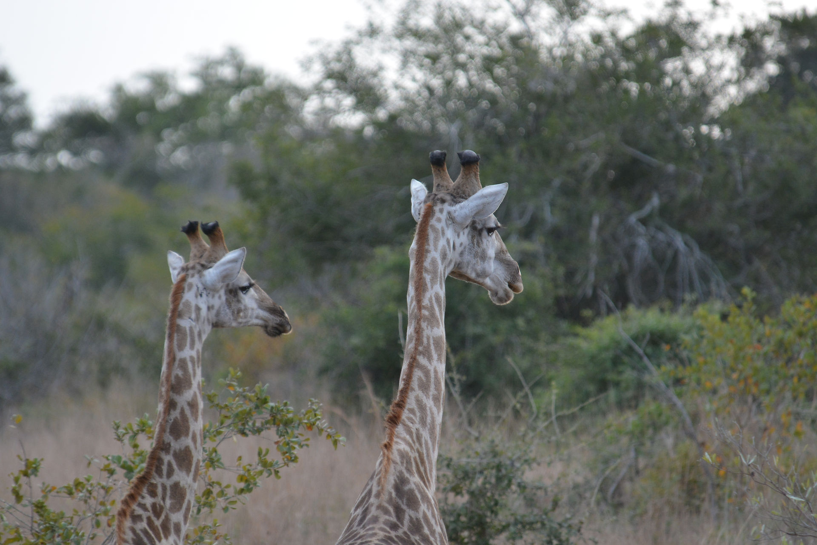
- 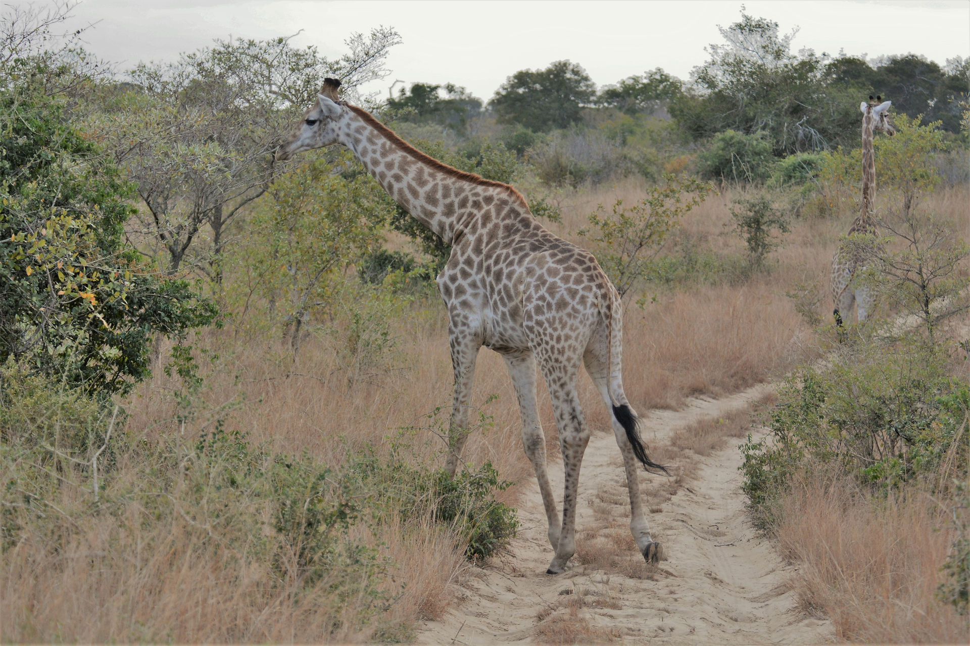
- 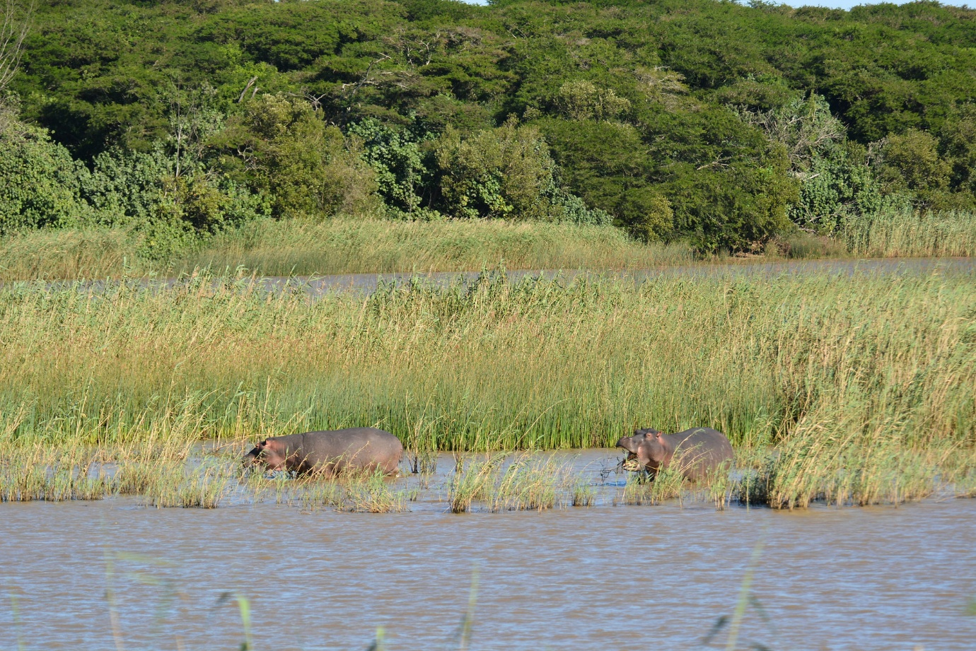
- 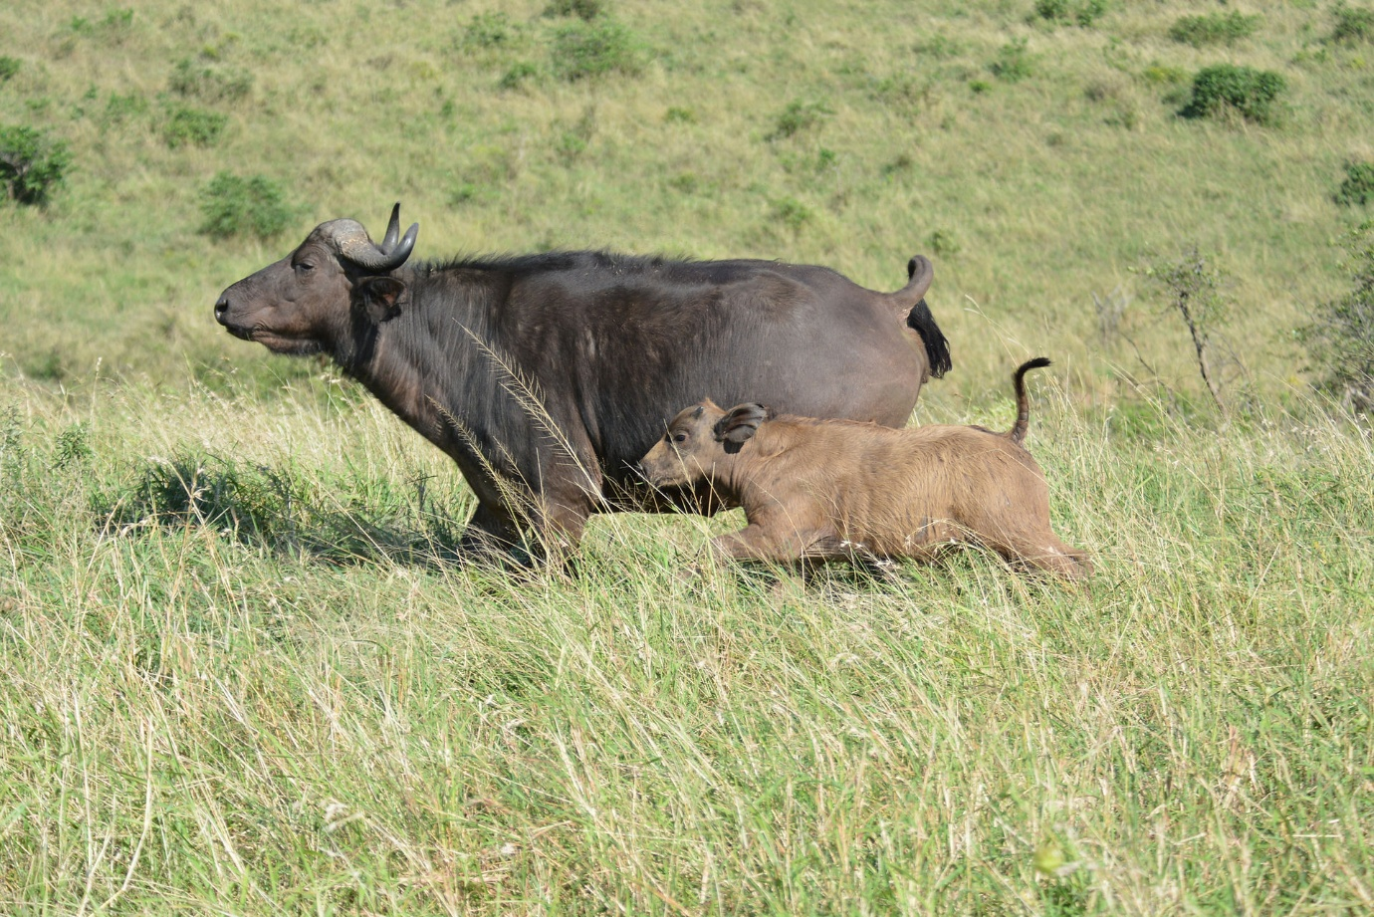
- 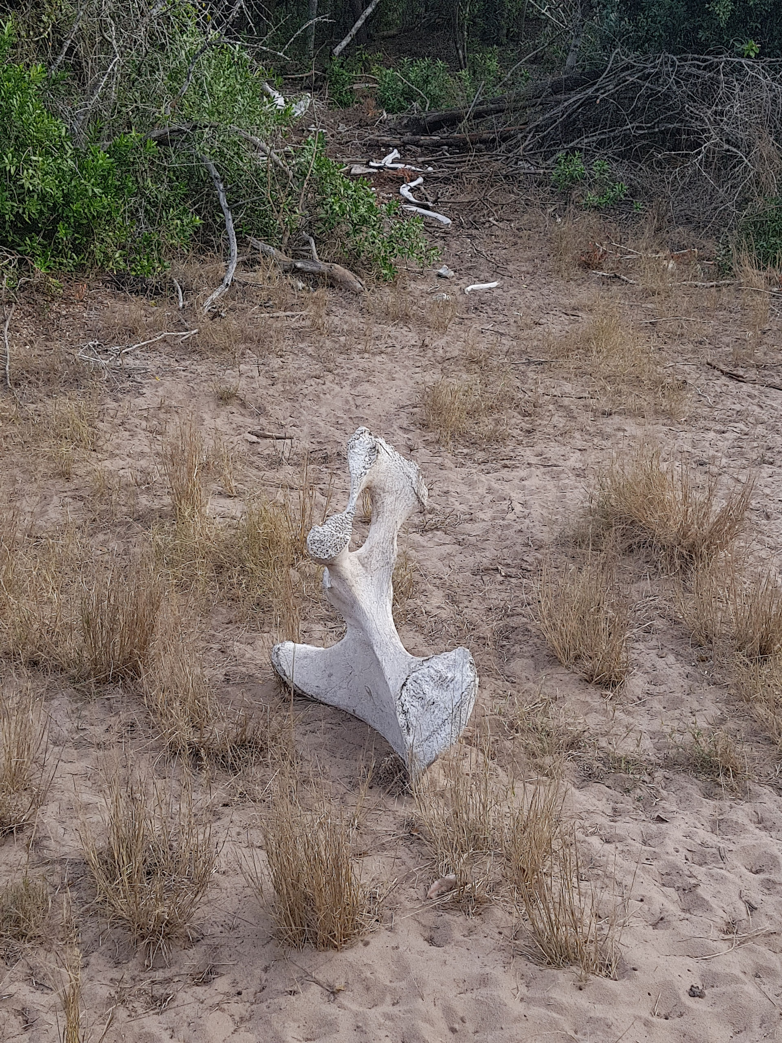
We saw the remains of an elephant that had died of old age a couple of years ago. Huge pelvic bone and long ribs. The skull was placed at the entrance to The reserve which we had seen on the way in ￼￼ We also got to see dung beetles, some of them get squashed which is a little sad for the dung beetle population. We ended up back at the waterhole. When we got there it was much busier with Nyala and Impala all around the edge. The 2 storks and eygyptian geese were there aswell. It's funny reading the signs from the animals, the geese were the first to raise the alarm, then the Nyala kept looking into the bush. Then she rushed in, the lioness, a half hearted attempt and slowed quickly. Then there was nothing at the waterhole ! The only things that come in when she is there are the elephants. 2 of them came in from the far left and wandered straight to the water source. This waterhole is supplied by a water tower so that they always have water, so the elephants rather than drinking the muddy pond water, literally drink from the tap ! Back to base and a lovely breakfast. It gave us the whole middle of the day to relax. Clive went back out to the waterhole to just sit and watch. We caught up on photos and editing and stuff. The Lodge is really relaxing with Nyala everywhere, one trip back to the tent and I￼ had to get past 7 of them on the path. Lunch was at 2 - it's almost too much food with every meal being a main meal. Then off out again at 3. We headed out to the open marshland so that we would be there for sunset and it was really worth it.
- 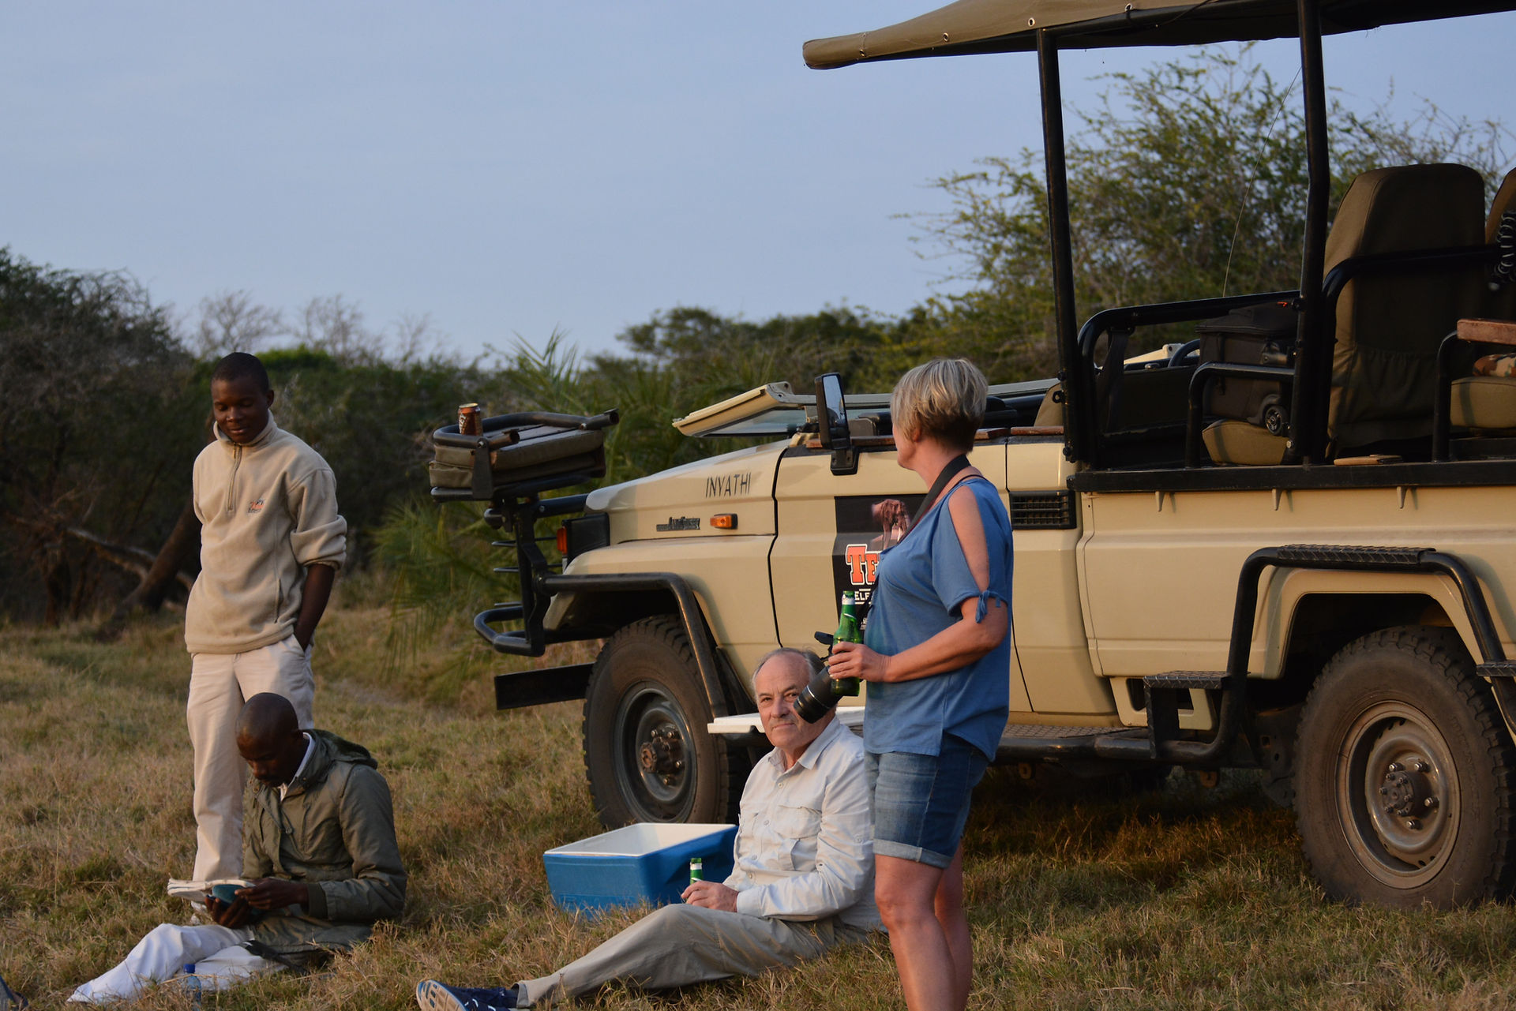
- 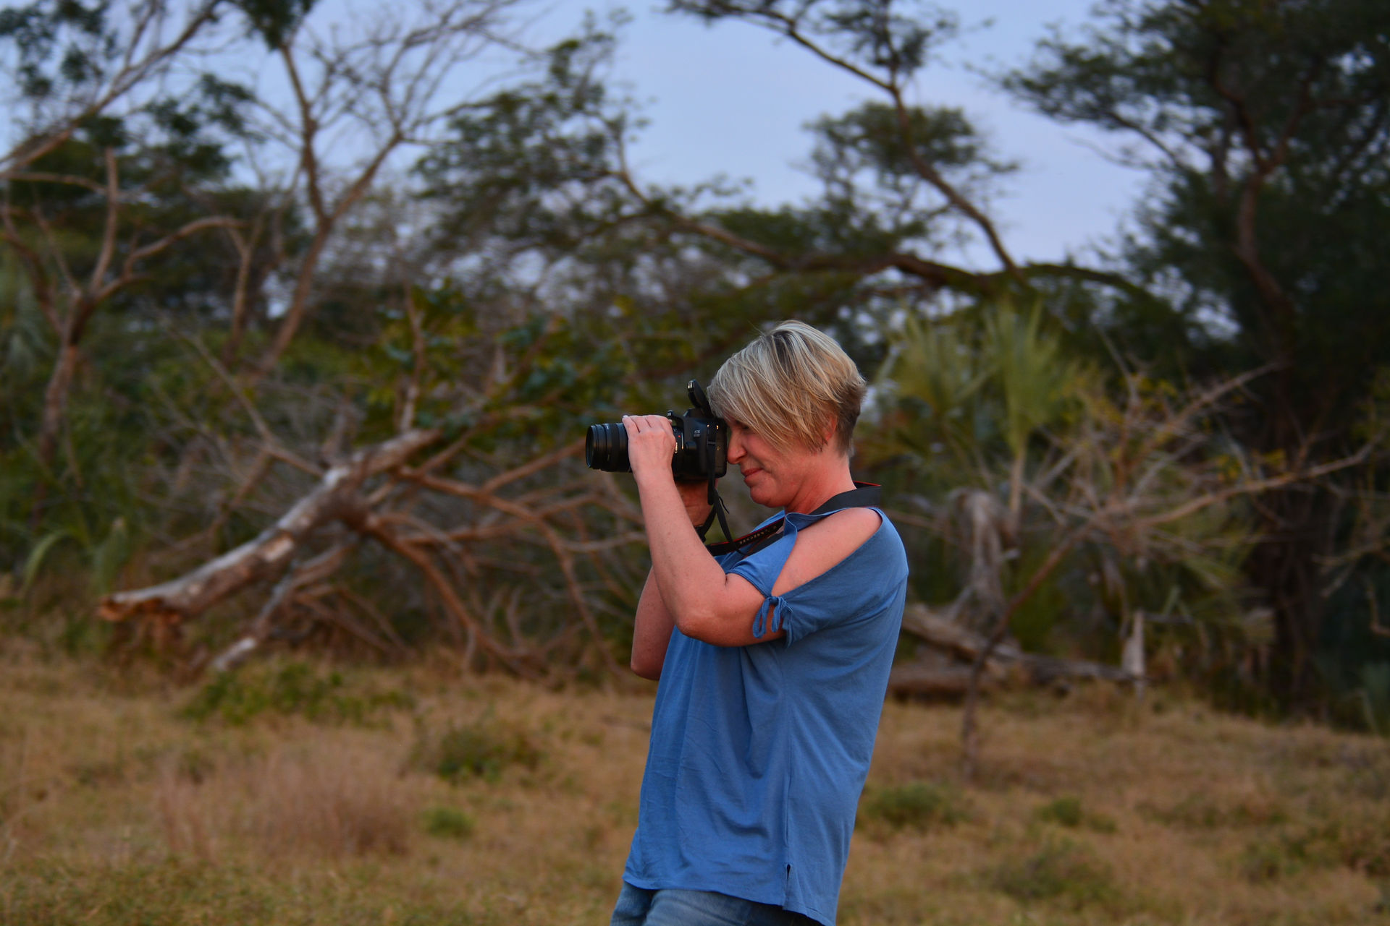
- 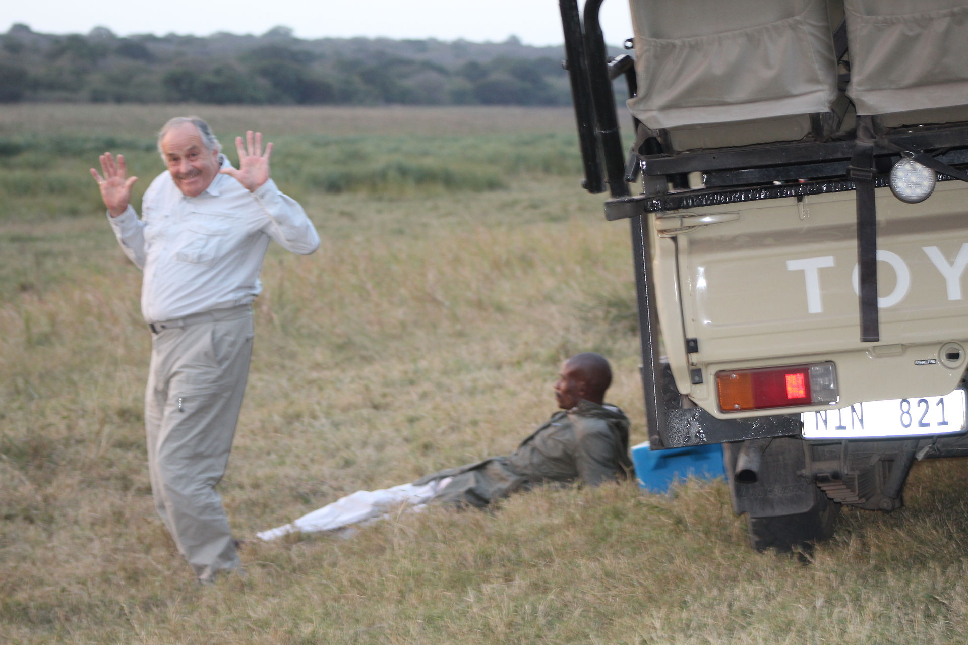
- 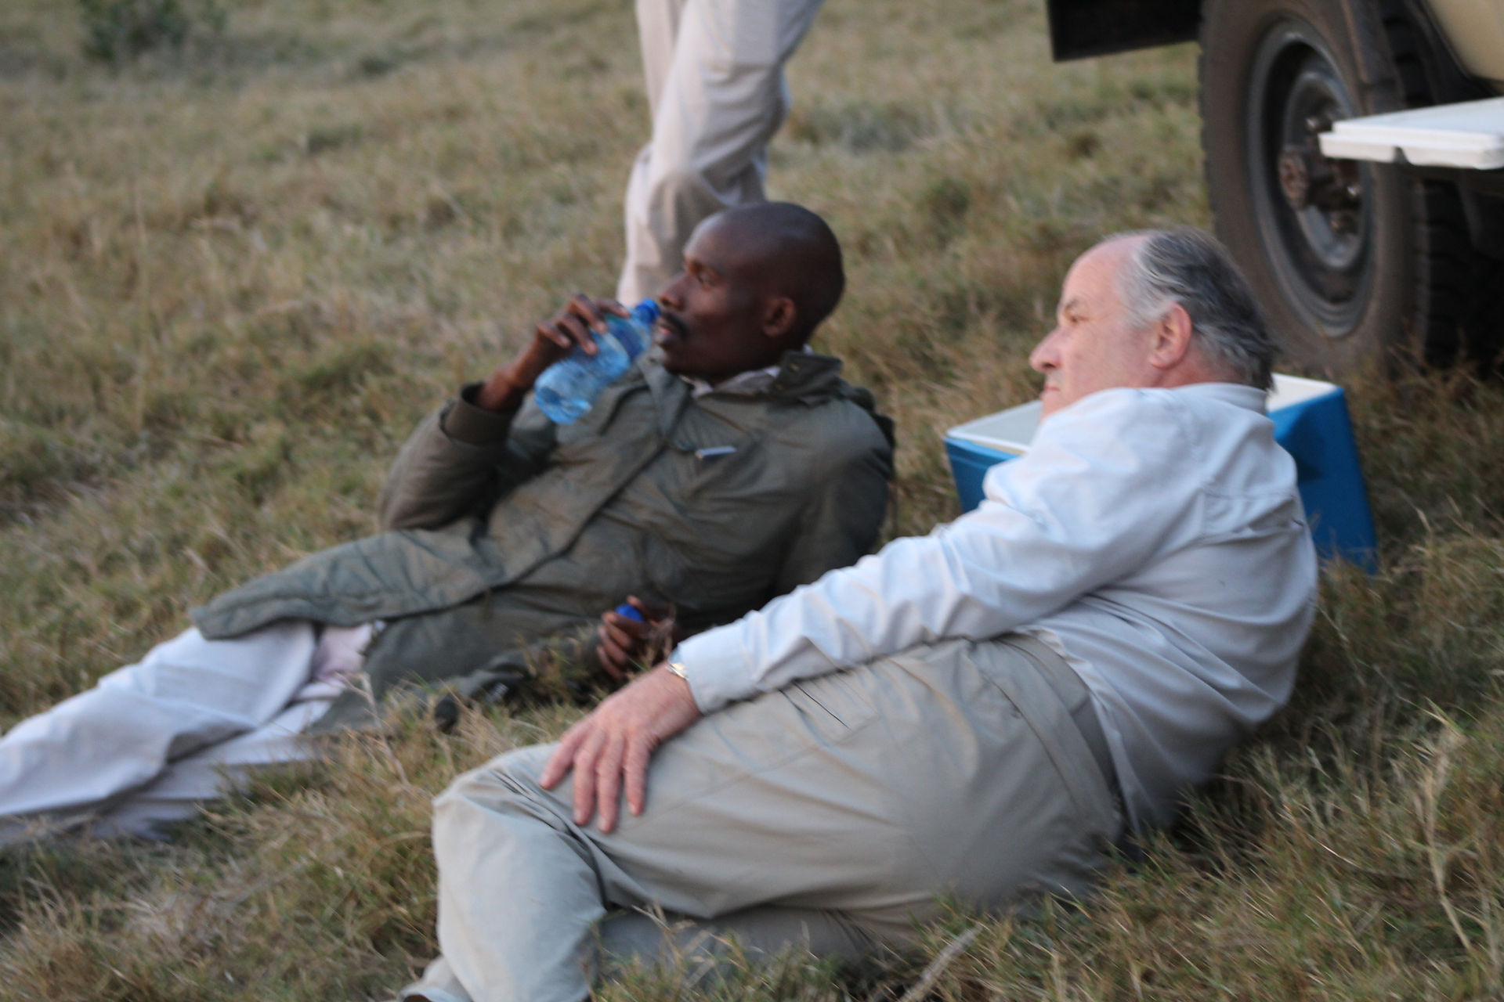
- 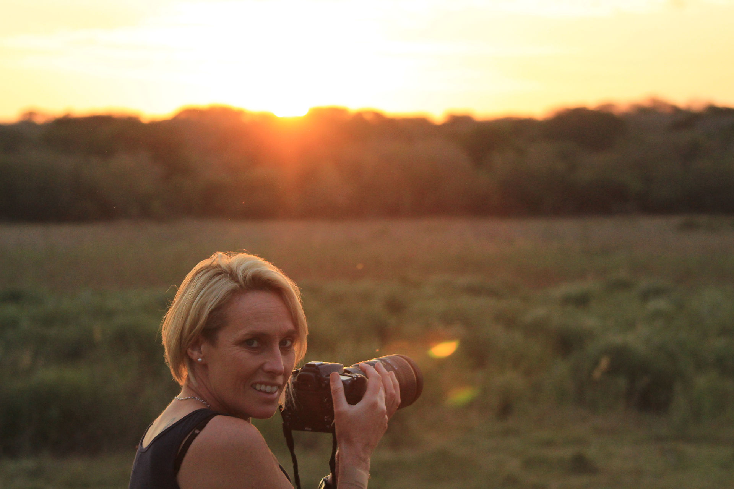
- 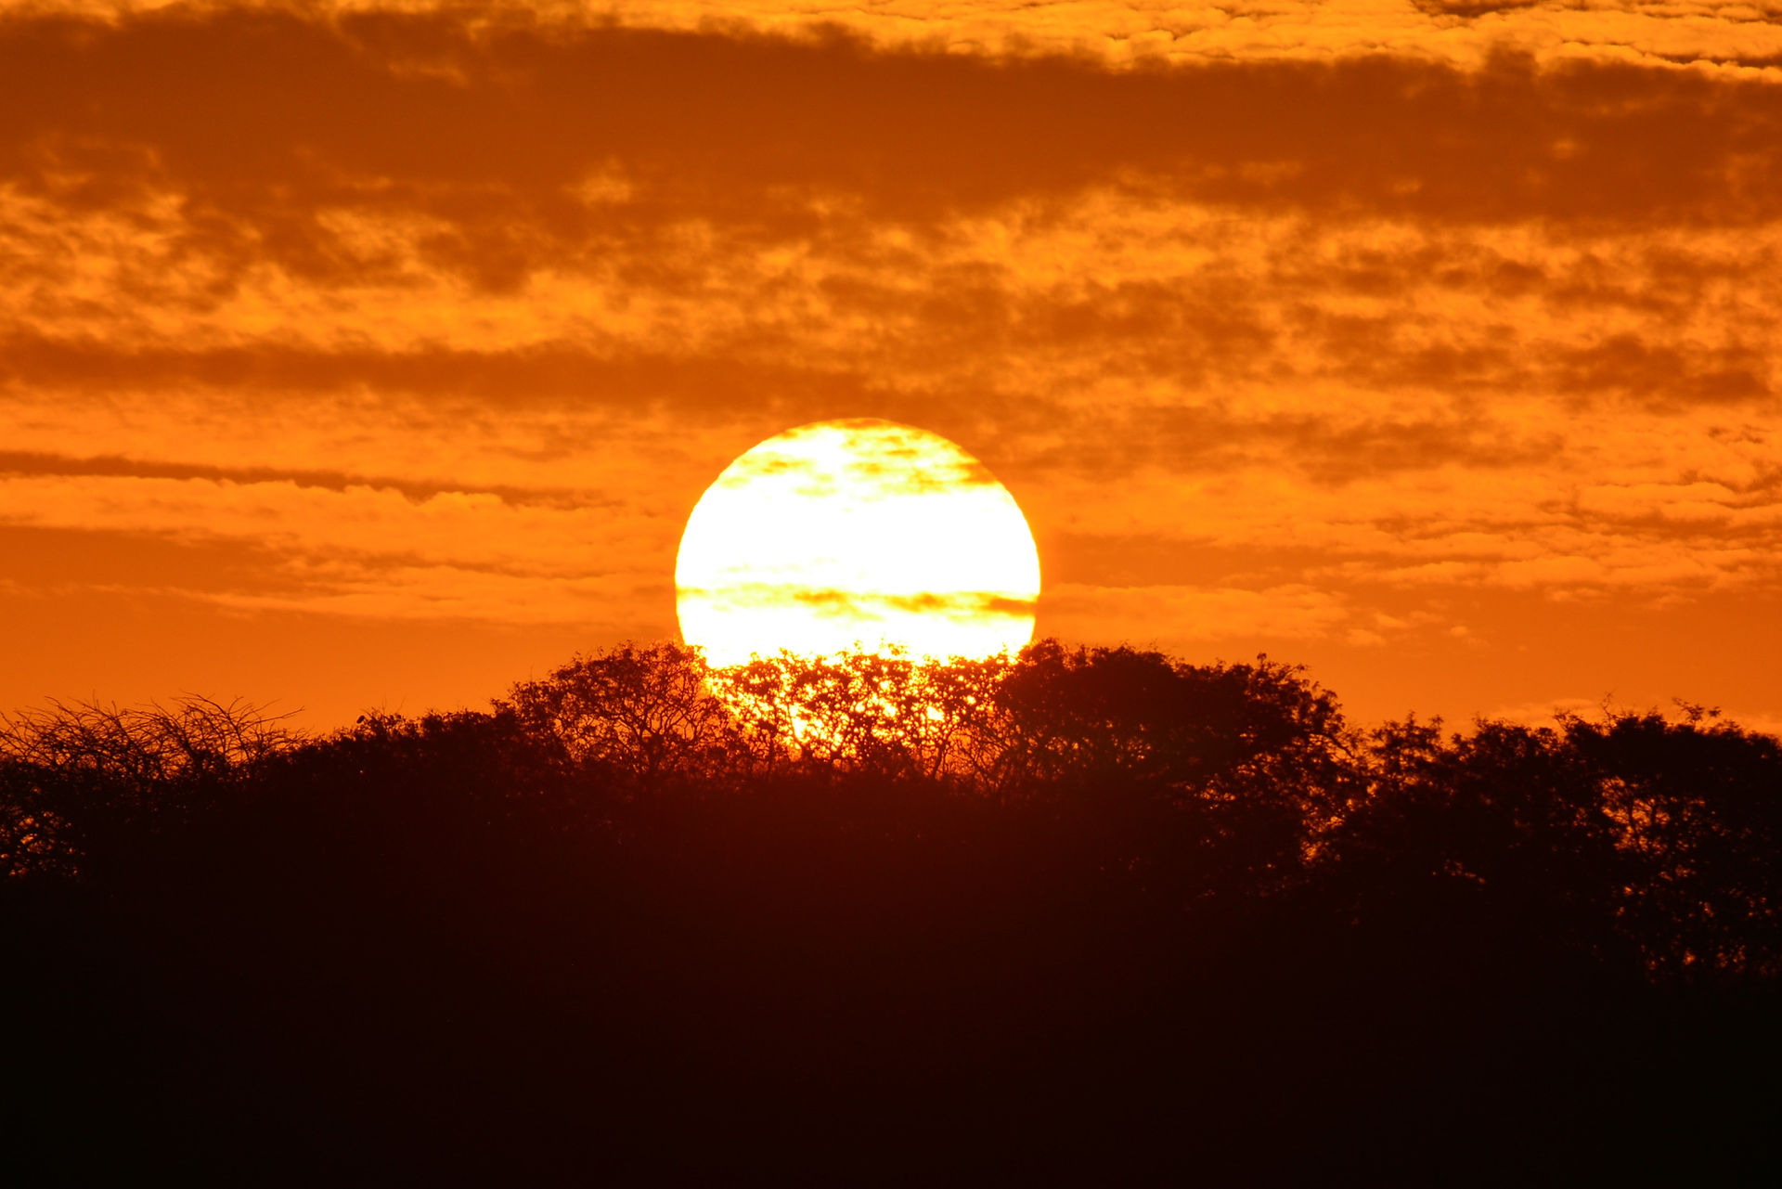
- 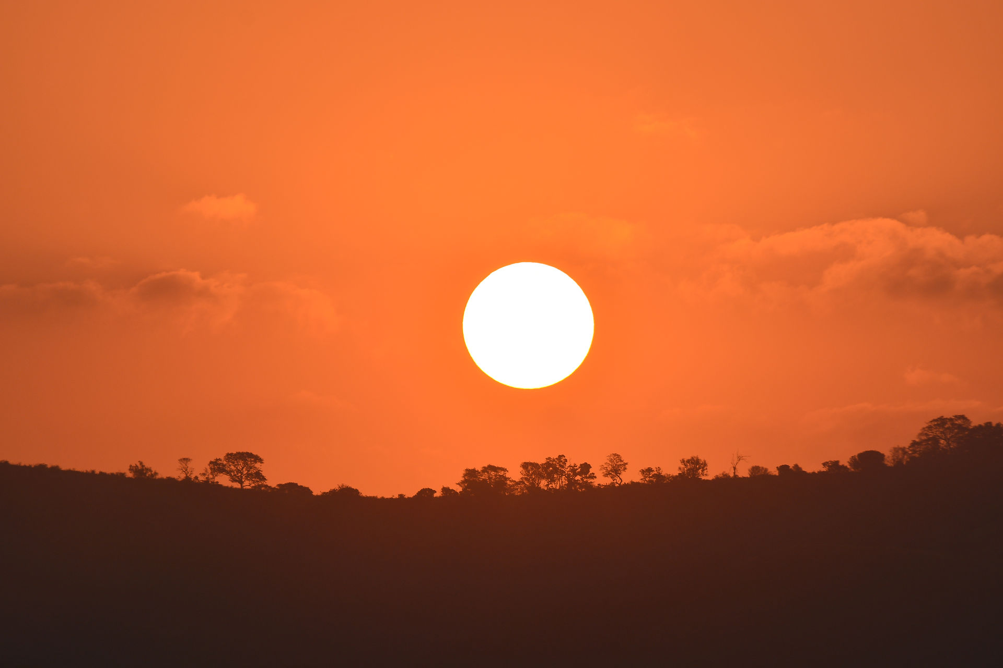
- 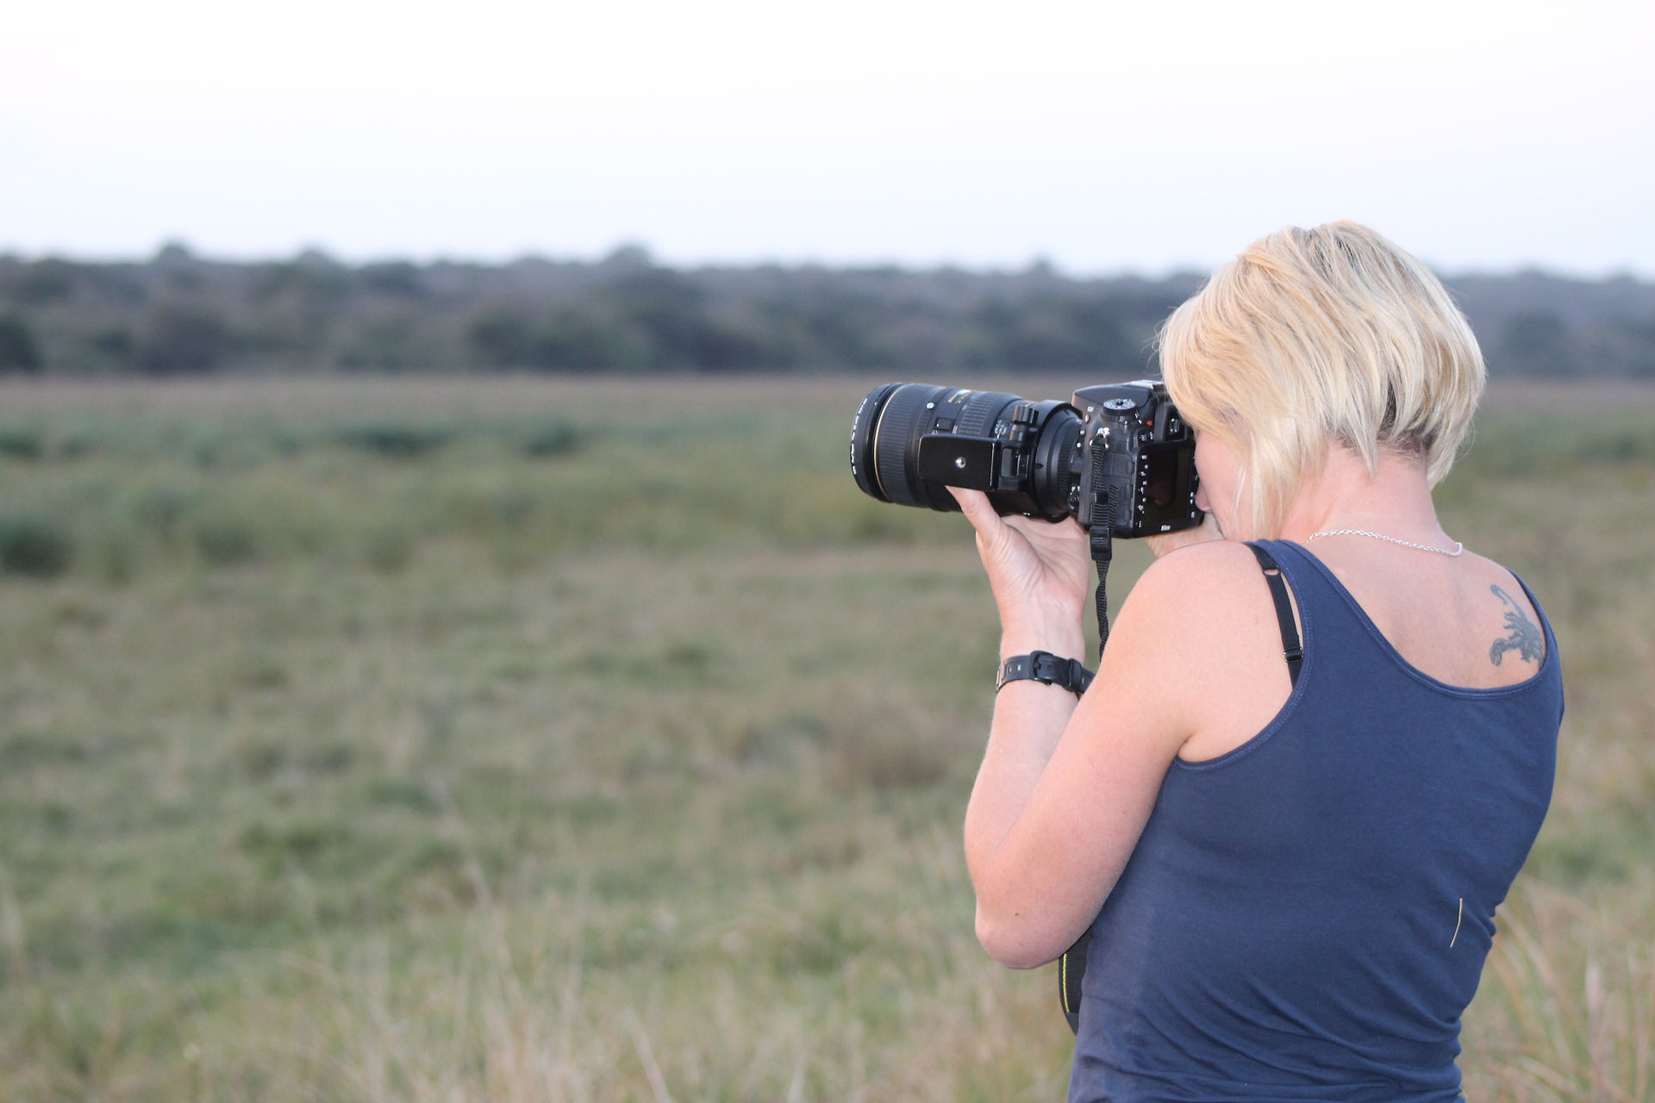

The sky was lovely and we sat with cameras and beers. Just as the sun had set an elephant wandered into view. It was amazing to be just out in the open with an elephant. The hour getting ready in the tent was lovely with the sounds of the bush all around and then a walk with our torches to the Lodge. Dinner was lots again and then we were treated to a couple of jokes from the manager, we weren't too sure what the punchline was but loved his impression of the elephants ears flapping. ( We were terribly sad to hear 2 years later that he had died ) They had a camp fire lit every night, but we had a massage booked so went back to our tent. Next to the tent was also a spa tent with two massage tables. We wandered over and thank goodness there was a heater, but we later realised that the heater wasn't really on us ! It was a nice massage but not quite like Thailand but still relaxing. The night was then quite long with the screaming of the bush babies waking me everytime. They do sound like a demented giant crow ! Up at 5:30 the next morning to squeeze in one more trip to the waterhole. Really worth it with the sun coming up and just us. Cosi had brought us some coffee so we sat watching the mist around the water. Nothing was there to start with, too early and too cold. Gradually Nyala and Impala came. Then she strutted out... The lioness, walked to the water and had a drink, as she turned, she was making a small guttural noise and then the 4 cubs appeared from the bush, gambolling around like naughty little children. They all walked together and had a￼ drink before heading to the old￼ carcus again. Obviously hungry now and needing another kill, instead they had to keep stripping these bones, really separating the rib cage and chewing on each rib. The lioness went off leaving the Cubs. As nervous Impala came back in, the Cubs watched them. At one stage one small Nyala was left alone at the edge of the water and the Cubs made a half hearted attempt to catch it, but they are lazy and just lay down again. Unfortunately no elephants came. They would have been lovely in that light but it didn't happen. Lots of birds came and I am making a collection of pictures to be able to identify them.
- 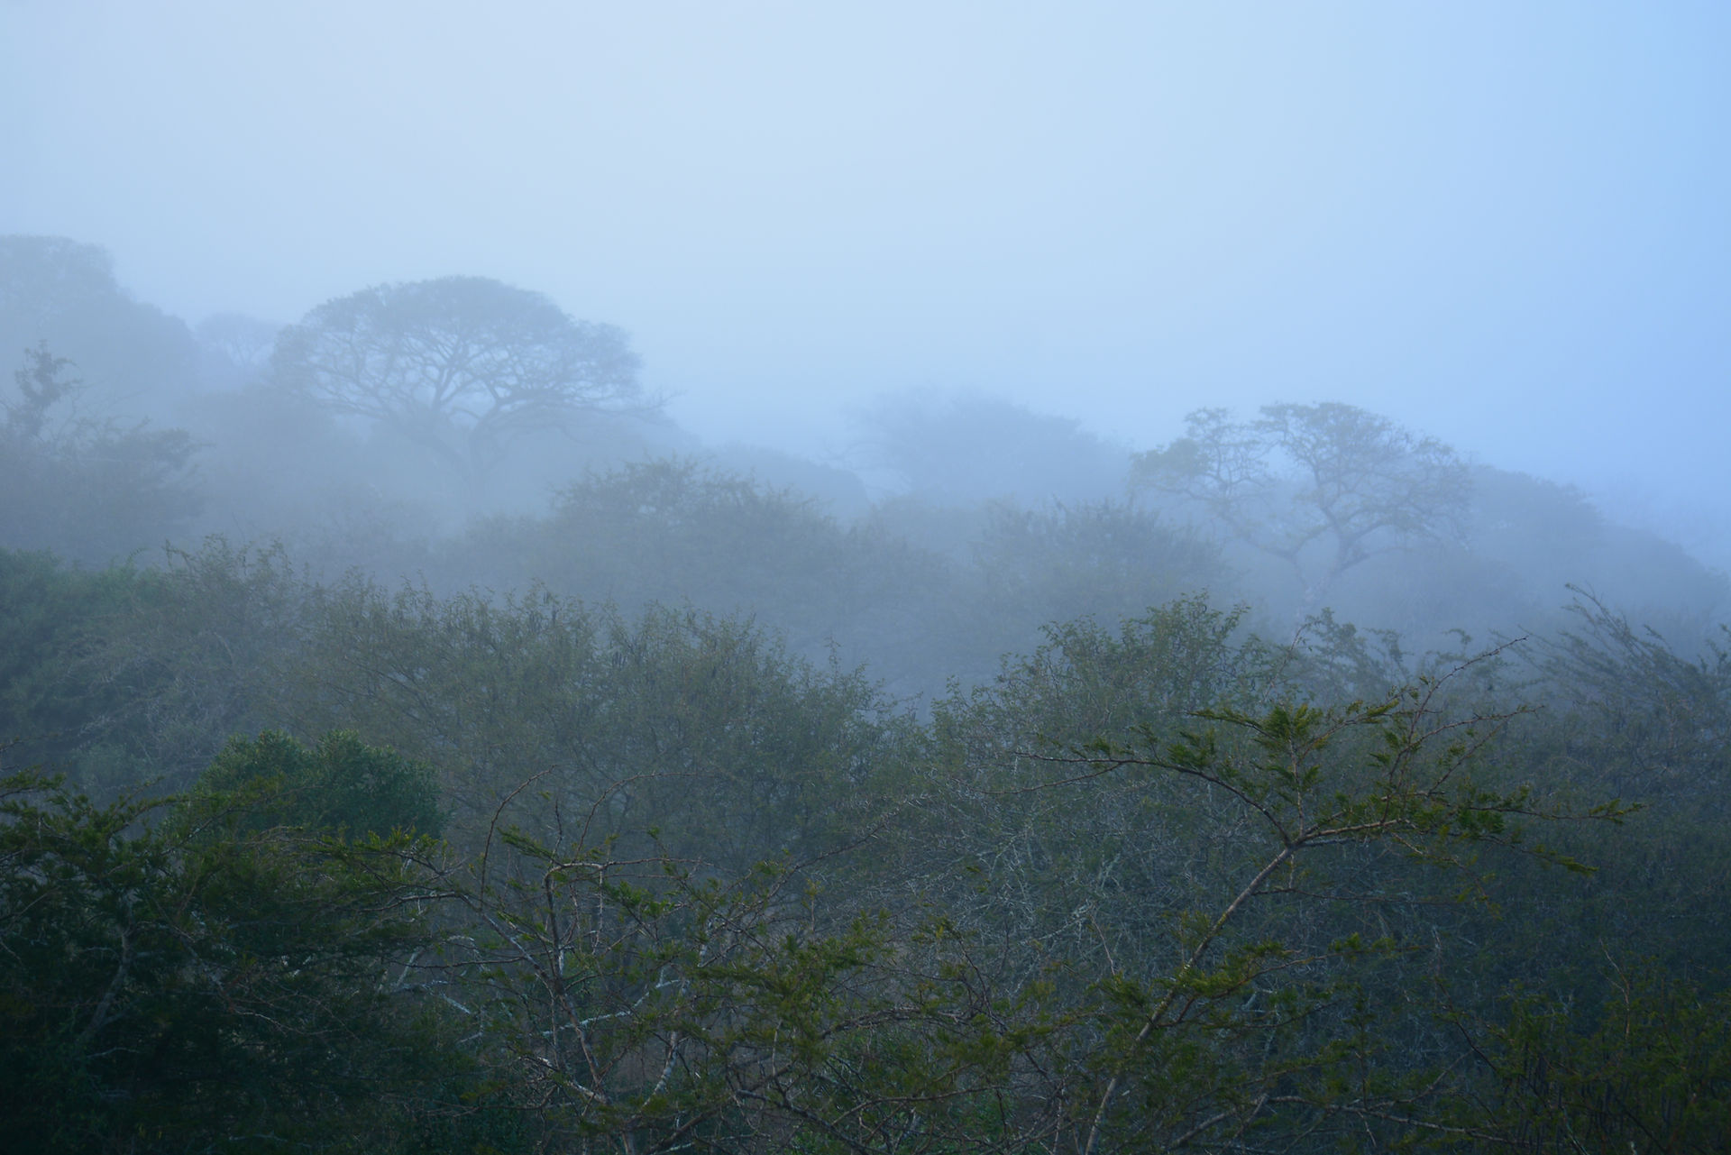
- 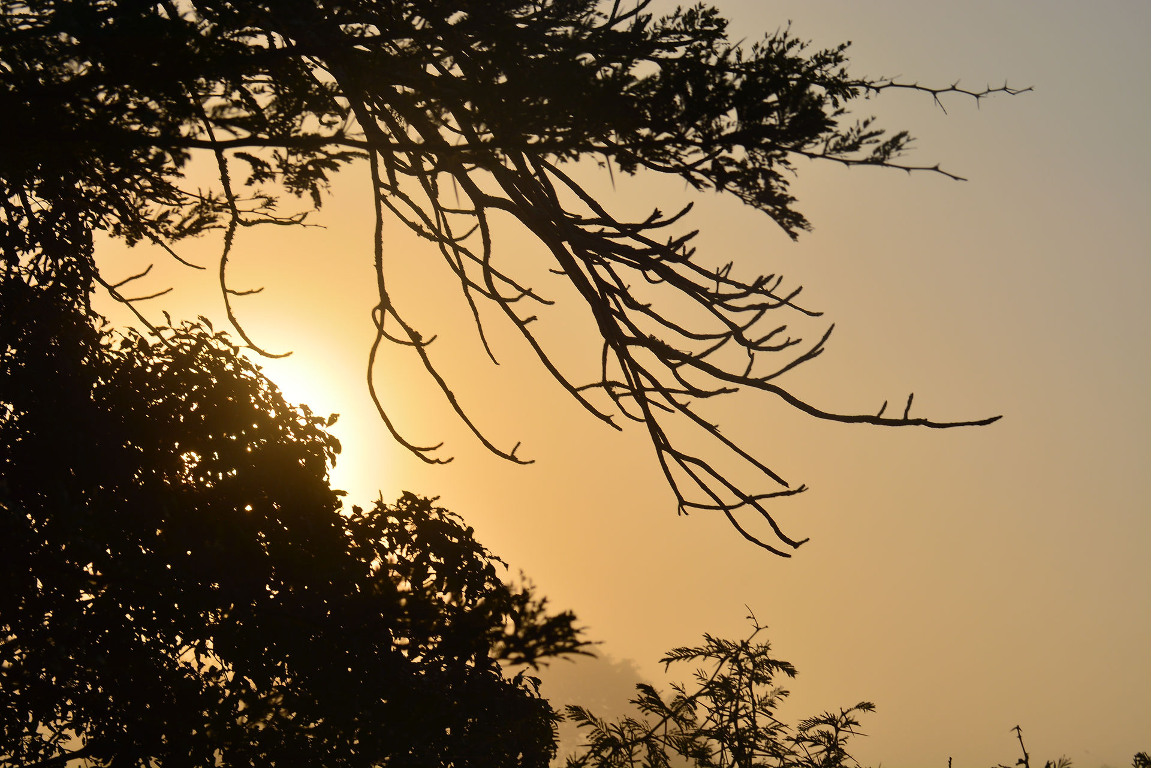
- 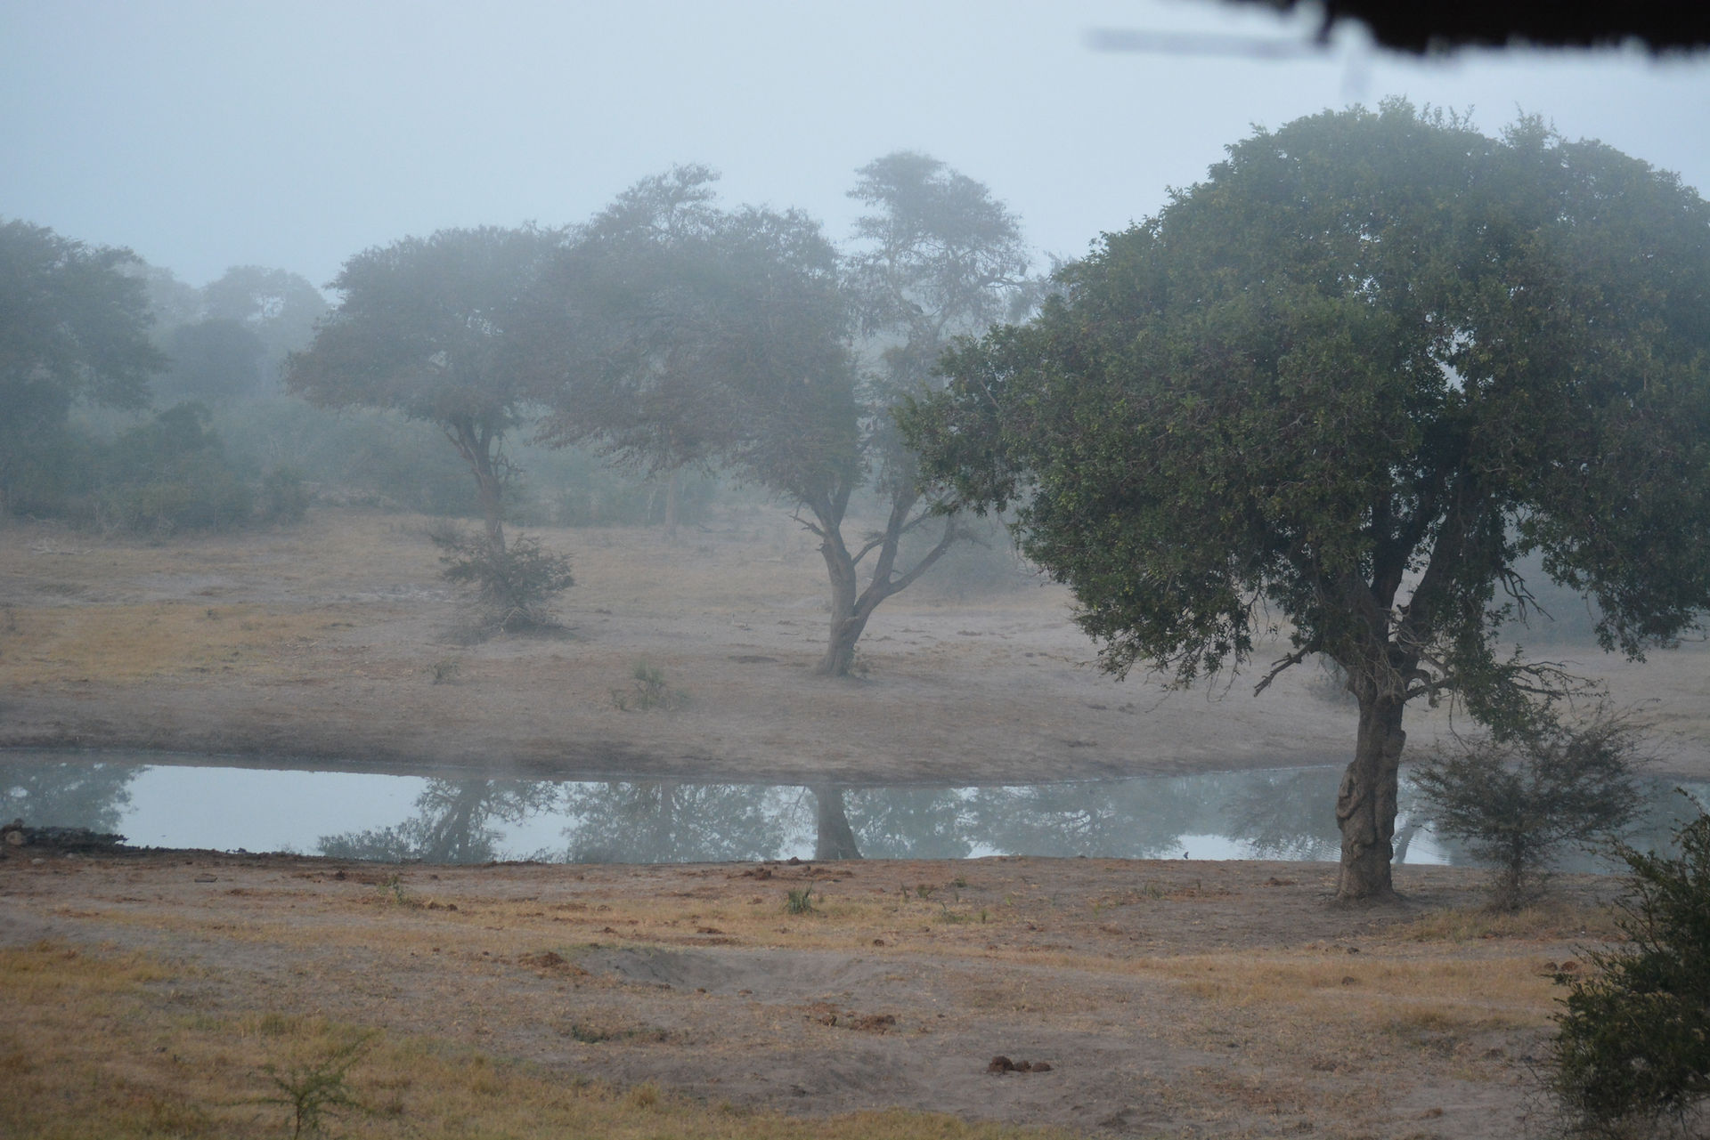
- 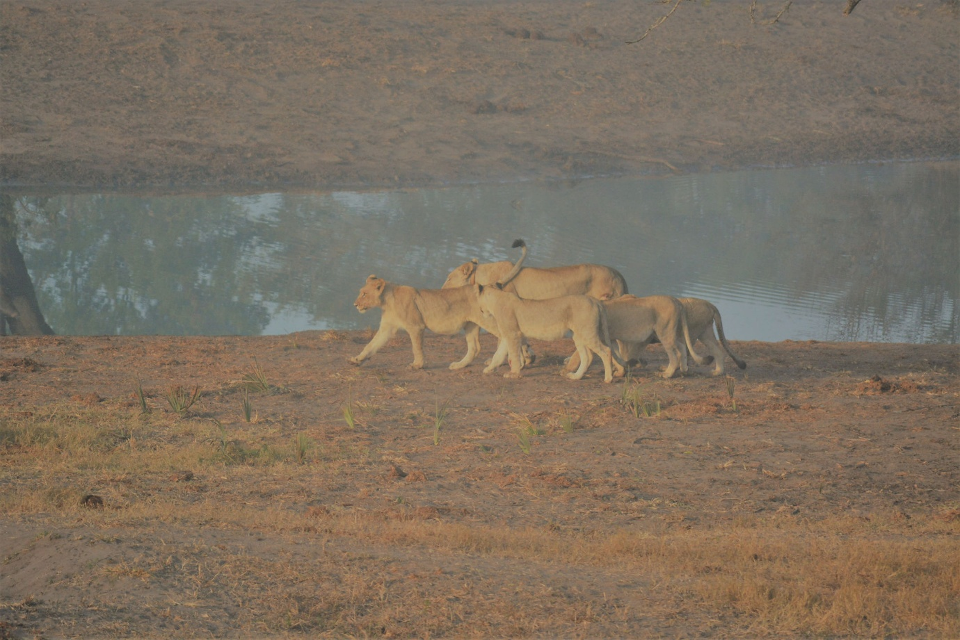
- 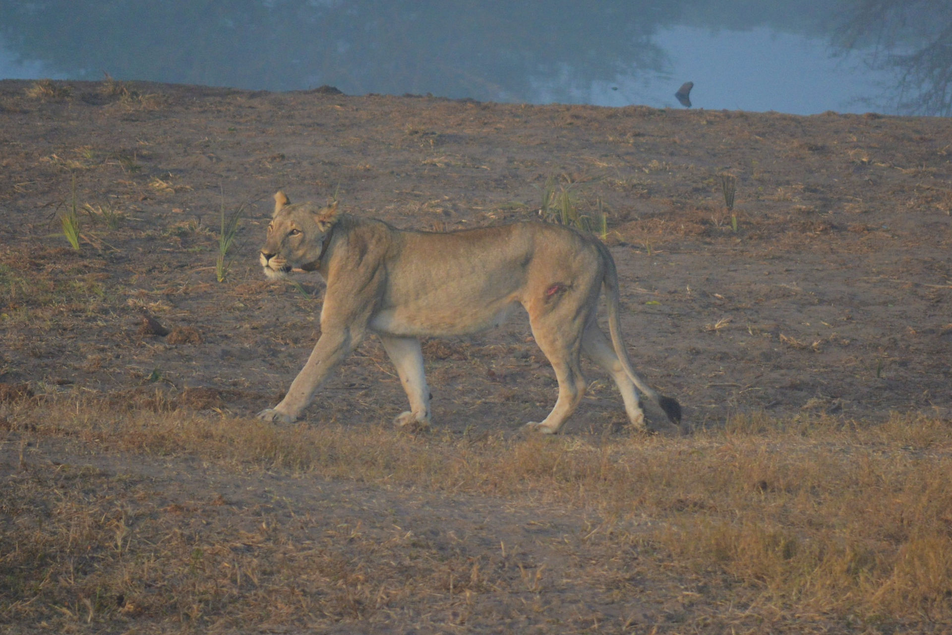
Tony came to pick us up and took us back to Umkumbi Lodge and it was lovely to have an afternoon to chill by the pool, and the bar of course. Hippo Day This was a beautiful day with breakfast at The Lodge followed by a trip on Tony's Tours. Today was off to St Lucia Ismangalisio wetland park. We skimmed onto the boat with seconds to spare as it was waiting for us and off we set. Cameras back out and trundled up a wide river with hippos immediately visible. At first it looked like a mass of black rocks but was in fact a mess of hippos ! All huddled together, they are collectively known as a Pod and their nearest relative is the Whale. We also had a beautiful Fish Eagle and got really close to it and some good photos. Down a little side river were 2 crocs and also a couple of babies. We had one Hippo that obliged with a great big open mouth which I managed to pretty much miss photo wise. The boat was a great size and we were able to get a coffee and move about. We occasionally sprinted upstairs to get better Fish Eagle shots.￼ Tony was waiting for us when we got back and we had an hour to go to the shops. We investigated cameras just in case we could buy Lucie one but they were double the price of the U.K. So didn't do that. Then Tony drove us for a lovely lunch by the ￼ estuary with Hippos, we bought him lunch to thank him for all the organising he was doing for us. At the end of this day, Tony drove us out into the bush and we got to see the best sunset in the middle of nowhere. Which is just the best place to be.￼ Full Game Drive Day We knew this would be a long day and set off at 6am with a packed breakfast and flask of coffee. Brekkie was a cheese sandwich, a hard boiled egg, an apple, a chocolate bar for later, a muffin. We had wrapped up warm for the 40 minute open jeep trip to get to the game reserve. Once we were there we witnessed lots of open jeeps lined up waiting for a coach load of Chinese tourists. It was almost like another safari as we watched them pile out of their coach and into the jeeps. Our guide Patrick found this highly amusing. Off we trundled into the Reserve. The smell of a dead Rhino greeted us, not visible. Then close by were lion tracks and really dark dung, Patrick knew this meant that the lions had been eating the Rhino. We went straight through Hluhluwe and with the windscreen folded down at he front it was now really cold. It was a strange day because we wanted to cover such a vast area with carrying on into imfluoze reserve aswell. This meant that we were kind of just rattling around covering ground. We stopped at a lovely picnic place for￼ coffee and our breakfast. You are not allowed to stop around the reserve, it has to be the designated areas. They are not fenced which is a funny feeling, elephant dung was around the picnic tables, it would be weird to see them in there. The best part of imfluoze was a viewing spot overlooking a river with a lioness way down the bank, she entertained everyone by getting up and walking the full length right up in front of us. We also got great views of white backed vultures and watched them circling and then landing one by one until a herd of vultures had formed a little gang on the sand bank. meanwhile on the right of the stage the Wildebeest that was trying its damndest to blend in with the Impala, was half walking half running to the riverbank. So we had a gang of vultures, a random lioness and a mess of Wildebeest mixed with Impala as we stood getting hotter and hotter. Annoyingly lots of people turned up then.￼ The rest of it was trundling around. We did see a roller which was great. Then up went the windscreen and we went all the way back through both parks. A long day that had to be done￼ but prefer the shorter game drives and sitting at waterholes. Last full day and probably our favourite. Tony's Tours was happening today and off we set to another smaller game reserve called Umkuse. Tony drove and Lisa was able to come with us aswell so it gave them a day out. Terrain slightly different and we all had eyes peeled for the elusive leopard which never did show itself. A great waterhole with some finches all over a bush. It was great at to photo them and later ID them. Terrapins lay on the shore not doing very much. A mongoose appeared briefly before upending itself into a hole at the base of a tree. Zebra came in and lots of Nyala and Impala. The very best bit was then going to a picnic site right on the river with lots of Hippos. So close to them it was strange. Their grunting noises seemed to sound as though they were about to rush out of the￼ bush at us and with the statistics that they kill thousands of people.... It made for a nerve wracking BBQ lunch ! There were brick bbqs that you can just use and Tony had brought charcoal and sausages and rolls and a bit of salad. It was just the best setting

